IEEE P802.15
Wireless Personal Area Networks

Project | IEEE P802.15 Working Group for Wireless Personal Area Networks (WPANs)
Title | LB207/D01 comment resolution -- Clarifications -- CIDs 291, 488, 497, 501, 1019
Date Submitted | January 12, 2025
Sources | Alex Krebs (Apple)  krebs @ apple.com
Re:
Abstract
Purpose | To propose resolution for MMS related comments for “P802.15.4ab™/D (pre-ballot) C Draft Standard for Low-Rate Wireless Networks”.
Notice | This document does not represent the agreed views of the IEEE 802.15 Working Group or IEEE 802.15.4ab Task Group. It represents only the views of the participants listed in the “Sources” field above. It is offered as a basis for discussion and is not binding on the contributing individuals. The material in this document is subject to change in form and content after further study. The contributors reserve the right to add, amend or withdraw material contained herein.
Table of contents

CID 1019 (Revised) 3
CID 291 (Reassign to Rojan) 4
CID 488, 497, 501 (Revised) 5

CID 1019 (Revised)

Name | Index # | Page | Sub-clause | Line # | Comment | Proposed Change
Billy Verso | 1019 | 13 | 3,1 | 23 | the term "hash" is used in the text, a definition should be added. | include a definition for the term "hash"

Discussion: Agree that a lower-case "hash" is confusing. However, instead of (re)defining what a hash is, we should simply make sure that it is understood that the field name is "RPA Hash" and that computation thereof is accurately referenced. Note that there is another specific comment #1156 in 15-24-569-01-04ab that has already being agreed to resolve as proposed below.

Proposed Resolution: Revised

Disposition Detail: Replace all occurrences of "RPA hash" with "RPA Hash" (unless already covered by DCN 15-24-569-01-04ab)

CID 291 (Reassign to Rojan)

Name | Index # | Page | Sub-clause | Line # | Comment | Proposed Change
Tero Kivinen | 291 | 17 | 7.3.7.1 | 3 | Adding a new frame format that does not allow security or privacy in 2024 is really bad. We must not do such thing. Security and privacy is required for the modern 802.15.4 operating environments, especially on the phones etc. Privacy cannot be provided without security, and the currently defined security and privacy features in compact frames are not suitable for the use these frames are intended for. | Define compact frame format so that it can use the 802.15.4 security and reuse the privacy to be defined in TG4ac. It is known that IEEE has long standing tradition of making insecure and broken standards, but lets try to get away from that tradition.

Discussion: There is an ongoing work in " Proposed enhancements to secure Compact frames" DCN 15-24-587-00-04ab presented by Rojan at the Kobe F2F. This comment is likely to be resolved to the commenter's satisfaction alongside the other comments submitted to Rojan. I'd suggest to reassign this comment to Rojan, too.

Proposed Resolution:

Disposition Detail:

CID 488, 497, 501 (Revised)

Name | Index # | Page | Sub-clause | Line # | Comment | Proposed Change
Tero Kivinen | 488 | 81 | 10.38.9.3.7 | 21 | The nbChannelBitmaskSet is not obtained from the bits 0 to 41, it is constructed from there by returning list of integers in such way that for each bit from 0 to 41 it returns the bit number which are set. | Properly define the generation of the NbChannelBitMaskSet.
Tero Kivinen | 497 | 82 | 10.38.9.3.8 | 25 | The nbChannelBitmaskSet is not obtained from the bits 0 to 9, it is constructed from there by returning list of integers in such way that for each bit from 0 to 9 it returns a channel number. | Properly define the generation of the NbChannelBitMaskSet.
Tero Kivinen | 501 | 83 | 10.38.9.3.9 | 15 | The nbChannelBitmaskSet is not obtained from the bits 0 to 31, it is constructed from there by returning list of integers in such way that for each bit from 0 to 31 it returns the bit number which are set. | Properly define the generation of the NbChannelBitMaskSet.

Discussion: The referenced sentences are only the caption of the following text. The following text properly defines the generation of the NbChannelBitMaskSet. See here:

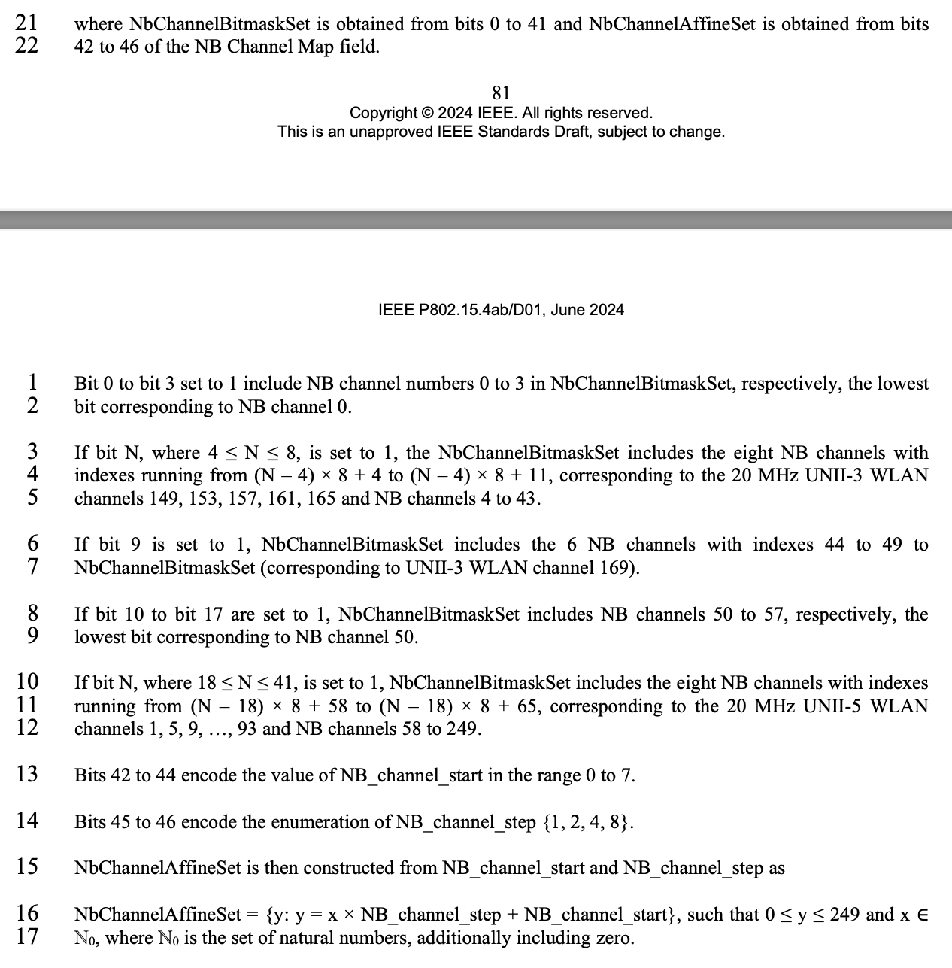
Here is the proper definition:
Comment is rightfully noting lack of proper definition here

Proposed Resolution: Revised

Disposition Detail: Add the words "as follows:" at the end of p.81 l.22, p.82 l.26, and p.83 l.16, respectively.

