**IEEE P802.15**

**Wireless Personal Area Networks**

|  |  |
| --- | --- |
| Project | IEEE P802.15 Working Group for Wireless Personal Area Networks (WPANs) |
| Title | **Comment resolution 963** |
| Date Submitted | Feb 5th, 2025 |
| Sources | Riku Pirhonen (NXP) |
| Abstract | Comment resolution for 963 |
| Purpose | Propose resolutions to comments received on IEEE P802.15.4ab/D01, June 2024. |
| Notice | This document does not represent the agreed views of the IEEE 802.15 Working Group or IEEE 802.15.4ab Task Group. It represents only the views of the participants listed in the “Sources” field above.It is offered as a basis for discussion and is not binding on the contributing individuals. The material in this document is subject to change in form and content after further study. The contributors reserve the right to add, amend or withdraw material contained herein. |
|  |  |

Resolution proposal

## Comment 963 – Revised

|  |  |  |  |  |  |  |
| --- | --- | --- | --- | --- | --- | --- |
| **Name** | **Index #** | **Page** | **Sub-clause** | **Line #** | **Comment** | **Proposed Change** |
| Riku Pirhonen | 963 | 193 | 16.2.11.2 | 8 | When Ipatov codes are used as RSF, MMRS is identical to the preamble and similar length RSF identical to SYNC. By adding the same SFD as in SHR at end of each Ipatov-RSF, each RSF could act as a SHR in case the first SHR is lost e.g. due to interference. This improves the robustness of ranging as the sequence is not necessarily lost in case the first SHR is lost. | Continue on line 8: "When these codes are used, a copy of the SFD sequence is added at the end of each RSF. RSF consists of MMRS repetitions and SFD, and can be identical to the initial SHR (SYNC+SFD) fragment" |

**Discussion**

The comment highlights that UWB driven MMS mode is vulnerable to loss of the first SYNC + SFD fragment of the UWB MMS packet. If this fragment is not received, e.g., due to interference, there is no successful signal acquisition, and the whole ranging round fails.

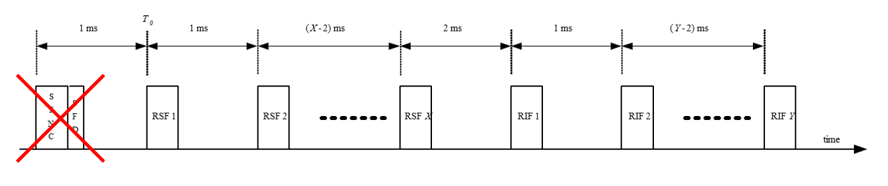

*Example of ranging round failing due to loss of SYNC+SFD fragment.*

The preamble code index of the UWB driven mode SYNC + SFD fragment is defined by the same Sequence Code Index which defines the MMRS symbol used for the RSFs (subclause 10.38.9.3.10). When the UWB PHY MMS packet uses the length-91 [or length-127] codes, and the RSF MSR value equals SYNC PSR value, the SYNC and RSF are identical. *(If this applies to only to length-91 codes, or also to length 127 codes, depends on the pending resolution to CID 1362 in Doc 15-25-0069)*.

In order to improve robustness, and to avoid losing the ranging round due to possibly failed first fragement, in case of length-91 [or length-127] codes the UWB PHY MMS packet can be simplified and all the fragments made identical. By repeating the SYNC + SFD instead of plain RSF (=SYNC), all the fragments in the packet can be used for acquisition.

The more RSF+SFD (SYNC+SFD) fragments there are, the higher probability there is that at least one of those is received successfully and can be used for acquisition. The remaining fragments after acquisition can be used as in regular MMS scheme.

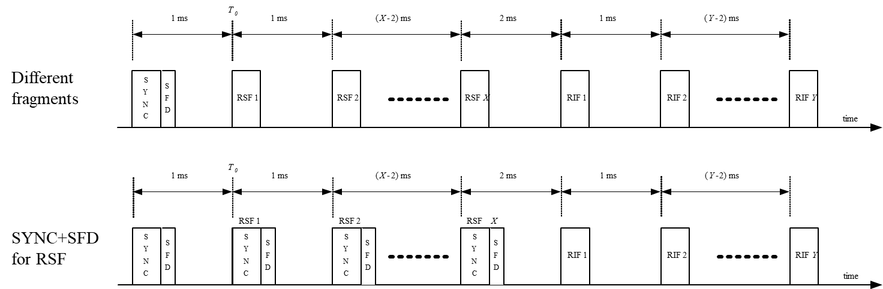

*Comparison of basic and robust use of RSF fragments.*

There are multiple options how MAC can set this configuration, for example:

* The Ranging MAC Configuration field, currently sets the number of RSFs and RIFs
* The Ranging PHY Configuration field, sets code index, RSF and RIF properties and UWB channel

The Ranging PHY Configuration field was already modified by contribution Doc 15-24-0506, so it can be used also for this purpose as well. The resolutions changed two field names and allocated an additional bit for the RIF Fragment Length field to facilitate shorter fragment lengths. Proposal is to add one bit, RSF with SFD, to the Configuration field.

Combining the already accepted changes from Doc 15-24-0506 and the update from this resolution, the Ranging PHY Configuration field will look as below.

|  |  |  |  |  |  |  |
| --- | --- | --- | --- | --- | --- | --- |
| **Bits: 0-5** | **6-12** | **13-15** | **16-~~17~~18** | **~~18~~19** | **~~18~~20-~~24~~26** | **~~25~~27-31** |
| Sequence Code Index | MMRS complementary set zeros | ~~N_MSR~~  RSF Fragment Length | ~~STS Segment~~ RIF Fragment  Length | RSF with SFD | UWB Channel | Reserved |

**Figure 52 – The Ranging PHY Configuration field**

**Revised resolution details**

**Resolution step 1:** Modify Figure 52 on page 84 as follows:

|  |  |  |  |  |  |  |
| --- | --- | --- | --- | --- | --- | --- |
| **Bits: 0-5** | **6-12** | **13-15** | **16-~~17~~18** | **~~18~~19** | **~~18~~20-~~24~~26** | **~~25~~27-31** |
| Sequence Code Index | MMRS complementary set zeros | ~~N_MSR~~  RSF Fragment Length | ~~STS Segment~~ RIF Fragment  Length | RSF with SFD | UWB Channel | Reserved |

**Figure 52 – The Ranging PHY Configuration field**

**Resolution step 2:** Add following text on page 84, after line 20.

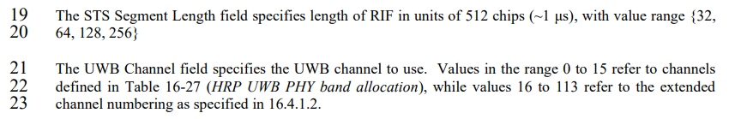

The RSF with SFD field can be set to value 1 to indicate use of SFD at end of each 91-length [and 127-length] code based RSF, so that each RSF fragment becomes identical to the UWB SYNC + SFD fragment.

**Resolution step 3:** Add following text to page 193, after line 8.

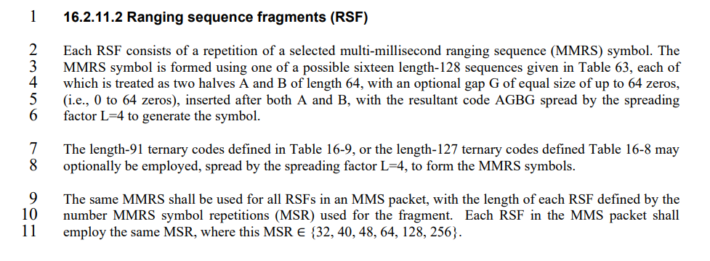

When the length-91 ternary codes [or the length-127 ternary codes] are used as the RSF MMRS symbols in the UWB driven mode, the MMRS repetitions can optionally be followed by a SFD similar to the one in SYNC + SFD to improve the robustness of the MMS packet as any of the fragments can be used for signal acquisition.

The text in brackets applies depending on the outcome of Comment 1362 resolution.

**Resolution step 4:** Add following row to Table 12-8 on page 181.

|  |  |  |  |
| --- | --- | --- | --- |
| **Attribute** | **Type** | **Range** | **Description** |
| … | … | … | … |
| *phyUwbMmsRsfZeros* | Integer | 32, 40, 48, 64, 128, 256 | Number of zeros inserted at middle and end of the complementary set sequence when the *phyUwbMmsRsfCodeIndex* is selecting a code from Table 63. |
| *phyUwbMmsRsfSfd* | Boolean | TRUE, FALSE | Enables RSF + SFD when TRUE;  Doesn’t use SFD after RSF when FALSE. |