**IEEE P802.15**

**Wireless Personal Area Networks**

|  |  |  |
| --- | --- | --- |
| Project | IEEE P802.15 Working Group for Wireless Personal Area Networks (WPANs) | |
| Title | **Draft 1.0 Comment Resolution CIDs 264, 901, 1252, 1253** | |
| Date Submitted | Dec 2024 | |
| Sources | Panpan Li, Bin Qian, Lei Huang, Rojan Chitrakar, David Xun Yang (Huawei) |  |
| Re: |  | |
| Abstract |  | |
| Purpose | To propose comments resolution for “P802.15.4ab™/D1.0 Draft Standard for Low-Rate Wireless Networks” | |
| Notice | This document does not represent the agreed views of the IEEE 802.15 Working Group or IEEE 802.15.4ab Task Group. It represents only the views of the participants listed in the “Sources” field above.It is offered as a basis for discussion and is not binding on the contributing individuals. The material in this document is subject to change in form and content after further study. The contributors reserve the right to add, amend or withdraw material contained herein. | |

**R0: 264, 901, 1252, 1253**

***-------------------------------------------------------------------------------------------------------------------------------***

***Comment Index #264, 901, 1252, 1253 in 15-24-0371-10-04ab-consolidated-comments-draft-1-0***

|  |  |  |  |  |  |  |  |
| --- | --- | --- | --- | --- | --- | --- | --- |
| **Index #** | **Commenter** | **Sub-Clause** | **Page** | **Line** | **Comment** | **Proposed Change** | **Proposed resolution** |
| 264 | Li-Hsiang Sun | 10.39.6.1 | 150 | 4 | The example does not match formula on p149 for OF=2, N=6 | fix the formula, the (OF+1) in formula for OF=1,2 should be replace by a value of (1+1), i.e. there is 1 overlapping channel in the grid to a base channel for the case of OF=1 and 2 so for these 2 cases the order should be the same | Revised |
| 901 | Carl Murray | 10.39.6.1 | 150 | 11 | "Figure 160 and the associated text is incomplete as it does not address the SHR of the sensing packet. What happens if the SHR overlaps an SF (of its owns SFs or another packets).  " | Update the figure to include the SHR and describe the spacing when the SHR overlaps an SF. | Revised |
| 1252 | Billy Verso | 10.39.6.1 | 150 | 4 | No such thing as sensing fragments, the sensing packet has sensing segments. | Change to sensing segments. | Revised |
| 1253 | Billy Verso | 10.39.6.1 | 150 | 11 | Figure 160 is misleading since it is not showing the sensing packet completely with SHR, and the 4 sensing segments. | Update figure to show full sensing packet(s) with SHR | Revised |

**Discussion:**

According to the discussion and SP results from doc 15-24-0579-02, the group has agreed to transmit the SHR and the first sensing segment over the same channel together in the frequency stitching.

**Resolution: Revised**

*Proposed text changes on P802.15.4ab™-D01:*

**10.39.6.1 Application Control IE (AC IE)**

*Change Line 4-7 on Page 150 as follows*

Figure 160 shows an example of frequency stitching channel use for a sequence of sensing segments, , as selected when the Channel Sequence Order field value is 1, the Carrier Frequency Grid field value is 2, the Number of Transmissions field value is 5, and the Frequency Stitching Type field is 2. There are two sensing packets, each with three sensing segments.

In the figure, the interval between overlapping channel use from two sensing packets is greater than or equal to 1 ms.

*Change Figure 160 on Page 150 as follows*

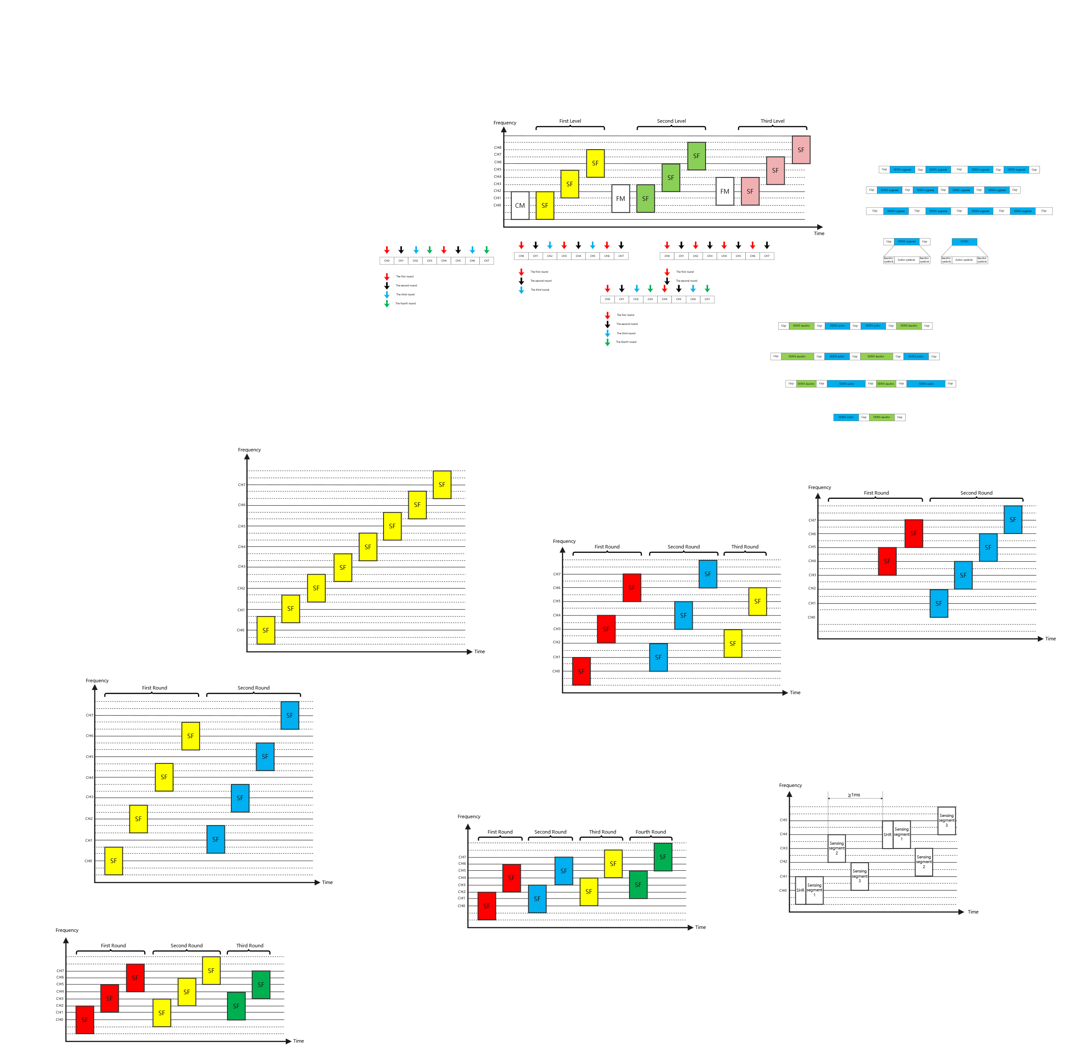

Figure 160—Frequency stitching channel sequence example