**IEEE P802.15**

**Wireless Personal Area Networks**

|  |  |  |
| --- | --- | --- |
| Project | IEEE P802.15 Working Group for Wireless Personal Area Networks (WPANs) | |
| Title | **Draft 1.0 Comment Resolution CIDs 251, 1283, 1284, 1469** | |
| Date Submitted | Nov 2024 | |
| Sources | Panpan Li, Bin Qian, Lei Huang, Rojan Chitrakar, David Xun Yang (Huawei) |  |
| Re: |  | |
| Abstract |  | |
| Purpose | To propose comments resolution for “P802.15.4ab™/D1.0 Draft Standard for Low-Rate Wireless Networks” | |
| Notice | This document does not represent the agreed views of the IEEE 802.15 Working Group or IEEE 802.15.4ab Task Group. It represents only the views of the participants listed in the “Sources” field above.It is offered as a basis for discussion and is not binding on the contributing individuals. The material in this document is subject to change in form and content after further study. The contributors reserve the right to add, amend or withdraw material contained herein. | |

**R0: 251, 1283, 1284, 1469**

***---------------------------------------------------------------------------------------------------------------------------------------***

***Comment Index #251 in 15-24-0010-27-04ab-cc-consolidated-comments***

|  |  |  |  |  |  |  |
| --- | --- | --- | --- | --- | --- | --- |
| **Index #** | **Commenter** | **Sub-Clause** | **Page** | **Line** | **Comment** | **Proposed Change** |
| 251 | Li-Hsiang Sun | 10.39.5.3 | 136 | 8 | If the sensing requesting device is a sensing receiver, from the spec text it is not clear whether the requesting device needs to send CIR report. The initiator normally does not schedule the requesting device for CIR reporting in this case. However if the sensing requesting device cannot perform frequency stitching reporting it may report multiple 499.2 MHz CIRs and requesting the aggregated CIR from the sensing initiator | If sensing requesting device does not support aggregated CIR report but requested in SBP request IE Sensing ctrl as a sensing receiver, and requested aggregated CIR report, the sensing initiator should schedule 499.2 MHz CIR reports from the sensing requesting device |

**Resolution: Revised**

*Proposed text changes on P802.15.4ab™-D01:*

**10.39.5.3 SBP reporting**

*Add Line 2-8 on page 136 as follows*

In the SBP reporting procedure, the sensing initiator may sequentially transmit one or more CIR Report IEs carrying the sensing measurement reports of the corresponding sensing measurement exchange to the sensing requesting device. Alternatively, the sensing initiator may transmit an combined sensing measurement report to the sensing requesting device, which includes two or more CIR Report IEs, each CIR Report IE carrying the sensing measurement reports of the corresponding sensing measurement exchange. The CIR Report IE transmitted by the sensing initiator shall include the address of the sensing responder that generated the sensing measurement report carried in the CIR Report IE. If the sensing requesting device is a sensing receiver and it does not support report for aggregated channel when frequency stitching is enabled, it may request report for aggragated channel from the sensing initiator by configuring the Sensing Control field in SBP Request IE.

***---------------------------------------------------------------------------------------------------------------------------------------***

***Comment Index #1283, 1284 in 15-24-0010-27-04ab-cc-consolidated-comments***

|  |  |  |  |  |  |  |
| --- | --- | --- | --- | --- | --- | --- |
| **Index #** | **Commenter** | **Sub-Clause** | **Page** | **Line** | **Comment** | **Proposed Change** |
| 1283 | Billy Verso | 16.2.10 | 191 | 5.1 | Since the PHY has to change frequency between the segments the sequence should be described/defined here in the PHY clause. Suggest to define four PIB parameters to hold the channel number for each of Frequency Stitch Segment, e.g. *phyFSS1channel*, and define a PIB attribute *phyFSEnable* to enable the frequency stitch mode (making the gaps 40 when TRUE, and 1 when FALSE) | Add a PHY clause paragraph to specify frequency stitching and describe the sequence, with reference to phy PIB configuration parameters, as per comment suggestion. |
| 1284 | Billy Verso | 16.2.10 | 191 | 5.2 | For frequency stitching it is likely that the first frequency change would be wanted between the SHR and the first segment of SENS. My previous comment would allow for that. [For normal use the phyCurrentChannelInfo specifies the operating channel, so this can/should still be used to give the channel for the non-SENS parts of the sensing packet, and the whole packet when phyFSEnable is FALSE. | Add some text in 10.39 to note that frequency stitching first frequency change may be before the first SENS segment, i.e., if the channel for the first segment as specified in phyFSS1channel, is different from the phyCurrentChannelInfo. Refer forward to the phy clause 16.2.10 where (hopefully after my previous comment) the frequency stitching operation is specified. |

**Discussion:** agree with commentor. In DCN 462r2, to resolve CIDs 1282, 1468, 1285, we revised the paragraph describing the gap durations, thus here no need further modifications.

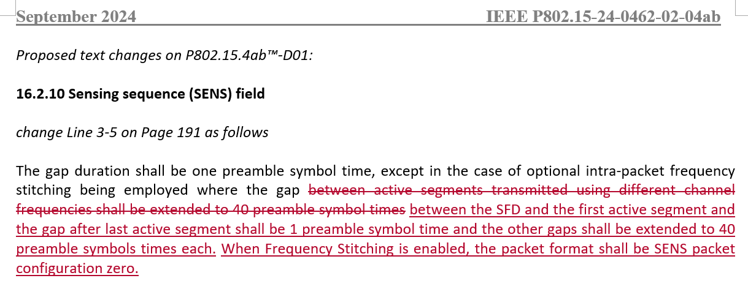

**Resolution: Revised**

*Proposed text changes on P802.15.4ab™-D01:*

*Insert after Line 2 on Page 181 as follows*

**12.3.12 Other PHY related PIB attributes**

*Insert the following new attributes into Table 12-14.*

**Table 12-14—Other PHY related PIB attributes**

|  |  |  |  |
| --- | --- | --- | --- |
| **Attribute** | **Type** | **Range** | **Description** |
| … | … | … | … |
| *phyFSEnable* | Boolean | TRUE, FALSE | When TRUE, frequency stitching is enabled. When FALSE, frequency stitching is disabled. |
| *phyFSType* | Enumeration | 0, 1, 2 | 0 corresponds to intra-packet frequency stitching, 1 corresponds to inter-packet frequency stitching and 2 corresponds to combination of intra-packet and inter-packet frequency stitching. |
| *phyFSS1channel* | Enumeration | 16-113 | Channel number defined in 16.4.1.2 used by first sensing segment |
| *phyFSS2channel* | Enumeration | 16-113 | Channel number defined in 16.4.1.2 used by second sensing segment |
| *phyFSS3channel* | Enumeration | 16-113 | Channel number defined in 16.4.1.2 used by third sensing segment |
| *phyFSS4channel* | Enumeration | 16-113 | Channel number defined in 16.4.1.2 used by forth sensing segment |
| … | … | … | … |

**10.39.3 Frequency Stitching**

*change Line 8-17 on Page 129 as follows*

Frequency stitching combines CIR measurements over multiple carrier frequencies, to improve sensing link budget and accuracy. Frequency stitching is an optional feature that may be applied in all the operating modes defined in 10.39.2. Frequency stitching may be performed with overlapping carrier frequencies or non-overlapping carrier frequencies. The carrier frequency grid configuration determines the percentage overlap of transmissions in frequency stitching. A carrier frequency grid configuration of 124.8 MHz indicates an overlap of 75%, a carrier frequency grid configuration of 249.6 MHz indicates an overlap of 50% and a carrier frequency grid configuration of 374.4 MHz indicates an overlap of 25%. A carrier frequency grid configuration of 499.2 MHz indicates no overlap of transmissions in frequency stitching. The sensing report may be shared per transmission, or an aggregated report may be sent after the last transmission. During frequency stitching, the first frequency change may occur before the first SENS segment, i.e., if the channel for the first segment as specified in phyFSS1channel, is different from the phyCurrentChannelInfo. The channel used for sensing segments are specified by phyFSS1channel, phyFSS2channel, phyFSS3channel and phyFSS4channel as in 12.3.12.

***---------------------------------------------------------------------------------------------------------------------------------------***

***Comment Index #1469 in 15-24-0010-27-04ab-cc-consolidated-comments***

|  |  |  |  |  |  |  |
| --- | --- | --- | --- | --- | --- | --- |
| **Index #** | **Commenter** | **Sub-Clause** | **Page** | **Line** | **Comment** | **Proposed Change** |
| 1469 | Jaegook Lee | 13.3.2 | 185 | 18 | IEEE 802.15.4 (sec. 12.3.5) Adjacent channel rejection was designed in consideration of 5 MHz channel spacing. In IEEE 802.15.4ab, O-QPSK channel spacing was changed from 5 MHz to 2.5 MHz. Since channel spacing has been halved, adjacent channel rejection may need to be designed considering this new channel spacing. | as in the comment |

**Resolution: Rejected.**

**Reject reason:** The O-QPSK transmit PSD has been revised in DCN 15-24/0142-01. Group has reached consensus that the absolute limit of O-QPSK transmit PSD shall comply with the local regulations and thus deleted from draft standard. So adjacent channel rejection doesn’t need to be redesigned.

