**IEEE P802.15**

**Wireless Personal Area Networks**

|  |  |
| --- | --- |
| Project | IEEE P802.15 Working Group for Wireless Personal Area Networks (WPANs) |
| Title | **Comment resolution –Non-interleaved mode 96, 952, 953, 97, 954, 955, 956, 959** |
| Date Submitted | Feb 12th, 2025 |
| Sources | Riku Pirhonen (NXP), Frank Leong (NXP) |
| Abstract | Comment resolution for 96, 952, 953, 97, 954, 955, 956, 959 |
| Purpose | Propose resolutions to comments received on IEEE P802.15.4ab/D01, June 2024. |
| Notice | This document does not represent the agreed views of the IEEE 802.15 Working Group or IEEE 802.15.4ab Task Group. It represents only the views of the participants listed in the “Sources” field above.It is offered as a basis for discussion and is not binding on the contributing individuals. The material in this document is subject to change in form and content after further study. The contributors reserve the right to add, amend or withdraw material contained herein. |
|  |  |

# Summary of comments

The following comments are resolved in this document:

|  |  |  |  |  |  |  |
| --- | --- | --- | --- | --- | --- | --- |
| **Name** | **Index #** | **Page** | **Sub-clause** | **Line #** | **Comment** | **Proposed Change** |
| Frank Leong | 96 | 69 | 10.38.5 | 3 | The example only represents interleaved MMS operation. A non-interleaved example should be added. | Add a paragraph stating "The responder may start transmitting a first RIF or RSF fragment at 1200 RSTU after the start of the last initiator RSF or RIF fragment." Add another similar paragraph for the DS-TWR case. |
| Riku Pirhonen | 952 | 69 | 10.38.5 | 7 | In order to support traditional SS-TWR and DS-TWR, non-interleaved mode is proposed. It would delay sending responder MMS packet by RpDuration and, for DS-TWR, initiator can send another MMS packet after two RpDurations. | In non-interleaved mode responder shall start transmission of MMS packet after one RpDuration from the start of the ranging phase, and when DS-TWR is desired, initiator may transmit a second MMS packet after two RpDurations from the start of the ranging phase. |
| Riku Pirhonen | 953 | 69 | 10.38.5 | 12 | Add behavior in case of the proposed non-interleaved mode. | After macMmsRpDuration, or in case of non-interleaved mode after double or triple macMmsRpDuration as defined by the ExtendedRpDuration, and transmission and reception of all the fragments… |
| Frank Leong | 97 | 69 | 10.38.5 | 15 | The example only represents interleaved MMS operation. A non-interleaved example should be added. | Add two similar figures, one showing non-interleaved SS-TWR MMS operation (2*RpDuration), and another showing non-interleaved DS-TWR MMS operation (3*RpDuration). |
| Riku Pirhonen | 954 | 69 | 10.38.5 | 16 | Add picture of the proposed non-interleaved mode | Add picture that shows non-interleaved mode with double and triple RpDuration. |
| Riku Pirhonen | 955 | 86 | 10.38.9.3.12 | 1 | Add ExtendedRpDuration field to the Managemetn MAC Configuration field figure | Add ExtendedRpDuration field between RpDuration and Reserved, and use bits 44 and 45 for this |
| Riku Pirhonen | 956 | 86 | 10.38.9.3.12 | 33 | Add description for ExtendedRpDuration field | The ExtendedRpDuration field enables non-interleaved MMS packets by extending the ranging phase to double or triple of the RpDuration. By default, bits are 00, which means interleaved initiator and responder transmissions. Bit values 01 meand double RpDuration and non-interleaved transmission by initiator and responder as shown in Figure XX [in chapter 10.38.5], and bits set to 10 mean triple RpDuration and non-interleaved transmissions by initiator – responder – initiator, as shown in figure XX [in chapter 10.38.5]. Bit combination 11 is reserved. |
| Riku Pirhonen | 959 | 125 | 10.38.10.1 | 1 | Add MAC PIB attribute macMmsExtendedRpDuration to Table 20 on the row after MacMmsRpDuration | macMmsExtendedRpDuration, Integer, 0 - 3, 0 = Interleaved ranging phase, 1 = Non-interleaved ranging phase of double RpDuration, 2 = Non-interleaved ranging phase of triple RpDuration, 3 = reserved, Default 0 |

**General discussion**

IEEE802.15.4ab draft 01 defines the UWB MMS packet fragments to be sent interleaved. After the initiator has sent one fragment, the responder will send a fragment 500 us later and this continues until all the fragments have been sent.

This contribution resolves comments that address a non-interleaved mode. Initiator POLL and UWB MMS Packet fragements are sent by the Initiator and received by the Responder before the Responder sends its RESP message and UWB MMS Packet fragments. In case of DS-TWR, the Initiator sends another POLL and UWB MMS Packet after it has completed reception of the UWB MMS Packet from the Responder.

In case of NBA-MMS, the UWB MMS Packet is sent immediately after the corresponding NB Poll or Response packets. The Initiator doesn’t wait for the Responder RESP packet.In case of UWB driven mode, the SYNC + SFD fragment is part of the packet and a SP0 packet is sent instead of the NB POLL or RESP packets.

The original comments suggested the non-interleaved mode to be configured by stretching the ranging phase to allow non-interleaved packet exchange. Based on the feedback from the working group, the non-interleaved packets are revised to be sent in subrounds consisting of control and ranging phases.

Non-interleaved mode can be used for OWR, SS-TWR or DS-TWR the same way as 4z based ranging (subclause 10.29.1.2), but instead of a single slot, the control and ranging phases extend over multiple slots. Compared to 4z, DS-TWR can be supported with the link budget improvement provided by MMS packets.

The non-interleaved subrounds are defined by taking in use three reserved bits in the Management MAC Configuration field, described in 10.38.9.3.12, Figure 54. The non-interleaved mode can be negotiated during the Initialization by exchanging the Management MAC Configuration field in the Advertising Response and Start of Ranging frames.

**DS-TWR report message**

To support DS-TWR a report message with fields for *Treply* and *Tround* needs to be added. This could be done in several ways.

* A new Message Control variant can be added to existing Compact Frame IDs 5 (variant 10), 6 (variant 20), 10 (variant 20) and 11 (variant 20).
* DS-TWR could have a Compact Frame ID of its own, “DS-TWR message”. Separate Secure Reports were deleted, so the first ID available is 17. This could serve both as a initiator or responder message, and one-to-one and one-to-many ranging because they are identical.

The first option is chosen in this resolution document, it aligns better with the ID hierarchy. The current proposal doesn’t support short term operation parameters, Contention based one-to-many ranging, Time efficient one-to-many ranging or Multiple RSF transmissions per slot. Support for some of these modes can be added by defining corresponding report messages.

In addition a message flow diagram for DS-TWR is provided.

**Resolution details**

## Comment 96 – Revised

|  |  |  |  |  |  |  |
| --- | --- | --- | --- | --- | --- | --- |
| **Name** | **Index #** | **Page** | **Sub-clause** | **Line #** | **Comment** | **Proposed Change** |
| Frank Leong | 96 | 69 | 10.38.5 | 3 | The example only represents interleaved MMS operation. A non-interleaved example should be added. | Add a paragraph stating "The responder may start transmitting a first RIF or RSF fragment at 1200 RSTU after the start of the last initiator RSF or RIF fragment." Add another similar paragraph for the DS-TWR case. |

**Resolution:** Covered by resolution to CID 952, see below, which adds paragraph “10.38.X Non-interleaved mode” and includes the descriptive text for non-interleaved MMS operation.

## Comment 952 – Revised

|  |  |  |  |  |  |  |
| --- | --- | --- | --- | --- | --- | --- |
| **Name** | **Index #** | **Page** | **Sub-clause** | **Line #** | **Comment** | **Proposed Change** |
| Riku Pirhonen | 952 | 69 | 10.38.5 | 7 | In order to support traditional SS-TWR and DS-TWR, non-interleaved mode is proposed. It would delay sending responder MMS packet by RpDuration and, for DS-TWR, initiator can send another MMS packet after two RpDurations. | In non-interleaved mode responder shall start transmission of MMS packet after one RpDuration from the start of the ranging phase, and when DS-TWR is desired, initiator may transmit a second MMS packet after two RpDurations from the start of the ranging phase. |

**Discussion**

Instead of ExtendedRpDuration, control and ranging phases are repeated and these are called sub-rounds.

**Resolution step 1:** Add the text in red on line 8 onwards, page 56.

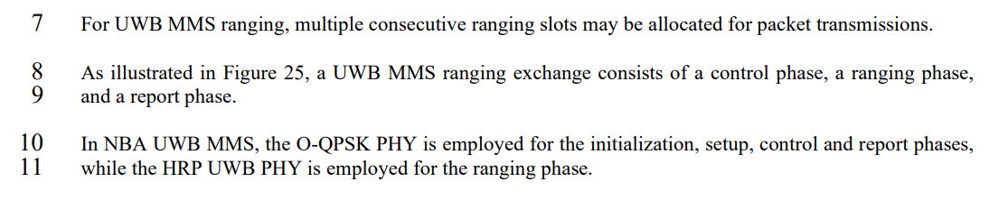

As illustrated in Figure 25, an interleaved one-to-one UWB MMS ranging exchange consists of a control phase, a ranging phase, and a report phase. In case of non-interleaved or one-to-many ranging one ranging round may have multiple sub-rounds, that have Control, Ranging and, in case of one-to-many ranging, Report phases, as described in Clause 10.38.X and 10.38.8.

**Resolution step 2:** One page 70, line 15, after subclause 10.38.6 and before existing subclause 10.38.7, add a new subclause on non-interleaved mode.

**10.38.X Non-interleaved mode**

An optional non-interleaved mode can be used to reduce the amount of transitions between transmission and reception at the cost of total ranging time. An example of non-interleaved mode ranging round is shown in Figure X.

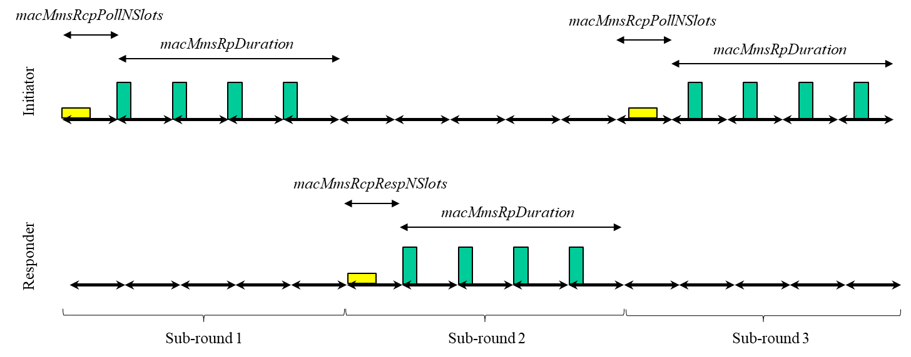

**Figure X. NBA-MMS non-interleaved ranging using four fragments and three subrounds to support DS-TWR with three messages.**

An non-interleaved ranging round may consist of one, two, three or four sub-rounds or an hybrid sub-round. These correspond to one-way ranging (OWR), single-sided two-way ranging (SS-TWR), double-sided two-way-ranging (DS-TWR) with three packets, double-sided two-ranging with four packets and to a hybrid mode, where a basic interleaved SS-TWR exchange is followed by a single OWR sub-round. The mode is defined by *NonInterleavedMode* parameter as described in 10.38.9.3.12. Non-interlaved control and ranging phases may be followed by an optional report phase. OWR sub-round can be from the initiator to the responder or from the responder to the initiator, which is defined by the *macMmsRcpPollNSlots* and *macMmsRcpRespNSlots*.

Operation in NBA-MMS mode. After sending the POLL meassage, the initiator does not wait for the response message, and instead transmits the UWB packet after *macMmsRcpPollNSlots* duration from the beginning of the poll message. This is one subround and would complete one-way ranging. After the inititator UWB packet is completed, and if the responder is to respond, it sends its RESP message one RpDuration after the start of the received initiator UWB packet, and a UWB MMS packet *macMmsRcpRespNSlots* after the start of the RESP message. If the initiator is to send a second UWB packet, e.g. for DS-TWR, it sends a POLL packet RpDuration after the start of a received responder UWB MMS packet and its UWB MMS packet *macMmsRcpPollNSlots* after the start of the POLL packet.

Operation in UWB driven mode is similar to the NBA-MMS operation, but uses UWB driven control and ranging phases.

**Resolution step 3:** In order to support DS-TWR, a report format with fields for *Treply* and *Tround* is needed. There are four report messages:

* Subclause 10.38.9.9 One-to-one Initiator report
* Subclause 10.38.9.10 One-to-one Responder report
* Subclause 10.38.9.14 One-to-many Responder report
* Subclause 10.38.9.15 One-to-many Initiator report

Add following text and figures at the end of these subclauses. The Message control field values take into account the changes presented in Doc 24/687r2.

***10.38.9.9 One-to-one Initiator Report Compact frame***

*Page 99, Line 23 and 24*

The Message Content field value (contained in the Message Control Version field) shall be 0 or 1. This value determines the formatting of the Message Content field.

When the Message Control field value is 0, t~~T~~he Message Content field shall be formatted as shown in Figure 80.

*Page 100, after line 6*

When the Message Control field value is 1, the Message Content field shall be formatted as shown in Figure XX.

|  |  |  |
| --- | --- | --- |
| **Octets: 5** | **Octets: 5** | **0/variable** |
| Reply Time | Round-trip Time | Passthrough |

**Figure XX – Format of the Message Content field in the One-to-one Initiator Report Compact frame when the the Message Control field value is 1.**

The Reply Time field value is an unsigned integer reporting the time difference, measured at the initiator, between the RMARKERs of the MMS fragments received from the responder and the MMS fragments transmitted by the initiator in the later sub-round. The Round-trip Time field value is an unsigned integer that reports the time difference, measured at the initiator, between the RMARKERs of the initiator’s MMS fragments from the first sub-round and the responder’s MMS fragments. The units of time are specified in 10.29.1.4 (Ranging counter time unit).

The Passthrough field is defined in 10.38.9.3.6. Its presence can be inferred from the frame length.

***10.38.9.10 One-to-one Responder Report Compact frame***

*Page 100, Line 12*

The Message Content field value (contained in the Message Control Version field) shall be 0 ~~or,~~ 1 or 2. This value determines the formatting of the Message Content field.

*Page 101, after line 14*

When the Message Control field value is 2, the Message Content field shall be formatted as shown in Figure XX.

|  |  |  |
| --- | --- | --- |
| **Octets: 5** | **Octets: 5** | **0/variable** |
| Reply Time | Round-trip Time | Passthrough |

**Figure XX – Format of the Message Content field in the One-to-one Responder Report Compact frame when the the Message Control field value is 2.**

The Reply Time field value is an unsigned integer reporting the time difference, measured at the responder, between the RMARKERs of the MMS fragments received from the initiator and the MMS fragments transmitted by the responder in the later sub-round. The Round-trip Time field value is an unsigned integer that reports the time difference, measured at the responder, between the RMARKERs of the responders’s MMS fragments and the initiator’s later MMS fragments. The units of time are specified in 10.29.1.4 (Ranging counter time unit).

The Passthrough field is defined in 10.38.9.3.6. Its presence can be inferred from the frame length.

***10.38.9.14 One-to-many Responder Report Compact frame***

*Page 110, Line 3*

The Message Content field value (contained in the Message Control Version field) shall be 0 ~~or,~~ 1 or 2. This value determines the formatting of the Message Content field.

*Page 110, after line 22*

When the Message Control field value is 2, the Message Content field shall be formatted as shown in Figure XX.

|  |  |  |
| --- | --- | --- |
| **Octets: 5** | **Octets: 5** | **0/variable** |
| Reply Time | Round-trip Time | Passthrough |

**Figure XX – Format of the Message Content field in the One-to-many Responder Report Compact frame when the the Message Control field value is 2.**

The Reply Time field value is an unsigned integer reporting the time difference, measured at the responder, between the RMARKERs of the MMS fragments received from the initiator and the MMS fragments transmitted by the responder in the later sub-round. The Round-trip Time field value is an unsigned integer that reports the time difference, measured at the responder, between the RMARKERs of the responders’s MMS fragments and the initiator’s later MMS fragments. The units of time are specified in 10.29.1.4 (Ranging counter time unit).

The Passthrough field is defined in 10.38.9.3.6. Its presence can be inferred from the frame length.

***10.38.9.15 One-to-many Initiator Report Compact frame***

*Page 111, Line 7*

The Message Content field value (contained in the Message Control Version field) shall be 0 ~~or,~~ 1 or 2. This value determines the formatting of the Message Content field.

*Page 112, after line 3*

When the Message Control field value is 2, the Message Content field shall be formatted as shown in Figure XX.

|  |  |  |
| --- | --- | --- |
| **Octets: 5** | **Octets: 5** | **0/variable** |
| Reply Time | Round-trip Time | Passthrough |

**Figure XX – Format of the Message Content field in the One-to-many Initiator Report Compact frame when the the Message Control field value is 2.**

The Reply Time field value is an unsigned integer reporting the time difference, measured at the initiator, between the RMARKERs of the MMS fragments received from the responder and the MMS fragments transmitted by the initiator in the later sub-round. The Round-trip Time field value is an unsigned integer that reports the time difference, measured at the initiator, between the RMARKERs of the initiator’s MMS fragments from the first sub-round and the responder’s MMS fragments. The units of time are specified in 10.29.1.4 (Ranging counter time unit).

The Passthrough field is defined in 10.38.9.3.6. Its presence can be inferred from the frame length.

***10.29.6.6 (IEEE 802.15.4-2024)***

*Add the text and figure below at the end of subclause 10.29.6.6.*

In case of MMS, HRP UWB PHY MMS Packets can be used for DS-TWR

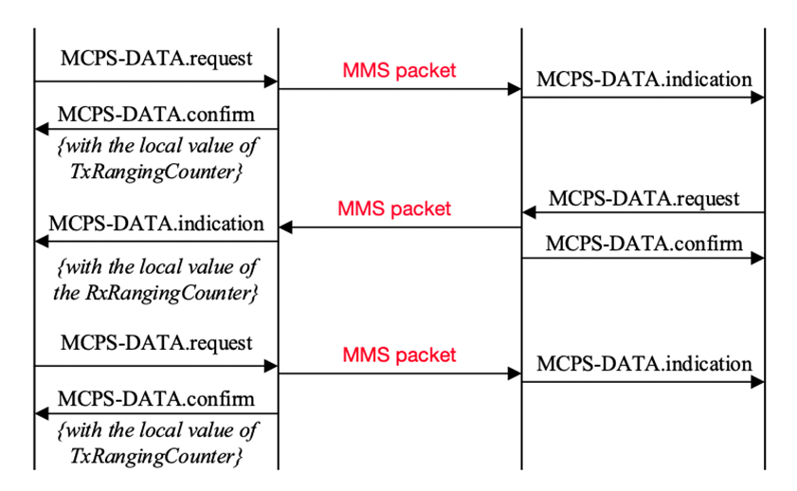

**Figure 10-XXX Message sequence chart for DS-TWR with MMS UWB Packet**

## Comment 953 – Reject

|  |  |  |  |  |  |  |
| --- | --- | --- | --- | --- | --- | --- |
| **Name** | **Index #** | **Page** | **Sub-clause** | **Line #** | **Comment** | **Proposed Change** |
| Riku Pirhonen | 953 | 69 | 10.38.5 | 12 | Add behavior in case of the proposed non-interleaved mode. | After macMmsRpDuration, or in case of non-interleaved mode after double or triple macMmsRpDuration as defined by the ExtendedRpDuration, and transmission and reception of all the fragments… |

**Resolution:** ExtendedRpDuration is replaced by the use of sub-rounds. See resolution for CID 952.

## Comment 97 - Revised

|  |  |  |  |  |  |  |
| --- | --- | --- | --- | --- | --- | --- |
| **Name** | **Index #** | **Page** | **Sub-clause** | **Line #** | **Comment** | **Proposed Change** |
| Frank Leong | 97 | 69 | 10.38.5 | 15 | The example only represents interleaved MMS operation. A non-interleaved example should be added. | Add two similar figures, one showing non-interleaved SS-TWR MMS operation (2*RpDuration), and another showing non-interleaved DS-TWR MMS operation (3*RpDuration). |

**Resolution:** 2*RpDuration and 3*RpDuration are replaced by the use of sub-rounds and an example is provided in figure X. See resolution CID 952.

## Comment 954 – Revised

|  |  |  |  |  |  |  |
| --- | --- | --- | --- | --- | --- | --- |
| **Name** | **Index #** | **Page** | **Sub-clause** | **Line #** | **Comment** | **Proposed Change** |
| Riku Pirhonen | 954 | 69 | 10.38.5 | 16 | Add picture of the proposed non-interleaved mode | Add picture that shows non-interleaved mode with double and triple RpDuration. |

**Resolution:** Double and triple RpDuration are replaced by the use of sub-rounds and an example is provided in figure X. See resolution for CID 952.

## Comment 955 - Revised

|  |  |  |  |  |  |  |
| --- | --- | --- | --- | --- | --- | --- |
| **Name** | **Index #** | **Page** | **Sub-clause** | **Line #** | **Comment** | **Proposed Change** |
| Riku Pirhonen | 955 | 86 | 10.38.9.3.12 | 1 | Add ExtendedRpDuration field to the Managemetn MAC Configuration field figure | Add ExtendedRpDuration field between RpDuration and Reserved, and use bits 44 and 45 for this |

**Resolution:** On page 86, Figure 54 on line 1, add *NonInterleavedMode* bits to the Management MAC Configuration field, highlighted with a red frame in the picture below:

Draft 01:

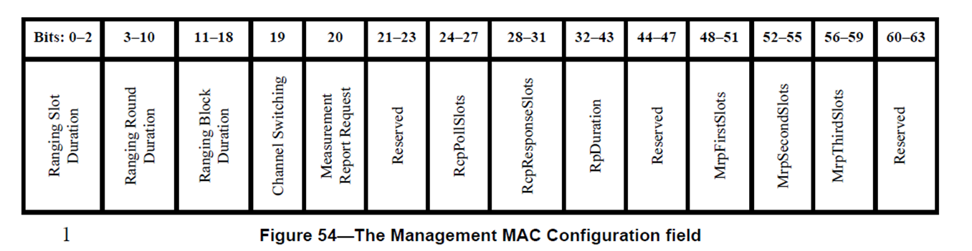

Resolution:

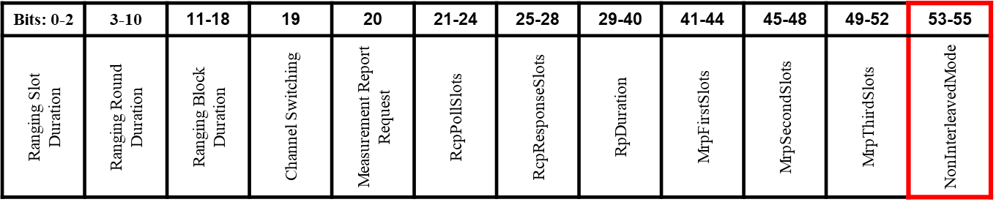

## Comment 956 - Revised

|  |  |  |  |  |  |  |
| --- | --- | --- | --- | --- | --- | --- |
| **Name** | **Index #** | **Page** | **Sub-clause** | **Line #** | **Comment** | **Proposed Change** |
| Riku Pirhonen | 956 | 86 | 10.38.9.3.12 | 33 | Add description for ExtendedRpDuration field | The ExtendedRpDuration field enables non-interleaved MMS packets by extending the ranging phase to double or triple of the RpDuration. By default, bits are 00, which means interleaved initiator and responder transmissions. Bit values 01 meand double RpDuration and non-interleaved transmission by initiator and responder as shown in Figure XX [in chapter 10.38.5], and bits set to 10 mean triple RpDuration and non-interleaved transmissions by initiator – responder – initiator, as shown in figure XX [in chapter 10.38.5]. Bit combination 11 is reserved. |

**Resolution:** Add the text shown in red on page 86, line 33.

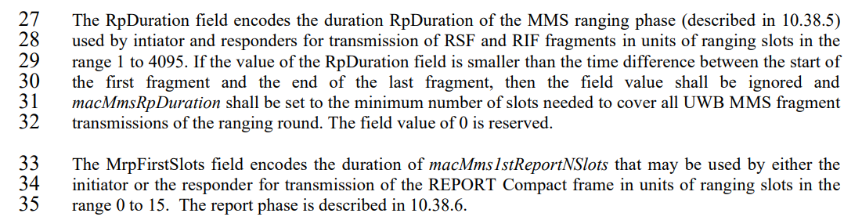

*Page 86, after line 32*

The NonInterleavedMode field contains the value of *macMmsNonInterleavedMode*, which defines number of sub-rounds used for non-interleaved mode control and ranging phases as defined in the table below.

|  |  |  |  |
| --- | --- | --- | --- |
|  | **Bit 53** | **Bit 54** | **Bit 55** |
| Interleaved mode | 0 | 0 | 0 |
| One non-interleaved sub-round | 1 | 0 | 0 |
| Two non-interleaved sub-rounds | 0 | 1 | 0 |
| Three non-interleaved sub-rounds | 1 | 1 | 0 |
| Four non-interleaved sub-rounds | 0 | 0 | 1 |
| Hybrid sub-rounds | 1 | 0 | 1 |
| Reserved | 0 | 1 | 1 |
| Reserved | 1 | 1 | 1 |

.

## Comment 959 – Revised

|  |  |  |  |  |  |  |
| --- | --- | --- | --- | --- | --- | --- |
| **Name** | **Index #** | **Page** | **Sub-clause** | **Line #** | **Comment** | **Proposed Change** |
| Riku Pirhonen | 959 | 125 | 10.38.10.1 | 1 | Add MAC PIB attribute macMmsExtendedRpDuration to Table 20 on the row after MacMmsRpDuration | macMmsExtendedRpDuration, Integer, 0 - 3, 0 = Interleaved ranging phase, 1 = Non-interleaved ranging phase of double RpDuration, 2 = Non-interleaved ranging phase of triple RpDuration, 3 = reserved, Default 0 |

**Resolution:** Page 125, line 1, Table 20, add the row highlighted with red frame.

Draft 01:

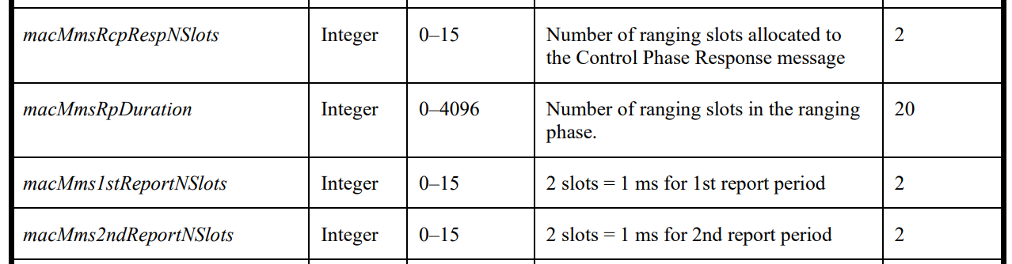

Resolution:

