**IEEE P802.15**

**Wireless Personal Area Networks**

|  |  |
| --- | --- |
| Project | IEEE P802.15 Working Group for Wireless Personal Area Networks (WPANs) |
| Title | **Comment resolution –Non-interleaved mode 952, 953, 97, 954, 955, 956, 959** |
| Date Submitted | Nov 12th, 2024 |
| Sources | Riku Pirhonen (NXP), Frank Leong (NXP) |
| Abstract | Comment resolution for 952, 953, 97, 954, 955, 956, 959 |
| Purpose | Propose resolutions to comments received on IEEE P802.15.4ab/D01, June 2024. |
| Notice | This document does not represent the agreed views of the IEEE 802.15 Working Group or IEEE 802.15.4ab Task Group. It represents only the views of the participants listed in the “Sources” field above.It is offered as a basis for discussion and is not binding on the contributing individuals. The material in this document is subject to change in form and content after further study. The contributors reserve the right to add, amend or withdraw material contained herein. |
|  |  |

# Summary of comments

The following comments are offered a resolution in this document:

|  |  |  |  |  |  |  |
| --- | --- | --- | --- | --- | --- | --- |
| **Name** | **Index #** | **Page** | **Sub-clause** | **Line #** | **Comment** | **Proposed Change** |
| Riku Pirhonen | 952 | 69 | 10.38.5 | 7 | In order to support traditional SS-TWR and DS-TWR, non-interleaved mode is proposed. It would delay sending responder MMS packet by RpDuration and, for DS-TWR, initiator can send another MMS packet after two RpDurations. | In non-interleaved mode responder shall start transmission of MMS packet after one RpDuration from the start of the ranging phase, and when DS-TWR is desired, initiator may transmit a second MMS packet after two RpDurations from the start of the ranging phase. |
| Riku Pirhonen | 953 | 69 | 10.38.5 | 12 | Add behavior in case of the proposed non-interleaved mode. | After macMmsRpDuration, or in case of non-interleaved mode after double or triple macMmsRpDuration as defined by the ExtendedRpDuration, and transmission and reception of all the fragments… |
| Frank Leong | 97 | 69 | 10.38.5 | 15 | The example only represents interleaved MMS operation. A non-interleaved example should be added. | Add two similar figures, one showing non-interleaved SS-TWR MMS operation (2*RpDuration), and another showing non-interleaved DS-TWR MMS operation (3*RpDuration). |
| Riku Pirhonen | 954 | 69 | 10.38.5 | 16 | Add picture of the proposed non-interleaved mode | Add picture that shows non-interleaved mode with double and triple RpDuration. |
| Riku Pirhonen | 955 | 86 | 10.38.9.3.12 | 1 | Add ExtendedRpDuration field to the Managemetn MAC Configuration field figure | Add ExtendedRpDuration field between RpDuration and Reserved, and use bits 44 and 45 for this |
| Riku Pirhonen | 956 | 86 | 10.38.9.3.12 | 33 | Add description for ExtendedRpDuration field | The ExtendedRpDuration field enables non-interleaved MMS packets by extending the ranging phase to double or triple of the RpDuration. By default, bits are 00, which means interleaved initiator and responder transmissions. Bit values 01 meand double RpDuration and non-interleaved transmission by initiator and responder as shown in Figure XX [in chapter 10.38.5], and bits set to 10 mean triple RpDuration and non-interleaved transmissions by initiator – responder – initiator, as shown in figure XX [in chapter 10.38.5]. Bit combination 11 is reserved. |
| Riku Pirhonen | 959 | 125 | 10.38.10.1 | 1 | Add MAC PIB attribute macMmsExtendedRpDuration to Table 20 on the row after MacMmsRpDuration | macMmsExtendedRpDuration, Integer, 0 - 3, 0 = Interleaved ranging phase, 1 = Non-interleaved ranging phase of double RpDuration, 2 = Non-interleaved ranging phase of triple RpDuration, 3 = reserved, Default 0 |

**Resolution proposals**

## Comment 952

|  |  |  |  |  |  |  |
| --- | --- | --- | --- | --- | --- | --- |
| **Name** | **Index #** | **Page** | **Sub-clause** | **Line #** | **Comment** | **Proposed Change** |
| Riku Pirhonen | 952 | 69 | 10.38.5 | 7 | In order to support traditional SS-TWR and DS-TWR, non-interleaved mode is proposed. It would delay sending responder MMS packet by RpDuration and, for DS-TWR, initiator can send another MMS packet after two RpDurations. | In non-interleaved mode responder shall start transmission of MMS packet after one RpDuration from the start of the ranging phase, and when DS-TWR is desired, initiator may transmit a second MMS packet after two RpDurations from the start of the ranging phase. |

In interleaved mode the UWB MMS packets with multiple fragments sent by the initiator and the responder are interleaved so that after the initiator has sent one fragment, the responder will send a fragment and this continues until all the fragments have been sent. In non-interleaved mode the initiator sends a full UWB MMS packet, the responder sends a full UWB MMS packet and to complete DS-TWR the initiator sends another full UWB MMS packet. In order to provide precise synchronization in case of NBA-MMS, the NB poll and response packets are transmitted immediately before the corresponding UWB MMS packet. In case of initiator, the MMS packet is transmitted immediately after the NB packet, without waiting for NB response.

**Resolution step 1:** Remove the text in blue and add the text in red on line 8, page 56.

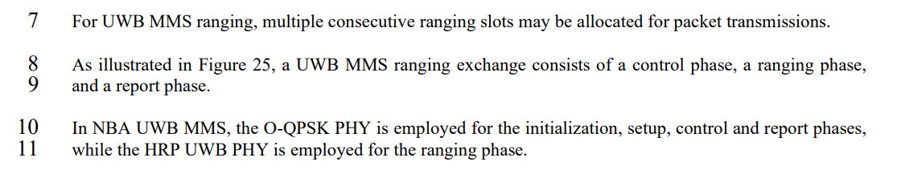

As illustrated in Figure 25, a basic interleaved one-to-one UWB MMS ranging exchange consists of a control phase, a ranging phase, and a report phase. In case of non-interleaved or one-to-many ranging one ranging round may have multiple Control, Ranging and Report phases, as described in Clause 10.38.X and 10.38.8.

**Resolution step 2:** One page 70, line 15, after chapter 10.38.6 and before current Clause 10.38.7, add a new Clause on non-interleaved mode.

**10.38.X Non-interleaved mode**

An optional non-interleaved one-to-one mode can be used to reduce the amount of transitions between transmission and reception at the cost of total ranging time. Non-interleaved mode is illustrated in Figure X and has a few differences compared to the interleaved mode.

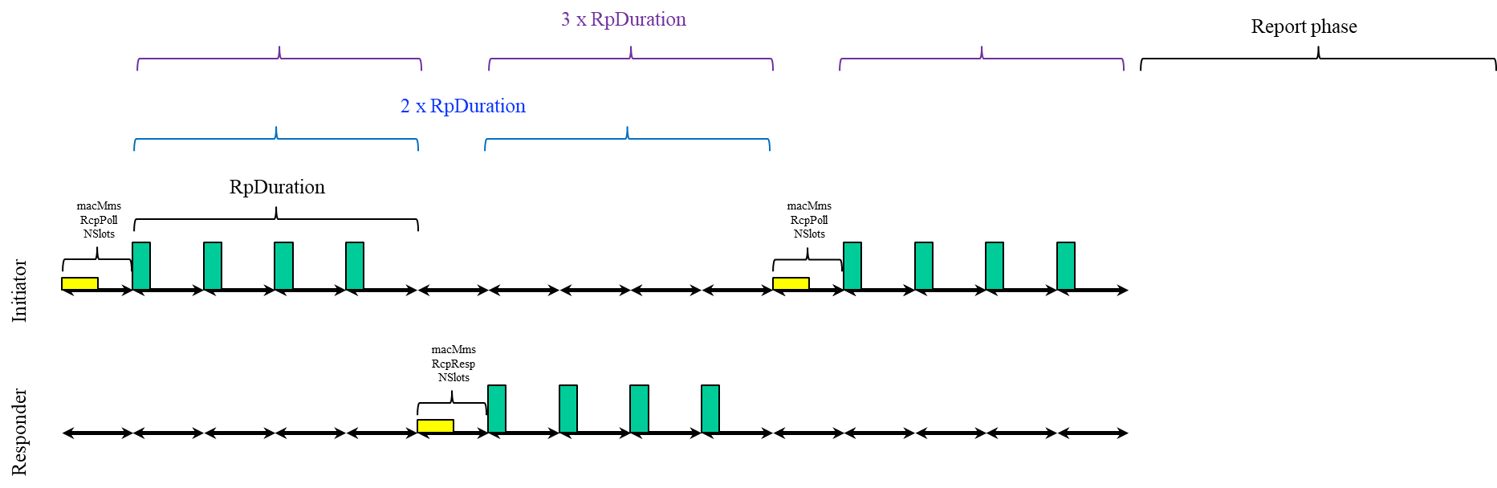

Figure X. Non-interleaved ranging

An non-interleaved ranging round may consist of one, two, or three UWB packets, which correspond to one-way ranging, single-sided two-way ranging, and double-sided two-way-ranging. The mode is defined with the *ExtendedRpDuration* parameter as described in 10.38.9.3.12.

Operation in NBA-MMS mode. After sending the poll meassage, the initiator does not wait for the response message, and instead starts to transmit the UWB packet after *macMmsRcpPollNSlots* duration from the beginning of the poll message. After the inititator UWB packet is completed, if the responder is to respond, it sends its response response message one RpDuration after the start of the initiator UWB packet, and a responder UWB MMS packet *macMmsRcpRespNSlots* after the start of the response message. If the initiator is to send a second UWB packet, it sends a poll packet RpDuration after the start of responder UWB MMS packet and its UWB MMS packet *macMmsRcpPollNSlots* after the start of the poll packet.

Operation in UWB driven mode. If the control packet is in use, the control phase is similar to interleaved mode. In the ranging phase, the responder UWB MMS packet is sent one RpDuaration from the start of the initiator UWB MMS packet and the second intitator UWB packet RpDuration from the start of the responder UWB MMS packet. Ifthe control packet is not used, the control phase length is set to zero, and only the ranging phase is executed as above.

## Comment 953

|  |  |  |  |  |  |  |
| --- | --- | --- | --- | --- | --- | --- |
| **Name** | **Index #** | **Page** | **Sub-clause** | **Line #** | **Comment** | **Proposed Change** |
| Riku Pirhonen | 953 | 69 | 10.38.5 | 12 | Add behavior in case of the proposed non-interleaved mode. | After macMmsRpDuration, or in case of non-interleaved mode after double or triple macMmsRpDuration as defined by the ExtendedRpDuration, and transmission and reception of all the fragments… |

**Resolution:** Covered by the resolution for CID 952.

## Comment 97

|  |  |  |  |  |  |  |
| --- | --- | --- | --- | --- | --- | --- |
| **Name** | **Index #** | **Page** | **Sub-clause** | **Line #** | **Comment** | **Proposed Change** |
| Frank Leong | 97 | 69 | 10.38.5 | 15 | The example only represents interleaved MMS operation. A non-interleaved example should be added. | Add two similar figures, one showing non-interleaved SS-TWR MMS operation (2*RpDuration), and another showing non-interleaved DS-TWR MMS operation (3*RpDuration). |

**Resolution:** Covered by the resolution for CID 952.

## Comment 954

|  |  |  |  |  |  |  |
| --- | --- | --- | --- | --- | --- | --- |
| **Name** | **Index #** | **Page** | **Sub-clause** | **Line #** | **Comment** | **Proposed Change** |
| Riku Pirhonen | 954 | 69 | 10.38.5 | 16 | Add picture of the proposed non-interleaved mode | Add picture that shows non-interleaved mode with double and triple RpDuration. |

**Resolution:** Covered by the resolution for CID 952.

## Comment 955

|  |  |  |  |  |  |  |
| --- | --- | --- | --- | --- | --- | --- |
| **Name** | **Index #** | **Page** | **Sub-clause** | **Line #** | **Comment** | **Proposed Change** |
| Riku Pirhonen | 955 | 86 | 10.38.9.3.12 | 1 | Add ExtendedRpDuration field to the Managemetn MAC Configuration field figure | Add ExtendedRpDuration field between RpDuration and Reserved, and use bits 44 and 45 for this |

Description

**Resolution:** On page 86, Figure 54 on line 1, sdd ExtendedRpDuration bits to the Management MAC Configuration field, highlighted with a red frame in the picture below:

Draft 01:

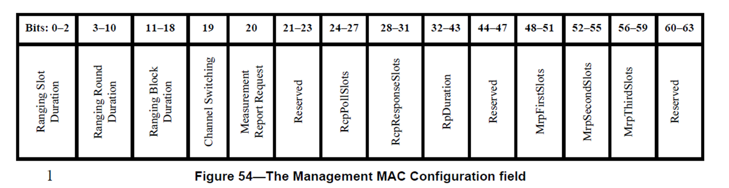

Resolution:

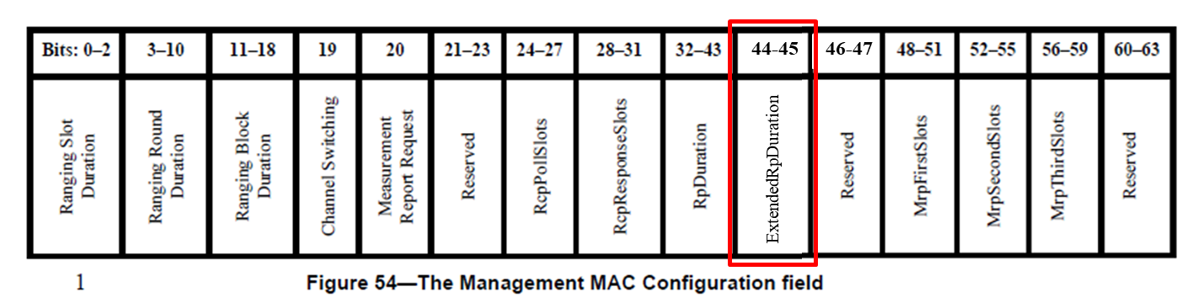

## Comment 956

|  |  |  |  |  |  |  |
| --- | --- | --- | --- | --- | --- | --- |
| **Name** | **Index #** | **Page** | **Sub-clause** | **Line #** | **Comment** | **Proposed Change** |
| Riku Pirhonen | 956 | 86 | 10.38.9.3.12 | 33 | Add description for ExtendedRpDuration field | The ExtendedRpDuration field enables non-interleaved MMS packets by extending the ranging phase to double or triple of the RpDuration. By default, bits are 00, which means interleaved initiator and responder transmissions. Bit values 01 meand double RpDuration and non-interleaved transmission by initiator and responder as shown in Figure XX [in chapter 10.38.5], and bits set to 10 mean triple RpDuration and non-interleaved transmissions by initiator – responder – initiator, as shown in figure XX [in chapter 10.38.5]. Bit combination 11 is reserved. |

Description

**Resolution:** Add the text shown in red on page 86, line 33.

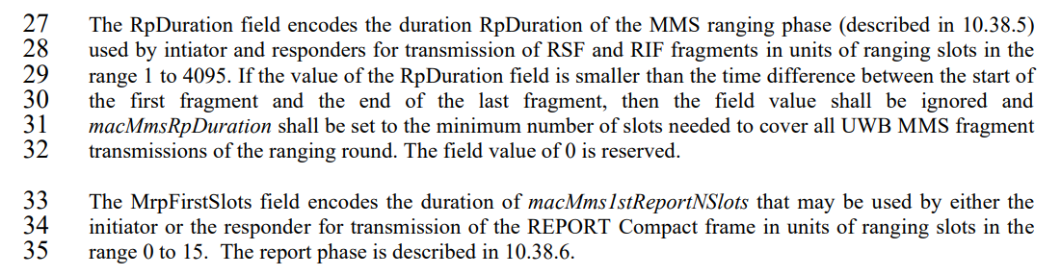

Page 86, line 33

…the first fragment and the end of the last fragment, then the field value shall be ignored and macMmsRpDuration shall be set to the minimum number of slots needed to cover all UWB MMS fragment transmissions of the ranging round. The field value of 0 is reserved.

The ExtendedRpDuration field enables non-interleaved MMS packets by extending the ranging phase to double or triple of the RpDuration when needed. By default, the bits are set to 00, which means interleaved initiator and responder transmissions. Bit values 01 mean single RpDuration with transmission of a single UWB MMS packet with no response. Bit values 10 mean double RpDuration and non-interleaved transmission by initiator and responder, and bits set to 11 mean triple RpDuration and non-interleaved transmissions by initiator – responder – initiator, as shown in figure X [in Clause 10.38.X, CID #952].

The MrpFirstSlots field encodes the duration of macMms1stReportNSlots that may be used by either the initiator or the responder for transmission of the REPORT Compact frame in units of ranging slots in the range 0 to 15…

## Comment 959

|  |  |  |  |  |  |  |
| --- | --- | --- | --- | --- | --- | --- |
| **Name** | **Index #** | **Page** | **Sub-clause** | **Line #** | **Comment** | **Proposed Change** |
| Riku Pirhonen | 959 | 125 | 10.38.10.1 | 1 | Add MAC PIB attribute macMmsExtendedRpDuration to Table 20 on the row after MacMmsRpDuration | macMmsExtendedRpDuration, Integer, 0 - 3, 0 = Interleaved ranging phase, 1 = Non-interleaved ranging phase of double RpDuration, 2 = Non-interleaved ranging phase of triple RpDuration, 3 = reserved, Default 0 |

**Resolution:** Page 125, line 1, Table 20, add the row highlighted with red frame.

Draft 01:

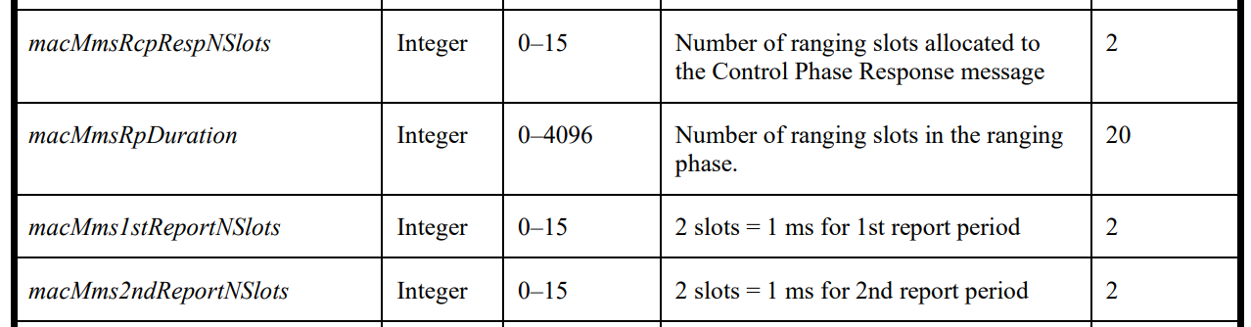

Resolution:

