**IEEE P802.15**

**Wireless Personal Area Networks**

|  |  |
| --- | --- |
| Project | IEEE P802.15 Working Group for Wireless Personal Area Networks (WPANs) |
| Title | **Comment resolution – 957, 1400, 958** |
| Date Submitted | Jan 16th, 2025 |
| Sources | Riku Pirhonen (NXP) |
| Abstract | Comment resolution for 957, 1400, 958 |
| Purpose | Propose resolutions to comments received on IEEE P802.15.4ab/D01, June 2024. |
| Notice | This document does not represent the agreed views of the IEEE 802.15 Working Group or IEEE 802.15.4ab Task Group. It represents only the views of the participants listed in the “Sources” field above.It is offered as a basis for discussion and is not binding on the contributing individuals. The material in this document is subject to change in form and content after further study. The contributors reserve the right to add, amend or withdraw material contained herein. |
|  |  |

# Summary of comments

Note that comments 31, 40, 187, 671 that were in an earlier revision of this document have been addressed by in other documnts, e.g. 664r2. CID 963 is moved to Doc 25/066.

The following comments are offered a resolution in this document:

|  |  |  |  |  |  |  |
| --- | --- | --- | --- | --- | --- | --- |
| **Name** | **Index #** | **Page** | **Sub-clause** | **Line #** | **Comment** | **Proposed Change** |
| Riku Pirhonen | 957 | 87 | 10.38.9.3.14 | 25 | To keep NB and UWB clock synchronization simple, and avoid issues with the 100 ppm tolerance requirement, the Time Offset value should take chip rate clock into account. For NB it is 2 MHz (0.5 µs) and for UWB 1/499.2 MHz (~2ns). The smallest common step size is 2.5 µs. Add the same comment to the corresponding PIB attribute if such is defined. | … and the value shall be mulitple of 2.5 µs. |
| Alex Krebs | 1400 | 87 | 10.38.9.3.14 | 25 | We discussed/agreed limiting time offset to 1s before to improve responder energy consumption. I wonder if it is too strict to mandate this, since 1. SOR time offset is a one-time process hence impact on overall energy consumption is scanning once per ranging session 2. energy consumption wrt to SOR time offset is determined by the responder's crystal accuracy which is an implementation choice. My suggestion is to not prohibit use, but rather make a more practical recommendation in the standard, allowing higher accurcy devices to take advantage of the full value range. | Replace "The maximum...second." by  A value of 0-300ms is recommended for this field to limit packet arrival time uncertainty for the responder device. |
| Riku Pirhonen | 958 | 87 | 10.38.9.3.15 | 29 | Offset value betwee two NB packets should be multiple of chip rate of 2 MHz (0.5 µs). The smallest common step size is thus 0.5 µs. | … and the value shall be mulitple of 0.5 µs. |

Resolution proposals

## Comment 957 - Reject

|  |  |  |  |  |  |  |
| --- | --- | --- | --- | --- | --- | --- |
| **Name** | **Index #** | **Page** | **Sub-clause** | **Line #** | **Comment** | **Proposed Change** |
| Riku Pirhonen | 957 | 87 | 10.38.9.3.14 | 25 | To keep NB and UWB clock synchronization simple, and avoid issues with the 100 ppm tolerance requirement, the Time Offset value should take chip rate clock into account. For NB it is 2 MHz (0.5 µs) and for UWB 1/499.2 MHz (~2ns). The smallest common step size is 2.5 µs. Add the same comment to the corresponding PIB attribute if such is defined. | … and the value shall be mulitple of 2.5 µs. |

The issue brought up by the comment is relevant and needs to be addressed in implementation, but it does not need to be mandated by the standard.

**Resolution:** Reject

## Comment 1400 – Accept revised

|  |  |  |  |  |  |  |
| --- | --- | --- | --- | --- | --- | --- |
| **Name** | **Index #** | **Page** | **Sub-clause** | **Line #** | **Comment** | **Proposed Change** |
| Alex Krebs | 1400 | 87 | 10.38.9.3.14 | 25 | We discussed/agreed limiting time offset to 1s before to improve responder energy consumption. I wonder if it is too strict to mandate this, since 1. SOR time offset is a one-time process hence impact on overall energy consumption is scanning once per ranging session 2. energy consumption wrt to SOR time offset is determined by the responder's crystal accuracy which is an implementation choice. My suggestion is to not prohibit use, but rather make a more practical recommendation in the standard, allowing higher accurcy devices to take advantage of the full value range. | Replace "The maximum...second." by  A value of 0-300ms is recommended for this field to limit packet arrival time uncertainty for the responder device. |

**Resolution as proposed:** Replace the text on page 87, line 25 as shown below.

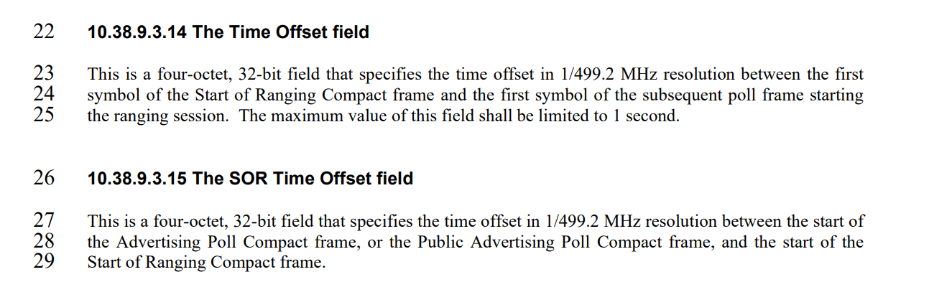

~~The maximum value of this field shall be limited to 1 second.~~ A value of 300ms or less is recommended for this field to limit packet arrival time uncertainty for the responder device.

## Comment 958 - Reject

|  |  |  |  |  |  |  |
| --- | --- | --- | --- | --- | --- | --- |
| **Name** | **Index #** | **Page** | **Sub-clause** | **Line #** | **Comment** | **Proposed Change** |
| Riku Pirhonen | 958 | 87 | 10.38.9.3.15 | 29 | Offset value betwee two NB packets should be multiple of chip rate of 2 MHz (0.5 µs). The smallest common step size is thus 0.5 µs. | … and the value shall be mulitple of 0.5 µs. |

The issue brought up by the comment is relevant, but is to be addressed by implementation, and does not need to be mandated by the standard.

**Resolution:** Reject