IEEE P802.15
Wireless Personal Area Networks

Project | IEEE P802.15 Working Group for Wireless Personal Area Networks (WPANs)
Title | Proposed text to clarify the HCS generation for dyamic data mode PHR
Date Submitted | October 2024
Sources | Vinod Kristem, Xiliang Luo (Apple)
Re:
Abstract
Purpose | To propose the text to clarify the HCS generation for dyamic data mode PHR in “P802.15.4ab™/D01 Draft Standard for Low-Rate Wireless Networks”
Notice | This document does not represent the agreed views of the IEEE 802.15 Working Group or IEEE 802.15.4ab Task Group. It represents only the views of the participants listed in the “Sources” field above. It is offered as a basis for discussion and is not binding on the contributing individuals. The material in this document is subject to change in form and content after further study. The contributors reserve the right to add, amend or withdraw material contained herein.

Discussion:
Please refer to the DCN 15-24-0558-01-04ab-HCS-generation-for-Dynamic-PHR
Proposed Change:
Update the Draft D01 spec as suggested below:
16.2.7.4.3 PHR2
Update the last paragraph of 16.2.7.4.3 as follows:
The HCS field shall be an 8-bit CRC computed over the first 15 bits of the PHR PHR2, that is referred to as calculation field. The HCS shall be calculated using the polynomial $G_{8}\left(x\right)=x^{8}+x^{2}+x+1$, generated and transmitted as specified in 21.2.4 (PHR of SUN OFDM PHY) below.
The HCS is the one’s complement of the modulo-2 sum of the two remainders in a) and b):
a) The remainder resulting from $[x^{k}(x^{7}+x^{6}+…+1)]$ divided (modulo 2) by $G_{8}(x)$, where the value $k$ is the number of bits in the calculation field.
b) The remainder resulting from the calculation field contents, treated as a polynomial, multiplied by $x^{8}$ and then divided (modulo 2) by $G_{8}(x)$.
At the transmitter, the initial remainder of the division shall be preset to all ones and is then modified via division of the calculation field by the generator polynomial $G_{8}(x)$. The one’s complement of this remainder is the HCS field. The HCS field is transmitted commencing with the coefficient of the highest order term.
A typical implementation of HCS generation is depicted in Figure x.
- Initialize the remainder register $(r_{0},r_{1},…, r_{7})$ to all ones.
- Shift the sequence $b_{0},b_{1},…, b_{14}$ into the divider beginning with $b_{0}$.
- After the last bit, $b_{14}$, is shifted into the divider, the one’s complement of the remainder register contains the HCS: $\left(b_{15},b_{16},…, b_{22}\right)=(\sim r_{0},\sim r_{1},…, \sim r_{7})$

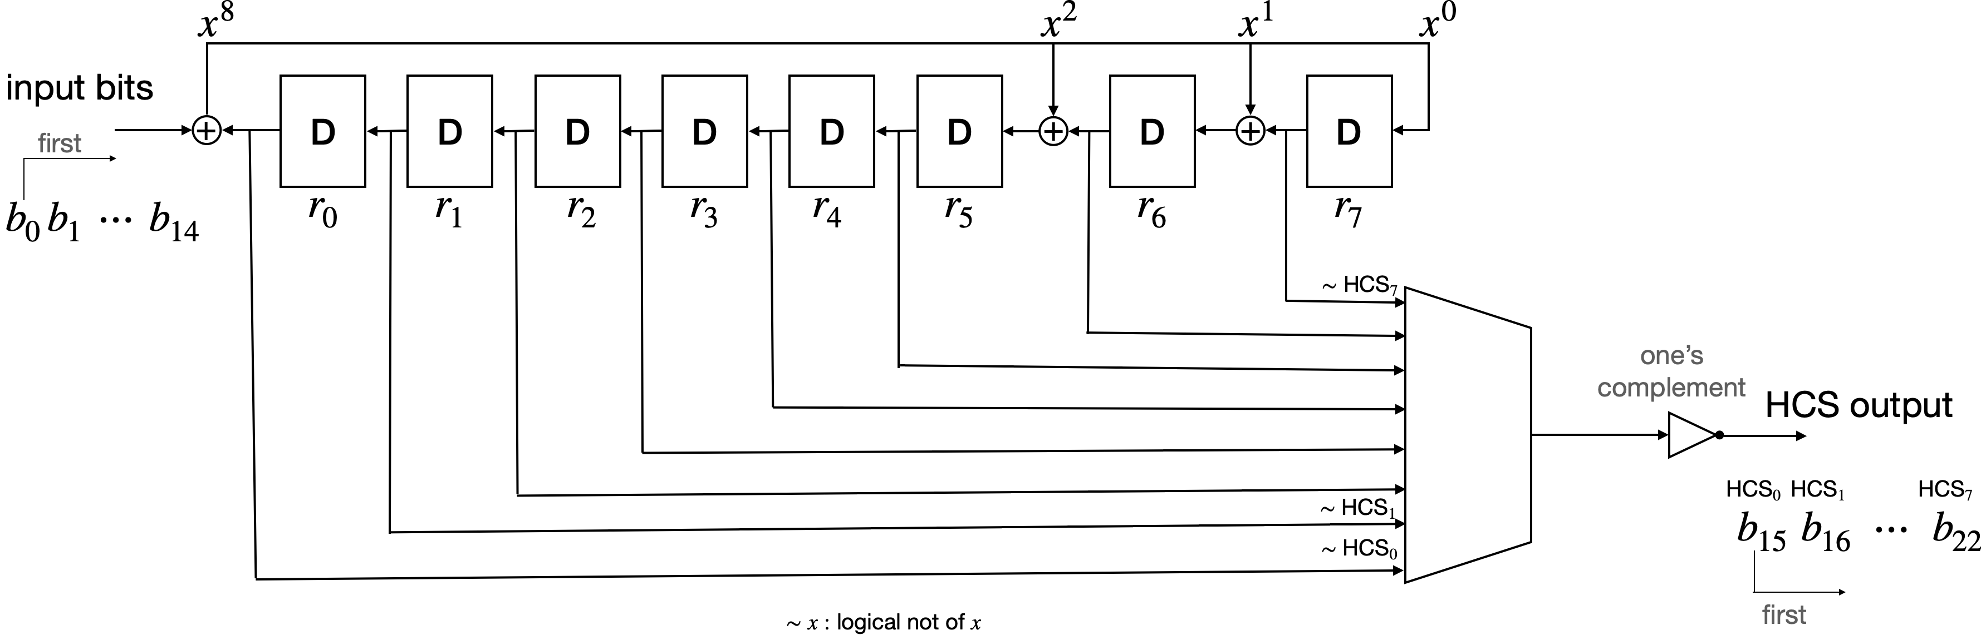
Figure x: Typical HCS implementation for PHR2
At the receiver, the initial remainder is preset to all ones and the serial incoming 23 bits of the calculation field concatenated with HCS, when divided by $G_{8}(x)$ in the absence of transmission errors, results in a unique non-zero remainder value. The unique remainder value is the polynomial $x^{7}+x^{6}+x^{5}+x^{4}+x+1$, equivalent to HCS output hex value of 0X0C.
An example PHR2 with HCS is shown in Figure y.
Bits: 0 | 1 | 2-13 |  |  |  |  |  |  |  |  |  |  |  | 14 | 15-22
0 | 0 | 0 | 0 | 0 | 0 | 0 | 0 | 1 | 0 | 1 | 0 | 1 | 0 | 0 | 1 | 0 | 1 | 1 | 1 | 1 | 0 | 0
Figure y: Example PHR2 with HCS

