**IEEE P802.15**

**Wireless Personal Area Networks**

|  |  |  |
| --- | --- | --- |
| Project | IEEE P802.15 Working Group for Wireless Personal Area Networks (WPANs) | |
| Title | **Proposed Resolution for Hyper-block comments – Part2** | |
| Date Submitted | September 2024 | |
| Sources | Rojan Chitrakar, Lei Huang (Huawei)  [rojan.chitrakar@huawei.com](mailto:rojan.chitrakar@huawei.com) |  |
| Re: |  | |
| Abstract |  | |
| Purpose | To propose resolution for “P802.15.4ab™/D01 Draft Standard for Low-Rate Wireless Networks” | |
| Notice | This document does not represent the agreed views of the IEEE 802.15 Working Group or IEEE 802.15.4ab Task Group. It represents only the views of the participants listed in the “Sources” field above.It is offered as a basis for discussion and is not binding on the contributing individuals. The material in this document is subject to change in form and content after further study. The contributors reserve the right to add, amend or withdraw material contained herein. | |

Rev 0: Initial version.

***Comment Indices in 15-24-0371-00-04ab-consolidated-comments-draft-1-0:***

|  |  |  |  |  |  |  |  |
| --- | --- | --- | --- | --- | --- | --- | --- |
| **Name** | **Index#** | **Pg** | **Sub-Clause** | **Ln** | **Comment** | **Proposed Change** | **Disposition** |
| Billy Verso | 1085 | 45 | 10.32.3.5 | 13 | I suppose if there is an assignment like this it is superseding any previous assignment rather than adding to it. Worth specifying what is the case. | Specify that the slot assignment in ERR are superseding previous assignment or additional. | Reject  This assignment is no different from others such as RR IE and similar behaviour from the controlee can be expected. |
| Billy Verso | 1086 | 45 | 10.32.3.5 | 14 | ERR IE doesn't include controlee address field so I assume this is picked up from the MAC address of the frame. Worth saying the too | state "the ERR IE applies to the device addressed by the MHR of the frame carrying the ERR IE" | Reject  ERR IE is no different from others such as RR IE and similar behaviour from the controlee can be expected. |

**Discussion**：

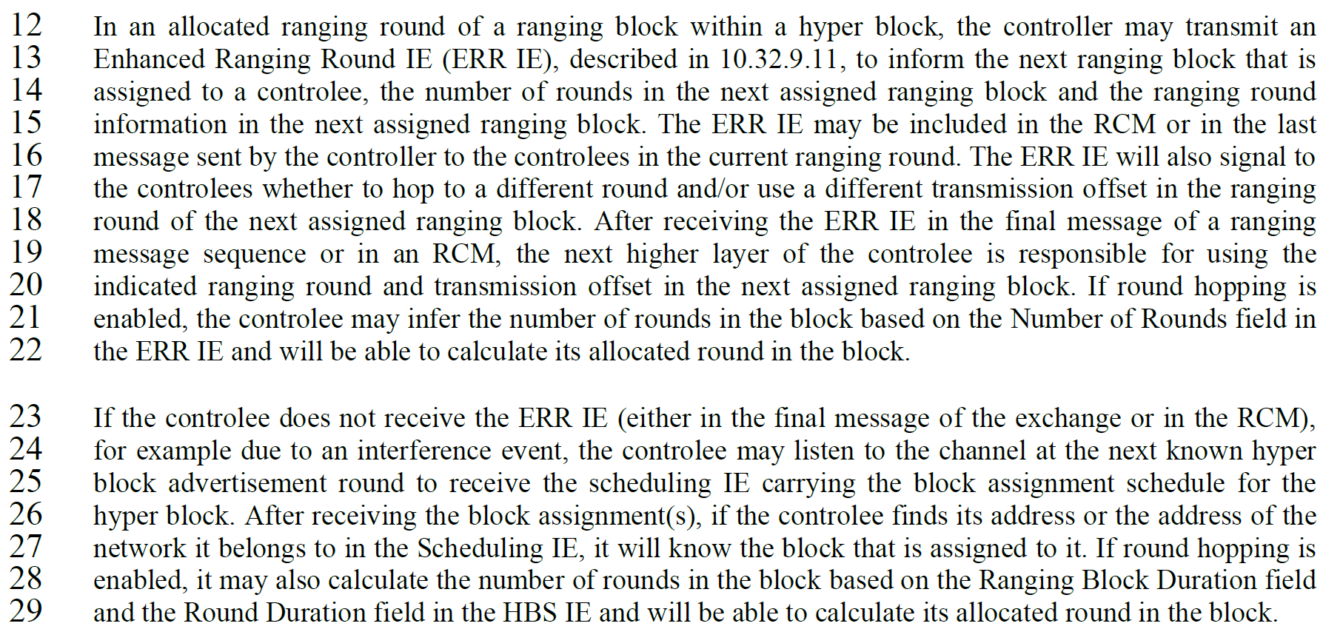

**Disposition: Revised**

**10.32.3.5 Hyper block mode**

***Change the sub-clause as follows (Track changes ON)***

…

In an allocated ranging round of a ranging block within a hyper block, the controller may transmit an Enhanced Ranging Round IE (ERR IE), described in 10.32.9.11, to inform the next ranging block that is assigned to a controlee, the number of rounds in the next assigned ranging block and the ranging round information in the next assigned ranging block. The ERR IE may be included in the RCM or in the last message sent by the controller to the controlees in the current ranging round. The ERR IE will also signal to the controlees whether to hop to a different round and/or use a different transmission offset in the ranging round of the next assigned ranging block. After receiving the ERR IE in the final message of a ranging message sequence or in an RCM, the next higher layer of the controlee uses the indicated ranging round and transmission offset in the assigned ranging block until another ERR IE or scheduling IE with a different block assignment is received. If round hopping is enabled, the controlee may infer the number of rounds in the block based on the Number of Rounds field in the ERR IE and will be able to calculate its allocated round in the block.

**10.32.9.11 Enhanced Ranging Round IE (ERR IE)**

***Change the sub-clause as follows (Track changes ON)***

The ERR IE is used by the controller to inform the next assigned ranging block, the number of rounds in

the next assigned ranging block and the ranging round information in the next assigned ranging block to

to a controlee (in a unicast frame). The Content field of the ERR IE shall be formatted as illustrated in Figure 19.