**IEEE P802.15**

**Wireless Personal Area Networks**

|  |  |  |
| --- | --- | --- |
| Project | IEEE P802.15 Working Group for Wireless Personal Area Networks (WPANs) | |
| Title | **Proposed Text for Draft 1.0 Comment Resolution – RCM, Parameter Overlapping** | |
| Date Submitted | September 12, 2024 | |
| Sources | Youngwan So (SAMSUNG Electronics)  [youngwan.so@samsung.com](mailto:youngwan.so@samsung.com) |  |
| Re: |  | |
| Abstract |  | |
| Purpose | To propose resolution for miscellaneous hyper block related comments for “P802.15.4ab™/D1.0 Draft Standard for Low-Rate Wireless Networks” . | |
| Notice | This document does not represent the agreed views of the IEEE 802.15 Working Group or IEEE 802.15.4ab Task Group. It represents only the views of the participants listed in the “Sources” field above.It is offered as a basis for discussion and is not binding on the contributing individuals. The material in this document is subject to change in form and content after further study. The contributors reserve the right to add, amend or withdraw material contained herein. | |

Rev 0: Initial version.

* RCM : 184, 1071, 1296
* Parameter Overlapping : 1066, 1075, 939, 1076, 218,

Rev 1:

***Comment Indices in 15-24-0371-01-04ab-consolidated-comments-draft-1.0:***

|  |  |  |  |  |  |  |  |
| --- | --- | --- | --- | --- | --- | --- | --- |
| **Name** | **Index#** | **Pg** | **Sub-Clause** | **Ln** | **Comment** | **Proposed Change** | **Disposition** |
| Wenzheng Li | 184 | 41 | 10.32.1 | 23 | To be more accurate, an RCM can also contains HBS IE, ERR IE | An RCM is a data frame conveying either an Advanced Ranging Control IE (ARC IE) described in 10.31.9.1 or an Application Control IE (AC IE) carrying a Ranging Control field (as described 10.39.6.1) or an Hyper Block Structure IE (HBS IE) as described in 10.32.9.12 or Enhanced Ranging Round IE (ERR IE) as described in 10.32.9.11 or any combination of them. | Revised |

**Disposition Detail:**

The following is the relevant section (FYI).

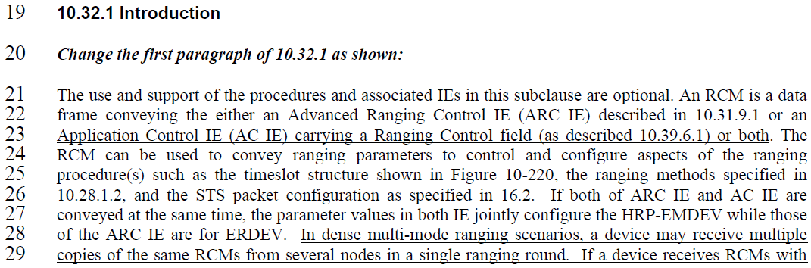

The part pointed out above in current specification is describing RCM message is conveying ARC IE and AC IE. But the comment is asking to contain more IEs such as HBS IE, ERR IE to be more accurate. It’s right that HBS IE and ERR IE mentioned are delivered by RCM, but there are more than that IEs delivered by the RCM, such as RR IE and Scheduling IE. So rather than listing up bunch of IEs in that sentence, mentioning in each respective sub-section that corresponding IEs are carried by RCM looks more preferable.

In HBS IE subcluase, HBS IE is described to be carried by RCM, but Scheduling IE is not. So we also clarify in the scheduling IE subclause that it is carried in RCM

**Proposed text changes on P802.15.4ab™/Draft 1.0 :**

***Change the chapter 10.32.1 P41L23 as follows:***

**10.32.1 Introduction**

***Change the first paragraph of 10.32.1 as shown:***

The use and support of the procedures and associated IEs in this subclause are optional. An RCM is a data

frame conveying the IEs such as Advanced Ranging Control IE (ARC IE) described in 10.31.9.1 or an

Application Control IE (AC IE) carrying a Ranging Control field (as described 10.39.6.1) or both. The

RCM can be used to convey ranging parameters to control and configure aspects of the ranging

procedure(s) such as the timeslot structure shown in Figure 10-220,

***Change the chapter 10.32.9.10 P46L22 as follows:***

**10.32.9.10 Scheduling IE**

The Scheduling IE is carried in RCM messages and is used by the controller to schedule blocks or slots to be used by intended controlee.

***Comment Indices in 15-24-0371-01-04ab-consolidated-comments-draft-1.0:***

|  |  |  |  |  |  |  |  |
| --- | --- | --- | --- | --- | --- | --- | --- |
| **Name** | **Index#** | **Pg** | **Sub-Clause** | **Ln** | **Comment** | **Proposed Change** | **Disposition** |
| Billy Verso | 1071 | 43 | 10.32.3.5 | 10 | I don't think anything would be "repeatedly transmitted in every RCM", as it only makes sense to send something once in each RCM, so the language needs to be corrected. | Change to "Each RCM may include an HBS IE, to (continually) provide/confirm the hyper block structure configuration." | Revised |

**Disposition Detail:**

The following is the relevant section (FYI).

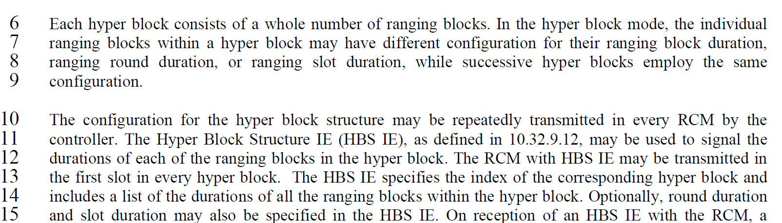

Commenter is pointing out that language needs correction.

The relevant text was intended to simply say “Each RCM carries HBS IE to provide/confirm the hyper block structure configuration information.”, NOT “The same information (i.e. HBS IE) is repeated multiple times within each RCM.” But, my sentence looks to make readers misleading.

I also agree with proposed comment and the language is corrected based on his suggestion.

Revised.

**Proposed text changes on P802.15.4ab™/Draft 1.0 :**

***Change the chapter 10.32.3.5 P43L10 as follows:***

Each RCM shall include an HBS IE to provide the Hyper block structure configuration unless those information is provided in out of band way..

***Comment Indices in 15-24-0371-01-04ab-consolidated-comments-draft-1.0:***

|  |  |  |  |  |  |  |  |
| --- | --- | --- | --- | --- | --- | --- | --- |
| **Name** | **Index#** | **Pg** | **Sub-Clause** | **Ln** | **Comment** | **Proposed Change** | **Disposition** |
| Billy Verso | 1066 | 41 | 10.32.1 | 26 | "If both of ARC IE and AC IE are conveyed at the same time, the parameter values in both IE jointly configure the HRP-EMDEV while those of the ARC IE are for ERDEV." Is suggesting mixed networks of legacy ERDEV and the newer EMDEV being defined by 4ab. If this is the case then the parameters need to be aligned, and text needs to say this, perhaps we need a special sub-clause to describe these mixed networks and how to set up the parameters so that they can operate properly. | Add clause to explain such a mixed network and specify which parameters in AC IE "SHALL be" set the same as the parameters in the ARC IE. At the very least, the slot, round, block parameters need to be the same, but there may be others to consider also. | Revised |

**Disposition Detail:**

The following is the corresponding section and text (red lined).

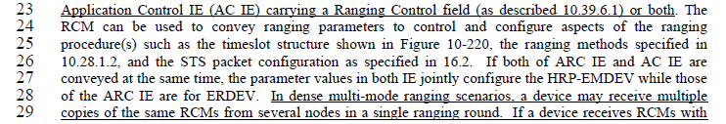

That sentence DOES NOT suggest mixed network of legacy devices and newer devices. But I was just asked to be clear about what happens if a device receives both of ARC IE and AC IE, as they have duplicate parameter fields. ARC IE is to send ranging configuration information to controlees and AC IE is to send the session configuration information for application control. Each of those two IEs have its own purposes and are conveyed through RCM. Here they have a common parameter fields; Block Duration, Round Duration, Slot Duration, Session ID. To avoid the devices’ confusion, those four common parameter values in both IE shall be the same.

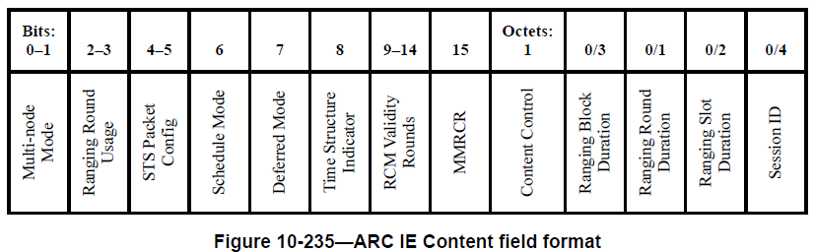

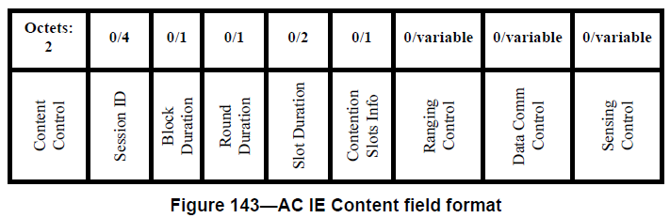

**[Four overlapping parameter fields in ARC IE and AC IE]**

**Proposed text changes on P802.15.4ab™/Draft 1.0 :**

***Change the chapter 10.32.1 P41L26 as follows:***

The use and support of the procedures and associated IEs in this subclause are optional. An RCM is a data frame conveying the either an Advanced Ranging Control IE (ARC IE) described in 10.31.9.1 or an Application Control IE (AC IE) carrying a Ranging Control field (as described 10.39.6.1) or both. The RCM can be used to convey ranging parameters to control and configure aspects of the ranging procedure(s) such as the timeslot structure shown in Figure 10-220, the ranging methods specified in 10.28.1.2, and the STS packet configuration as specified in 16.2. If multiple IEs having duplicate parameter fields (e.g. ARC IE and AC IE) are conveyed at the same time, the parameter values in those IE jointly configure the controlees. In case of ARC IE and AC IE, the duplicate parameter fieldsare Block Duration, Round Duration, Slot Duration, Session ID and the value shall be the same so to avoid confusion of controlee. In dense multi-mode ranging scenarios, a device may receive multiple copies of the same RCMs from several nodes in a single ranging round.

***Comment Indices in 15-24-0371-01-04ab-consolidated-comments-draft-1.0:***

|  |  |  |  |  |  |  |  |
| --- | --- | --- | --- | --- | --- | --- | --- |
| **Name** | **Index#** | **Pg** | **Sub-Clause** | **Ln** | **Comment** | **Proposed Change** | **Disposition** |
| Pablo Corbalán  Pelegrín | 1296 | 43 | 10.32.3.5 | 10 | In block-based mode, there is a controller per block or session with a repeatable block. Is the Hyper block controller also the controller of each block within the hyper block? This should be clarified. If various devices could act as controllers of the different blocks within the hyper block, then we would need to align these controllers and forward the HBS IE in the RCM of each individual block. Currently the text suggests the HBS IE may be only included in the RCM of the first slot in every hyper block. However, if some devices do not participate in block 1 of the hyper block but do in block 2, then they will not hear that RCM and therefore lose sight of the hyper block structure. | Add text to clarify whether the Hyper Block Controller is also the controller of each block within the Hyper Block or if instead there could be a different controller per block. Additionally, we may consider sending the HBS IE in the first slot of each block of the hyper block. Otherwise it should be clearly stated that all controlees need to listen to the very first slot to receive the RCM with the HBS IE. | Revised |

**Disposition Detail:**

The following is the corresponding section (FYI).

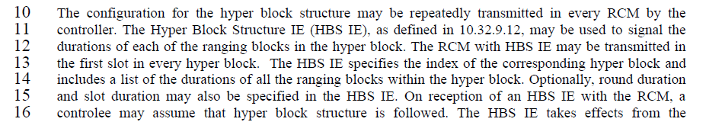

Hyper Block Controller is also the controller of each block within the Hyper Block. In hyper block mode, there is a controller per session with a series of blocks. The difference is that the block-based mode session is a series of blocks with the same structure, while the hyper block mode session is a series of blocks where each of which can have different structure, in terms of block duration, round duration, etc.

I agree it’s good if we let all controlees listen to the very first slot to receive the RCM with the HBS IE, so to help have sight of the hyper block structure, but it is left as controlee’s decision rather than mandating it.

**Proposed text changes on P802.15.4ab™/Draft 1.0 :**

***Change the chapter 10.32.3.5 P43L10 as follows:***

The configuration for the hyper block structure may be repeatedly transmitted in every RCM by the controller. Hyper Block Controller is also the controller of each block within the Hyper Block. The Hyper Block Structure IE (HBS IE), as defined in 10.32.9.12, may be used to signal the durations of each of the ranging blocks in the hyper block. The RCM with HBS IE may be transmitted in the first slot in every hyper block. The HBS IE specifies the index of the corresponding hyper block and includes a list of the durations of all the ranging blocks within the hyper block. Optionally, round duration and slot duration may also be specified in the HBS IE. On reception of an HBS IE with the RCM, a controlee may assume that hyper block structure is followed. The HBS IE takes effects from the corresponding hyper block where HBS IE exists.

***Comment Indices in 15-24-0371-01-04ab-consolidated-comments-draft-1.0:***

|  |  |  |  |  |  |  |  |
| --- | --- | --- | --- | --- | --- | --- | --- |
| **Name** | **Index#** | **Pg** | **Sub-Clause** | **Ln** | **Comment** | **Proposed Change** | **Disposition** |
| Billy Verso | 1075 | 43 | 10.32.3.5 | 20 | "and where there are common parameters in both ARC IE and HBS IE" seems a bit vague, someone should do the work and give a list of all the common parameters that, either "SHALL" have the same value in both IE, or define which has precedence otherwise, and I would suggest this should be the ARC IE. Or, you could if HBS IE is present in the RCM then the ARC IE shall be omitted. | Explicitly list the common parameters and shall have the same values in both ARC IE and HBS IE, | Revised |
| Youngwan So | 939 | 43 | 10.32.3.5 | 22 | The overlapping parameters from different IEs within the same frame must have the same value so to avoid the ambiguity | Change   From "these corresponding overlapping parameter values should be the same"  To  "these corresponding overlapping parameter values shall be the same" | Agreed |
| Billy Verso | 1076 | 43 | 10.32.3.5 | 21 | "these corresponding overlapping parameter values should be the same. " this "should" should be a "shall". Otherwise operation is undefined. | Change "should" to "shall", or define the operation as to what is the correct operation when they are not the same. | Revised |
| Srivathsa Masthi Parthasarathi | 218 | 43 | 10.32.3.5 | 18, 19 | Conflicting slot duration in HBS IE and RCM needs to be handled | clarification on when HBS IE transmitted along with RCM, there needs to be a override of same configuration value | Revised |

**Disposition Detail:**

The following is the corresponding section (FYI).

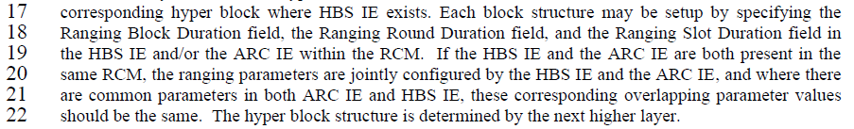

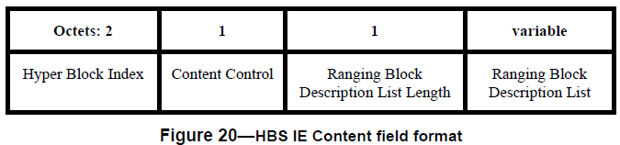

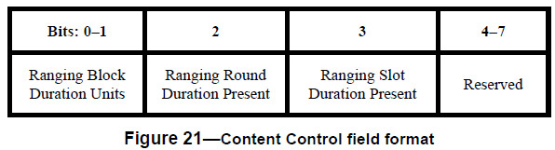

Common Parameter fields

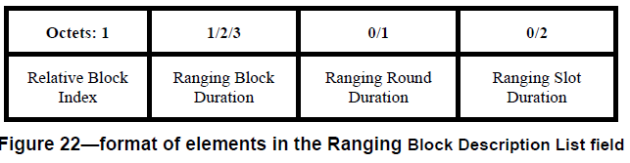

**[HBS IE]**



**[ARC IE]**

If we compare both of HBS IE and ARC IE as above, we can see three overlapping parameter fields, i.e. Block Duration, Round Duration and Slot Duration.

The Ranging Block Duration, Ranging Round Duration and Ranging Slot Duration are the common parameter fields, and each of those can be omitted from IEs by using presence flags (i.e. Content Control field of HBS IE and ARC IE). Each overlapping fields’ value shall be the same each other if they are commonly present in multiple messages at the same time and if neither of the fields are existing as present flags are off, the last fields’ value are recommended to use.

**CID #1075**

Agree with comment. Explicitly listed the common values as suggested: Block, Round, Slot duration.

**CID #939 & 1076 &218**

Agree with comment. Changed should to shall..

**Proposed text changes on P802.15.4ab™/Draft 1.0 :**

***Change the chapter 10.32.3.5 P43L20 as follows:***

………

corresponding hyper block where HBS IE exists. Each block structure is setup by specifying the Ranging Block Duration field, the Ranging Round Duration field, and the Ranging Slot Duration field in the HBS IE and/or the ARC IE within the RCM. If the HBS IE and the ARC IE are both present in the same RCM, the ranging parameters are jointly configured by the HBS IE and the ARC IE. Regarding the common parameters, i.e. the Ranging Block Duration field, the Ranging Round Duration field, and the Ranging Slot Duration, these overlapping parameter values shall be the same. The hyper block structure is determined by the next higher layer.

………………..