IEEE P802.15
Wireless Personal Area Networks

Project | IEEE P802.15 Working Group for Wireless Personal Area Networks (WPANs)
Title | Proposed Resolutions for common message fields
Date Submitted | September 2024
Sources | Rojan Chitrakar, Lei Huang (Huawei)  rojan.chitrakar@huawei.com
Re:
Abstract
Purpose | To propose resolution for “P802.15.4ab™/D01 Draft Standard for Low-Rate Wireless Networks”
Notice | This document does not represent the agreed views of the IEEE 802.15 Working Group or IEEE 802.15.4ab Task Group. It represents only the views of the participants listed in the “Sources” field above. It is offered as a basis for discussion and is not binding on the contributing individuals. The material in this document is subject to change in form and content after further study. The contributors reserve the right to add, amend or withdraw material contained herein.

Rev 0: Initial version.

Comment Indices in 15-24-0371-00-04ab-consolidated-comments-draft-1-0:
Name | Index# | Pg | Sub-Clause | Ln | Comment | Proposed Change | Disposition
Billy Verso | 1204 | 80 | 10.38.9.3 | 15 | I am not a big fan of defining fields separately to the messages, but I can see how it is used/useful in some cases here. Some suggestions for improvement. (Really editorial but marking technical so the TG has oversight before technical editor just does it.) | (A) If individual field clause is not explicitly referenced then rather than a separate numbered clause it could be defined by a paragraph in the overview.  (B) if the description is short 1 to 2 lines, then include it in the message format definitions rather than the clause reference.  (C) if the field is only used in one message or one message type the move its description to the message definition clause to avoid jumping to a cross referenced field. | Accept.  Change as proposed with the suggested categorization:  A)  10.38.9.3.2 The Message Control field  10.38.9.3.3 The Message Content field  10.38.9.3.4 FCS  B)  10.38.9.3.18 The MIC field  10.38.9.3.19 The Block Index field  10.38.9.3.20 The Round Index field  10.38.9.3.21 The Key ID field  C)  10.38.9.3.22 The Advertising Data field  10.38.9.3.23 The Status field
Billy Verso | 1214 | 88 | 10.38.9.3.19 | 25 | 10.38.9.3.19 The Block Index field, is simply "16-bit index of the current ranging block." a good candidate to insert in the text where it is used and not reference this tiny clause. | Make editorial and let the editor take care of it. | Accept
Billy Verso | 1215 | 88 | 10.38.9.3.20 | 27 | 10.38.9.3.20 The Round Index field, is simply "8-bit index of the current ranging round." another good candidate to insert in the text where it is used and not reference this tiny clause. | Make editorial and let the editor take care of it. | Accept
Tero Kivinen | 523 | 89 | 10.38.9.3.21 | 2 | It was helpful that block index, and round index fields defined the length of the field in the definition, so it is clear how long the field is supposed to be. This helps noticing places where the field length in the actual frame description does not match the field length of the data in that field. | Add text that this key id field is 8-bit long. | Reject  If the Key ID field description is moved to the respective frame format section as per CID 1204, the size of the field is obvious from the frame format.

Name | Index# | Pg | Sub-Clause | Ln | Comment | Proposed Change | Disposition
Tero Kivinen | 480 | 80 | 10.38.9.3.2 | 21 | The message control field and compact frame id fields should be combined, there is only less than 60 of valid combinations, so having one octet combining both would still leave few bits in that octet for other uses, and then the bits in the first octet of the compact frames could include other bits, for example security enabled, and version bits. | Combine message control field and compact frame id fields to one octet. | Reject  The frame id field indicates the type of compact frame while the message control field indicates the sub-types of the frame.  The group had discussed this in the earlier round and decided to keep the message control field and the frame id fields as separate fields.
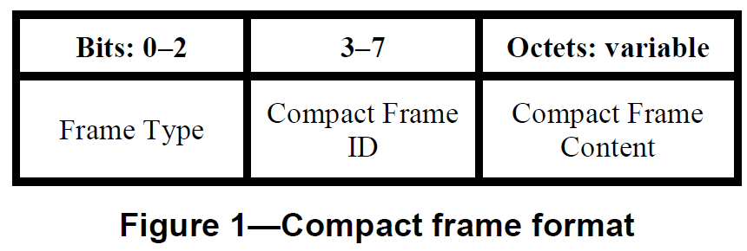
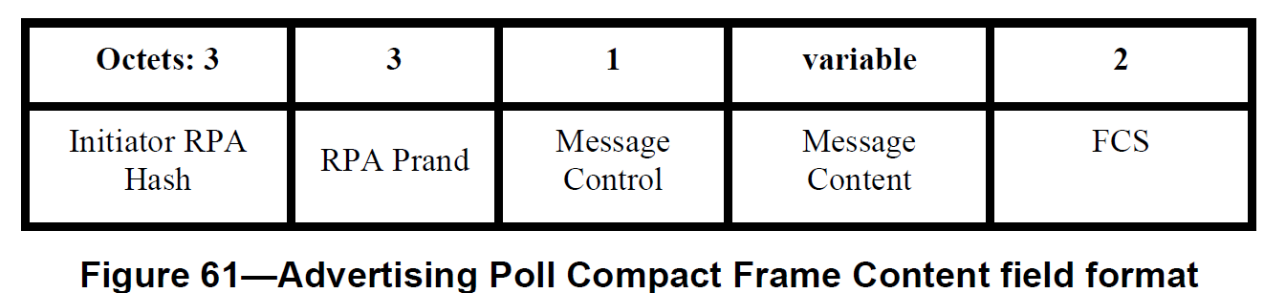
Tero Kivinen | 481 | 80 | 10.38.9.3.5 | 30 | If the compact frame id and message control fields are combined, then this structure comes much simplier, simply list of supported values. | Change to be list of supported combined compact id + message control field values. | Reject  The frame id field indicates the type of compact frame while the message control field indicates the sub-types of the frame.  The group had discussed this in the earlier round and decided to keep the message control field and the frame id fields as separate fields.
