**IEEE P802.15**

**Wireless Personal Area Networks**

|  |  |  |
| --- | --- | --- |
| Project | IEEE P802.15 Working Group for Wireless Personal Area Networks (WPANs) | |
| Title | **Proposed Resolution for Secure Report Compact frame – Part 1** | |
| Date Submitted | September 2024 | |
| Sources | Rojan Chitrakar, Lei Huang (Huawei)  [rojan.chitrakar@huawei.com](mailto:rojan.chitrakar@huawei.com) |  |
| Re: |  | |
| Abstract |  | |
| Purpose | To propose resolution for “P802.15.4ab™/D01 Draft Standard for Low-Rate Wireless Networks” | |
| Notice | This document does not represent the agreed views of the IEEE 802.15 Working Group or IEEE 802.15.4ab Task Group. It represents only the views of the participants listed in the “Sources” field above.It is offered as a basis for discussion and is not binding on the contributing individuals. The material in this document is subject to change in form and content after further study. The contributors reserve the right to add, amend or withdraw material contained herein. | |

Rev 0: Initial version.

***Comment Indices in 15-24-0371-00-04ab-consolidated-comments-draft-1-0:***

|  |  |  |  |  |  |  |  |
| --- | --- | --- | --- | --- | --- | --- | --- |
| **Name** | **Index#** | **Pg** | **Sub-Clause** | **Ln** | **Comment** | **Proposed Change** | **Disposition** |
| Libra Xiao | 914 | 120 | 10.38.9.21 | #22,#23,#24 | Original text is :"*The* ***Reply Time*** *field value is an unsigned integer reporting the time difference, measured at the responder, between the RMARKERs of the MMS fragments received from the initiator and the MMS fragments transmitted by the responder.*  "  It should be clarified how to obtain the value of the ***Reply Time*** parameter in the UWB MMS ranging phase with multiple RSFs and/or RIFs (as shown in the example in Figure 36), as the value of the ***Reply Time*** parameter can be the cumulative or mean value of multiple RSFs and/or RIFs. | "The Reply Time field value is an unsigned integer reporting the time difference, measured at the responder, between the RMARKERs of the MMS fragments received from the initiator and the MMS fragments transmitted by the responder. For the multiple RSFs and/or RIFs of the UWB MMS ranging phase,the value of the Reply Time should be the mean value of several Reply Time parameters measured at the responder. " | Reject |
| Libra Xiao | 920 | 120 | 10.38.9.21 | #3,#4,#5 | Original text is :"*The* ***Round-trip Time*** *field value is an unsigned integer that reports the time difference, measured at the initiator, between the RMARKERs of the initiator's MMS fragments and the responder's MMS fragments* "  It should be clarified how to obtain the value of the ***Round-trip Time*** parameter in the UWB MMS ranging phase with multiple RSFs and/or RIFs (as shown in the example in Figure 36), as the value of the ***Round-trip Time*** parameter can be the cumulative or mean value of multiple RSFs and/or RIFs. | "The Round-trip Time field value is an unsigned integer that reports the time difference, measured at the initiator, between the RMARKERs of the initiator's MMS fragments and the responder's MMS fragments For the multiple RSFs and/or RIFs of the UWB MMS ranging phase,the value of the Round-trip Time should be the mean value of several Round-trip Time parameters measured at the responder. " | Reject |
| Libra Xiao | 921 | 122 | 10.38.9.23 | #5,#6,#7 | Original text is :"*The* ***Round-trip Time*** *field value is an unsigned integer that reports the time difference, measured at the initiator, between the RMARKERs of the initiator's MMS fragments and the responder's MMS fragments* "  It should be clarified how to obtain the value of the ***Round-trip Time*** parameter in the UWB MMS ranging phase with multiple RSFs and/or RIFs (as shown in the example in Figure 36), as the value of the ***Round-trip Time*** parameter can be the cumulative or mean value of multiple RSFs and/or RIFs. | "The Round-trip Time field value is an unsigned integer that reports the time difference, measured at the initiator, between the RMARKERs of the initiator's MMS fragments and the responder's MMS fragments For the multiple RSFs and RIFs of the UWB MMS ranging phase,the value of the Round-trip Time should be the mean value of several Round-trip Time parameters measured at the responder. " | Reject |
| Libra Xiao | 916 | 123 | 10.38.9.24 | #12,#13,#14 | Original text is :"*The* ***Reply Time*** *field value is an unsigned integer reporting the time difference, measured at the responder, between the RMARKERs of the MMS fragments received from the initiator and the MMS fragments transmitted by the responder.*  "  It should be clarified how to obtain the value of the ***Reply Time*** parameter in the UWB MMS ranging phase with multiple RSFs and/or RIFs (as shown in the example in Figure 36), as the value of the ***Reply Time*** parameter can be the cumulative or mean value of multiple RSFs and/or RIFs. | "The Reply Time field value is an unsigned integer reporting the time difference, measured at the responder, between the RMARKERs of the MMS fragments received from the initiator and the MMS fragments transmitted by the responder. For the multiple RSFs and/or RIFs of the UWB MMS ranging phase,the value of the Reply Time should be the mean value of several Reply Time parameters measured at the responder. " | Reject |
| Libra Xiao | 918 | 100 | 10.38.9.9 | #3,#4,#5 | Original text is :"The Round-trip Time field value is an unsigned integer that reports the time difference, measured at the initiator, between the RMARKERs of the initiator's MMS fragments and the responder's MMS fragments "  It should be clarified how to obtain the value of the Round-trip Time parameter in the UWB MMS ranging phase with multiple RSFs and/or RIFs (as shown in the example in Figure 36), as the value of the Round-trip Time parameter can be the cumulative or mean value of multiple RSFs and/or RIFs. | "The Round-trip Time field value is an unsigned integer that reports the time difference, measured at the initiator, between the RMARKERs of the initiator's MMS fragments and the responder's MMS fragments For the multiple RSFs and/or RIFs of the UWB MMS ranging phase,the value of the Round-trip Time should be the mean value of several Round-trip Time parameters measured at the responder. " | Reject |
| Libra Xiao | 912 | 101 | 10.38.9.10 | #3,#4,#5 | Original text is :"The Reply Time field value is an unsigned integer reporting the time difference, measured at the responder, between the RMARKERs of the MMS fragments received from the initiator and the MMS fragments transmitted by the responder. "  It should be clarified how to obtain the value of the Reply Time parameter in the UWB MMS ranging phase with multiple RSFs and/or RIFs (as shown in the example in Figure 36), as the value of the Reply Time parameter can be the cumulative or mean value of multiple RSFs and/or RIFs. | "The Reply Time field value is an unsigned integer reporting the time difference, measured at the responder, between the RMARKERs of the MMS fragments received from the initiator and the MMS fragments transmitted by the responder. For the multiple RSFs and/or RIFs of the UWB MMS ranging phase, the Reply Time should be the mean value of several Reply Time parameters measured at the responder. " | Reject |
| Libra Xiao | 917 | 124 | 10.38.9.24 | #9,#10,#11 | Original text is :"The Reply Time field value is an unsigned integer reporting the time difference, measured at the responder, between the RMARKERs of the MMS fragments received from the initiator and the MMS fragments transmitted by the responder. "  It should be clarified how to obtain the value of the Reply Time parameter in the UWB MMS ranging phase with multiple RSFs and/or RIFs (as shown in the example in Figure 36), as the value of the Reply Time parameter can be the cumulative or mean value of multiple RSFs and/or RIFs. | "The Reply Time field value is an unsigned integer reporting the time difference, measured at the responder, between the RMARKERs of the MMS fragments received from the initiator and the MMS fragments transmitted by the responder. For the multiple RSFs and/or RIFs of the UWB MMS ranging phase,the value of the Reply Time should be the mean value of several Reply Time parameters measured at the responder. " | Reject |

**Discussion**：

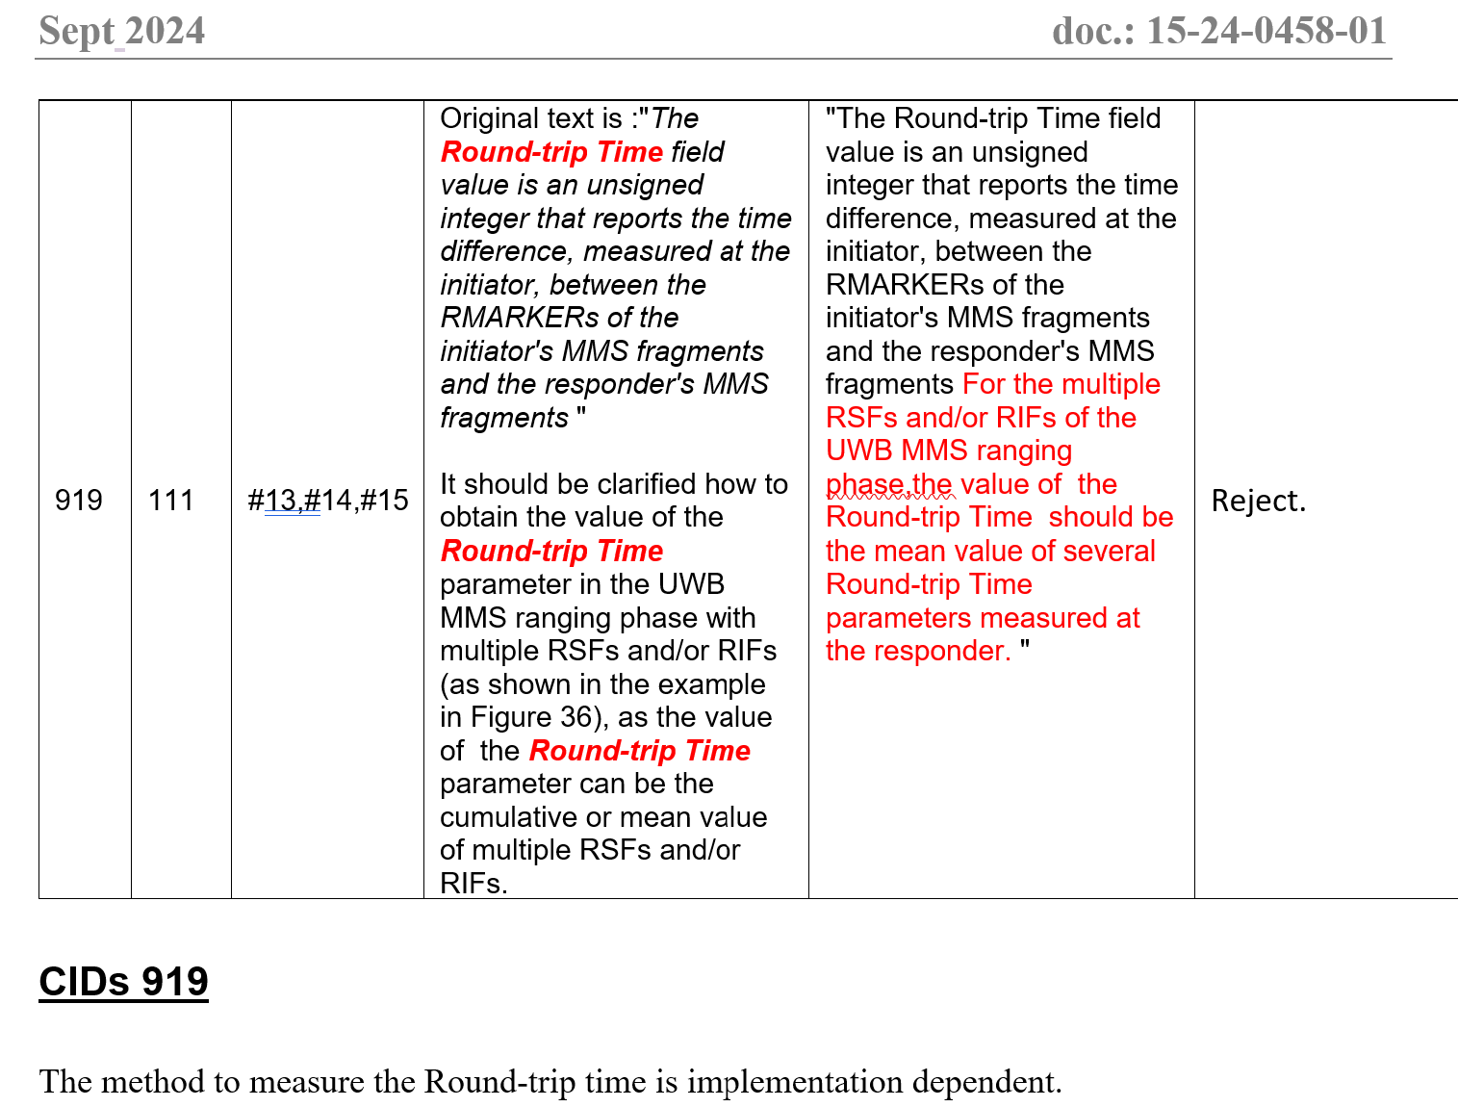

A similar comment (CID 919) was discussed in 24/458r1 and rejected.

**Disposition: Reject**

**Disposition Reason:**

The method to measure the Reply time and Round-trip time is implementation dependent.

|  |  |  |  |  |  |  |  |
| --- | --- | --- | --- | --- | --- | --- | --- |
| **Name** | **Index#** | **Pg** | **Sub-Clause** | **Ln** | **Comment** | **Proposed Change** | **Disposition** |
| Bin Qian | 172 | 122 | 10.38.9.23 | 14 | The description of the Round-trip Time One field and Round-trip Time Two field is not consist with that of the Round-trip time field in Line 5 | Adjust the description of the Round-trip Time One field and Round-trip Time Two field as the Round-trip Time field | Revise |

Discussion:

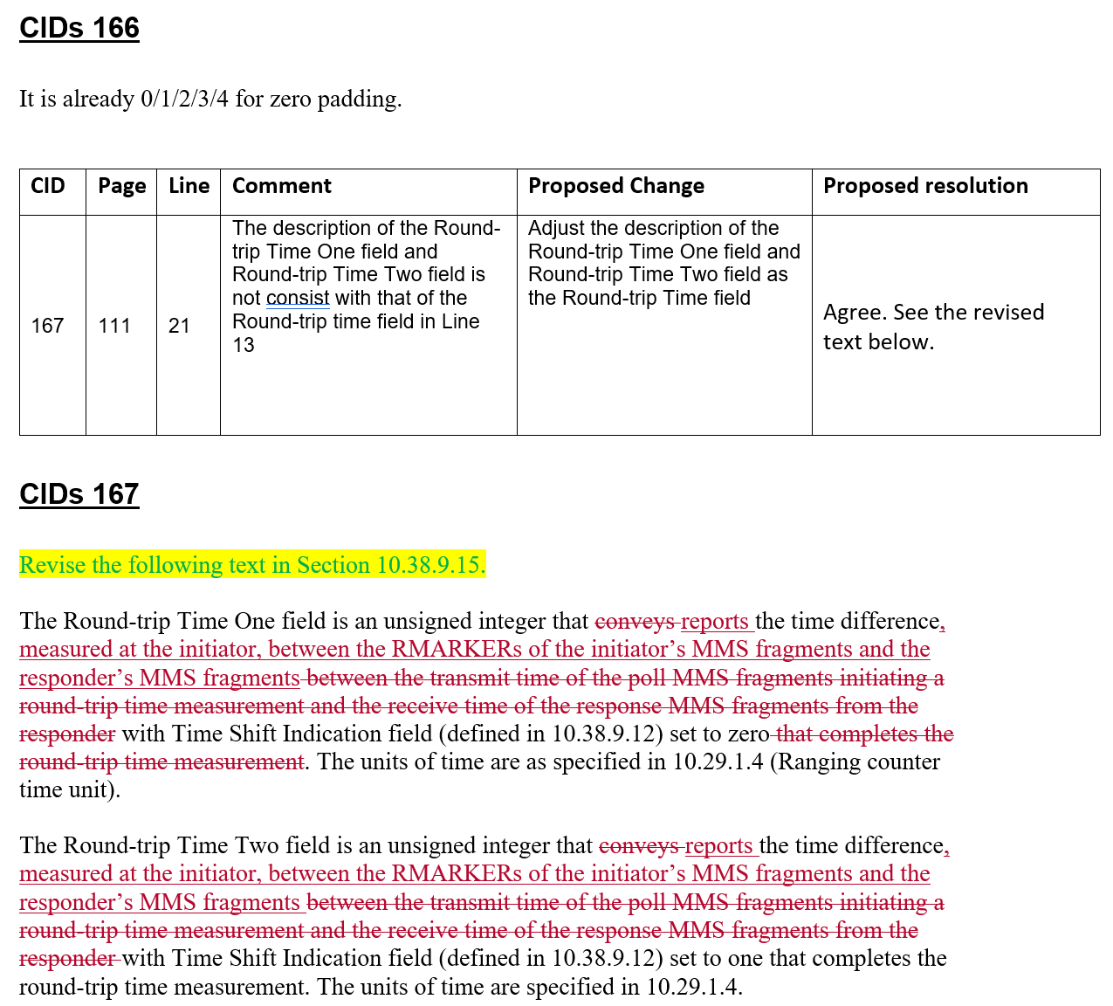

A similar comment (CID 167) was discussed in 24/458r1 and the same resolution is applied for CID 172.

*Change the text starting from Page 122 Ling 14 as follows (Track change on):*

The Round-trip Time One field is an unsigned integer that reports the time difference, measured at the initiator, between the RMARKERs of the initiator’s MMS fragments and the responder’s MMS fragments with Time Shift Indication field (defined in 10.38.9.12) set to zero. The units of time are as specified in 10.29.1.4 (Ranging counter time unit).

The Round-trip Time Two field is an unsigned integer that reports the time difference, measured at the initiator, between the RMARKERs of the initiator’s MMS fragments and the responder’s MMS fragments with Time Shift Indication field (defined in 10.38.9.12) set to one that completes the round-trip time measurement. The units of time are specified in 10.29.1.4.