**IEEE P802.15**

**Wireless Personal Area Networks**

|  |  |  |
| --- | --- | --- |
| Project | IEEE P802.15 Working Group for Wireless Personal Area Networks (WPANs) | |
| Title | **Proposed Resolution for MMS – Public part 1** | |
| Date Submitted | Sept. 2024 | |
| Sources | Hong Won Lee (LG Electronics)  [hongwon.lee@lge.com](mailto:hongwon.lee@lge.com) |  |
| Re: |  | |
| Abstract |  | |
| Purpose | To propose resolution for “P802.15.4ab™/D01 Draft Standard for Low-Rate Wireless Networks” . | |
| Notice | This document does not represent the agreed views of the IEEE 802.15 Working Group or IEEE 802.15.4ab Task Group. It represents only the views of the participants listed in the “Sources” field above.It is offered as a basis for discussion and is not binding on the contributing individuals. The material in this document is subject to change in form and content after further study. The contributors reserve the right to add, amend or withdraw material contained herein. | |

This submission contains the proposed comment resolutions for the CIDs 39, 134, 278, 436, 477, 478, 610, 614, 1150, 1151, 1155, 1157, 1158, 1433 and 1450

Rev 0: Initial version.

Rev 1: The proposed resolution for CIDs 614 and 1450 is separated.

Rev 2: The size of the SMC TLVs in the proposed resolution for CIDs 135, 278 and 610 is changed

***Comment index #1150 in 15-24-0371-01-04ab-consolidated-comments-draft-1-0.xlsx***

|  |  |  |  |  |  |  |  |
| --- | --- | --- | --- | --- | --- | --- | --- |
| **Name** | **Index#** | **Pg** | **Sub-Clause** | **Ln** | **Comment** | **Proposed Change** | **Disposition** |
| Billy Verso | 1150 | 63 | 10.38.3.6.1 | 25 | "may send", is not right I think because if it doesn't send them there will be no initialisation. | change to "sends" | Accept |

**Discussion**：

Agree with the commenter. "the initiator sends" is the correct expression for this paragraph because this sentence is included in the subsection "10.38.3.6 UWB MMS ranging session initialization using public addresses" to describe initialization and session setup



**Disposition: Accept**

**Overview of changed text in context**

***Change the sub-clause as follows (Track changes ON)***

**(*pp. 63 line #25*)**

In the initialization and setup stage, the initiator sends Public Advertising Poll Compact frames with a public initiator address as specified in 10.38.9.2.2.

***Comment index#1151 in 15-24-0371-01-04ab-consolidated-comments-draft-1-0.xlsx:***

|  |  |  |  |  |  |  |  |
| --- | --- | --- | --- | --- | --- | --- | --- |
| **Name** | **Index#** | **Pg** | **Sub-Clause** | **Ln** | **Comment** | **Proposed Change** | **Disposition** |
| Billy Verso | 1151 | 63 | 10.38.3.6.1 | 25 | There are lots of "may" in the text which are possibly also questionable for the same reason, and perhaps could be similarly removed. | Review uses of "may" everywhere, and consider removing/rewording to be more definite in language. | Revised |

**Discussion**：

There are three instances of "may" in sub-clause 10.38.3.6.1. Adding one sentence to point out that the features described in this sub-clause are optional. The three instances of “may” are removed as suggested by the commenter

**Disposition: Revised**

**Disposition Detail:**

**Proposed text changes on P802.15.4ab™/D01:**

**- Original Text**

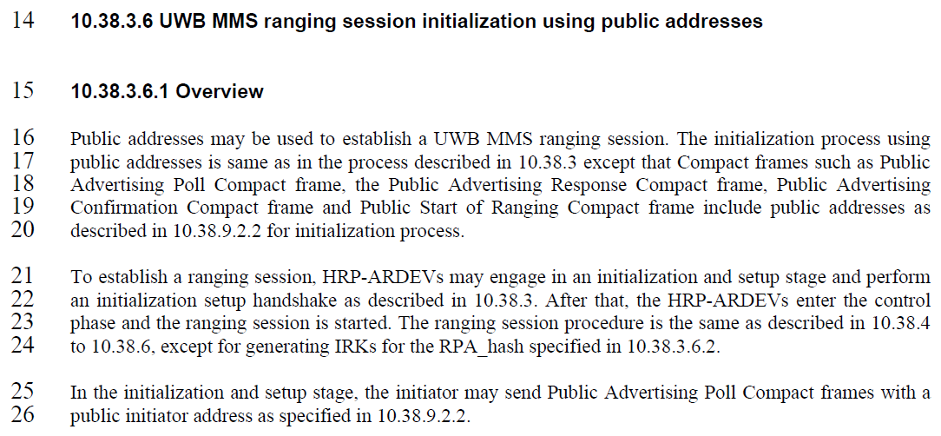

**- Proposed change**

***Change the sub-clause as follows (Track changes ON)***

**(*pp. 63 line #16*)**

**Add the following new sentence on page 63 after line 16**

The use of public addresses and support of the initialization setup procedure in this subclause are optional.

**(*pp. 63 line #16*)**

Public addresses is used to establish a UWB MMS ranging session. The initialization process using public addresses is same as in the process described in 10.38.3 except that Compact frames such as Public Advertising Poll Compact frame, the Public Advertising Response Compact frame, Public Advertising Confirmation Compact frame and Public Start of Ranging Compact frame include public addresses as described in 10.38.9.2.2 for initialization process.

**(*pp. 63 line #21*)**

To establish a ranging session, HRP-ARDEVs engages in an initialization and setup stage and perform an initialization setup handshake as described in 10.38.3.

**(*pp. 63 line #25*)**

In the initialization and setup stage, the initiator sends Public Advertising Poll Compact frames with a public initiator address as specified in 10.38.9.2.2.

***Comment index #1433 in 15-24-0371-01-04ab-consolidated-comments-draft-1-0.xlsx***

|  |  |  |  |  |  |  |  |
| --- | --- | --- | --- | --- | --- | --- | --- |
| **Name** | **Index#** | **Pg** | **Sub-Clause** | **Ln** | **Comment** | **Proposed Change** | **Disposition** |
| Lei HUANG | 1433 | 64 | 10.38.3.6.1 | 13 | It is better to clarify what are coordination packets. | Change "coordination packets" to "Acquisition Compact frames" | Accept |

**Discussion**：

Agree with the commenter. "coordination packets" should be changed to "Acquisition Compact frames," which is the term used throughout the draft

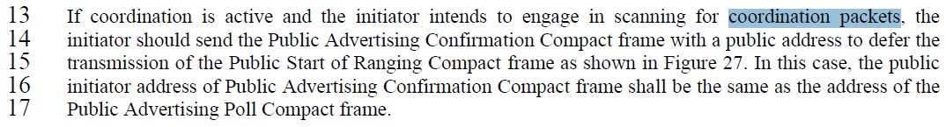

**Disposition: Accept**

**Overview of changed text in context**

***Change the sub-clause as follows (Track changes ON)***

**(*pp. 64 line #13*)**

If coordination is active and the initiator intends to engage in scanning for Acquisition Compact frames, the initiator should send the Public Advertising Confirmation Compact frame with a public address to defer the transmission of the Public Start of Ranging Compact frame as shown in Figure 27. In this case, the public initiator address of Public Advertising Confirmation Compact frame shall be the same as the address of the Public Advertising Poll Compact frame.

***Comment index #1155 in 15-24-0371-01-04ab-consolidated-comments-draft-1-0.xlsx***

|  |  |  |  |  |  |  |  |
| --- | --- | --- | --- | --- | --- | --- | --- |
| **Name** | **Index#** | **Pg** | **Sub-Clause** | **Ln** | **Comment** | **Proposed Change** | **Disposition** |
| Billy Verso | 1155 | 64 | 10.38.3.6.1 | 14 | "with a public address" is not needed here I think since the frame by definition has a public address, and the "with a public address" right before "to defer…" seems to suggest that is it the public address doing the deferral when in fact it is the confirmation message itself that is doing it. | delete "with a public address" | Revised |

**Discussion**：

Agree with the commenter. The definition of Public Advertising Confirmation Compact frame includes public addresses, therefore, "with a public address" is not necessary here. Coordination packets is changed to Acquisition Compact frames according to the resolution proposal of CID 1433

**Disposition: Revised**

**Disposition Detail:**

**Proposed text changes on P802.15.4ab™/D01:**

**- Original Text**

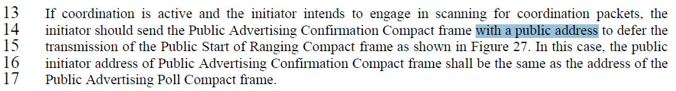***Change the sub-clause as follows (Track changes ON)***

**- Proposed change**

**(*pp. 64 line #13-15*)**

If coordination is active and the initiator intends to engage in scanning for Acquisition Compact frames, the initiator should send the Public Advertising Confirmation Compact frame to defer the transmission of the Public Start of Ranging Compact frame as shown in Figure 27.

***Comment index#39 in 15-24-0371-01-04ab-consolidated-comments-draft-1-0.xlsx***

|  |  |  |  |  |  |  |  |
| --- | --- | --- | --- | --- | --- | --- | --- |
| **Name** | **Index#** | **Pg** | **Sub-Clause** | **Ln** | **Comment** | **Proposed Change** | **Disposition** |
| Mickael Maman | 39 | 64 | 10.38.3.6.1 | 22 | is it possible to start an initialization process with public addresses for the variantes defined in 10.38.3.5 (e.g. multiple one-to-one, one to many) | as in comment | Revised |

**Discussion**：Yes, it is possible to start the initialization process with public addresses for all the cases defined in section 10.38.3.5. Please refer to the examples below

1. **multiple one-to-one ranging**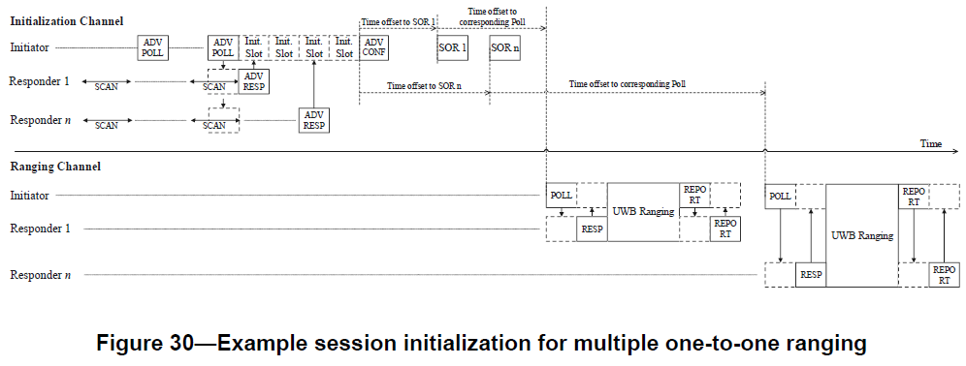
   1. Similar to the Advertising Poll Compact frame, there is a CapDuration subfield to set the number of slots for contention access period in Public Adverting Poll Compact frame.
   2. Similar to the Advertising Confirmation Compact frame, the Public Advertising Confirmation Compact frame has a Message Control field with a value of 0x10, which includes the Number of Responders and Responder SOR Time Offset List subfields. Using these, it is possible to initiate an initialization process for multiple one-to-one ranging
   3. Consequently, there is no big difference between the initialization procedure using private address and public address. Only addressing scheme is different in the initialization setup phase and how to generate RPA Hash in the ranging phase
2. **One-to-many**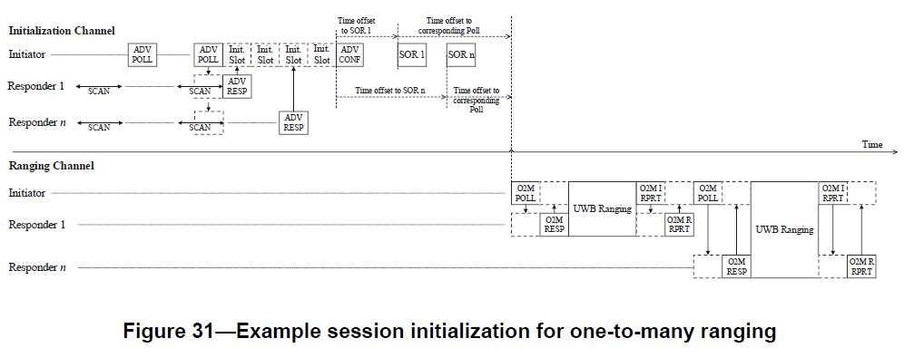
   1. Similar to the Advertising Poll Compact frame, there is a CapDuration subfield to set the number of slots for contention access period.
   2. Similar to the Advertising Response Compact frame, the Public Advertising Response Compact frame has a Message Control field with a value of 0x10, which includes the MMS Ranging Mode Configuration subfield for selecting one-to-many ranging.
   3. Similar to the Advertising Confirmation Compact frame, the Public Advertising Confirmation Compact frame includes a Message Control field with a value of 0x10, which contains the Number of Responders and Responder SOR Time Offset List subfields. These elements enable the initiation of an initialization process for one-to-many ranging sessions
   4. Consequently, there is no big difference between the initialization procedure using private address and public address for one-to-many ranging. Only the difference is addressing scheme in the initialization setup phase and how to generate RPA Hash in the ranging phase

Additionally, there is a paragraph that the initialization setup process is same as in the process described in 10.38.3 except the addressing scheme

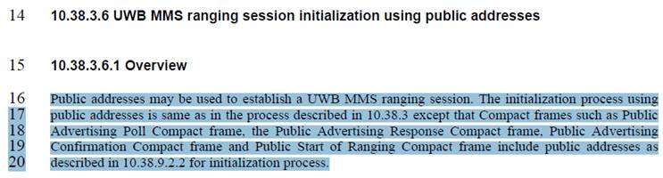

**Disposition: Revised**

***Comment index #436 15-24-0371-01-04ab-consolidated-comments-draft-1-0:***

|  |  |  |  |  |  |  |  |
| --- | --- | --- | --- | --- | --- | --- | --- |
| **Name** | **Index#** | **Pg** | **Sub-Clause** | **Ln** | **Comment** | **Proposed Change** | **Disposition** |
| Tero Kivinen | 436 | 65 | 10.38.3.6.2 | 2 | There is no need to list the frames used for initialization setup, as this will just be duplicating information and if someone adds or modifies the setup phase all these locations needs to be changed. | Simply say "after the initialization setup handshake usng public addresses the IRK". | Revised |

**Discussion**：

The commenter is right. The suggestion of the commenter may be accepted with modified sentence

**Disposition: Revised**

**Disposition Detail:**

**Proposed text changes on P802.15.4ab™/D01:**

**10.38.3.6 UWB MMS ranging session initialization using public addresses**

**- Original Text**

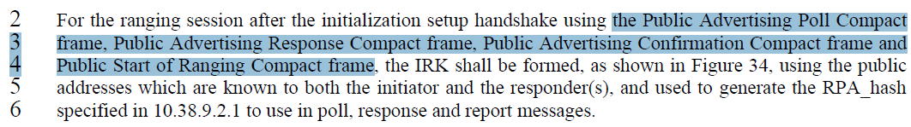

**- Proposed change**

***Change the sub-clause as follows (Track changes ON)***

**(*pp. 65 line #2 - 6*)**

For the ranging session after the initialization setup handshake using public addresses, the IRK shall be formed, as shown in Figure 34, to generate the RPA_hash specified in 10.38.9.2.1 to use in poll, response and report messages.

***Comment index #1157 in 15-24-0371-01-04ab-consolidated-comments-draft-1-0.xlsx***

|  |  |  |  |  |  |  |  |
| --- | --- | --- | --- | --- | --- | --- | --- |
| **Name** | **Index#** | **Pg** | **Sub-Clause** | **Ln** | **Comment** | **Proposed Change** | **Disposition** |
| Billy Verso | 1157 | 65 | 10.38.3.6.2 | 24 | Strange negatives here "The GroupID is NOT shared if a Public Advertising Poll Compact frame with the Message Control field value is NOT set to 0x21 on the initialization channel." Also I don't fully understand the sentence, it seems to be badly formed. | Rewrite to use positive definition of something that is done instead of defining something that isn't done. | Revise |
| Billy Verso | 1158 | 65 | 10.38.3.6.2 | 27 | Strange to talk about the frame with Message Control not set to 0x00. This should identify the frame with the particular the control field value wanted, rather than with one not wanted. Like this, maintenance of the text is harder, i.e., if a new ID value is defined would this line apply or not, could be hard to know to review/revise this line. | Change to positive specification of the desired frame and behaviour. | Revised |

**Discussion**：Agree with the commenter. Negative expression should be changed to positive definition

**Disposition: Revised**

**Disposition Detail:**

**Proposed text changes on P802.15.4ab™/D01:**

**10.38.3.6.2 RPA_hash generation and resolution after initialization using public addresses**

**- Original Text**

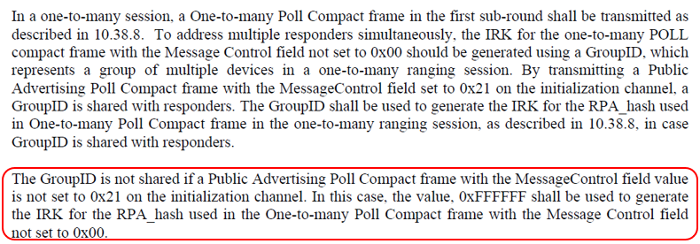

**- Proposed change**

***Change the sub-clause as follows (Track changes ON)***

**(*pp. 65 line #24 - 27*)**

Unless the Group ID is shared from the initiator to the responder(s) through a Public advertising Compact frame, the value, 0xFFFFFF shall be used to generate the IRK for the RPA_hash used in the One-to-many Poll Compact frame for the ranging sub-rounds that are the first one.

***Comment index #477 in 15-24-0371-01-04ab-consolidated-comments-draft-1-0.xlsx***

|  |  |  |  |  |  |  |  |
| --- | --- | --- | --- | --- | --- | --- | --- |
| **Name** | **Index#** | **Pg** | **Sub-Clause** | **Ln** | **Comment** | **Proposed Change** | **Disposition** |
| Tero Kivinen | 477 | 79 | 10.38.9.2.2 | 27 | The text on lines 27-32 is mostly redundant. Those frames already tell what addresses they are using, so repeating it here is not needed. | Remove lines 27-32 and replace it will text saying that Public Advertising Poll Compact frame (10.38.9.16), Public Advertising Response Compact frame (10.38.9.17), Public Start of Ranging Compact frame (10.38.9.18), and Public Advertising Confirmation Compact (10.38.9.19) frames use public addresses. | Revised |

**Discussion**：Agree with the commenter. The current description is redundant, as the addressing scheme for determining source and destination addresses is already covered in sub-clause 10.38.3.6. It would be more effective to focus on describing what public addresses are in sub-clause 10.38.9.2.2

**Disposition: Revised**

**Disposition Detail:**

**Proposed text changes on P802.15.4ab™/D01:**

**10.38.3.6.2 RPA_hash generation and resolution after initialization using public addresses**

**- Original Text**

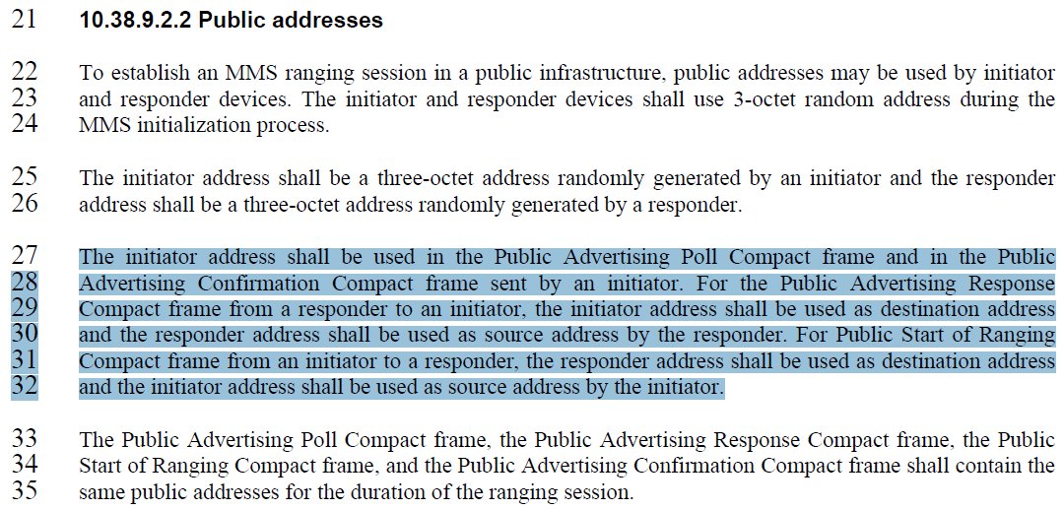

**- Proposed Change**

***Change the sub-clause as follows (Track changes ON)***

**(*pp. 79 line #27 - 32*)**

Public Advertising Poll Compact frame (10.38.9.16), Public Advertising Response Compact frame (10.38.9.17), Public Start of Ranging Compact frame (10.38.9.18), and Public Advertising Confirmation Compact (10.38.9.19) frames use public addresses.

***Comment index #478 in 15-24-0371-01-04ab-consolidated-comments-draft-1-0.xlsx***

|  |  |  |  |  |  |  |  |
| --- | --- | --- | --- | --- | --- | --- | --- |
| **Name** | **Index#** | **Pg** | **Sub-Clause** | **Ln** | **Comment** | **Proposed Change** | **Disposition** |
| Tero Kivinen | 478 | 79 | 10.38.9.2.2 | 27 | There is no need to repeat the which frames keep the same address, this text should say that same public address shall be used during the duration of the ranging session. | Replace lines 33-35 with text that says that "During the ranging session devices shall use the same public address". | Revised |

**Discussion**：Agree with the commenter. It is right expression that “During the ranging session, devices shall use the same public address”. Device shall maintain same public addresses generated during initialization setup phase to establish and maintain ranging session during ranging phase

**Disposition: Revised**

**Disposition Detail:**

**Proposed text changes on P802.15.4ab™/D01:**

**10.38.9.2.2 Public addresses**

**- Original Text**



**- Proposed change**

***Change the sub-clause as follows (Track changes ON)***

**(*pp. 79 line #33-35*)**

A device shall use the same public addresses it generated during the initialization setup phase for the duration of the ranging session, after the initialization setup phase is complete.

***Comment index #134, 278 and 610 in 15-24-0371-01-04ab-consolidated-comments-draft-1-0.xlsx***

|  |  |  |  |  |  |  |  |
| --- | --- | --- | --- | --- | --- | --- | --- |
| **Name** | **Index#** | **Pg** | **Sub-Clause** | **Ln** | **Comment** | **Proposed Change** | **Disposition** |
| Rojan Chitrakar | 134 | 112 | 10.38.9.16 | 10 | Similar to the ADV-Poll, with the new Presence Bitmap format, the 4 variants can likely be combined in a single variant by either making the Initialization Slot Duration and Cap Duration fields mandatory or adding relevant presence bits for Initialization Slot Duration and Cap Duration. | Consider combine the 4 variants in a single variant by either making the Initialization Slot Duration and Cap Duration fields mandatory in all variant or adding relevant presence bits for Initialization Slot Duration and Cap Duration. | Revised |
| Tero Kivinen | 610 | 112 | 10.38.9.3.22 | 10 | As most of the Message Content formats are same as in Advertising Poll Compact Frame defined in 10.38.9.4, it would be better to just say that for message content fields of 0x00, 0x10, and 0x20 are described in the 10.38.9.4, and only cover differences here, i.e., message content field valus 0x21 and 0x30. | Remove duplicated text and add reference to 10.38.9.4. | Revised |
| Li-Hsiang Sun | 278 | 113 | 10.398.9.16 | 1 | With SMC TLVs before advertising data, the receiver would not be able to parse the length of either field | reverse the order of advertising data and SMC TLVs | Revised |

**Discussion**：

Similar to the resolution proposal in CID#113 in DCN#15-2-380r1, the 4 variants by making the Initialization Slot Duration, Cap Duration and Advertising Data fields mandatory in all 4 variant and adding the presence bitmap for SMC TLVs and Group ID fields. Through changing these, CID#610 and CID#278 can be resolved as well

**Disposition: Revised**

**Disposition Detail:**

**Proposed text changes on P802.15.4ab™/D01:**

**- Original Text**

**10.38.9.3.24 The Presence Bitmap field**

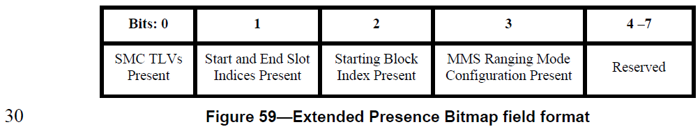

**10.38.9.16 Public Advertising Poll Compact frame**

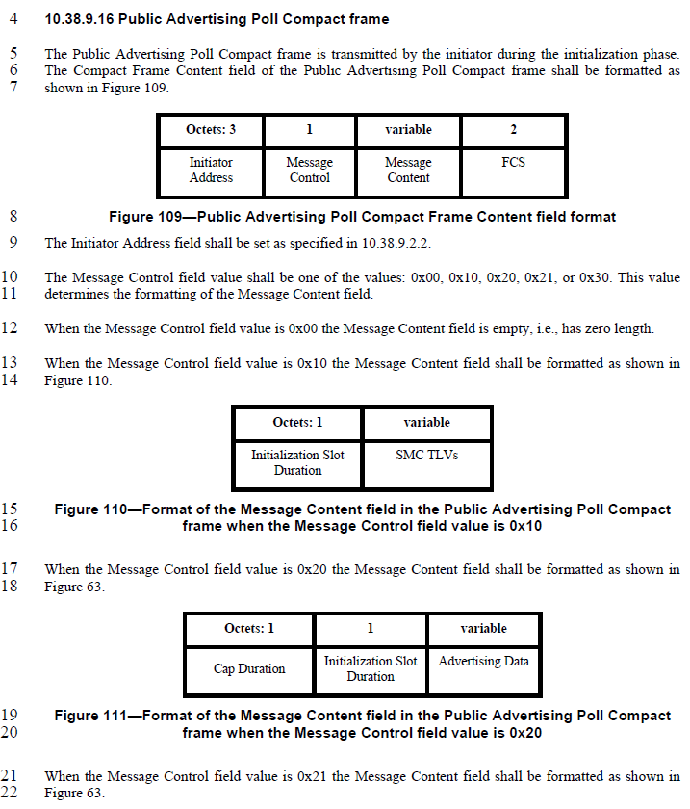

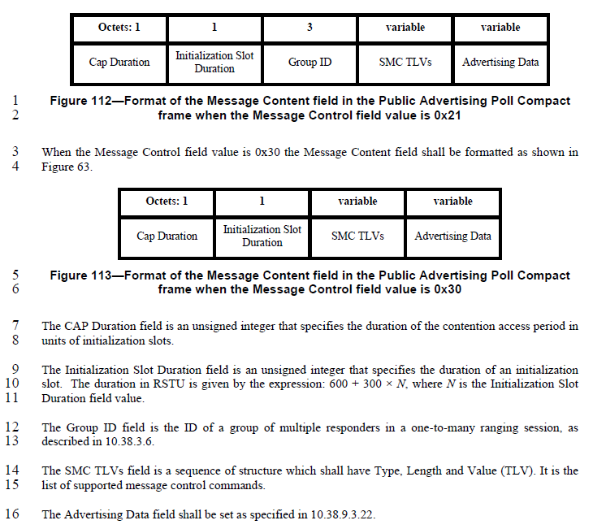

**- Proposed change**

***Change the sub-clause as follows (Track changes ON)***

**10.38.9.3.24 The Presence Bitmap field**

**(*pp. 90 line #30*)**

|  |  |  |  |  |  |
| --- | --- | --- | --- | --- | --- |
| **Bits: 0** | **1** | **2** | **3** | **4** | **5 - 7** |
| SMC TLVs Present | Start and End Slot Indices Present | Starting Block Index Present | MMS Ranging Mode Configuration Present | Group ID Present | Reserved |

**10.38.9.16 Public Advertising Poll Compact frame**

**(*pp. 112 line #10-11*)**

The Message Control field value shall be either 0x00 or 0x10. This value determines the formatting of the Message Content field.

**(*pp. 112 line #15-22, pp. 113 line #1-6*)**

When the Message Control field value is 0x10 the Message Content field shall be formatted as shown in Figure 110.

|  |  |  |  |  |  |
| --- | --- | --- | --- | --- | --- |
| **Octets: 1** | **1** | **1/2** | **0/3** | **variable** | **0/variable** |
| Initialization Slot Duration | Cap Duration | Presence Bitmap | Group ID | Advertising Data | SMC TLVs |

**Figure 110—Format of the Message Content field in the Public Advertising Poll Compact frame when the Message Control field value is 0x10l**

**Delete Figure 111**

**Delete Figure 112**

**Delete Figure 113**

**(*pp. 113 line #7-16*)**

The Initialization Slot Duration field is an unsigned integer that specifies the duration of an initialization slot. The duration in RSTU is given by the expression: 600 + 300 × *N*, where *N* is the Initialization Slot Duration field value.

The CAP Duration field is an unsigned integer that specifies the duration of the contention access period in 8 units of initialization slots.

The Presence Bitmap is set as specified in 10.38.9.3.24, except that the fields other than the SMC TLVs Present field, the Group ID Present field and the Extended Presence Bitmap Present field shall be set to zero.

The Group ID field is the ID of a group of multiple responders in a one-to-many ranging session, as described in 10.38.3.6.

The Advertising Data field shall be set as specified in 10.38.9.3.22.

The SMC TLVs field is the list of supported message control commands as defined in 10.38.9.3.5. This is used by the initiator to signal to responders which compact frames and which message control values it supports. Its length can be inferred from the frame length.

***Comment indices #614 and 1450 in 15-24-0371-01-04ab-consolidated-comments-draft-1-0.xlsx***

|  |  |  |  |  |  |  |  |
| --- | --- | --- | --- | --- | --- | --- | --- |
| **Name** | **Index#** | **Pg** | **Sub-Clause** | **Ln** | **Comment** | **Proposed Change** | **Disposition** |
| Tero Kivinen | 614 | 113 | 10.38.9.3.22 | 23 | If there is only one possible value for Message control field, it can be also omitted to make message more compact. | Remove message control field. | Revised |
| Huan-Bang Li | 1450 | 113 | 10.38.9.3.22 | 23 | 'one of 0x00' is strange. Is there another value? Add another value if yes. Delete 'one of' if no. | make change. | Revised |

**Discussion**：The Message Control field value in the Public Advertising Response Compact frame is not only one. It is consistent with the Message Control field as specified in 10.38.9.4. The text should be revised to align to the Advertising Response Compact frame to maintain consistency. This resolution proposal aligns with the resolution proposal for CID#114 related to Advertising Response Compact frame in DCN#371r13(Consolidated comments)



**Disposition: Revised**

**Disposition Detail:**

**Proposed text changes on P802.15.4ab™/D01:**

**10.38.9.17 Public Advertising Response Compact frame**

**- Original Text**

**(*pp. 113 line #23*)**

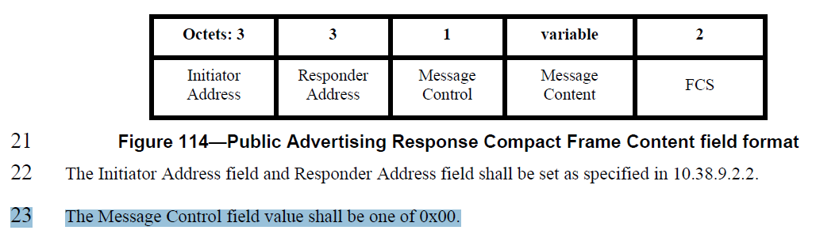

**(*pp. 114 line #1-3*)**

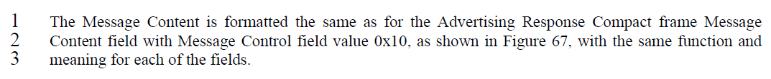

**- Proposed change**

***Change the sub-clause as follows (Track changes ON)***

**(*pp. 113 line #23*)**

The Message Control field value shall be either 0x00 or 0x10.

**(*pp. 114 line #1-3*)**

The Message Content is formatted the same as for the Advertising Response Compact frame Message Content field with Message Control field value 0x00 and 0x10, as shown in Figure 66 and Figure 67 respectively, with the same function and meaning for each of the fields.