**IEEE P802.15**

**Wireless Personal Area Networks**

|  |  |  |
| --- | --- | --- |
| Project | IEEE P802.15 Working Group for Wireless Personal Area Networks (WPANs) | |
| Title | **Proposed Resolution for Hyper Block – Bitmap-based block scheduling** | |
| Date Submitted | Sept. 2024 | |
| Sources | Hong Won Lee (LG Electronics)  [hongwon.lee@lge.com](mailto:hongwon.lee@lge.com) |  |
| Re: |  | |
| Abstract |  | |
| Purpose | To propose resolution for “P802.15.4ab™/D01 Draft Standard for Low-Rate Wireless Networks” . | |
| Notice | This document does not represent the agreed views of the IEEE 802.15 Working Group or IEEE 802.15.4ab Task Group. It represents only the views of the participants listed in the “Sources” field above.It is offered as a basis for discussion and is not binding on the contributing individuals. The material in this document is subject to change in form and content after further study. The contributors reserve the right to add, amend or withdraw material contained herein. | |

This submission contains the proposed comment resolutions for the CIDs 109, 976, 1095, 1107, 1408, 1409 and 1410

Rev 0: Initial version.

***Comment index #1095 in 15-24-0371-01-04ab-consolidated-comments-draft-1-0.xlsx***

|  |  |  |  |  |  |  |  |
| --- | --- | --- | --- | --- | --- | --- | --- |
| **Name** | **Index#** | **Pg** | **Sub-Clause** | **Ln** | **Comment** | **Proposed Change** | **Disposition** |
| Billy Verso | 1095 | 48 | 10.32.9.10 | 2 | Sentence "The Block Scheduling Bitmap field represents one or multiple ranging blocks assigned to a device for transmission using a single Scheduling List field element in a hyper block.", is unclear in meaning especially the part from "using..." onward. | Change to "The elements of this scheduling list type include a Block Scheduling Bitmap field to specify for each listed responder which ranging blocks of the hyper block it is assigned for its transmissions." | Accept |

**Discussion**：Agree with the commenter. “using a single Scheduling List field element” may not be clear to describe the pattern of scheduled blocks to a single device. The proposed change by the commenter clearly describes how the Block Scheduling Bitmap field is used for the pattern of scheduled blocks to a single device

**Disposition: Accept**

**Overview of changed text in context**

***Change the sub-clause as follows (Track changes ON)***

**(*pp. 48 line #1-4*)**

Scheduling List Type field value of five can be transmitted in the same ranging round as an HBS IE for block scheduling in hyper block mode, as described in 10.32.3.5. The elements of this scheduling list type include a Block Scheduling Bitmap field to specify for each listed responder which ranging blocks of the hyper block it is assigned for its transmissions.

***Comment index #109 in 15-24-0371-01-04ab-consolidated-comments-draft-1-0.xlsx***

|  |  |  |  |  |  |  |  |
| --- | --- | --- | --- | --- | --- | --- | --- |
| **Name** | **Index#** | **Pg** | **Sub-Clause** | **Ln** | **Comment** | **Proposed Change** | **Disposition** |
| Carlos Aldana | 976 | 50 | 10.32.9.10 | 25 | Table 11 lists only 2 values for Scaling Factor, yet Figure 16 allocates 2 bits. This is not consistent. | Please fix. | Revised |
| Rojan Chitrakar | 109 | 51 | 10.32.9.10 | 4 | Since the Relative Block Index in the HBS IE is only 1 octet, there can only be maximum 255 blocks in a hyper block, multipler value of 4 is sufficient. | Change the multiplier value for Scaling factor 1 to 4 to allow finer granularity control of the bitmap. | Revised |

**Discussion**： It would be better to define new Table for Block Scheduling Bitmap Length to be clear because Table 10 is defining for Slot Scheduling Bitmap Length. The original intention to add Scaling Factor is to extend Table 10, however, it is not proper due to maximum size and granularity. If we have new Table, the Scaling Factor is not needed any more

**Disposition: Revised**

**Disposition Detail:**

**Proposed text changes on P802.15.4ab™/D01:**

**10.32.9.10 Scheduling IE**

**- Original Text**

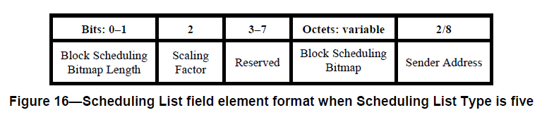

The Block Scheduling Bitmap Length field, along with the Scaling Factor field, specifies the size of the Block Scheduling Bitmap field. The Block Scheduling Bitmap Length field shall have one of the values specified in Table 10.

The Scaling Factor field specifies a size multiplier, which along with Block 1 Scheduling Bitmap Length field specifies the size of the Block Scheduling Bitmap field. The Scaling Factor field values and their meaning are specified in Table 11.

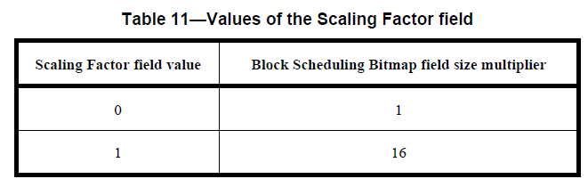

The size of the Block Scheduling Bitmap field is determined by taking the length from Table 10 indicated by the Block Scheduling Bitmap Length field value and multiplying it by the Table 11 multiplier indicated by the Scaling Factor field value. For example, a Block Scheduling Bitmap Length field value of zero and a Scaling Factor field value of one specify respectively a bitmap size of eight bits and a multiplier of sixteen, resulting in the Block Scheduling Bitmap field size being 8 × 16 = 128 bits.

**- Proposed change**

***Change the sub-clause as follows (Track changes ON)***

|  |  |  |  |  |
| --- | --- | --- | --- | --- |
| **Bits: 0 – 2** |  | **3 – 7** | **Octets: variable** | **2/8** |
| Block Scheduling Bitmap Length |  | Reserved | Block Scheduling Bitmap | Sender Address |

The Block Scheduling Bitmap Length field shall have one of the values specified in Table 11.

**Table 11—Values of Block Scheduling Bitmap Length field in the Scheduling IE**

|  |  |
| --- | --- |
| **Block Scheduling Bitmap Length field value** | **Meaning** |
| 0 | Scheduling Bitmap is 8 bits long |
| 1 | Scheduling Bitmap is 16 bits long |
| 2 | Scheduling Bitmap is 32 bits long |
| 3 | Scheduling Bitmap is 64 bits long |
| 4 | Scheduling Bitmap is 96 bits long |
| 5 | Scheduling Bitmap is 128 bits long |
| 6 | Scheduling Bitmap is 196 bits long |
| 7 | Scheduling Bitmap is 256 bits long |

***Comment indices #1408, 1409 and 1410 in 15-24-0371-01-04ab-consolidated-comments-draft-1-0.xlsx***

|  |  |  |  |  |  |  |  |
| --- | --- | --- | --- | --- | --- | --- | --- |
| **Name** | **Index#** | **Pg** | **Sub-Clause** | **Ln** | **Comment** | **Proposed Change** | **Disposition** |
| Hong Won Lee | 1409 | 51 | 10.32.9.10 | 10 | There is no description of bitmap-based block scheduling for block-based mode, which can be used. Bitmap-based block scheduling should be described for both hyper block mode and block-based mode, respectively | Add "In block-based mode, the Block Scheduling Bitmap Length and the the Scaling Factor field should be set to 0 because only the first bit in the Block Scheduling Bitmap shall be used" | Reject |
| Hong Won Lee | 1408 | 51 | 10.32.9.10 | 12 | There is no description of bitmap-based block scheduling for block-based mode, which can be used. Bitmap-based block scheduling should be described for both hyper block mode and block-based mode, respectively | Change from "and including the block in which the Scheduling IE is transmitted." to "and including the block in which the Scheduling IE is transmitted in hyper block mode." | Reject |
| Hong Won Lee | 1410 | 51 | 10.32.9.10 | 17 | There is no description of bitmap-based block scheduling for block-based mode, which can be used. Bitmap-based block scheduling should be described for both hyper block mode and block-based mode, respectively | Add "In block-based mode, the first bit maps to the current block in which the Scheduling IE is transmitted. The first bit in the bitmap is set to 1 to indicate that the current block is scheduled or set to 0 to indicate that the current block is not scheduled. The rest of bits except for the first bit shall be ignored in block-based mode." after the last sentence of the third paragraph in P51L17 | Reject |

**Discussion**： The original intention was to describe how Bitmap-based block scheduling is used in block-based mode. However, RDM IE or Bitmap-based slot scheduling can also be used in block-based mode. Compared to these methods, there is no benefit to using Bitmap-based block scheduling in block-based mode. Additionally, Controlees should be allocated on a block basis in the block-based mode, and as a result, block scheduling rules can naturally be created among controlees.

If we use the Bitmap-based block scheduling in the block-based mode, controlees can use the information to make duty cycle for power consumption. This can be described below

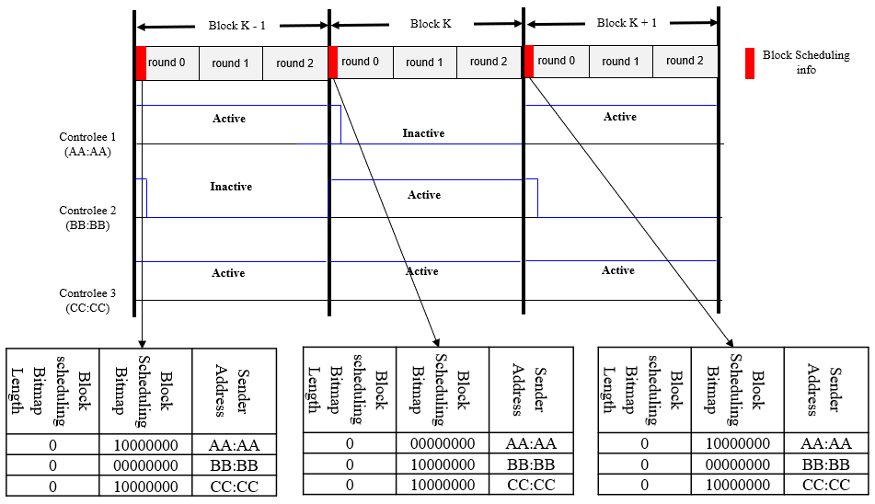

**Figure A – Duty cycles using the Bitmap-based block scheduling**

If we use the RDM IE in baseline or the Bitmap-based slot scheduling in the block-based mode, controlees also can use the information to make duty cycle for power consumption. This can be described below

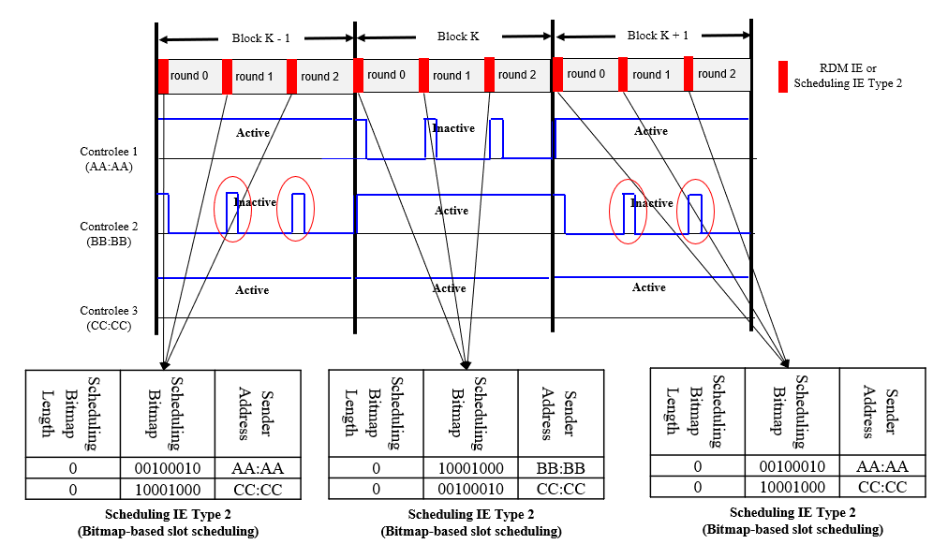

**Figure A – Duty cycles using the RDM IE or the Bitmap-based slot scheduling**

One benefit of using the Bitmap-based block scheduling is that controlees do not need to be awake during the RCM in the first slot of the following rounds (e.g. second and third round in the above figure) and this benefit is not significantly large

**Disposition: Rejected. Commenter has withdrawn the comment**

***Comment index #1107 in 15-24-0371-01-04ab-consolidated-comments-draft-1-0.xlsx***

|  |  |  |  |  |  |  |  |
| --- | --- | --- | --- | --- | --- | --- | --- |
| **Name** | **Index#** | **Pg** | **Sub-Clause** | **Ln** | **Comment** | **Proposed Change** | **Disposition** |
| Billy Verso | 1107 | 51 | 10.32.9.10 | 11 | Another "binary bitmap string". Elsewhere bitmaps are just bitmaps, a bit is binary by definition. | merge into the second sentence and say it "is a bitmap defining ….." | Revised |

**Discussion**：Agree with the commentor. Binary bitmap string representation can be simplified to just bitmap because a bit is binary by definition as commentor mentioned

**Disposition: Revised**

**Disposition Detail:**

**Proposed text changes on P802.15.4ab™/D01:**

**- Original Text**

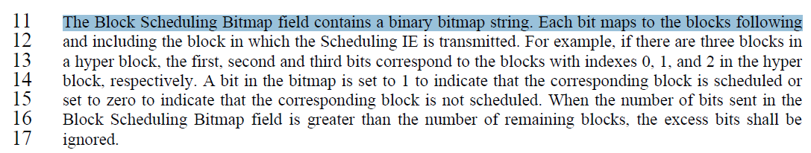

**- Proposed change**

***Revise the sub-clause 10.32.9.10 Scheduling IE in IEEE P802.15.4ab/D01 as follows:***

**10.32.9.10 Scheduling IE**

**(*pp. 51 line #11*)**

***Change the sub-clause as follows (Track changes ON)***

~~The Block Scheduling Bitmap field contains a binary bitmap string.~~

The Block Scheduling Bitmap field is a bitmap. Each bit maps to the blocks following and including the block in which the Scheduling IE is transmitted. For example, if there are three blocks in a hyper block, the first, second and third bits correspond to the blocks with indexes 0, 1, and 2 in the hyper block, respectively. A bit in the bitmap is set to 1 to indicate that the corresponding block is scheduled or set to zero to indicate that the corresponding block is not scheduled. When the number of bits sent in the Block Scheduling Bitmap field is greater than the number of remaining blocks, the excess bits shall be ignored.