**IEEE P802.15**

**Wireless Personal Area Networks**

|  |  |  |
| --- | --- | --- |
| Project | IEEE P802.15 Working Group for Wireless Personal Area Networks (WPANs) | |
| Title | **Proposed Resolution for Hyper-block comments** | |
| Date Submitted | September 2024 | |
| Sources | Rojan Chitrakar, Lei Huang (Huawei)  [rojan.chitrakar@huawei.com](mailto:rojan.chitrakar@huawei.com) |  |
| Re: |  | |
| Abstract |  | |
| Purpose | To propose resolution for “P802.15.4ab™/D01 Draft Standard for Low-Rate Wireless Networks” | |
| Notice | This document does not represent the agreed views of the IEEE 802.15 Working Group or IEEE 802.15.4ab Task Group. It represents only the views of the participants listed in the “Sources” field above.It is offered as a basis for discussion and is not binding on the contributing individuals. The material in this document is subject to change in form and content after further study. The contributors reserve the right to add, amend or withdraw material contained herein. | |

Rev 0: Initial version.

Rev 1: Deferred 1085, 1086

***Comment Indices in 15-24-0371-00-04ab-consolidated-comments-draft-1-0:***

|  |  |  |  |  |  |  |  |
| --- | --- | --- | --- | --- | --- | --- | --- |
| **Name** | **Index#** | **Pg** | **Sub-Clause** | **Ln** | **Comment** | **Proposed Change** | **Disposition** |
| Billy Verso | 1084 | 45 | 10.32.3.5 | 13 | "to inform the next ranging block that is assigned to a controlee," reads badly which makes it hard to understand, if I understand it correctly then it could be clarified by the proposed change.. | "to inform a controlee about its next ranging block assignment, and …." | Accept |
| B. Rolfe | 1329 | 45 | 10.32.3.5 | 21 | "the controlee may infer the number of rounds in the block based on the Number of Rounds field in 22 the ERR IE " is not stating an optional requirement but a possible inference (we don't have a normative description of how to infer). | Change to:" the controlee is able to determine the number of rounds in the block based on the Number of Rounds field in the ERR IE and will be able to calculate its allocated round in the block" | Accept |
| B. Rolfe | 1330 | 45 | 10.32.3.5 | 24 | " the controlee may listen to the channel at the next known hyper 25 block advertisement round" This is stating an option, but I think it should be strongly recommended ("should") behavior. | Change "may" to "should" | Accept |

**Discussion**：

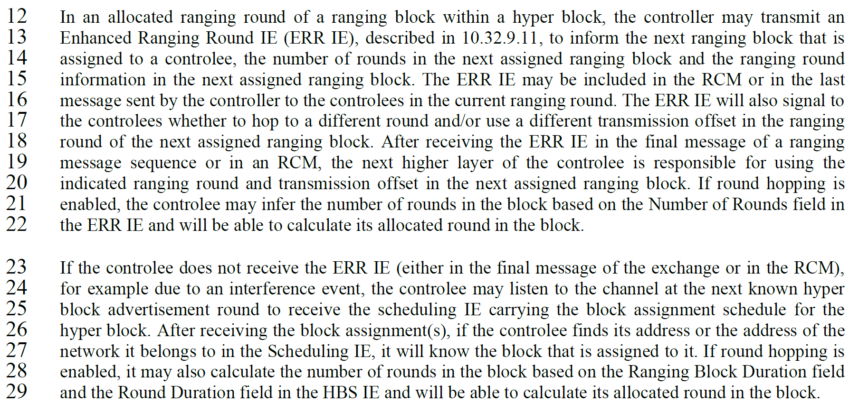

**Disposition: Revised**

**10.32.3.5 Hyper block mode**

***Change the sub-clause as follows (Track changes ON)***

…

In an allocated ranging round of a ranging block within a hyper block, the controller may transmit an Enhanced Ranging Round IE (ERR IE), described in 10.32.9.11, to inform a controlee about its next ranging block assignment , the number of rounds in the next assigned ranging block and the ranging round information in the next assigned ranging block. The ERR IE may be included in the RCM or in the last message sent by the controller to the controlees in the current ranging round. The ERR IE will also signal to the controlees whether to hop to a different round and/or use a different transmission offset in the ranging round of the next assigned ranging block. After receiving the ERR IE in the final message of a ranging message sequence or in an RCM, the next higher layer of the controlee is responsible for using the indicated ranging round and transmission offset in the next assigned ranging block. If round hopping is enabled, the controlee is able to determine the number of rounds in the block based on the Number of Rounds field in the ERR IE and will be able to calculate its allocated round in the block.

If the controlee does not receive the ERR IE (either in the final message of the exchange or in the RCM), for example due to an interference event, the controlee should listen to the channel at the next known hyper block advertisement round to receive the scheduling IE carrying the block assignment schedule for the hyper block. After receiving the block assignment(s), if the controlee finds its address or the address of the

network it belongs to in the Scheduling IE, it will know the block that is assigned to it. If round hopping is enabled, it may also calculate the number of rounds in the block based on the Ranging Block Duration field and the Round Duration field in the HBS IE and will be able to calculate its allocated round in the block.

|  |  |  |  |  |  |  |  |
| --- | --- | --- | --- | --- | --- | --- | --- |
| **Name** | **Index#** | **Pg** | **Sub-Clause** | **Ln** | **Comment** | **Proposed Change** | **Disposition** |
| Tero Kivinen | 323 | 29 | 9.2.13 | 18 | How does both of these modes (hyper block mode and non-hyper block mode) make sure that there can be only one transmission during the slot? | Add reference to the point where there is a restriction that any device can only send one frame per slot. This restriction is requirement for the security, thus it needs to be mandated by the specification. | Revise |

**Discussion:**

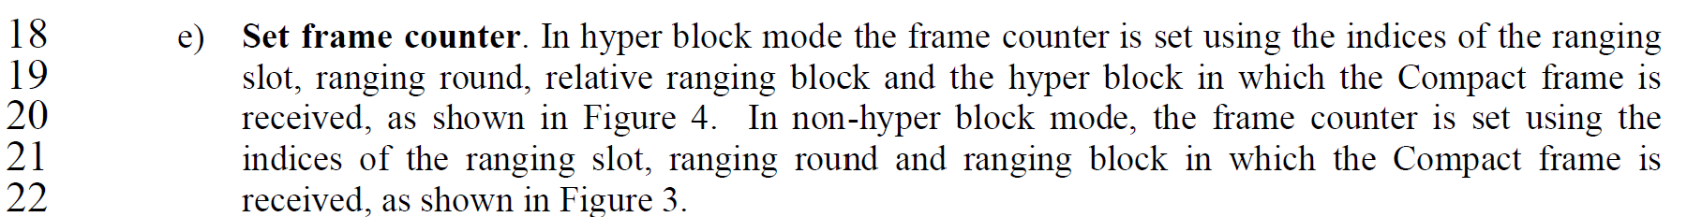

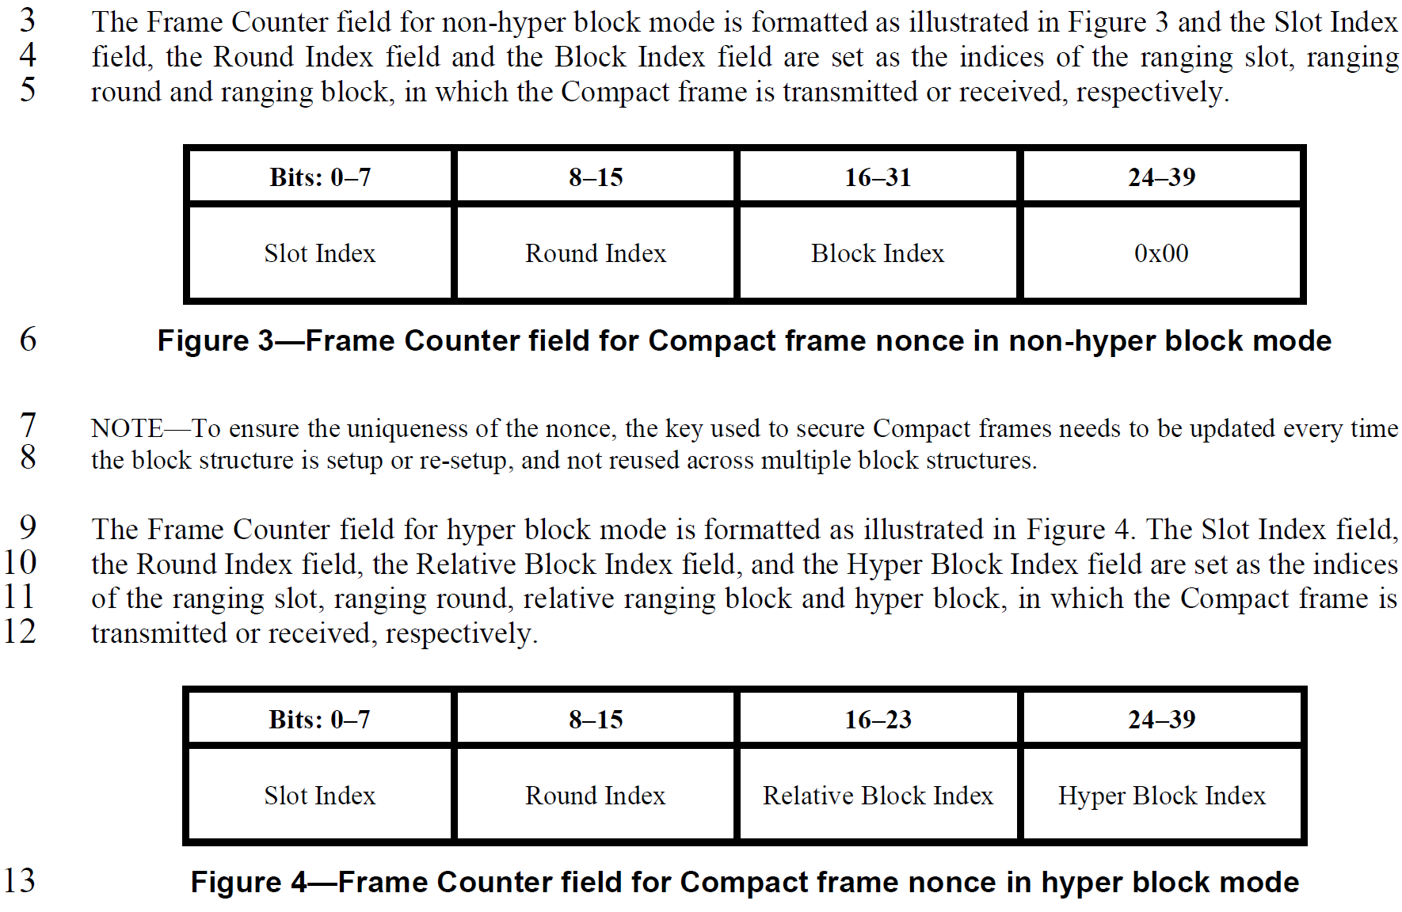

**Disposition: Revised**

**10.31.3 Ranging modes**

**10.31.3.1 Overview**

Three different ranging modes are defined: interval-based mode, block-based mode and hyper block mode.

The key difference between block-based mode and interval-based mode is that the mean time between successive ranging rounds in block-based mode is assumed to be constant (i.e., using a time structure with

uniform spacing), while interval-based mode adopts a time structure with adaptive spacing, and the time between successive ranging rounds may vary dynamically. The hyper block mode is described in 10.32.3.5. The next higher layer of the controller selects the mode and the corresponding time structure. A device shall operate in only one ranging mode at a time. This selection may be achieved by an out-of-band mechanism or in-band using the Time Structure Indicator in the ARC IE as described in 10.31.9.1.

**9.2.12 Outgoing frame security procedure for Compact frames**

…

e) Set frame counter. In hyper block mode the frame counter is set as the indices of the ranging slot,

ranging round, relative ranging block and the hyper block in which the Compact frame is to be

transmitted, as shown in Figure 4. In block-based mode, the frame counter is set as the

indices of the ranging slot, ranging round and ranging block in which the Compact frame is to be

transmitted, as shown in Figure 3.

**9.2.13 Incoming frame security procedure for the Compact frames**

…

e) Set frame counter. In hyper block mode the frame counter is set using the indices of the ranging

slot, ranging round, relative ranging block and the hyper block in which the Compact frame is

received, as shown in Figure 4. In block-based mode, the frame counter is set using the

indices of the ranging slot, ranging round and ranging block in which the Compact frame is

received, as shown in Figure 3.

**9.3.2.4 AEAD Nonce for Compact frames**

The nonce for Compact frames in the block-based mode or the hyper block mode (see 10.31.3) shall be formatted as shown in Figure 2, with the leftmost field in the figure defining the first octets and the rightmost field defining the last octet of the nonce.

…

The Frame Counter field for block-based mode is formatted as illustrated in Figure 3 and the Slot Index field, the Round Index field and the Block Index field are set as the indices of the ranging slot, ranging

round and ranging block, in which the Compact frame is transmitted or received, respectively.

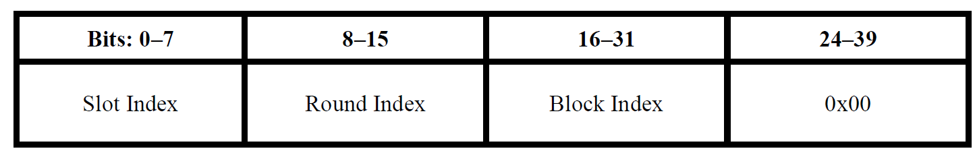

**Figure 3—Frame Counter field for Compact frame nonce in block-based mode**

|  |  |  |  |  |  |  |  |
| --- | --- | --- | --- | --- | --- | --- | --- |
| **Name** | **Index#** | **Pg** | **Sub-Clause** | **Ln** | **Comment** | **Proposed Change** | **Disposition** |
| Billy Verso | 1097 | 48 | 10.32.9.10 | 14 | Final Sentence in paragraph is not clear in meaning: "When block assignment scheduling is used and the Block Assignment List field carries address of networks, the Address Size field indicates short address."…. Specifically I don't know what "carries address of networks" means. | I am not sure what the sentence should say, but I am prepared to work with its author to come up with something that is more clear in meaning. | Revise |

**Discussion:**

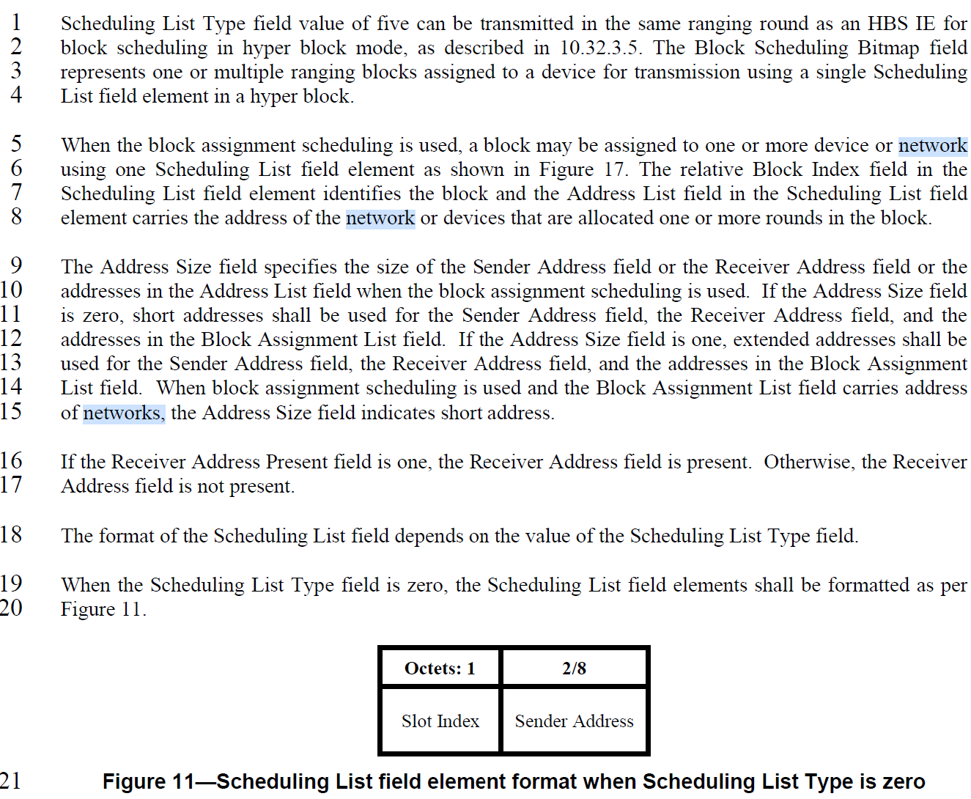

The original intention of using “network” was to refer to Ranging Area Network (RAN) of which the controlees and controller is a part of. However, it appears that the term RAN is removed in REVm_D6.0, so we propose to clarify that the term network refers to PAN (instead of RAN) and change “address of network” to “personal area network (PAN) identifier (ID) of the network”.

**Disposition: Revised**

**10.32.9.10 Scheduling IE**

…

*Change the paragraphs starting at Page 48 Line 5 as follows (Track change ON):*

When the block assignment scheduling is used, a block may be assigned to one or more device or network

using one Scheduling List field element as shown in Figure 17. The Relative Block Index field in the

Scheduling List field element identifies the block and the Address field of a Block Assignmentfield in the Scheduling List field element carries the PAN ID of the network or the address of the device that is allocated one or more rounds in the block.

The Address Size field specifies the size of the Sender Address field or the Receiver Address field or the

addresses in the Address List field when the block assignment scheduling is used. If the Address Size field

is zero, short addresses shall be used for the Sender Address field, the Receiver Address field, and the

addresses in the Block Assignment List field. If the Address Size field is one, extended addresses shall be

used for the Sender Address field, the Receiver Address field, and the addresses in the Block Assignment

List field.

…

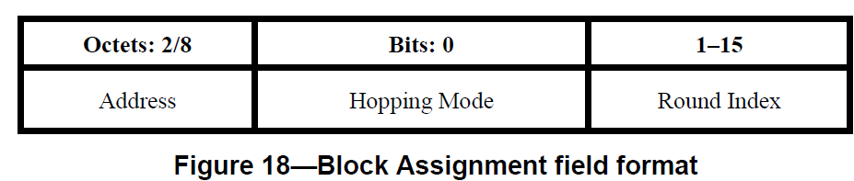

*Change the paragraphs starting at Page 52 Line 2 as follows (Track change ON):*

The Address field specifies the PAN ID of the network or the address of the device that is allocated one or more round in the block identified by the Relative Block Index field. The size of the Address field is specified by the Address Size field.

**10.32.3.5 Hyper block mode**

*Change the paragraphs starting at Page 45 Line 2 as follows (Track change ON):*

The Controller may also allocate a hyper block advertisement (HBA) round, at least once in each hyper

block, to advertise the assigned block for each participating device or network (e.g., PAN (Personal Area Network)). The hyper block advertisement round may be fixed as the first round of each ranging block in each hyper block, or it may be a negotiated round in a certain block of each hyper block. (e.g., negotiated during session setup). In each hyper block advertisement round, the Controller transmits a scheduling IE carrying the block assignment schedule, as defined in 10.32.9.10, for that hyper block. An example where

the controller allocates a hyper block advertisement (HBA) round in the first round of every ranging block

is illustrated in Figure 9.