**IEEE P802.15**

**Wireless Personal Area Networks**

|  |  |  |
| --- | --- | --- |
| Project | IEEE P802.15 Working Group for Wireless Personal Area Networks (WPANs) | |
| Title | **Draft 1.0 Comment Resolution CIDs 255, 257, 253, 1281, 1282, 1468, 1285, 1456, 178** | |
| Date Submitted | September 2024 | |
| Sources | Panpan Li, Bin Qian, Lei Huang, Rojan Chitrakar, David Xun Yang (Huawei) |  |
| Re: |  | |
| Abstract |  | |
| Purpose | To propose comments resolution for “P802.15.4ab™/D1.0 Draft Standard for Low-Rate Wireless Networks” | |
| Notice | This document does not represent the agreed views of the IEEE 802.15 Working Group or IEEE 802.15.4ab Task Group. It represents only the views of the participants listed in the “Sources” field above.It is offered as a basis for discussion and is not binding on the contributing individuals. The material in this document is subject to change in form and content after further study. The contributors reserve the right to add, amend or withdraw material contained herein. | |

**R0: 255, 257, 262, 253, 1281, 1282, 1468, 1285, 1456, 178**

***-------------------------------------------------------------------------------------------------------------------------------***

***Comment Index #255 in 15-24-0371-10-04ab-consolidated-comments-draft-1-0***

|  |  |  |  |  |  |  |
| --- | --- | --- | --- | --- | --- | --- |
| **Index #** | **Commenter** | **Sub-Clause** | **Page** | **Line** | **Comment** | **Proposed Change** |
| 255 | Li-Hsiang Sun | 10.39.6.1 | 142 | 11 | The Sensing Report Parameters Present shall be set to 1 if sensing mode is Sensing by proxy | as in comment |

**Resolution: Revised**

*Proposed text changes on P802.15.4ab™-D01:*

**10.39.6.1 Application Control IE (AC IE)**

*change Line 11-12 on Page 142 as follows*

The Sensing Report Parameters Present field when one indicates that the Sensing Report Parameters field is present, or when zero that it is not present. The Sensing Report Parameters Present field shall be set to one when the Sensing Mode field is configured to sensing by proxy.

***-------------------------------------------------------------------------------------------------------------------------------***

***Comment Index #257 in 15-24-0371-10-04ab-consolidated-comments-draft-1-0***

|  |  |  |  |  |  |  |
| --- | --- | --- | --- | --- | --- | --- |
| **Index #** | **Commenter** | **Sub-Clause** | **Page** | **Line** | **Comment** | **Proposed Change** |
| 257 | Li-Hsiang Sun | 10.39.6.1 | 144 | 2 | Report type shall not set to 1 or 2 when sensing ctrl is included in SBP request/response IE because the procedure in 10.39.5.3 only supports CIR reports | as in comment |

**Discussion:**

SBP support both CIR reports and Processed Target Feature reports.

**Resolution: Revised**

*Proposed text changes on P802.15.4ab™-D01:*

**10.39.5.3 SBP reporting**

*change Line 2-8 on Page 136 as follows*

In the SBP reporting procedure, the sensing initiator may sequentially transmit one or more CIR Report IEs and/or Processed Target Feature Report IEs carrying the sensing measurement reports of the corresponding sensing measurement exchange to the sensing requesting device. Alternatively, the sensing initiator may transmit an aggregated sensing measurement report to the sensing requesting device, which includes two or more CIR Report IEs and/or Processed Target Feature Report IEs, each CIR Report IE or Processed Target Feature Report IE carrying the sensing measurement reports of the corresponding sensing measurement exchange. The CIR Report IE and/or Processed Target Feature Report IE transmitted by the sensing initiator shall include the address of the sensing responder that generated the sensing measurement report carried in the CIR Report IE or Processed Target Feature Report IE.

**10.39.6.1 Application Control IE (AC IE)**

*change Line 4-5 on Page 144 as follows*

Table 32—Values of Report Type subfield of the Sensing Report Parameters field

|  |  |
| --- | --- |
| **Report Type Field Value** | **Meaning** |
| 0 | The CIR Report IE |
| 1 | The Processed Target Feature Report IE |
| 2 | Both the CIR Report IE and the Processed Feature Report IE |
| 3 | Reserved |

*change Line 9-10 on Page 144 as follows*

Table 33—Fields to be compressed

|  |  |
| --- | --- |
| **Report Type Field Value** | **Fields to be compressed when Compression field value is one** |
| 0 | The CIR Taps field of each receive report in the CIR Report IE (10.39.6.2). |
| 1 | The Full Target Report List field and the Sparse Target Report List field in the Processed Target Feature Report IE (10.39.6.6) |
| 2 | The CIR Taps field of each receive report in the CIR Report IE, and the Full Target List Report field and Sparse Target Report List field in the Processed Target Feature Report IE |

***-------------------------------------------------------------------------------------------------------------------------------***

***Comment Index #262 in 15-24-0371-10-04ab-consolidated-comments-draft-1-0***

|  |  |  |  |  |  |  |
| --- | --- | --- | --- | --- | --- | --- |
| **Index #** | **Commenter** | **Sub-Clause** | **Page** | **Line** | **Comment** | **Proposed Change** |
| 262 | Li-Hsiang Sun | 10.39.6.1 | 150 | 2 | Is intra-packet frequency stitching PPDU format specified in 16.2? | Clarify intra-packet frequency stitching PPDU format |

**Discussion:**

For intra-packet frequency stitching, different sensing segments in one sensing packet are transmitted at different channels, and the SHR is transmitted at same channel with the first sensing segment. For inter-packet frequency stitching, different packets are transmitted at different channels, while the segments of same packet are transmitted at the same channel.

**Resolution: Revised**

*Proposed text changes on P802.15.4ab™-D01:*

**10.39.6.1 Application Control IE (AC IE)**

*change Line 2-3 on Page 150 as follows*

Table 40—Values of Frequency Stitching Type field

|  |  |
| --- | --- |
| **Frequency Stitching Type field value** | **Meaning** |
| 0 | Intra-packet frequency stitching. |
| 1 | Inter-packet frequency stitching. |
| 2 | Combination of intra-packet frequency stitching and inter-packet frequency stitching. |
| 3 | Reserved |

Intra-packet frequency stitching means different sensing segments in one packet are transmitted at different channels, and the SHR is transmitted at the same channel with the first sensing segment. Inter-packet frequency stitching means different packets are transmitted at different channels, while the segments of same packet are transmitted at same channel.

***-------------------------------------------------------------------------------------------------------------------------------***

***Comment Index #253 in 15-24-0371-10-04ab-consolidated-comments-draft-1-0***

|  |  |  |  |  |  |  |
| --- | --- | --- | --- | --- | --- | --- |
| **Index #** | **Commenter** | **Sub-Clause** | **Page** | **Line** | **Comment** | **Proposed Change** |
| 253 | Li-Hsiang Sun | 10.39.6.4 | 157 | 18 | Some fields after SBP status code should be omitted if the status is REJECT or REJECTED__WITH_SUGGESTED_CHANGES | as in comment |

**Resolution: Revised**

*Proposed text changes on P802.15.4ab™-D01:*

**10.39.6.4 SBP Response IE**

*Insert the following after Line 24 on Page 157 as follows*

All fields after the SBP Status Code field are reserved if the SBP Status Code field value indicates REJECT.

*change Line 5-6 on Page 158 as follows*

The Sensing Session ID field contains a 4-octet session identifier of the sensing session corresponding to the SBP procedure. The Sensing Session ID field is reserved if the SBP Status Code field value indicates REJECTED_WITH_SUGGESTED_CHANGES.

***-------------------------------------------------------------------------------------------------------------------------------***

***Comment Index #1281 in 15-24-0371-10-04ab-consolidated-comments-draft-1-0***

|  |  |  |  |  |  |  |
| --- | --- | --- | --- | --- | --- | --- |
| **Index #** | **Commenter** | **Sub-Clause** | **Page** | **Line** | **Comment** | **Proposed Change** |
| 1281 | Billy Verso | 13.2.5 | 183 | 8 | When dynamic SFD selection is being used does the next higher layer need to know the SFD/Modulation used for the received packet? | Consider my question and add it if necessary as a pub status parameter or a parameter in the MCPS-DATA.indication. |

**Discussion:**

In document 24/0445r1, the proposed resolution for CID 22 gives the mapping between data rate and OQPSK PHY values.

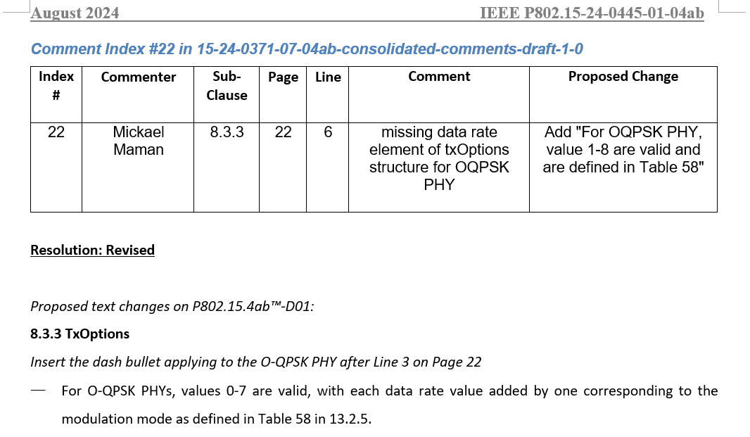

**Resolution: Revised**

*Proposed text changes on P802.15.4ab™-D01:*

**8.3.6 MCPS-DATA.indication**

*change Line 23 on Page 24 to Line 17 on Page 25 as follows*

MCPS-DATA.indication (

SrcAddrMode,

SrcPanId,

SrcAddr,

DstAddrMode,

DstPanId

DstAddr,

Msdu,

HeaderIeList,

PayloadIeList,

MpduLinkQuality,

Dsn,

FramePending,

Timestamp,

SecurityParams,

AckSent,

RangingReportDescriptor,

DataRate,

OqpskSfdPattern,

LdpcCode,

Rssi

)

*Change Table 8-32 as follows*

**Table 8-32—MCPS-DATA.indication parameters**

|  |  |  |  |
| --- | --- | --- | --- |
| **Attribute** | **Type** | **Range** | **Description** |
| … | … | … | … |
| OqpskSfdPattern | Enumeration | [1 1 1 0 0 1 0 1],  [1 0 0 0 1 0 1 0],  [0 1 0 0 1 0 0 1],  [0 0 1 0 1 0 1 1],  [1 0 1 0 0 0 0 1] | When DataRate equals to 0-6, *OqpskSfdPattern* shall be [1 1 1 0 0 1 0 1], when DataRateequals to 7, selection of modulation configuration is via the *OqpskSfdPattern* as per Table 57. |

***-------------------------------------------------------------------------------------------------------------------------------***

***Comment Index #1282, 1468, 1285 in 15-24-0371-10-04ab-consolidated-comments-draft-1-0***

|  |  |  |  |  |  |  |  |
| --- | --- | --- | --- | --- | --- | --- | --- |
| **Index #** | **Commenter** | **Sub-Clause** | **Page** | **Line** | **Comment** | **Proposed Change** | **Proposed resolution** |
| 1282 | Billy Verso | 16.2.10 | 191 | 4 | It is a little ambiguous whether the initial and final gaps are also 40 symbols in the case of frequency stitching since the wording says "between active se gments" | Change the sentence to say: "The gap duration shall be one preamble symbol time, except in the case of optional intra-packet frequency stitching being employed where the gap shall be 40 preamble symbol times" | Revised |
| 1468 | Jaegook Lee | 16.2.10 | 191 | 4 | According to the draft, the extended gap is employed BETWEEN active segments for the intra-packet stitching packet. This can be interpreted that the gap before the first segment or the gap after the last segment is one symbol gap, and only the gap between segments uses an extended gap. It should be clarified whether only one type of gap (one symbol or 40 symbols) is used for one packet or two types of gaps (one symbol & 40 symbols) are used for one packet as mentioned above. | as in the comment | Revised |
| 1285 | Billy Verso | 16.2.10 | 191 | 5.3 | Can we state that Frequency Stitching only applies to SENS packet configuration zero? Or is it envisioned to be relevant to the other SENS packet configurations? It would seem to be problematical for SENS packet configuration one. | State that when Frequency Stitching is enabled the packet format shall be SENS packet configuration zero | Revised |

**Discussion:**

In the case of optional intra-packet frequency stitching being employed, the gap between the SFD and the first sensing active segment and the gap after last sensing active segment shall be 1 preamble symbol time and the other gaps shall be 40 preamble symbols times each.

Frequency Stitching only applies to SENS packet configuration zero.

**Resolution: Revised**

*Proposed text changes on P802.15.4ab™-D01:*

**16.2.10 Sensing sequence (SENS) field**

*change Line 3-5 on Page 191 as follows*

The gap duration shall be one preamble symbol time, except in the case of optional intra-packet frequency stitching being employed where the gap between the SFD and the first active segment and the gap after last active segment shall be 1 preamble symbol time and the other gaps shall be extended to 40 preamble symbols times each. When Frequency Stitching is enabled, the packet format shall be SENS packet configuration zero.

***-------------------------------------------------------------------------------------------------------------------------------***

***Comment Index #1456 in 15-24-0371-10-04ab-consolidated-comments-draft-1-0***

|  |  |  |  |  |  |  |
| --- | --- | --- | --- | --- | --- | --- |
| **Index #** | **Commenter** | **Sub-Clause** | **Page** | **Line** | **Comment** | **Proposed Change** |
| 1456 | Huan-Bang Li | 13.2.3 | 182 | 20 | in that order' is not clear. | specify the order. |

**Resolution: Revised**

*Proposed text changes on P802.15.4ab™-D01:*

**13.2.3 Reference modulator diagram**

*change Line 18-20 on Page 191 as follows*

In the 5800 MHz and 6200 MHz bands an optional FEC, the half-rate K=7 convolutional code described in 16.3.3.3, is defined. When this is employed, the effected user data rate is halved as the n-th uncoded input bit becomes two coded bits and. Every four coded bits (,) from two input bits ( and) will be modulated into one symbol as per Figure 192.

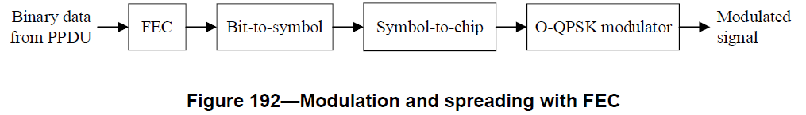

***-------------------------------------------------------------------------------------------------------------------------------***

***Comment Index #178 in 15-24-0371-10-04ab-consolidated-comments-draft-1-0***

|  |  |  |  |  |  |  |
| --- | --- | --- | --- | --- | --- | --- |
| **Index #** | **Commenter** | **Sub-Clause** | **Page** | **Line** | **Comment** | **Proposed Change** |
| 178 | Bin Qian | 16.4.4 | 209 | 18 | According to the definition of L, this duration of the pulse corresponds to UWB channel with 500 MHz. Regarding some UWB channels with larger bandwidth, the definition of L should be updated accordingly | Change the definition of L to be the duration of the pulse which is 3Tp. Tp is defined in Table 16-28 |

**Resolution: Revised**

*Proposed text changes on P802.15.4ab™-D01:*

**16.4.4 Baseband impulse response**

*change Line 16-19 on Page 209 as follows*

Mathematically this reference pulse is defined by:

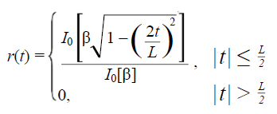

where $I_{0}$ is the zeroth-order modified Bessel function of the first kind, and *L* is the duration of the pulse which is 3. is defined in Table 16-28.