**IEEE P802.15**

**Wireless Personal Area Networks**

|  |  |  |
| --- | --- | --- |
| Project | IEEE P802.15 Working Group for Wireless Personal Area Networks (WPANs) | |
| Title | **Draft 1.0 Time Efficient O2M Ranging Related Comments Resolution** | |
| Date Submitted | August 2024 | |
| Sources | Panpan Li, Bin Qian, Lei Huang, Rojan Chitrakar, David Xun Yang (Huawei) |  |
| Re: |  | |
| Abstract |  | |
| Purpose | To propose comments resolution for “P802.15.4ab™/D1.0 Draft Standard for Low-Rate Wireless Networks” | |
| Notice | This document does not represent the agreed views of the IEEE 802.15 Working Group or IEEE 802.15.4ab Task Group. It represents only the views of the participants listed in the “Sources” field above.It is offered as a basis for discussion and is not binding on the contributing individuals. The material in this document is subject to change in form and content after further study. The contributors reserve the right to add, amend or withdraw material contained herein. | |

**R0: 22, 47, 152, 191, 465, 873, 1182, 1183, 1184, 1185, 1186, 1187, 1188, 1309**

***Comment Index #22 in 15-24-0371-07-04ab-consolidated-comments-draft-1-0***

|  |  |  |  |  |  |  |
| --- | --- | --- | --- | --- | --- | --- |
| **Index #** | **Commenter** | **Sub-Clause** | **Page** | **Line** | **Comment** | **Proposed Change** |
| 22 | Mickael Maman | 8.3.3 | 22 | 6 | missing data rate element of txOptions structure for OQPSK PHY | Add "For OQPSK PHY, value 1-8 are valid and are defined in Table 58" |

**Resolution: Revised**

*Proposed text changes on P802.15.4ab™-D01:*

**8.3.3 TxOptions**

*Insert the dash bullet applying to the O-QPSK PHY after Line 3 on Page 22*

* For O-QPSK PHYs, values 0-7 are valid, with each data rate value added by one corresponding to the modulation mode as defined in Table 58 in 13.2.5.

***-------------------------------------------------------------------------------------------------------------------------------***

***Comment Index #47, 192, 465 in 15-24-0371-07-04ab-consolidated-comments-draft-1-0***

|  |  |  |  |  |  |  |  |
| --- | --- | --- | --- | --- | --- | --- | --- |
| **Index #** | **Commenter** | **Sub-Clause** | **Page** | **Line** | **Comment** | **Proposed Change** | **Proposed Resolution** |
| 47 | Mickael Maman | 10.38.8.3 | 74 | 9 | recall that time efficient one to many ranging is optional | Support of time efficient one to many ranging is optional. | Revised |
| 465 | Tero Kivinen | 10.38.8.3 | 74 | 9 | Unknown or wrong acronyms. VR is not defined as acronym, and AR is acknowledgment request. | Expand VR/AR or remove them. | Revised |

*Proposed text changes on P802.15.4ab™-D01:*

**10.38.8.3 Time efficient one-to-many ranging**

*Change Line 9-12 on Page 74 as follows*

For some time-sensitive applications, e.g., virtual reality/augmented reality, it is useful to improve the time efficiency of the one-to-many ranging by allowing at most two responders to reply at different times within one ranging slot. The responders shall be capable of a fixed reply time of sufficient precision. The supported number of UWB MMS fragments (i.e., RSF and/or RIF) per ranging sub-round is limited to two fragments. Support of time efficient one-to-many ranging is optional.

***-------------------------------------------------------------------------------------------------------------------------------***

***Comment Index #191 in 15-24-0371-07-04ab-consolidated-comments-draft-1-0***

|  |  |  |  |  |  |  |
| --- | --- | --- | --- | --- | --- | --- |
| **Index #** | **Commenter** | **Sub-Clause** | **Page** | **Line** | **Comment** | **Proposed Change** |
| 191 | Wenzheng Li | 10.38.8.3 | 74 | 23 | For the time efficient one to many ranging, according to Figure 42 and description, only one One-to-many Poll Compact frame and one respective One-to-many Response Compact frame from each responders are exchanged in the control phase of each ranging sub-round. Two issues need to be clarified: 1. Is the One-to-many Poll Compact frame exchanged in the sub-round other than the first sub-round; 2. Can One-to-many Poll Compact frame and One-to-many Response Compact frame be exchanged multiple times as configured by Management MAC Configuration field in each sub-round. | It is better to follow the same mechanism as which in one to one ranging control phase for all sub-rounds in basic one to many ranging control phase. The number of One-to-many Poll Compact frames and the number of One-to-many Response Compact frames can be configured in the Management MAC Configuration field. |

**Discussion:**

For first question, it is mentioned in line 15 and line 23 on page 74 that the Figure 42 applies in each ranging sub-round.

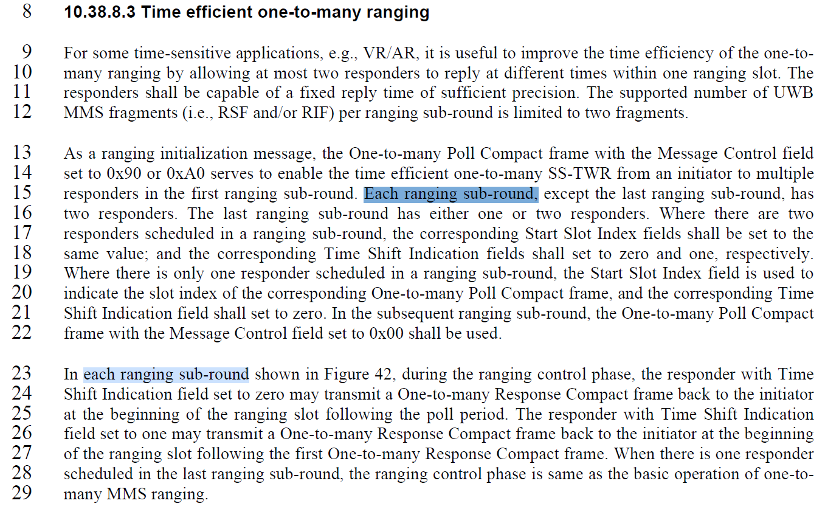

For second question, so far we didn’t see the necessity and benefits of such changes. Also, one-to-one ranging and the basic mode of one-to-many ranging do not support multiple poll and response exchange configurations.

**Resolution: RejectedReject reason:**

For first question, Page 74 have mentioned “each ranging sub-round” on Line 15 and Line 23.

For second question, so far we didn’t see the necessity and benefits of such changes. Also, one-to-one ranging and the basic mode of one-to-many ranging do not support multiple poll and response exchange configurations.

***-------------------------------------------------------------------------------------------------------------------------------***

***Comment Index #152, 873, 1182, 1183, 1184, 1185, 1186, 1187, 1188 in 15-24-0371-07-04ab-consolidated-comments-draft-1-0***

|  |  |  |  |  |  |  |  |
| --- | --- | --- | --- | --- | --- | --- | --- |
| **Index #** | **Commenter** | **Sub-Clause** | **Page** | **Line** | **Comment** | **Proposed Change** | **Proposed Resolution** |
| 1182 | Billy Verso | 10.38.8.3 | 74 | 30 | Lines 30 through to 14 on next page, are reiterating the PHY packet format in words, this should be clear from clause 16 and should not be repeated here, really it is just saying that the initiator sends at offset 0, and first and second responders send interleaved at offsets 400 and 800 RSTU. | Simplify the wording: Replace lines 30 through to 14 on next page with: "The UWB MMS packet format shall be as specified in clause 16.2.11 with fragments from responder one and responder two offset from the initiator's fragments by 400 and 800 RSTU respectively." | Revised |
| 1183 | Billy Verso | 10.38.8.3 | 74 | 30.1 | "There are three separate sentences here trying to define the activity of the initiator for three different cases of RSF/RIF packet formats. Might be clearer to start with the ""if packet format is XXX, the initiator…"" also may is too weak. A ""shall"" would be better, and a complete rewrite would be even better.  [THIS COMMENT IS SUPERCEDED BY MY COMMENT ON P74 L30, if that change is done this change is unnecessary]" | [THIS COMMENT IS SUPERCEDED BY MY COMMENT ON P74 L30, if that change is done this change is unnecessary]. Replace the paragraph with: "If phyUwbMmsRsfNumberFrags is zero, the initiator shall, send its first RIF fragment at the start of the ranging phase and each subsequent RIF at regular intervals of 1200 RSTUs. Otherwise, the initiator shall, send its first RSF fragment at the start of the ranging phase and each subsequent RSF at regular intervals of 1200 RSTUs; and thereafter, if phyUwbMmsRifNumberFrags is non-zero, the initiator shall send its first RIF fragment 2400 RSTUs after the start of the last RSF fragment, and subsequent RIF fragments at intervals of 1200 RSTUs." | Revised |
| 1184 | Billy Verso | 10.38.8.3 | 74 | 33 | "and continue to send the second RIF fragment at a regular interval" | [THIS COMMENT IS SUPERCEDED BY MY COMMENT ON P74 L30, if that change is done this change is unnecessary]. change to "and continue to send the subsequent RIF fragments at a regular intervals" | Revised |
| 1185 | Billy Verso | 10.38.8.3 | 74 | 33 | "and continue to send the second RIF fragment at a regular interval of 1200 RSTU" doesn't make sense. | [THIS COMMENT IS SUPERCEDED BY MY COMMENT ON P74 L30, if that change is done this change is unnecessary]. Change to "and continue to send subsequent RIF fragments at a regular intervals of 1200 RSTU", unless the change proposed from my comment on line 30 is accepted in which case no additional change is needed. | Revised |
| 1186 | Billy Verso | 10.38.8.3 | 74 | 35 | This case of mixed RSF/RIF packets is poorly constructed and does not mention subsequent RIF. It should be rewritten but, | [THIS COMMENT IS SUPERCEDED BY MY COMMENT ON P74 L30, if that change is done this change is unnecessary]. Rewrite the sentence to properly describe this case. | Revised |
| 1187 | Billy Verso | 10.38.8.3 | 75 | 1 | This paragraph is a copy of that on p74 lines 30-36, and my same comments apply, would recommend similar rewrite as per my comment on p74 L#30, but maybe a simpler approach could be taken. [THIS COMMENT IS SUPERCEDED BY MY COMMENT ON P74 L30, However the idea to use a table for the offsets as per the proposed change here is worth incorporating . | Replace paragraph and subsequent one with: "The responders transmit their fragments in the same manner as the initiator except they are offset from the start of the ranging phase by the time specified in Table X, based on the Time Shift Indication field value from the One-to-many Poll Compact frame with (Message Control = 0x90)."; and, add Table X in clause 10.38.9.12 with the offsets for the Time Shift Indication field values, instead of the paragraph style text that defines the offsets. | Revised |
| 1188 | Billy Verso | 10.38.8.3 | 75 | 8 | This paragraph is a copy of that on p74 lines 30-36, and my same comments apply, would recommend similar rewrite as per my comment on p74 L#30, but my proposed change for p75 L#1 is a good fix for those issues. | Apply the change I proposed for p75 line 1 | Revised |
| 152 | Bin Qian | 10.38.8.3 | 74 | 31 | Since the supported number of UWB MMS fragment per ranging sub-round is limited to two, the subsequent RSF fragments only include one fragment | Change "subsequent RSF fragments" to "the second RSF fragment" | Revised |
| 873 | Carl Murray | 10.38.8.3 | 75 | 8 | The text "The responder with Time Shift Indication field set to zero may start transmitting the first RSF fragment ..." is a repeat of line 1 suggesting that one of them is wrong | Change "zero" to "one" | Revised |

**Discussion:**

The Time Shift Indication field is already defined in Figure 99 on page 108 and it is mentioned in line 6-9 on page 108 that the Time Shift Indication field when zero/one indicates the corresponding responder transmits its initial UWB fragment by 400/800 RSTUs from the start of the ranging phase, respectively. Thus, it is not necessary to add Table X in clause 10.38.9.12 with the offsets for the Time Shift Indication field values

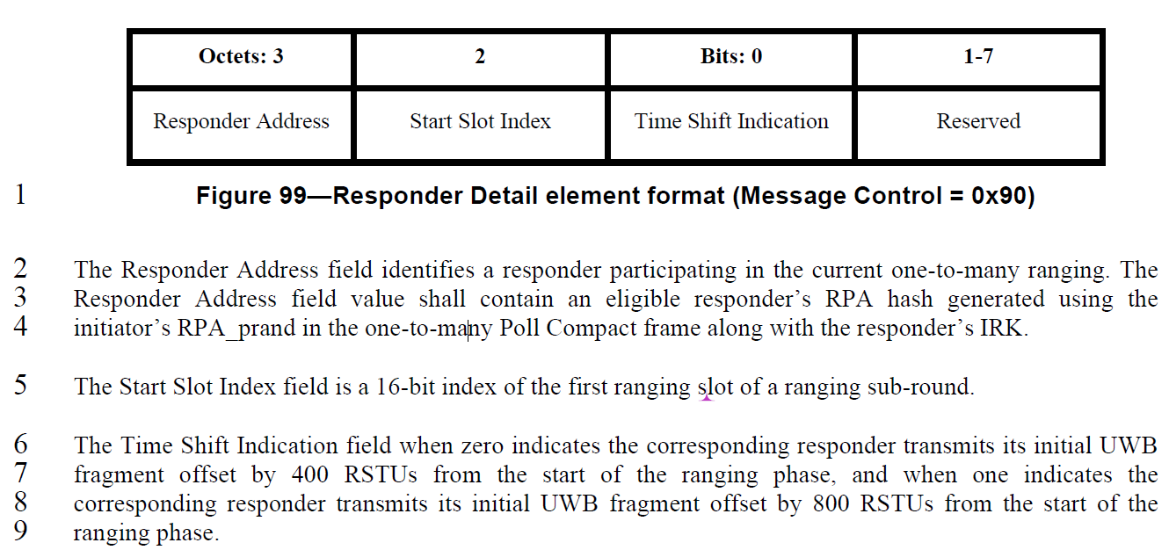

*Proposed text changes on P802.15.4ab™-D01:*

**10.38.8.3 Time efficient one-to-many ranging**

*Change Line 30 on Page 74 to Line 14 on Page 75 as follows*

The UWB MMS packet format shall be as specified in clause 16.2.11 with fragments from responder one and responder two offset from the initiator's fragments by 400 and 800 RSTU respectively.

***-------------------------------------------------------------------------------------------------------------------------------***

***Comment Index #1309 in 15-24-0371-07-04ab-consolidated-comments-draft-1-0***

|  |  |  |  |  |  |  |
| --- | --- | --- | --- | --- | --- | --- |
| **Index #** | **Commenter** | **Sub-Clause** | **Page** | **Line** | **Comment** | **Proposed Change** |
| 1309 | Pablo Corbalán Pelegrín | 10.38.8.3 | 75 | 2 | Is 400 RSTU the only allowed time offset value to schedule the RSF fragments from the two responder? Can this be also configurable? If the slot timing is > 1200 RSTUs, e.g., 2400 RSTU, then we may set this to 800 RSTU, is that correct? | Clarify whether 400 us is an example and whether this value can be configured. |

**Discussion:**

In the one-to-one ranging, the offset between first RSF/RIF transmission from the responder and first RSF/RIF transmission from the initiator is 600 RSTU.

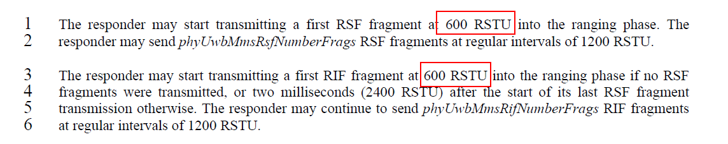

This offset is not configurable. Thus, it may not be necessary to configure the time offset in the time efficient one-to-many ranging.

**Resolution: Rejected**

**Reject reason:**

In the one-to-one ranging, the offset between first RSF/RIF transmission from the responder and first RSF/RIF transmission from the initiator is not configurable. Thus, it may not be necessary to configure the time offset in the time efficient one-to-many ranging.