IEEE 802.15
Wireless Specialty Networks (WSN)

Project | IEEE P802.15 Working Group for Wireless Specialty Networks (WSN)
Title | 802.15 TG4me CRG Minutes Aug 16, 2024
Date Submitted | [August 16, 2024]
Source | [Gary Stuebing]  [Cisco Systems] | email: [gstuebin@cisco.com]
Re: | [Scheduled June 28 CRG Meeting]
Abstract | [IEEE 802.15 TG4me CRG Minutes]
Purpose | [IEEE 802.15 TG4me CRG Minutes]
Notice | This document has been prepared to assist the IEEE 802.15. It is offered as a basis for discussion and is not binding on the contributing individual(s) or organization(s). The material in this document is subject to change in form and content after further study. The contributor(s) reserve(s) the right to add, amend or withdraw material contained herein.
Release | The contributor acknowledges and accepts that this contribution becomes the property of IEEE and may be made publicly available by 802.15.

Friday – August 16 – Conference Call
- Meeting called to order at 10:30am ET by TG chair, Gary Stuebing
Attendance:
- Gary Stuebing - CHAIR
- Tero Kivinen - Editor
- Billy Verso
- Ben Rolfe
- Clint Powell
- Phil Beecher
- Alex Krebs
- Ann Krieger
Quorum was reached.
Call for Patents – None Declared
Gary reviewed the results of the Ballot:
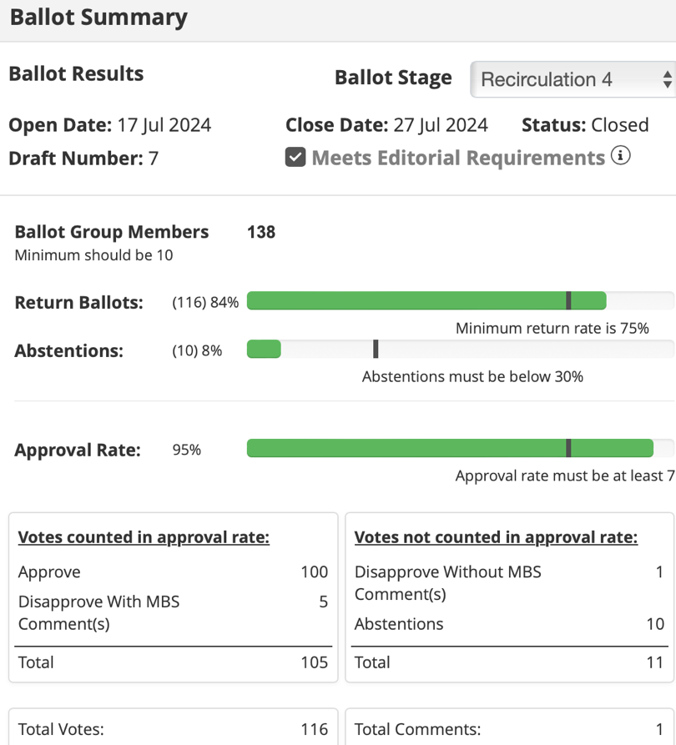
There was one comment with disapprove vote.
Comment Number R4-1 Name: Enzo Wentink Affiliation: Qualcomm Type: Technical
Page 60 Subclause:6.3.2,1
Comment: CSMA-CA should be mandatory for high PSD transmissions (for example narrowband transmissions) in UNII-3 and UNII-5, to avoid interference with other technologies in these bands. From the initial sponsor ballot: Comment: CSMA-CA should be mandatory for high PSD transmissions (for example narrowband transmissions) in UNII-3 and UNII-5, to avoid interference with other technologies in these bands. Proposed Change: Require that CSMA-CA (as described in 6.3.2.1) is used before every high PSD transmission in UNII-3 and UNII-5, with settings macMinBe = 0, macMaxCsmaBackoffs = 0, and CCA mode 1 with phyCCADuration value 16 us and probability of detection 100%. Disposition Status: REJECTED Disposition Detail: There are no channel plans defined for UNII-3 and UNII-5 in this standard. Additionally requirements for the CSMA-CA varies by the PHY, band, regulatory domain, application of the standard, and other factors outside the scope of the standard. Response to disposition: This disposition does not address the comment. The introduction of a high PSD PHY in bands where Wi-Fi is also active call for the introduction of a mandatory coexistence mechanism in those bands, for example LBT. An argument that's been voiced from 802.15 is that a coexistence mechanism can be selected that suits the needs and requirements of the specific use case, but this is not adequate, because it reasons from the side of the agressor and not the victim. Things don't work that way in coexistence, and a standard needs to set requirements on what should be done to ensure coexistence, which are typically measures that will not be voluntarily implemented by devices.
Proposed Change: Require that CSMA-CA (as described in 6.3.2.1) is used before every high PSD transmission in UNII-3 and UNII-5, with settings macMinBe = 0, macMaxCsmaBackoffs = 0, and CCA mode 1 with phyCCADuration value 16 us and probability of detection 100%.
Disposition Status: Reject
Disposition Detail: Out of scope of the standard. There are no channel definitions in U-NII-3 or U-NII-5 for any narrowband PHYs in the standard being balloted.
Phil Beecher moved to accept the Comment Resolutions as proposed in DCN 15-24-0341-09-04me. Ben Rolfe seconded. The motion was accepted unanimously.
Tero will update DCN 25-15-0341-08-04me and upload new version with updates.
Gary will update DCN 25-15-0359-06-04me (Revcom Package) and upload new version with updates
Gary will update DCN 25-15-0374-0374-02-04me (Must be satisfied comments) and upload new version with updates.
Phil Beecher moved to submit P802-15-04-D07 to the REVCOM Agenda. Ann Krieger seconded. The motion passed unanimously.
Gary will request the Working Group Chair to submit to REVCOM.
The next meetings will be in Hawaii at the IEEE Interim Plenary.
Gary will update the My Project comment data base by end of day.
The meeting ended at 11:00am EDT

