**IEEE P802.15**

**Wireless Personal Area Networks**

|  |  |  |
| --- | --- | --- |
| Project | IEEE P802.15 Working Group for Wireless Personal Area Networks (WPANs) | |
| Title | **Draft 1.0 NB PHY Related Comments Resolution** | |
| Date Submitted | August 2024 | |
| Sources | Panpan Li, Bin Qian, Lei Huang, Rojan Chitrakar, David Xun Yang (Huawei) |  |
| Re: |  | |
| Abstract |  | |
| Purpose | To propose comments resolution for “P802.15.4ab™/D1.0 Draft Standard for Low-Rate Wireless Networks” | |
| Notice | This document does not represent the agreed views of the IEEE 802.15 Working Group or IEEE 802.15.4ab Task Group. It represents only the views of the participants listed in the “Sources” field above.It is offered as a basis for discussion and is not binding on the contributing individuals. The material in this document is subject to change in form and content after further study. The contributors reserve the right to add, amend or withdraw material contained herein. | |

***Comment Index #1457 in 15-24-0371-02-04ab-consolidated-comments-draft-1-0***

|  |  |  |  |  |  |  |  |
| --- | --- | --- | --- | --- | --- | --- | --- |
| **Index #** | **Commenter** | **Sub-Clause** | **Page** | **Line** | **Comment** | **Proposed Change** | **Resolution** |
| 1457 | Huan-Bang Li | 13.3.14 | 185 | 22 | tolerance' should be more precise. | replace by 'center frequency tolerance' | Accepted |

**Discussion:**

‘Center frequency tolerance’ is well used in existing standards IEEE P802.15.4me/D05.

**Resolution: Accepted**

***-------------------------------------------------------------------------------------------------------------------------------***

***Comment Index #91 in 15-24-0371-02-04ab-consolidated-comments-draft-1-0***

|  |  |  |  |  |  |  |  |
| --- | --- | --- | --- | --- | --- | --- | --- |
| **Index #** | **Commenter** | **Sub-Clause** | **Page** | **Line** | **Comment** | **Proposed Change** | **resolution** |
| 91 | Mickael Maman | 12.3 | 181 | 2 | The PHY O-QPSK configuration is currently not detailed using primitives | We propose to add a table for "O-QPSK related PIB attributes" with the following attributes: - phyOqpskSyncLen - phyOqpskSfdSelector - phyOqpskFecPhr - phyOqpskFecPayload - phyOqpskSpreadingFactor Possible values based on table 57, 58, 59, 60 of the 802.15.4ab amendment and table 13-1, 13-2 22-14, 22-15 of the 802.15.4me standard | Revised |
| 1279 | Billy Verso | 13.2.5 | 183 | 5 | There is no mechanism for next higher layer to select the Modulation modes for the 5800 MHz and 6200 MHz bands. | Add at the end of this sentence: "The modulation mode is selected using the phyOqpskModulationConfiguration attribute." Add new phyOqpskModulationConfiguration PIB attribute integer, with description: "Selects the O-QPSK PHY modulation modes for the 5800 MHz and 6200 MHz bands, as listed in Table 58", and value range: "As defined by Config # in Table 58". | Accepted |
| 92 | Mickael Maman | 13.1.2.3 | 182 | 13 | Missing SFD patterns for config #6, #7 and #8 | as in comment | Rejected |
| 1280 | Billy Verso | 13.2.5 | 183 | 8 | For in Table 58 for config #8, how does the transmitter know what actual mode to use, maybe should separate config #8 into 5 separate configs #8 to #12, each one defining what the TX should do, (i.e. one of the 5 options in Table 57), but where for all 5 of these the receiver uses the SFD to decide how to demodulate the PHR and data, as per Table 57. | Separate out the config#8 into the 5 options as suggested. | Revised |

**Discussion:**

In Table 58, the configuration set includes the Sync Length, SFD Length, FEC in PHR and FEC in Payload. Thus, it is sufficient to add phyOqpskModulationConfig attribute.

The SFD pattern for Config #1-7 in Table 58 is the first pattern in Table 57: ‘As per Figure 13-3’. The SFD patterns for Config #8 in Table 58 are all the patterns given in Table 57.

The Config #8 is used to indicate the dynamic signalling of data modulation by SFD patterns. In 10.38.9.3.17, the management PHY Config field is used by initiator and responder to exchange the NB configuration. If we separate Config #8 into 5 options, the dynamic signalling will be static signalling and we don’t need this Management PHY Configuration field anymore. Furthermore, if dynamic signalling of data modulation is enabled, another attribute phyOqpskSfdPattern could be used to instruct the transmitter.

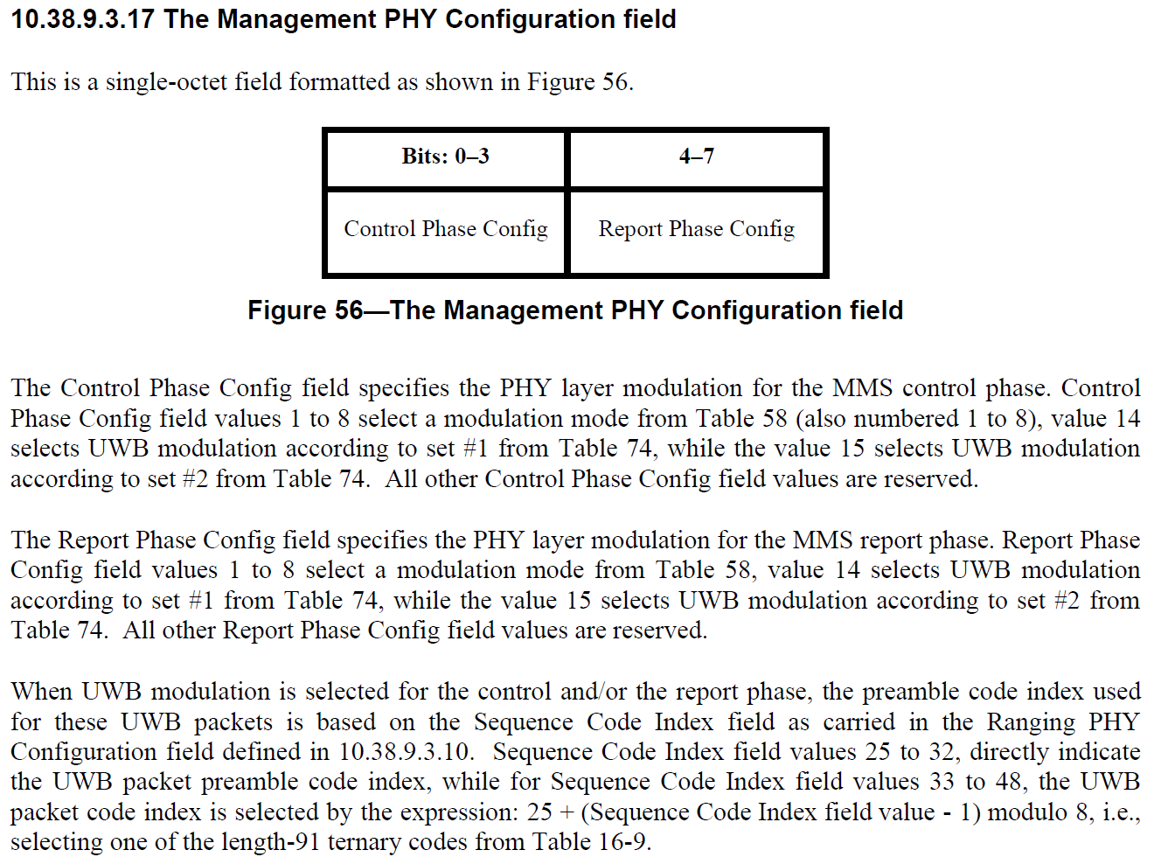

**Resolution: Revised**

**12.3.12 Other PHY related PIB attributes**

*Insert the following new attributes into Table 12-14.*

**Table 12-14—Other PHY related PIB attributes**

|  |  |  |  |
| --- | --- | --- | --- |
| **Attribute** | **Type** | **Range** | **Description** |
| … | … | … | … |
| *phyOqpskModulationConfig* | Integer | As defined by Config # in Table 58 | This attribute Selects the O-QPSK PHY modulation modes for the 5800 MHz and 6200 MHz bands, as listed in Table 58. |
| *phyOqpskSfdPattern* | Enumeration | [1 1 1 0 0 1 0 1],  [1 0 0 0 1 0 1 0],  [0 1 0 0 1 0 0 1],  [0 0 1 0 1 0 1 1],  [1 0 1 0 0 0 0 1] | When *phyOqpskModulationConfig* equals to 1-7, *phyOqpskSfdPattern* shall be [1 1 1 0 0 1 0 1], when *phyOqpskModulationConfig* equals to 8, selection of modulation configuration is via the *phyOqpskSfdPattern* as per Table 57. |

**13.2.5 Symbol-to-chip mapping**

*Change Line 4 on page 183 as follows*

Additional optional symbol-to-chip mapping and modulation options are specified in Table 58. The modulation mode is selected using the *phyOqpskModulationConfig* attribute defined in 12.3.12.

***-------------------------------------------------------------------------------------------------------------------------------***

***Comment Index #1274 in 15-24-0371-02-04ab-consolidated-comments-draft-1-0***

|  |  |  |  |  |  |  |
| --- | --- | --- | --- | --- | --- | --- |
| **Index #** | **Commenter** | **Sub-Clause** | **Page** | **Line** | **Comment** | **Proposed Change** |
| 1274 | Billy Verso | 13.1.2.3 | 182 | 7 | ", with out of band selection being the default behaviour" is slightly strange phrasing, and "default" has connotations in standards context that we should probably avoid.. | Change to: "with the selection of these being agreed via out-of-band means" |

**Resolution: Accepted**

***-------------------------------------------------------------------------------------------------------------------------------***

***Comment Index #1275 in 15-24-0371-02-04ab-consolidated-comments-draft-1-0***

|  |  |  |  |  |  |  |
| --- | --- | --- | --- | --- | --- | --- |
| **Index #** | **Commenter** | **Sub-Clause** | **Page** | **Line** | **Comment** | **Proposed Change** |
| 1275 | Billy Verso | 13.1.2.3 | 182 | 10 | I think "default" not the right term to refer to the 250kb/s modulation. PHY parameters don't really have defaults. | Change "default" to "mandatory" |

**Resolution: Accepted**

***-------------------------------------------------------------------------------------------------------------------------------***

***Comment Index #1276 in 15-24-0371-02-04ab-consolidated-comments-draft-1-0***

|  |  |  |  |  |  |  |
| --- | --- | --- | --- | --- | --- | --- |
| **Index #** | **Commenter** | **Sub-Clause** | **Page** | **Line** | **Comment** | **Proposed Change** |
| 1276 | Billy Verso | 13.1.2.3 | 182 | 12 | For clarity there should be a statement that says what the SFD is when the dynamic SFD signalling is not being used. | Add sentence at end of paragraph: "When the dynamic modulation signalling is not being employed, the SFD defined by Figure 13-3 shall be used for each of Config #1 to #7 in Table 58 [Modulation modes for the 5800 MHz and 6200 MHz bands])." |

**Resolution: Accepted**

***-------------------------------------------------------------------------------------------------------------------------------***

***Comment Index #1277 in 15-24-0371-02-04ab-consolidated-comments-draft-1-0***

|  |  |  |  |  |  |  |
| --- | --- | --- | --- | --- | --- | --- |
| **Index #** | **Commenter** | **Sub-Clause** | **Page** | **Line** | **Comment** | **Proposed Change** |
| 1277 | Billy Verso | 13.1.2.3 | 182 | 14 | In Table 57 only config #1 is mandatory, so for mode #8 where this table applies, is the assumption that that support for all configs #2 to #5 is mandatory, or how are both sides expected to know what is appropriate to use? | Say this is done/agreed OOB, or mandate support for all, or add a mechanism for both sides to signal what they support so the other end only uses supported modes. |

**Resolution: Revised**

**Proposed text changes on P802.15.4ab™-D01:**

*Insert the following at the end of Line 12 on Page 124*

**10.38.9.3.26 Supported O-QPSK Modulation Modes (SOMM)**

This field is a single-octet field formatted as shown in Figure xx, where each bit when set to one indicates the support of the one O-QPSK Modulation Mode shown in Table 58.

|  |  |  |  |  |  |  |  |
| --- | --- | --- | --- | --- | --- | --- | --- |
| **Bit: 0** | **1** | **2** | **3** | **4** | **5** | **6** | **7** |
| Config #2 Support | Config #3 Support | Config #4 Support | Config #5 Support | Config #6 Support | Config #7 Support | Config #8 Support | Reserved |

Figure xx—The Supported O-QPSK Modulation Modes field

**10.38.9.4 Advertising Poll Compact frame**

*Change Line 20 on page 92 as follows*

|  |  |  |  |
| --- | --- | --- | --- |
| **Octets: 1** | **1** | **Variable** | **1** |
| Cap Duration | Initialization Slot Duration | SMC TLVs | SOMM |

**10.38.9.5 Advertising Response Compact frame**

*Change Line 1 on page 94 as follows*

|  |  |  |  |  |  |  |  |  |
| --- | --- | --- | --- | --- | --- | --- | --- | --- |
| **Octets: 1** | **0/2/5/6** | **0/1** | **0/7** | **0/4** | **0/1** | **0/variable** | **0/1** | **0/1** |
| Presence Bitmap | NB Channel Map | Management PHY Configuration | Management MAC Configuration | Ranging PHY Configuration | Ranging MAC Configuration | SMC TLVs | MMS Ranging Mode Configuration | SOMM |

*Insert the following at the end of Line 16 on Page 94*

The SOMM field indicates the supported O-QPSK modulation mode and if present shall be set as per 10.39.9.26.

**10.38.9.3.24 1 The Presence Bitmap field**

*Change Line 30 on page 90 as follows*

|  |  |  |  |  |  |
| --- | --- | --- | --- | --- | --- |
| **Bits: 0** | **1** | **2** | **3** | **4** | **5-7** |
| SMC TLVs Present | Start and End Slot Indices Present | Starting Block Index Present | MMS Ranging Mode Configuration Present | SOMM Present | Reserved |

*Insert the following at the end of Line 10 on Page 91*

The SOMM Present field when set to one indicates that the SOMM field is present in the Message Content field. A value of zero indicates absence of the SOMM field in the Message Content field.

***-------------------------------------------------------------------------------------------------------------------------------***

***Comment Index #1455 in 15-24-0371-02-04ab-consolidated-comments-draft-1-0***

|  |  |  |  |  |  |  |
| --- | --- | --- | --- | --- | --- | --- |
| **Index #** | **Commenter** | **Sub-Clause** | **Page** | **Line** | **Comment** | **Proposed Change** |
| 1455 | Huan-Bang Li | 13.1.2.3 | 182 | 10 | replace 'modulation rate' by 'modulation data rate' | make change. |

**Discussion:**

‘modulation rate’ is well used in existing standards IEEE P802.15.4me/D05, while ‘modulation data rate’ is not seen.

**Resolution: Rejected**