IEEE P802.15
Wireless Personal Area Networks

Project | IEEE P802.15 Working Group for Wireless Personal Area Networks (WPANs)
Title
Date Submitted | 5th August 2024
Source | Carl Murray (Qorvo), | carl.murray at qorvo.com
Re: | CIDs 1113, 1114, 1115, 1116, 1334, 1770
Abstract
Purpose | To propose resolution for “P802.15.4ab™/D01 Draft Standard for Low-Rate Wireless Networks”.
Notice | This document does not represent the agreed views of the IEEE 802.15 Working Group or IEEE 802.15.8 Task Group. It represents only the views of the participants listed in the “Source(s)” field above. It is offered as a basis for discussion and is not binding on the contributing individual(s) or organization(s). The material in this document is subject to change in form and content after further study. The contributor(s) reserve(s) the right to add, amend or withdraw material contained herein.
Release | The contributor acknowledges and accepts that this contribution becomes the property of IEEE and may be made publicly available by P802.15.

CID 1113:
This document provides changes to
Name | Index# | Pg | Sub-Clause | Ln | Comment | Proposed Change | Disposition
Billy Verso | 1113 | 55 | 10.38.2 | 26 | Somewhere in this overview, we should state that NB and UWB PHYs are not transmitting or receiving at exactly the same time which I assume is the case. This would help designers better understand the requirements. (The only case for TX and RX at exactly the same time is monostatic sensing, which separate to MMS). | Add a paragraph to make a statement along the lines of: For MMS ranging, the UWB radio does not transmit and receive at the same time, nor does the O-QPSK radio, and UWB and O-QPSK radios do not operate at the same time. Or stating this differently, In NBA UWB MMS ranging, NB transmission, NB reception, UWB transmission, and UWB reception are mutually exclusive operations that do not overlap with each other in time. | Revised

Add the following new paragraph on page 56 after line 21 –
In NBA UWB MMS operation, for any single device, NB transmission, NB reception, UWB transmission, and UWB reception are mutually exclusive operations that do not overlap with each other in time. The interframe spacings between these operations are defined in XXX. (when comment ID 1195 is resolved)

CID 1114
Name | Index# | Pg | Sub-Clause | Ln | Comment | Proposed Change | Disposition
Billy Verso | 1114 | 56 | 10.38.2 | 1 | I think some of the parameters talked about here are potentially in the realms of the next higher layer protocol and perhaps not configured directly into the MAC. Maybe for this introductory statement a rewording could help make this more generic. | Change "is configured for UWB MMS ranging by specifying" to "is reused for UWB MMS ranging including the specification of" | Accepted

Overview of changed text in context
The ranging block structure is configured for UWB MMS ranging by specifying is reused for UWB MMS ranging including the specification of the ranging slot duration, the ranging round duration, and the ranging block duration in RSTU. For UWB MMS ranging, the ranging slot, ranging round, and ranging block durations shall be integer multiples of 300 RSTUs.

CID 1115
Name | Index# | Pg | Sub-Clause | Ln | Comment | Proposed Change | Disposition
Billy Verso | 1115 | 56 | 10.38.2 | 5 | This phrase "carrier coherence" is not clear to me in meaning or how transmission offset might influence it.. I have no problem with the specifying that offset shall be zero, but I think we should note why. | Add a definition of this term and a NOTE giving some explanation of this requirement. | Revised

Change the text on page 56 beginning on line 4 as indicated
The round hopping, specified in 10.32.3.3 may be optionally applied to UWB MMS ranging. To ease carrier coherence between UWB MMS phases, To simplify scheduling when round hopping is used, the transmission offset shall be zero.

CID 1116
Name | Index# | Pg | Sub-Clause | Ln | Comment | Proposed Change | Disposition
Billy Verso | 1116 | 56 | 10.38.2 | 15 | A ranging round is typically the time from the start of ranging exchange between two devices to the start of their next exchange. In figure 25, "Ranging Round" should be changed to "UWB MMS ranging exchange" to match the text, although later in the text this may be called a "ranging sub-round", but I think that term is never actually defined. This would be a good place to define it, if we want to use it to cover what is in Figure 25. | Define "MMS ranging sub-round" here, and add the definition to clause 3.1. Review all usages of sub-round to ensure that they are consistent (use "MMS ranging sub-round") everywhere. Change figure 25 "Ranging Round" to "MMS Ranging Sub-round". | Revised

From 10.38.2 pg 56
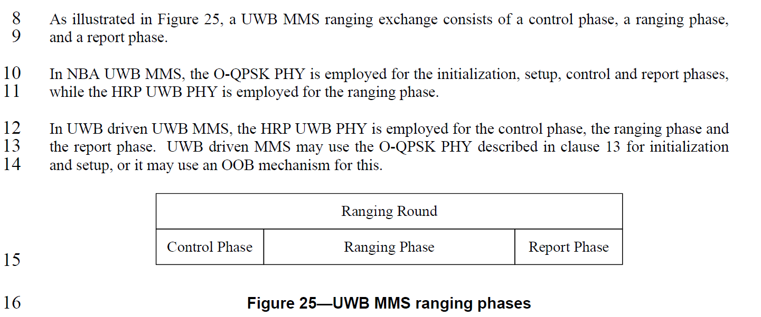
From 15.4me-D04 section 10.32.2 page 482, line 13
A ranging block is a time period for ranging. Each ranging block consists of a whole number of ranging
rounds, where a ranging round is a period of sufficient duration to complete one entire range-measurement
cycle involving the set of ERDEVs participating in the ranging exchange.
The issue is that TG4ab currently defines a ‘Ranging Round’ for MMS as per figure 25 but this in reality is a ‘Ranging Sub-round’. This is implicitly assumed elsewhere in the text eg figure 40. It is noted that a ‘Ranging Round’ can be composed of a single ‘Ranging Sub-round’.
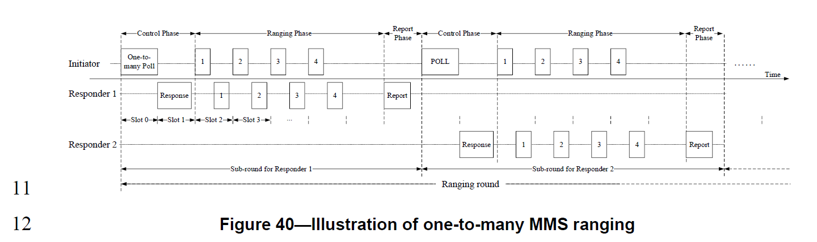
Resolution
- Make the following change on page 56 lines 8 and 9.
  - As illustrated in Figure 25, a ranging sub-round which incorporates a UWB MMS ranging exchange, consists of a control phase, a ranging phase, and a report phase.

- In figure 25 on page 56 change ‘Ranging Round’ to ‘MMS Ranging Sub-round.
- Search for ‘ranging round’ and replace by ‘ranging sub-round’ where appropriate.

CID 1334
Name | Index# | Pg | Sub-Clause | Ln | Comment | Proposed Change | Disposition
B. Rolfe | 1334 | 56 | 10.38.2 | 14 | Marginally incorrect use of "may" suggesting something outside of this standard (if only just). | alternatively, another OOB mechanism will be used. | Revised

Change the text on page 56 beginning on line 12 as indicated
In UWB driven UWB MMS, the HRP UWB PHY is employed for the control phase, the ranging phase and the report phase. UWB driven MMS may use the O-QPSK PHY described in clause 13 for initialization and setup, or it may use an OOB mechanism can be used for this.

CID 1170
Name | Index# | Pg | Sub-Clause | Ln | Comment | Proposed Change | Disposition
Billy Verso | 1170 | 68 | 10.38.5 | 23 | Lines 23 through to Line 6 of the next page, are trying to explain the PHY packet in words, this should be clear from clause 16 and should not be repeated here. | Delete as much as possible from this clause, since it is already specified in clause 16 (which is where this PHY level stuff it should be specified). Clause 16 should reference/use the PIB phyUwbMmsRsfNumberFrags and phyUwbMmsRifNumberFrags configurations, so they don’t need to be mentioned here again. All it that is needed to say is that, responder fragments are offset by 600 RSTU, as shown in the figure. | Revised

Change the text in 16.2.11 on page 192, starting on line 15 as indicated
Where X and Y are phyUwbMmsRsfNumberFrags and phyUwbMmsRifNumberFrags respectively the number of RSF and RIF fragments respectively in the MMS UWB packet, the following are the combinations that should be supported by the HRP-ARDEV in the case of NBA UWB MMS operations:

⎯ RSF only MMS packets, i.e., where Y=0 and X ∈ {1, 2, 4, 8, 16}.
⎯ RIF only MMS packets, i.e., where X=0 and Y ∈ {1, 2, 4, 8}.
⎯ Mixed RSF/RIF packets, i.e., where X ∈ {1, 2, 4, 8}, Y ∈ {1, 2, 4, 8}.

Change the text in 10.38.5 on page 68, starting on line 22 as indicated -
The UWB MMS ranging phase follows the control phase.

In the ranging phase, the initiator shall transmit phyUwbMmsRsfNumberFrags RSF fragments starting its first fragment at the start of the ranging phase, with each subsequent RSF fragment starting 1200 RSTU from the start of the previous one.

In the ranging phase, the initiator shall transmit a HRP UWB PHY MMS packet as described in 16.2.11.

The initiator may start transmitting a first RIF fragment at the start of the ranging phase if no RSF fragments are present, or two milliseconds (2400 RSTU) after the start of its last RSF fragment transmission otherwise. The initiator may continue to send phyUwbMmsRifNumberFrags RIF fragments at regular intervals of 1200 RSTU.

The responder may start transmitting a first RSF fragment at 600 RSTU into the ranging phase. The responder may send phyUwbMmsRsfNumberFrags RSF fragments at regular intervals of 1200 RSTU.

The responder may start transmitting a HRP UWB PHY MMS packet as described in 16.2.11 at 600 RSTU into the ranging phase.

The responder may start transmitting a first RIF fragment at 600 RSTU into the ranging phase if no RSF fragments were transmitted, or two milliseconds (2400 RSTU) after the start of its last RSF fragment transmission otherwise. The responder may continue to send phyUwbMmsRifNumberFrags RIF fragments at regular intervals of 1200 RSTU.

