IEEE P802.15
Wireless Personal Area Networks

Project | IEEE P802.15 Working Group for Wireless Personal Area Networks (WPANs)
Title | Proposed Resolution for UWB driven MMS and OOB assisted MMS
Date Submitted | July 2024
Sources | Wenzheng Li, Zhongxing Yu (Calterah Semiconductor)  wenzheng.li@calterah.com; zhongxing.yu@calterah.com;
Re:
Abstract
Purpose | To propose resolution for “P802.15.4ab™/D01 Draft Standard for Low-Rate Wireless Networks” .
Notice | This document does not represent the agreed views of the IEEE 802.15 Working Group or IEEE 802.15.4ab Task Group. It represents only the views of the participants listed in the “Sources” field above. It is offered as a basis for discussion and is not binding on the contributing individuals. The material in this document is subject to change in form and content after further study. The contributors reserve the right to add, amend or withdraw material contained herein.

Rev 0: Initial version.

Comment Indices in 15-24-0371-00-04ab-consolidated-comments-draft-1-0:
Name | Index# | Pg | Sub-Clause | Ln | Comment | Proposed Change | Disposition
Wenzheng Li | 187 | 68 | 10.38.5 | 23 | In this sub-clause, the ranging phase only for NBA UWB MMS is stated. For the UWB driven UWB MMS, the initial exchanged MMS fragment shall be SYNC+SFD. | Add the example of UWB-driven MMS in 10.38.5;  Add the description of UWB-driven MMS in 16.2.11;

According to the submission of 15-24-0362-01-04ab:
Name | Index# | Pg | Sub-Clause | Ln | Comment | Proposed Change | Disposition
Wenzheng Li |  | 54  68  191 | 10.38.1  10.38.5  16.2.11.1 |  | Suggest that initial SYNC+SFD packets exchange in ranging phase is a MUST to get the fine synchronization for one to one and one to many MMS ranging in both UWB-driven MMS and OOB assisted MMS | Add the description of initial SYNC+SFD packets exchange in 10.38.1, 10.38.5 and 16.2.11 for the case of OOB assisted MMS

Discussion：
For the UWB-driven MMS:
According to the conclusion for UWB-driven MMS, the initial SYNC+SFD packets should be exchanged in the ranging phase, which has been already included in the sub-clause 10.38.1
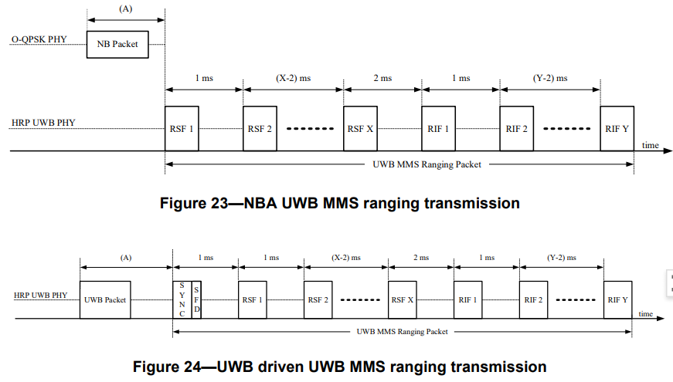
It is beneficial to get fine synchronization between initiator and responder in the UWS-driven MMS.
However, in the sub-clause 10.38.5, only the example of NBA MMS ranging phase is depicted, which may be in inconsistent with the description for UWB-driven MMS and NBA MMS ranging transmission in sub-clause, and may lead to the misunderstanding of the ranging fragments exchange in the ranging phase for UWB-driven MMS.
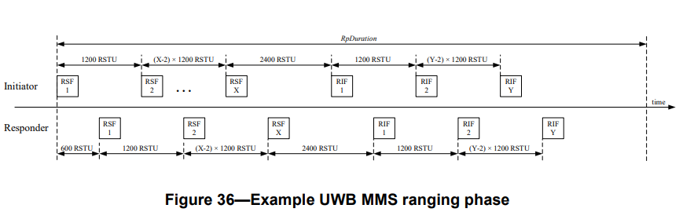
And for the MMS PHY description in the sub-clause, the clear description for both UWB-driven MMS and NBA MMS is also needed.
So, in this proposal, it is suggested to
- Add the example of UWB-driven MMS ranging phase in the sub-clause 10.38.5
- Clarify the MMS PHY description for both UWB-driven MMS and NBA MMS in the sub-clause 16.2.11
For the OOB assisted MMS:
According to the submission of 15-24-0362-01-04ab, the OOB assisted is expected to play a important role in the automotive market for UWB MMS, in order to take fully advantage of link budget gain of UWB MMS. However, the OOB assisted MMS is stated out of 4ab scope in the sub-clause of 10.38.1 in the current D1.0 version.
It is not challenged that detailed OOB assisted MMS shall be within the scope of 4ab, but it is suggested that a simple instruction of OOB MMS mechanism can be given, which may benefit the deployment of OOB MMS mechanism between different UWB devices.
In this proposal , it is suggested:
- Add the simple description of OOB MMS mechanism in sub-clause 10.38.1, especially to clarify that the OOB MMS can apply the similar ranging phase as that of UBW-driven MMS with the initial exchange of SYNC+SFD fragment exchange, in order to get the synchronization between UWB devices.
Disposition: Revised
Disposition Detail:
Proposed text changes on P802.15.4ab™/D01:
10.38.1 Introduction
Change the sub-clause as follows (Track changes ON)
The HRP UWB PHY based advanced ranging device (HRP-ARDEV), further specified in clause 16, supports a UWB multi-millisecond (MMS) packet mode, which provides for improved UWB ranging sensitivity. The MMS technique accumulates the channel impulse response (CIR) estimate from a sequence of fragments which are sent in separate milliseconds to utilize the allowed per millisecond regulatory transmit power budget. The HRP UWB PHY MMS packet is specified in 16.2.11.
This clause describes the UWB MMS operation and the details of the MAC and PHY interactions involved in UWB MMS based two-way ranging. There are two general methods to initiate the UWB MMS exchange and accumulation, each of which is optional but at least one of which is required to support UWB MMS mode:
⎯ Narrowband assisted (NBA) UWB MMS. Here the O-QPSK PHY described in clause 13 is employed for initialization, setup, control and result reporting and to initiate switching into UWB for the UWB MMS packet exchange, and, where O-QPSK PHY shares a common clock source with the UWB PHY, to determine the clock offset to assist the MMS accumulation.
⎯ UWB driven UWB MMS. Here UWB itself, (i.e., HRP UWB PHY described in clause 16), is employed for control and result reporting, and to initiate switching to the UWB MMS packet mode at the appropriate times.
Another PHY may be employed for control and reporting, and to initiate switching to UWB for the UWB MMS packet. This alternative is considered an OOB mechanism and is not detailed below.
Figure 23 and Figure 24 illustrate the core UWB MMS ranging transmission concept for the NBA and UWB driven cases, respectively. The UWB ranging sensitivity is improved by combining multiple ranging sequence fragments (RSF) and/or multiple ranging integrity fragments (RIF). In the figures, the time interval, A, is the time interval between the start of the packet in the control phase and the start of the MMS packet in the ranging phase as described in 10.38.4 and 10.38.5 respectively. For the NBA UWB MMS case, of Figure 23, values of 1.5 ms and 2 ms shall be supported for this time interval. In the UWB driven case of Figure 24, the HRP UWB PHY MMS packet includes the initial SYNC and SFD fragment as specified in 16.2.11, and a value of 1 ms shall be supported for time interval A.

(A)
O-QPSK PHY
1 ms
(X-2) ms
2 ms
1 ms
(Y-2) ms
HRP UWB PHY

time
UWB MMS Ranging Packet

RSF X
XRIF Y

RIF 2
RIF 2

RIF 1
RIF 1

RSF X
RSF X

RSF 2
RSF 2

RSF 1
RSF 1
NB Packet

Figure 23—NBA UWB MMS ranging transmission

Figure 24—UWB driven UWB MMS ranging transmission
HRP UWB PHY | (A) |  | 1 ms |  |  | 1 ms |  | (X-2) ms |  | 2 ms |  | 1 ms |  | (Y-2) ms
 | UWB Packet |  | S  Y N C | S F D |  | RSF 1 |  | RSF 2 |  | RSF X |  | RIF 1 |  | RIF 2 |  | RIF Y | time
 |  |  | UWB MMS Ranging Packet

If another PHY is employed for control and reporting, the UWB MMS ranging transmission should follow the UWB driven case of Figure 24, the HRP UWB PHY MMS packet should include the initial SYNC and SFD fragment as specified in 16.2.11.

10.38.5 UWB MMS ranging phase
The UWB MMS ranging phase follows the control phase. For the NBA MMS, in the ranging phase, the initiator shall transmit phyUwbMmsRsfNumberFrags RSF fragments starting its first fragment at the start of the ranging phase, with each subsequent RSF fragment starting 1200 RSTU from the start of the previous one. The initiator may start transmitting a first RIF fragment at the start of the ranging phase if no RSF fragments are present, or two milliseconds (2400 RSTU) after the start of its last RSF fragment transmission otherwise. The initiator may continue to send phyUwbMmsRifNumberFrags RIF fragments at regular intervals of 1200 RSTU.
For the UWB driven MMS, in the ranging phase, the initiator shall transmit a SYNC+SFD fragment starting its first fragment at the start of the ranging phase , then the initiator shall transmit phyUwbMmsRsfNumberFrags RSF fragments starting its first RSF fragment with the interval of 1200 RSTU to the start of the ranging phase, with each subsequent RSF fragment starting 1200 RSTU from the start of the previous one. The initiator may start transmitting a first RIF fragment with the interval of 1200 RSTU to the start of the ranging phase if no RSF fragments are present, or two milliseconds (2400 RSTU) after the start of its last RSF fragment transmission otherwise. The initiator may continue to send phyUwbMmsRifNumberFrags RIF fragments at regular intervals of 1200 RSTU.
For the NBA MMS, the responder may start transmitting a first RSF fragment at 600 RSTU into the ranging phase. The responder may send phyUwbMmsRsfNumberFrags RSF fragments at regular intervals of 1200 RSTU. The responder may start transmitting a first RIF fragment at 600 RSTU into the ranging phase if no RSF fragments were transmitted, or two milliseconds (2400 RSTU) after the start of its last RSF fragment transmission otherwise. The responder may continue to send phyUwbMmsRifNumberFrags RIF fragments at regular intervals of 1200 RSTU.
For the UWB driven MMS, the responder may start transmitting a first SYNC+SFD fragment at 600 RSTU into the ranging phase, then the responder may start transmitting as first RSF fragment at 1200+600 RSTU into the ranging phase. The responder may send phyUwbMmsRsfNumberFrags RSF fragments at regular intervals of 1200 RSTU. The responder may start transmitting a first RIF fragment at 1200+600 RSTU into the ranging phase if no RSF fragments were transmitted, or two milliseconds (2400 RSTU) after the start of its last RSF fragment transmission otherwise. The responder may continue to send phyUwbMmsRifNumberFrags RIF fragments at regular intervals of 1200 RSTU.
Figure 36 shows an example NBA UWB MMS ranging phase. In the figure, X is phyUwbMmsRsfNumberFrags and Y is phyUwbMmsRifNumberFrags either of which may be zero. The total duration of the UWB MMS ranging phase is macMmsRpDuration slots. macMmsRpDuration shall be set at minimum to the required duration for all RSF and RIF fragments to be transmitted and received but may be larger to provide flexibility in scheduling the report phase and/or to allow extra time after the final fragment.
Figure 37 shows an example UWB driven MMS ranging phase. In the figure, X is phyUwbMmsRsfNumberFrags and Y is phyUwbMmsRifNumberFrags either of which may be zero. The total duration of the UWB MMS ranging phase is macMmsRpDuration slots. macMmsRpDuration shall be set at minimum to the required duration for all RSF and RIF fragments to be transmitted and received but may be larger to provide flexibility in scheduling the report phase and/or to allow extra time after the final fragment.
The OOB mechanism should follow the UWB driven MMS ranging phase, when the time synchronization is needed between initiator and responder.
After macMmsRpDuration and transmission and reception of all fragments, the device enters the reporting phase if this is enabled, for sending/receiving the ranging reports as appropriate, otherwise the ranging round is completed at this time, (e.g., when the ranging report is conveyed via an OOB mechanism).
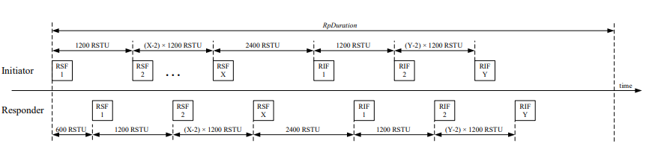
Figure 36—Example NBA UWB MMS ranging phase
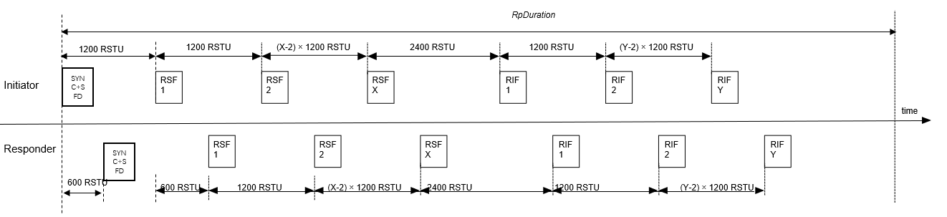
Figure 37—Example UWB driven MMS ranging phase
16.2.11.1 General
The HRP-ARDEV should support transmission and reception of the MMS modulation packet formats as specified in this subclause. The mandatory parameter sets are specified in 10.38.11 and 10.38.12.
In the MMS modulation, the packet, which is intended for ranging measurements, consists of a series of ranging fragments each sent in a separate millisecond to utilize the per millisecond regulatory transmit power budget, i.e., where each fragment is sent at close to the regulatory limit, allowing the receiver to use multiple fragments to improve sensitivity.
The general format of the transmitted MMS packet is shown in Figure 198.
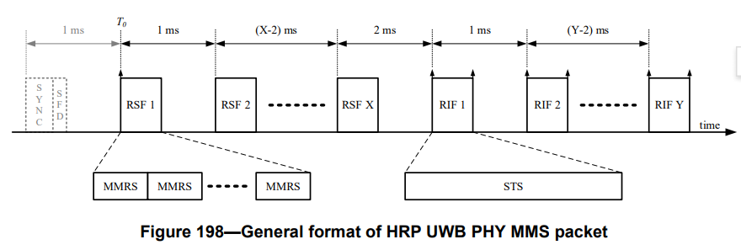
The MMS UWB packet consists of multiple fragments which are classified into three types: a fragment consisting of SYNC and SFD defined in 16.2.6, ranging sequence fragments (RSF) defined in 16.2.11.2 and ranging integrity fragments (RIF) defined in 16.2.11.3.
The HRP UWB PHY MMS packet is used in two cases, Narrowband assisted UWM MMS and UWB driven UWB MMS. The procedures and packet exchanges for these two cases are described in 10.38, and their mandatory operating parameter sets are specified in 10.38.11 and 10.38.12 respectively.
A fragment of SYNC and SFD is used for the initial packet exchange as specified in 10.38.5 for the UWB driven UWB MMS and OOB mechanism.
The same pulse shape following the time domain mask specified in Figure 16-24 shall be used for the entire MMS packet and all pulses within the packet shall be modulated with a constant amplitude.
Within the same MMS packet transmission, all RSF and RIF fragments shall begin on millisecond offsets with respect to T0 which is the start time of the first RSF or RIF transmitted in the packet. Where the MMS packet consists of both RSF and RIF fragments, the time between the start of the last RSF and the start of first RIF shall be two milliseconds.
Where X and Y are the number of RSF and RIF fragments respectively in the MMS UWB packet, the following are the combinations that should be supported by the HRP-ARDEV in the case of NBA UWB MMS operations: ⎯ RSF only MMS packets, i.e., where Y=0 and X ∈ {1, 2, 4, 8, 16}.
⎯ RIF only MMS packets, i.e., where X=0 and Y ∈ {1, 2, 4, 8}.
⎯ Mixed RSF/RIF packets, i.e., where X ∈ {1, 2, 4, 8}, Y ∈ {1, 2, 4, 8}.
In the case of UWB-driven UWB MMS operations, the following are the combinations that should be 22 supported by the HRP-ARDEV:
⎯ RSF only MMS packets, i.e., where Y=0 and X ∈ {1, 2, 4, 8}.
⎯ RIF only MMS packets, i.e., where X=0 and Y ∈ {1, 2, 4, 8}.
⎯ Mixed RSF/RIF packets, i.e., where X ∈ {1, 2, 4, 8}, Y ∈ {1, 2, 4, 8}.
The mandatory parameter sets are specified in 10.38.11 and 10.38.12.
Where the MMS packet includes RSF fragments, the RMARKER is defined as the peak of the first pulse in the first RSF in the packet. Where the MMS packet includes RIF fragments, additional RIF RMARKERs are defined for each RIF fragment, as the peak of the first pulse in the RIF and the peak of the last pulse in the RIF. These RMARKER positions are illustrated by the small vertical arrows in Figure 198.
For two-way ranging (TWR) with MMS packets, the fragment transmissions of the transmitted MMS packet are interleaved with fragment receptions of the received MMS response packet. Subclause 10.38 details the MMS procedures and packet exchanges.

