IEEE P802.15
Wireless Personal Area Networks

Project | IEEE P802.15 Working Group for Wireless Personal Area Networks (WPANs)
Title | Proposed Resolution for Compact frame – Miscel-1
Date Submitted | July 2024
Sources | Rojan Chitrakar, Lei Huang (Huawei)  rojan.chitrakar@huawei.com
Re:
Abstract
Purpose | To propose resolution for “P802.15.4ab™/D01 Draft Standard for Low-Rate Wireless Networks”
Notice | This document does not represent the agreed views of the IEEE 802.15 Working Group or IEEE 802.15.4ab Task Group. It represents only the views of the participants listed in the “Sources” field above. It is offered as a basis for discussion and is not binding on the contributing individuals. The material in this document is subject to change in form and content after further study. The contributors reserve the right to add, amend or withdraw material contained herein.

Rev 0: Initial version.

Comment Indices in 15-24-0371-00-04ab-consolidated-comments-draft-1-0:
Name | Index# | Pg | Sub-Clause | Ln | Comment | Proposed Change | Disposition
Billy Verso | 1039 | 27 | 9.2.12 | 8 | "This procedure does not apply to Compact frames that are not listed above.", should perhaps state more clearly that other compact frames cannot be secured, since neither procedures of 9.2.12 nor 9.2.2 apply. | Add at the end of the line, ", i.e., other Compact frames can not be secured." | Accept
Billy Verso | 1042 | 28 | 9.2.13 | 13 | "This procedure does not apply to Compact frames that are not listed above.", should perhaps state more clearly that other compact frames cannot be secured, since neither procedures of 9.2.12 nor 9.2.2 apply. | Add at the end of the line, ", i.e., other Compact frames can not be secured." | Accept
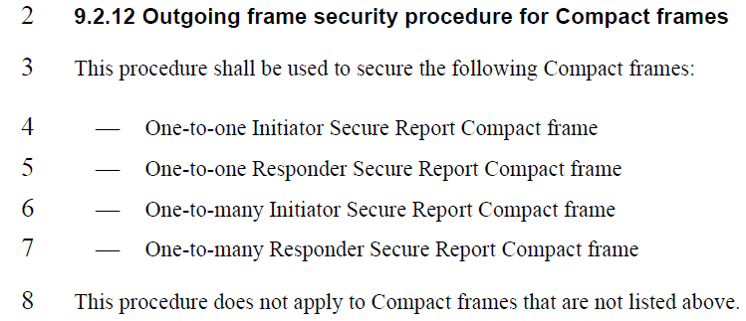
Rojan Chitrakar | 104 | 27 | 9.2.12 | 29 | relative ranging block should be relative block as per 10.32.3.5 Hyper block mode. | replace relative ranging block with relative block | Accept
Rojan Chitrakar | 106 | 29 | 9.2.13 | 19 | relative ranging block should be relative block as per 10.32.3.5 Hyper block mode. | replace relative ranging block with relative block | Accept
Rojan Chitrakar | 107 | 30 | 9.3.2.4 | 11 | relative ranging block should be relative block as per 10.32.3.5 Hyper block mode. | replace relative ranging block with relative block | Accept
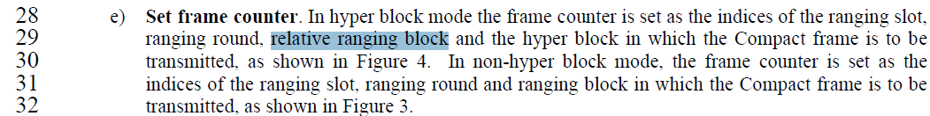
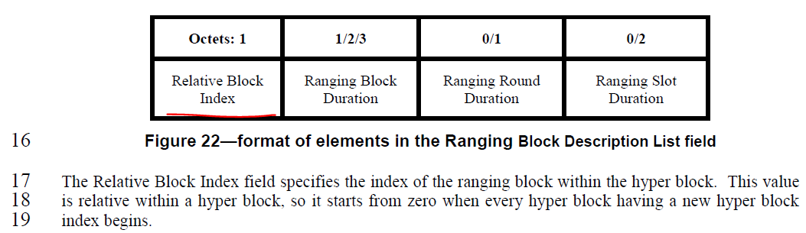
Alex Krebs | 1383 | 30 | 9.3.2.4 | 6 | Typo in Bits | Change 24 to 32 | Accept
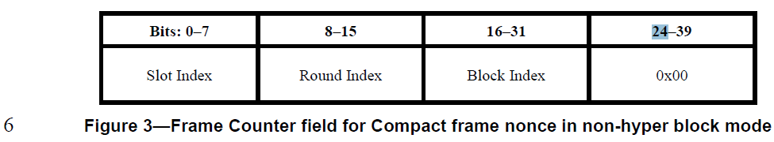
Tero Kivinen | 382 | 52 | 10.32.9.10 | 1 | The section 10.38.9.3.20 defines round index as 8-bit field and the security restricts it to 8-bit field. Here the round index is 14 bit field. | Change Round Index to 8-bit field.
Tero Kivinen | 381 | 52 | 10.32.9.11 | 17 | The section 10.38.9.3.20 defines round index as 8-bit field and the security restricts it to 8-bit field. Here the round index is 14 bit field. | Change Round Index to 8-bit field.
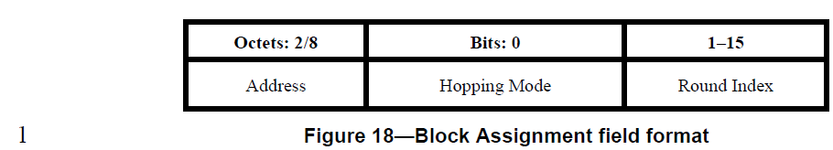
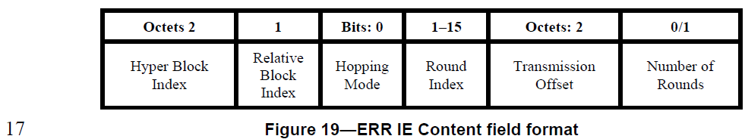
Disposition: Reject
Disposition Reason: The two cited fields are from the Scheduling IE and ERR IE respectively, both of which are carried in legacy 802.15.4 frames and not Compact frame and hence are not subjected to the 8-bit limitation which only apply to Compact frames.

