IEEE P802.15
Wireless Personal Area Networks

Project | IEEE P802.15 Working Group for Wireless Personal Area Networks (WPANs)
Title | Proposed Resolution for Advertising Poll Compact frame
Date Submitted | July 2024
Sources | Rojan Chitrakar, Lei Huang (Huawei)  rojan.chitrakar@huawei.com
Re:
Abstract
Purpose | To propose resolution for “P802.15.4ab™/D01 Draft Standard for Low-Rate Wireless Networks”
Notice | This document does not represent the agreed views of the IEEE 802.15 Working Group or IEEE 802.15.4ab Task Group. It represents only the views of the participants listed in the “Sources” field above. It is offered as a basis for discussion and is not binding on the contributing individuals. The material in this document is subject to change in form and content after further study. The contributors reserve the right to add, amend or withdraw material contained herein.

Rev 0: Initial version.
Rev 1: Added CID 60

Comment Indices in 15-24-0371-00-04ab-consolidated-comments-draft-1-0:
Name | Index# | Pg | Sub-Clause | Ln | Comment | Proposed Change | Disposition
Rojan Chitrakar | 113 | 92 | 10.38.9.4 | 11 | With the new Presence Bitmap format, the 3 variants (0x10, 0x20 and 0x30) can be combined in a single variant by either making the Initialization Slot Duration and Cap Duration fields mandatory or adding relevant presence bits for Initialization Slot Duration and Cap Duration. | Combine the 3 variants (0x10, 0x20 and 0x30) in a single variant by either making the Initialization Slot Duration and Cap Duration fields mandatory in all 3 variant or adding relevant presence bits for Initialization Slot Duration and Cap Duration. | Revised
Mickael Maman | 60 | 93 | 10.39.9.4 | 5 | missing the range of N | add "in the range 0 to 15. | Revised

Discussion：
Propose to combine the 3 variants by making the Initialization Slot Duration and Cap Duration fields mandatory in all 3 variant and adding the presence bitmap for SMC TLVs field.
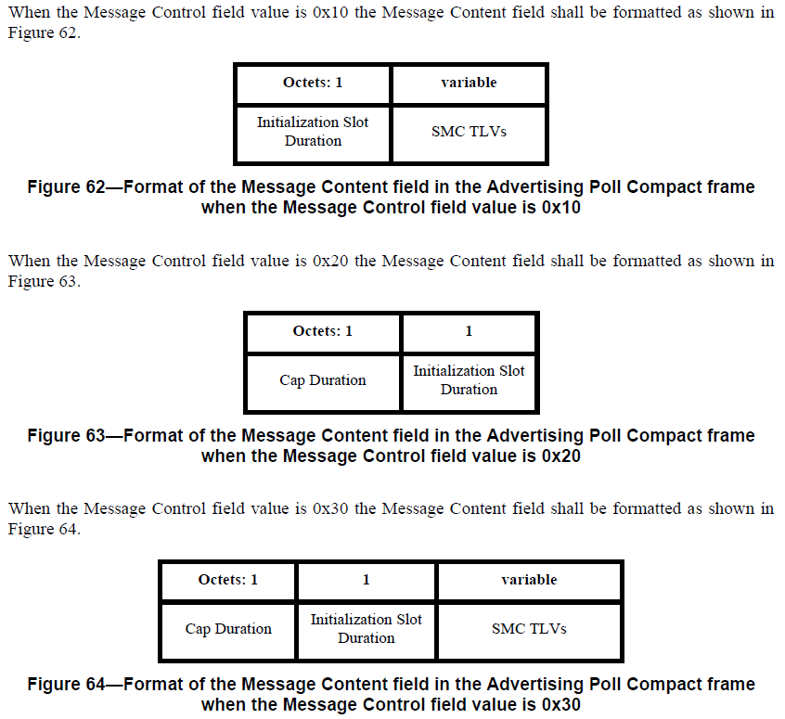
Disposition: Revised
10.38.9.4 Advertising Poll Compact frame
Change the sub-clause as follows (Track changes ON)
…
The Message Control field value shall be either 0x00 or 0x10. This value determines the formatting of the Message Content field.
…
When the Message Control field value is 0x10 the Message Content field shall be formatted as shown in Figure 62.

Octets: 1 | 1 | 1/2 | variable
Initialization Slot Duration | Cap Duration | Presence Bitmap | SMC TLVs
Figure 62—Format of the Message Content field in the Advertising Poll Compact frame when the Message Control field value is 0x10

Delete Figure 63.

Delete Figure 64.

The Initialization Slot Duration field is an unsigned integer in the range 0 to 15 that specifies the duration of an initialization
slot. The duration in RSTU is given by the expression: 600 + 300 × N, where N is the Initialization Slot
Duration field value.

The CAP Duration field is an unsigned integer that specifies the duration of the contention access period in units of initialization slots.

The Presence Bitmap is set as specified in 10.38.9.3.24, except that the fields other than the SMC TLVs Present field and the Extended Presence Bitmap Present field shall be set to zero.

The SMC TLVs field is the list of supported message control commands as defined in 10.38.9.3.5. This is
used by the initiator to signal to responders which compact frames and which message control values it
supports.

