IEEE P802.15
Wireless Personal Area Networks

Project | IEEE P802.15 Working Group for Wireless Personal Area Networks (WPANs)
Title | Proposed Resolution for Vendor Specific Compact frame
Date Submitted | July 2024
Sources | Rojan Chitrakar, Lei Huang (Huawei)  rojan.chitrakar@huawei.com
Re:
Abstract
Purpose | To propose resolution for “P802.15.4ab™/D01 Draft Standard for Low-Rate Wireless Networks”
Notice | This document does not represent the agreed views of the IEEE 802.15 Working Group or IEEE 802.15.4ab Task Group. It represents only the views of the participants listed in the “Sources” field above. It is offered as a basis for discussion and is not binding on the contributing individuals. The material in this document is subject to change in form and content after further study. The contributors reserve the right to add, amend or withdraw material contained herein.

Rev 0: Initial version.

Comment Indices in 15-24-0371-00-04ab-consolidated-comments-draft-1-0:
Name | Index# | Pg | Sub-Clause | Ln | Comment | Proposed Change | Disposition
Rojan Chitrakar | 101 | 18 | 7.3.7.4 | 1 | Compact Frame ID 30 is reserved for vendor specific use but the format is not defined. A lack of common format will lead to interoperability issues between different vendors. | Define the Compact Frame Content field for the vendor specific compact frame. The vendor specific Header IE Content field can be used as a reference. The first 3 octets carry the Vendor OUI field while the rest of the Content field is left to the vendors to design.
Tero Kivinen | 293 | 18 | 7.3.7.4 | 1 | If there is vendor specific use reserved then there should be format specified for it (having vendor ID in the beginning etc). If this is just reservation then there is no need to explicitly reserve specific number for it, as if there is number reserved but no format, then vendors might start using it using their own formats causing interoperability issues in the future. | Remove "Reserved for vendor specific use" and change 21-29 to 21-30 on the previous line. Defining new vendor specific format for this frame seems unneeded as we already have several other frame types which can be used for vendor specific content.
Billy Verso | 1025 | 18 | 7.3.7.4 | 2 | "Reserved for vendor specific use". Elsewhere in 802.15.4 vendor specific use is allowed and understood through the use of the Vendor OUI, but compact frames do not include such a field, so the is no way to allow vendor specific functionality without potential conflicts. | Define how this can be used / interpreted by individual vendors without conflict, or, change to a simple "Reserved".

Discussion：
Compact Frame ID value 30 is reserved for vendor specific use but the format is not defined which can lead to lack of interoperability among vendors. The format of other vendor specific fields can be used.
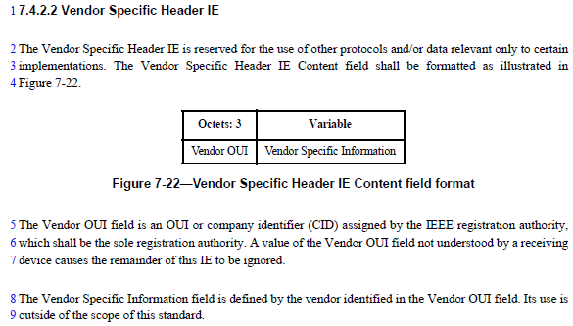
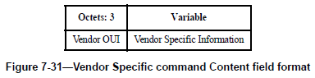

Disposition: Revised
Disposition Detail:
Proposed text changes on P802.15.4ab™/D01:
10.38.9 Messages for UWB MMS operation
Add the following new subsection at the end of 10.38.9
10.38.9.xx Vendor Specific Compact frame
The Vendor Specific Compact frame is reserved for the use of other protocols and/or data relevant only to certain implementations. The Compact Frame Content field of the Vendor Specific Compact frame shall be formatted as illustrated in Figure xxx.
Octets: 3 | variable
Vendor OUI | Vendor Specific Information
Figure xxx— Vendor Specific Compact frame Content field format
The Vendor OUI field is an OUI or company identifier (CID) assigned by the IEEE registration authority, which shall be the sole registration authority. A value of the Vendor OUI field not understood by a receiving device causes the remainder of this frame to be ignored.
The Vendor Specific Information field is defined by the vendor identified in the Vendor OUI field. Its use is outside of the scope of this standard.

Note to editor: Add the reference to 10.38.9.xx (Vendor Specific Compact frame) in Table 1—Compact frames

