IEEE P802.15
Wireless Personal Area Networks

Project | IEEE P802.15 Working Group for Wireless Personal Area Networks (WPANs)
Title | <802.15 TG4ab (NG-UWB) Conf. Call Mins. May. to Jul. 2024>
Date Submitted | [14 Jul, 2024]
Source | [David Xun Yang]  [Huawei]  [Bantian, Shenzhen, China] | Voice: [+86.159.1411.7462]  Fax: [--]  E-mail: [david.yangxun@huawei.com]
 | [Benjamin A. Rolfe]  [BCA]  [--] | Voice: [+1.408.395.7207]  Fax: [--]  E-mail: [ben.rolfe@ieee.org]
Re: | [802.15 TG4ab Conf. Call Mins]
Abstract | [Official Minutes of the Call]
Purpose | [Record the main points of the call]
Notice | This document has been prepared to assist the IEEE P802.15. It is offered as a basis for discussion and is not binding on the contributing individual(s) or organization(s). The material in this document is subject to change in form and content after further study. The contributor(s) reserve(s) the right to add, amend or withdraw material contained herein.
Release | The contributor acknowledges and accepts that this contribution becomes the property of IEEE and may be made publicly available by P802.15.

802.15 TG4ab (NG-UWB) Conf. Call Minutes
between May. and Jul. 2024 Mtgs.

Tuesday, 28 May 2024

Opening
9:02 AM ET 802.15 TG4ab Chair, Ben Rolfe (BCA), called the meeting to order.

Minutes
>25 participants were noted during the duration of the call

Utilizing the meeting and agenda doc. # 15-24-0327-00, the Chair conducted the following business:
- Opening
- Reviewed IEEE Patent Policy
  - Made call for claims with no responses
- Reviewed IEEE SA Participation Policy
- Reviewed IEEE SA Copyright Policy
- Reviewed 802 Rules

Announcement
Chair reviewed the proposed agenda (doc. # 15-24-0328-00). There was no objection to the updated agenda. It was approved with unanimous consent.

Editor Billy Verso (Qorvo) reviewed the progress of comment resolutions and discuss about the remaining comments.

Michael Mclaughlin (Qorvo) presented “Proposed UWB MMS packet options”
(doc. # 15-24-0329-00)
This presentation is to propose more features to meet customer requirement.
There were lots of discussions on the candidate features to meet the demand.
Chair reminded that the current priority is to have a draft for letter ballot.

Carl Murray (Qorvo) presented “Draft C comment resolution for MMS fragments”
(doc. # 15-24-0326-00)

Billy Verso (Qorvo) presented “Ack CI 188 72 190 191”
(doc. # 15-24-0325-00)
There was no objection to the comment resolutions as in doc. # 15-24-0325-00.

Chair asked if there is any presentation in this afternoon. There was a request.

Chair recessed the call @10:03am ET until 6pm ET.

Tuesday, 28 May 2024

Opening
6:02 PM ET 802.15 TG4ab Chair, Ben Rolfe (BCA), called the meeting to order

Minutes
>25 participants were noted during the duration of the call

Utilizing the meeting and agenda doc. # 15-24-0327-02, the Chair conducted the following business:
- Opening
- Reviewed IEEE Patent Policy
  - Made call for claims with no responses
- Reviewed IEEE SA Participation Policy
- Reviewed IEEE SA Copyright Policy
- Reviewed 802 Rules

Announcement
Chair reviewed the proposed agenda (doc. # 15-24-0328-02). There was no objection to the agenda.

Pooria Pakrooh (Qualcomm) presented “Draft C Proposed comment resolutions for NB Channel Map”
(doc. # 15-24-0318-00)

Carl Murray (Qorvo) presented “Draft C comment resolution for MMS (CIDs 7, 29, 52, 80, 81, 90, 91, 212, 269, 318, 683, 729, 859-862, 879, 894 and 901)”
(doc. # 15-24-0221-03)
There were lots of discussions.

Carlos Aldana (Meta) presented “DraftC comment resolution assigned to me - Part 1 (CIDs 152, 153, 178, 179, 200, 232, 233, 234, 235, 236, 294, 313, 677, 678)”
(doc. # 15-24-0294-02)

Chairs and the editor reviewed the comment resolution to-do list.

Chair recessed the call @7:10pm ET until 9am, 4 Jun, ET.

Thursday, 30 May 2024

Opening
9:03 AM ET 802.15 TG4ab Chair, Ben Rolfe (BCA), called the meeting to order.

Minutes
>25 participants were noted during the duration of the call

Utilizing the meeting and agenda doc. # 15-24-0327-03, the Chair conducted the following business:
- Opening
- Reviewed IEEE Patent Policy
  - Made call for claims with no responses
- Reviewed IEEE SA Participation Policy
- Reviewed IEEE SA Copyright Policy
- Reviewed 802 Rules

Announcement
Chair reviewed the proposed agenda (doc. # 15-24-0328-03). There was no discussion on the updated agenda.

Pooria Pakrooh (Qualcomm) presented “Draft C Proposed comment resolutions for NB Channel Map”
(doc. # 15-24-0318-01)
There were discussions.
There was no objection to comment resolutions as in doc. # 15-24-0318-01.

There was discussion on doc 0326, 0183 and 0221. They were deferred to PM session today.

The comment resolutions on CID 220 and 221 were deferred to PM session today.

Mickael Maman (STMicroelectronics) and Sven Zeisberg (Zigpos) presented “Proposed resolution for CID 197 on multiple RCMs”
(doc. # 15-24-0330-00)
There was no objection to comment resolutions as in doc. # 15-24-0330-00.

Vinod Kristem (Apple) presented “CR for HRP UWB PHY CID 274 and 275”
(doc. # 15-24-0274-00)
There was no objection to comment resolutions as in doc. # 15-24-0274-00.

Carlos Aldana (Meta) presented “CIDs 231, 310 Proposed Resolution”
(doc. # 15-24-0322-01)
There was no objection to comment resolutions as in doc. # 15-24-02322-01.

Chairs and the editor reviewed the comment resolution to-do list.

PM agenda reviewed and adopted by unanimous consent.

Chair recessed the call @10:03am ET until 6pm 30 May, ET.

Thursday, 30 May 2024

Opening
6:00 PM ET 802.15 TG4ab Chair, Ben Rolfe (BCA), called the meeting to order.

Minutes
>30 participants were noted during the duration of the call

Utilizing the meeting and agenda doc. # 15-24-0327-04, the Chair conducted the following business:
- Opening
- Reviewed IEEE Patent Policy
  - Made call for claims with no responses
- Reviewed IEEE SA Participation Policy
- Reviewed IEEE SA Copyright Policy
- Reviewed 802 Rules

Announcement
Chair reviewed the proposed agenda (doc. # 15-24-0328-05). There was no discussion on the updated agenda.

Carl Murray(Qorvo) presented “Draft C comment resolution for MMS (CIDs 7, 29, 52, 80, 81, 90, 91, 212, 269, 318, 683, 729, 859-862, 879, 894 and 901)”
(doc. # 15-24-0221-04)
There was no objection to comment resolutions as in doc. # 15-24-0221-01.

Carl

Billy Verso (Qorvo) presented “Primitives for sensing addressing CIDs 220 and 221”
(doc. # 15-24-0332-00)
There was no objection to comment resolutions as in doc. # 15-24-0332-00.

Pooria Pakrooh (Qualcomm) presented “draftc-proposed-comment-resolutions-for-CIDs 223, 431, 666”
(doc. # 15-24-0331-02)
There was no objection to comment resolutions as in doc. # 15-24-0331-02.

There were still 4 comments left: CIDs 859, 860, 861, and 862. Motions were run for these comments.

Motion #1:
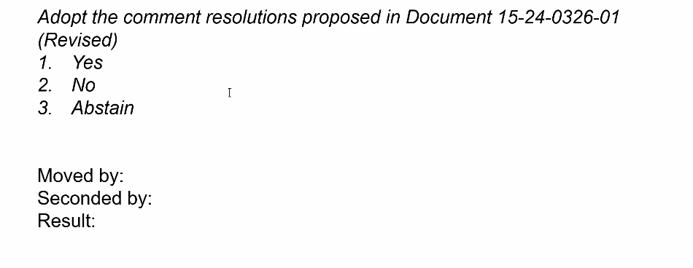
Move: Carl Murray, second: Billy Verso. Result: Y: 8, N: 8, Abs: 3.

Motion #2:
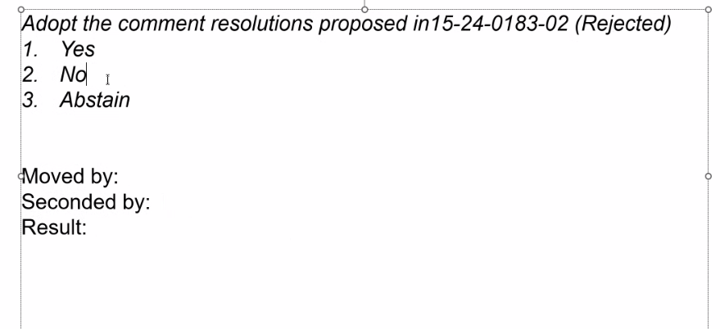
Move: Pooria Pakrooh, Second: Frank Leung. Result: Y 8, N 7, Abs 3.

These comments were rejected. Clint Chaplin (Samsung) planned to update the doc to r35.

Chair went through doc. # 15-24-0452-04.

Motion #3:
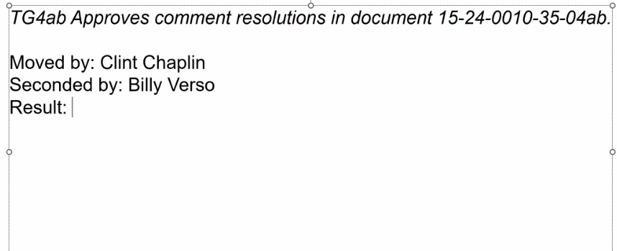
There was no objection to the motion (30 voters presented). Unanimous consent.

TG Motion:
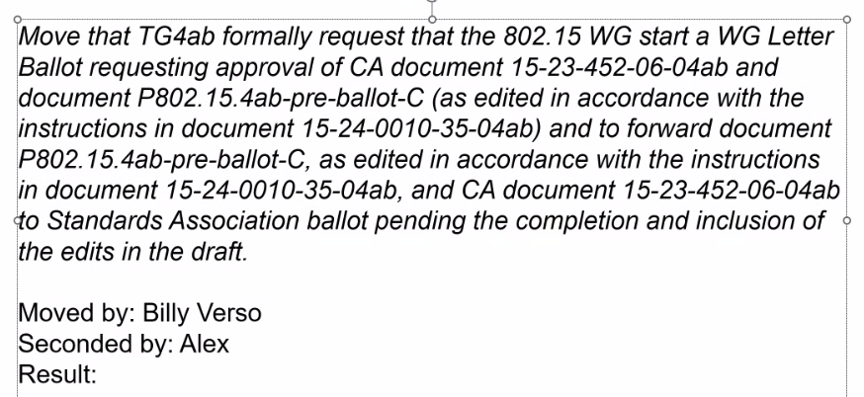
Result: Y: 25, N: 0, Abs: 0. Motion passed.

Chair reviewed the schedule for the following letter ballot and telecons.

Chair recessed the call @7:40pm ET until 9am 11 Jul, ET.

Thursday, 11 Jul 2024

Opening
9:03 AM ET 802.15 TG4ab Chair, Ben Rolfe (BCA), called the meeting to order.

Minutes
~20 participants were noted during the duration of the call

Utilizing the meeting and agenda doc. # 15-24-0327-05, the Chair conducted the following business:
- Opening
- Reviewed IEEE Patent Policy
  - Made call for claims with no responses
- Reviewed IEEE SA Participation Policy
- Reviewed IEEE SA Copyright Policy
- Reviewed 802 Rules

Announcement
Chair reviewed the proposed agenda (doc. # 15-24-0328-06). There was no discussion on the updated agenda.

There were still hours to the end of comment collection of letter ballot. Chair reviewed part of received comments and assigned comments to volunteers.

There was no request to present in this afternoon.

Chair asked if there is any other business to discuss. No request heard.

Chair adjourned the call @9:54am ET.

