IEEE P802.15
Wireless Personal Area Networks

Project | IEEE P802.15 Working Group for Wireless Personal Area Networks (WPANs)
Title | Proposed resolution for comment ID 197 on multiple RCMs
Date Submitted | May 2024
Sources | Mickael Maman (STMicroelectronics), Sven Zeisberg (Zigpos)
Re:
Abstract
Purpose | To propose comments resolution for “P802.15.4ab™/D (pre-ballot) C Draft Standard for Low-Rate Wireless Networks”
Notice | This document does not represent the agreed views of the IEEE 802.15 Working Group or IEEE 802.15.4ab Task Group. It represents only the views of the participants listed in the “Sources” field above. It is offered as a basis for discussion and is not binding on the contributing individuals. The material in this document is subject to change in form and content after further study. The contributors reserve the right to add, amend or withdraw material contained herein.

Comment Index #197 in 15-24-0010-03-04ab-consolidated-comments-draft-c
Commenter | Index # | page | Sub-Clause | Line | Comment | Proposed Change
Billy Verso | 197 | 30 | 10.31.2 | 5 | To explain the notion of multiple devices sending RCM messages, it would be good to cross reference a description that explains how receipt of RCM is handled in a device potentially receiving different RCM from multiple sources. | If not already present, insert description text in an appropriate subclause. Cross reference the description from here.

Discussion of comment ID 197:
In section 10.31.2 Ranging block and round structure
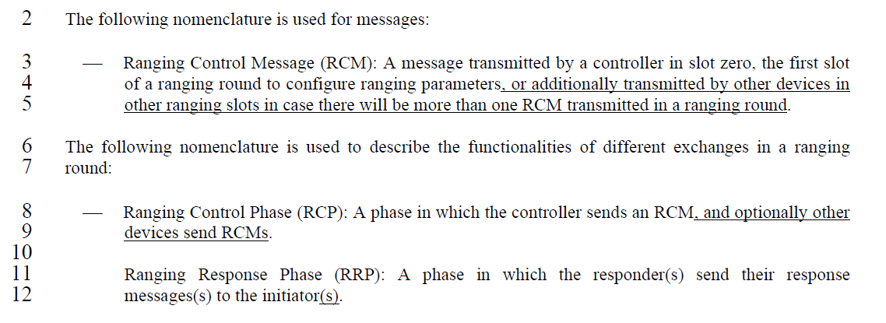
In dense multi-mode ranging (MMR) scenarios, a device can receive several copies of the same RCMs from several (fixed) nodes in a single ranging round. Details are explained in our contributions IEEE 15-23-0034-02-04ab (section 5.4, 6.7 and 6.8).
If a device receives RCMs from different initiators with different contents in the same ranging round, It is up to implementation to select the RCM. It may be based on a majority decision or the best received packet quality (e.g., RSSI or LQI).
Proposed resolution:
revised
Proposed text changes on P802.15.4ab™/D (pre-ballot) C for comment ID 197:
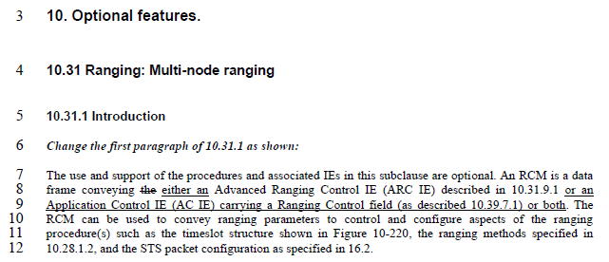
Add after line 12:
In dense multi-mode ranging (MMR) scenarios, a device may receive multiple copies of the same RCMs from several nodes in a single ranging round. If a device receives RCMs with different contents in the same ranging round, the selection of the RCM by the device is implementation dependent. It may be based on a majority decision or the best received packet quality (e.g., RSSI or LQI).

