IEEE P802.15
Wireless Personal Area Networks

Project | IEEE P802.15 Working Group for Wireless Personal Area Networks (WPANs)
Title | Proposed Resolution for Comments #231, 310
Date Submitted | May 28, 2024
Sources | Carlos Aldana (Meta)
Re:
Abstract
Purpose | To propose resolution to comment with CID #231, 310 for “P802.15.4ab™/Draft (pre-ballot) C Draft Standard for Low-Rate Wireless Networks”
Notice | This document does not represent the agreed views of the IEEE 802.15 Working Group or IEEE 802.15.4ab Task Group. It represents only the views of the participants listed in the “Sources” field above. It is offered as a basis for discussion and is not binding on the contributing individuals. The material in this document is subject to change in form and content after further study. The contributors reserve the right to add, amend or withdraw material contained herein.

Comment Index #231

Billy Verso | 231 | 134 | 10.40.3 | 17 | Seem to me that we are missing the MLME primitives necessary to allow the upper layers to initiate transmission of the HRP UWB Association Request command, and indicate its reception etc. | Add them.
Discussion: Agree with commenter.
Proposed Resolution: Revised
Editor: Please add the following text (after Section 10.21.4) as a new Section 10.21.XX titled “HRP-EMDEV Association”:
An HRP-EMDEV device is instructed to associate through the MLME-ASSOCIATE.request primitive by setting HRP-EMDEVMode to true. When HRP-EMDEVMode is set to true, the MAC sublayer of an unassociated device initiates the association procedure by sending an HRP UWB Association Request command to the coordinator of an existing PAN. The HRP UWB Association Request command shall be sent as described in 10.40.4.1.

If the HRP-EMDEV device does not receive an HRP UWB Association Response command from the coordinator in the next block, the MLME shall issue the MLME-ASSOCIATE.confirm primitive with a Status of NO_DATA, and the association attempt shall be deemed a failure. If the HRP-EMDEV device does receive an HRP UWB Association Response command from the coordinator in the next block, the MLME shall issue the MLME-ASSOCIATE.confirm primitive with a Status of SUCCESS. The field HRP-EMDEV Association Status in MLME-ASSOCIATE.confirm primitive provides additional information as to whether the association attempt is deemed success or failure. If the value of the Association status field in the HRP-EMDEV Association Status in MLME-ASSOCIATE.confirm primitive is either 0 or 2, the association attempt shall be deemed a success. If the value of the Association status field in the HRP-EMDEV Association Status in MLME-ASSOCIATE.confirm primitive is either 1, 3, or 4, the association attempt shall be deemed a failure.

If the coordinator next higher layer accepts the association request, it sends an MLME-ASSOCIATE.response to the MAC sublayer with HRP-EMDEVMode set to true. If the coordinator next higher layer rejects the association request, it will send an MLME-ASSOCIATE.response with an HRP-EMDEV Association Status parameter indicating the reason for the rejection. Upon receipt of an MLME-ASSOCIATE.response primitive with HRP-EMDEVMode set to true, the MAC sublayer shall generate an HRP UWB Association Response command. If the request was successful, the HRP UWB Association Response command contains an HRP-EMDEV Association Status field indicating a successful association. If the request failed, the HRP UWB Association Response command contains the HRP-EMDEV Association Status field set to indicate the reason the request failed.

The HRP UWB Association Response command shall be sent as described in 10.40.4.2.

Figure YYY illustrates a sequence of messages for association, where we need to replace “Association Request” with “HRP UWB Association Request” and “Association Response” with “HRP UWB Association Response”.
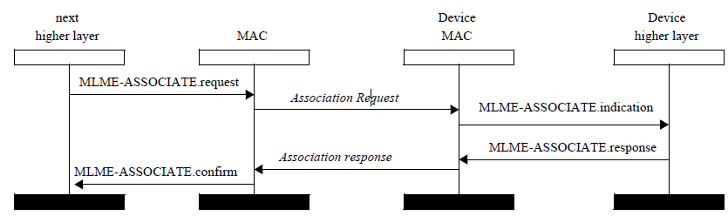
Figure YYY

NOTE TO EDITOR : In Tables 10-104, 10-106, 10-107, please add a row called HRP-EMDEVMode that is Boolean, with the following description : Indicated whether device is HRP-EMDEV or not.

NOTE TO EDITOR : In addition to the change above, please add the following 2 rows to Table 10-107.

Name | Type | Valid range | Description
AssocExtendedAddress | Integer | 0x0000000000000000-0xffffffffffffffff | The extended address used by the controlee.
HRP-EMDEV Association Status | Enumeration | As defined in Table 35 | The association status of the association attempt from association request command as defined in 10.40.4.2

NOTE TO EDITOR : In addition to the change above, please add the following 1 rows to Table 10-106.

Name | Type | Valid range | Description
HRP-EMDEV Association Status | Enumeration | As defined in Table 35 | The association status of the association attempt from association request command as defined in 10.40.4.2

Comment Index #310

Bin Qian | 310 | 33 | 10.31.9.10 | 23 | It seems the receiver address is redundant since it is already in the MAC header | Remove the Receiver Address Present field and Receiver Address field in the Scheduling List field
Discussion: In case of the Control Message, in which Scheduling IE should be, the receiver address in MAC header should be the broadcasting address.
The address field in the legacy RDM IE indicates the sender but there is no information about the receiver. Having receiver address field in the scheduling IE will help devices enter sleep mode and save power if the slot is not intended for them. Another reason to allow for receiver address is the multistatic sensing mode, where different slots in a round are allocated to different responders.
Proposed Resolution: Reject.

