IEEE P802.15
Wireless Personal Area Networks

Project | IEEE P802.15 Working Group for Wireless Personal Area Networks (WPANs)
Title | Time efficient MMS for one to many DS TWR ranging
Date Submitt | May 2024  Zhongxing Yu ，Wenzheng Li ，Zhepeng Ma
Sources
Re:
Abstract
Purpose | To propose a time efficient solution for DS-TWR MMS to save power consumption which has great advantage in power consumption aspect.
Notice | This document does not represent the agreed views of the IEEE 802.15 Working Group or IEEE 802.15.4ab Task Group. It represents only the views of the participants listed in the “Sources” field above. It is offered as a basis for discussion and is not binding on the contributing individuals. The material in this document is subject to change in form and content after further study. The contributors reserve the right to add, amend or withdraw material contained herein.

Discussion:
In car key one to many DS-TWR ranging scenario, It is important that the ranging support larger distance and cost lower power consumption. So, we apply MMS in this scenario. But one by one ranging cost to much power consumption. A time efficient one to many DS-TWR ranging solution introduced here to resolve power consumption issue. The new solution has a great advantage in power consumption aspect. The power consumption of new solution is about 1/5 that of the ranging one by one solution

Resolution: new
Proposed text changes on P802.15.4ab™/D (pre-ballot) C:

10.38.9.3 Time Efficient one-to-many ranging
10.38.9.3.1 Time Efficient one-to-many SS-TWR ranging
For some time-sensitive applications, e.g., VR/AR, it is useful to improve the time efficiency of the one-to-many ranging by allowing two responders to reply at different times within one ranging slot. The
esponders shall be capable of a fixed reply time of sufficient precision. The supported number of UWB
MMS fragments (i.e., RSF and/or RIF) per ranging round is limited to two fragments.As a ranging initialization message, the Poll Compact frame with the Message Control field set to 0x90 or 0xA0 serves to enable the time efficient one-to-many SS-TWR from an initiator to even number of responders. For two responders involved in each sub-round, the corresponding Start Slot Index fields shall set to the same value; and the corresponding Time Shift Indication fields shall set to zero and one,
respectively. The Start Slot Index field is used to indicate the slot index of the corresponding Poll Compact frame.In each sub-round, as shown in Figure 39, the initiator may start transmitting the first UWB RSF fragment at RpRsfOffset slots into the ranging phase, and continue to send the second UWB RSF fragment at an interval of 1200 RSTUs. The responder with Time Shift Indication field set to zero may start transmitting the first UWB RSF fragment at RpRsfOffset slots plus 400 RSTUs into the ranging phase, and continue to send the second UWB RSF fragment at an interval of 1200 RSTUs. The responder with Time Shift Indication field set to one may start transmitting the first UWB RSF fragment at RpRsfOffset slots plus 800 RSTUs into the ranging phase, and continue to send the second UWB RSF fragment at an interval of 1200 RSTUs.
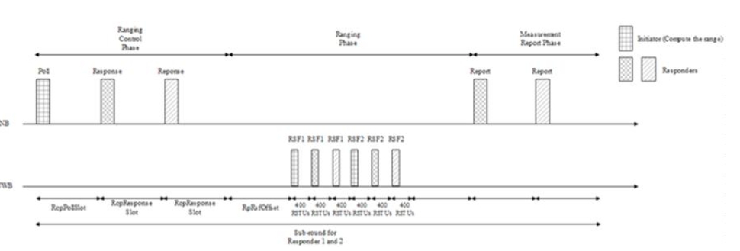
Figure 39—Illustration of time efficient one-to-many MMS ranging
For the time efficient one-to-many MMS ranging, the One-to-many Initiator Report Compact frame with
the Message Control field set to 0x10 may serve to enable the transmission of the measurement report from the initiator to the two responders involved in the same sub-round. This message indicates the turnaround time of the two responders involved in the same sub-round in the TurnAroundTime1 and TurnAroundTime2 fields, respectively. Alternatively, two One-to-many Initiator Report Compact frames with the Message Control field set to 0x00 may be sent by the initiator individually to the two responders involved in the same sub-round.
10.38.9.3.2 Time Efficient one-to-many DS-TWR ranging
For some time-sensitive applications, such as car key and vehicle ranging, the car key needs to save power, so it needs more time to sleep and less time to ranging. In normal case, the car key works as initiator and there are 4-7 UWB anchor in vehicle side as responder and perform DS-TWR ranging. The control phase and report phase are like SS-TWR. But the responder numbers are large than or equal to 2. In the ranging phase, they are different. When MMS applied in DS-TWR, the initiator should Tx 2 time in 2ms and Rx one time for each respond in a RSF period in which Each Tx should be at the beginning of 1ms. The first half responds perform standard DS-TWR with initiator, and the second half responds perform eSS-TWR which is like DS-TWR which is defined in Fira. The example below shows 4 responds and 4 RSF scenario.
The initiator performs TxRxTx ranging with respond1, the ranging method between them is standard DS-TWR. And Initiator performs the same DS-TWR ranging with respond2. But to respond3 or respond4, the initiator performs TxTxRx eSS-TWR ranging with respond3 or respond4, which is defined in Fira.
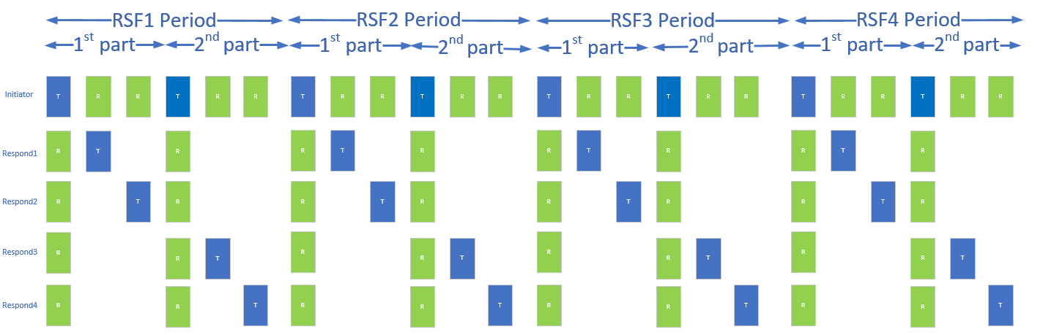
Figure 40—Illustration of RSF DS-TWR time efficient one-to-many MMS ranging
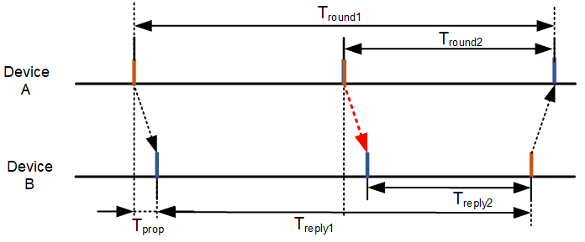
Figure 41—Illustration of eSS-TWR ranging
When RIF applied in the DS-TWR ranging, its Tx and Rx ranging is like RSF. The below example shows 2 RSF and 2RIF in a packet and applied 4 responds.
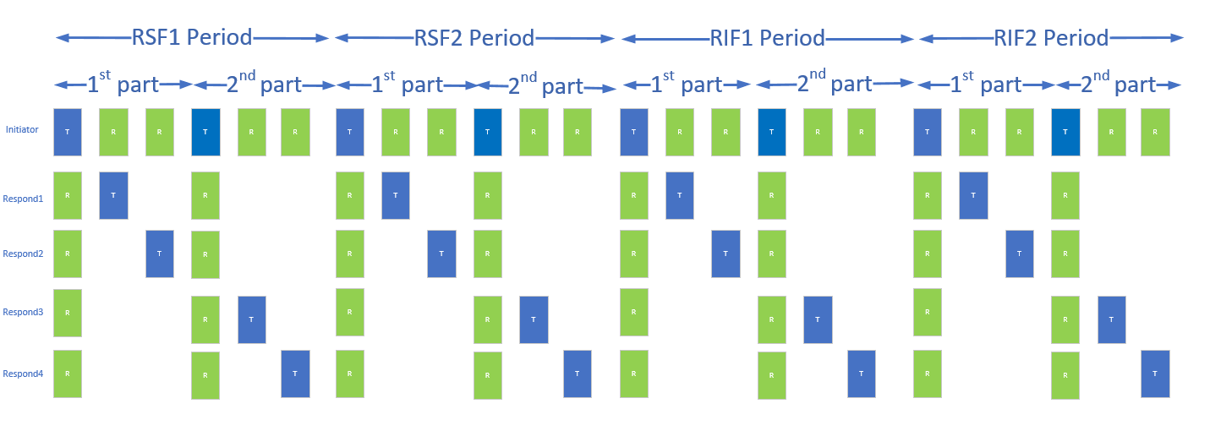
Figure 42—Illustration of RSF and RIF DS-TWR time efficient one-to-many MMS ranging
When there are odd number responds, the responds cannot be separated into two parts equally. The first half part of initiator RSF/RIF period should contains one more responds fragment than the second part and the second half part will be added a dummy fragment time at the last fragment. The below chart shows where the dummy fragment locates, and the first part fragments are one more than second part fragments.
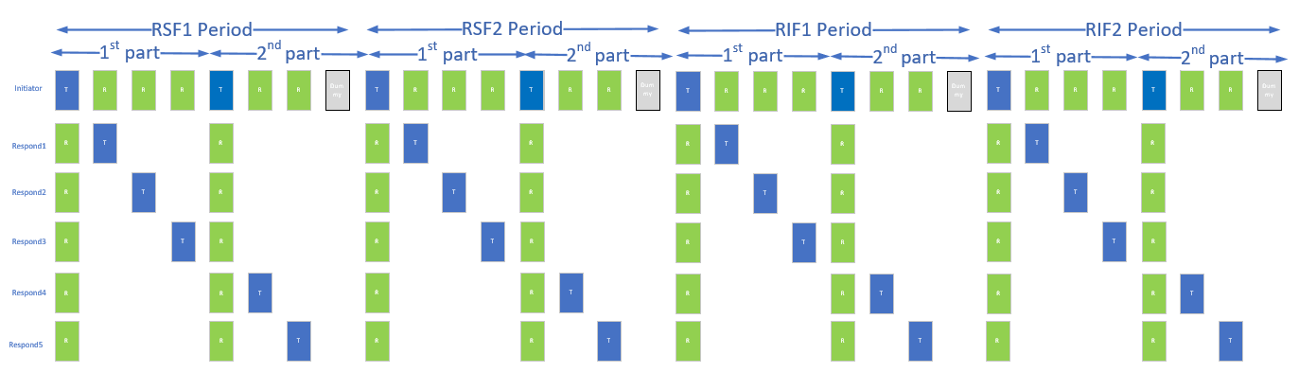
Figure 43—Illustration of RSF and RIF DS-TWR Ranging dummy fragment position
In each RSF/RIF period, there are first part and second part. The first part and second part times are the same and they are equal to a normal slot. Normally it should be configured to 1200RSTUs(1ms) and the slot should configured to multiple of 1200RSTUs(1ms) if the amount of responds are too many to insert into 2ms.
As a ranging initialization message, the Poll Compact frame with the Message Control field set to 0xB0 or 0xC0 serves to enable the time efficient one-to-many DS-TWR from an initiator to more than or equal to 2 responders. In the message content field, the number of responders should be set to 2 or more, and the start slot index is set to start slot index of ranging phase. In the Responder Detail List, there are number of responders detail information which include responder address and sequence number. The sequence number is the order for responder Tx packet.
The whole RSF period contains 2 slots and is divided into [ceil (1+ number of responds)/2]*2 fragments equally. For example, when 1 initiator and 4 responder ranging, the RSF periods 2 slot will be divided into [ceil(1+4)/2]*2 = 6 fragment time equally ,each is 1/3 slot. and divided into 8 fragments, each is 1/4 slot when 1 initiator and 5 responders ranging. Each respond needs to Tx according to its sequence number assigned in Responder Detail element format. And know its ranging method is DS-TWR or eSS-TWR according to the sequence number also. If the sequence number is smaller than or equal to ceil (Number of Responders/2), it should use DS-TWR. Otherwise, it should use eSS-TWR.
10.38.10.12 One-to-many Poll Compact frame
add words after
“When the Message Control field value is 0xA0 the Message Content is the same as for Message Control field value is 0x90, except this one-to-many poll Compact frame is signaling that both initiator and responder devices are to send a measurement report. “
When the Message Control field value is 0xB0 the Message Content field shall be formatted as shown in Figure 90.
Octets: 1 | Octets: 1 | variable
Number of Responders | Start Slot Index | Responder Detail List
Figure 88—Format of the Message Content field in the One-to-many Poll Compact frame when the Message Control field value is 0xB0
Octets: 3 | 1
Responder Address | Sequence number
Figure 91—Responder Detail element format (Message Control = 0xB0)

