IEEE P802.15
Wireless Personal Area Networks

Project | IEEE P802.15 Working Group for Wireless Personal Area Networks (WPANs)
Title | DraftC comment resolution - MMS ranging phase offset - CIDs 206, 207, 695
Date Submitted | May 03, 2024
Sources | Alex Krebs (Apple)  krebs @ apple.com
Re:
Abstract
Purpose | To propose resolution for MMS related comments for “P802.15.4ab™/D (pre-ballot) C Draft Standard for Low-Rate Wireless Networks”.
Notice | This document does not represent the agreed views of the IEEE 802.15 Working Group or IEEE 802.15.4ab Task Group. It represents only the views of the participants listed in the “Sources” field above. It is offered as a basis for discussion and is not binding on the contributing individuals. The material in this document is subject to change in form and content after further study. The contributors reserve the right to add, amend or withdraw material contained herein.

Name | CID | p. | Sub-clause | l. | Comment | Proposed Change | Proposed Resolution
Billy Verso | 206 | 51 | 10.38.5 | 23 | Figure 21 shows RSF exactly 1ms or 2ms start to start away from the NB packet, but this text is suggesting that the RSF position is variable using the RpRsfOffset configuration, which is itself confusing as it is offset from some a poorly defined start of the ranging phase | Delete RpRsfOffset. | Revise. (Accept, changes see below)
Carl Murray | 695 | 51 | 10.38.5 | 23 | Recommend replacing both RpRsfOffset and RpRifOffset with a single parameter as RpRifOffset is redundant, eg RpFirstFragmentOffset |  | Revise. (see #206, + MAC changes following DraftB #140 made RpRifOffset 2ms static)

Instructions to the editor: Change p.51 starting l.20 as follows:

10.38.5 UWB MMS ranging phase

The UWB MMS ranging phase follows the control phase.
In the ranging phase, the initiator shall transmit phyUwbMmsRsfNumberFrags RSF fragments starting its
first fragment at RpRsfOffset into the ranging phase, with each subsequent RSF fragment starting 1200
RSTU from the start of the previous one.
The initiator may start transmitting a first RIF fragment at RpRifOffset slots into the ranging phase if no
RSF fragments are present, or RpRifOffset after the start of its last RSF fragment transmission otherwise.
The initiator may continue to send up to phyUwbMmsRifNumberFrags RIF fragments at regular intervals of
1200 RSTU.

The responder may start transmitting a first RSF fragment at 600 RSTU into the ranging
phase. The responder may continue to send up to phyUwbMmsRifNumberFrags RIF fragments at regular
intervals of 1200 RSTU.

The responder may start transmitting a first RIF fragment at 600 RSTU into the ranging
phase if no RSF fragments were transmitted, or RpRifOffset after the start of its last RSF fragment
transmission otherwise. The responder may continue to send up to phyUwbMmsRifNumberFrags RIF
fragments at regular intervals of 1200 RSTU.

The value of RpRifOffset is 2 ms if RSF fragments were transmitted, and 0 ms otherwise..

Figure 29 shows an example UWB MMS ranging phase. In the figure, X is phyUwbMmsRsfNumberFrags
and Y is phyUwbMmsRifNumberFrags either of which may be zero. The total duration of the UWB MMS
ranging phase is macMmsRpDuration slots. macMmsRpDuration shall be set at minimum to the required
duration for all RSF and RIF fragments to be transmitted and received but may be larger to provide
flexibility in scheduling the report phase.

After macMmsRpDuration and transmission and reception of all fragments, the device enters the reporting
phase if this is enabled, for sending/receiving the ranging reports as appropriate, otherwise the ranging
round is completed at this time, (e.g., when the ranging report is conveyed via an OOB mechanism).

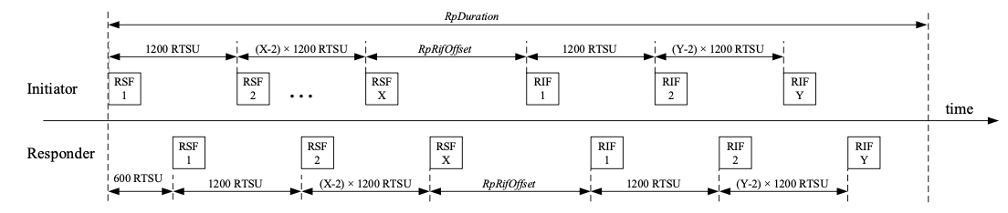
Figure 29—Example UWB MMS ranging phase

Note to the editor: typo in Figure 29: RTSU-->RSTU .

Billy Verso | 207 | 52 |  | 10 | This line is mandating that macMmsRpDuration be set to a certain value, which if this is being done by the upper layer, might be better being rephrased to dictate MAC behavior instead. Also this ranging phase should include the RpRsfOffset if it is still needed, (I proposed deleting in an earlier comment). | Reword to say macMmsRpDuration shall be ignored if it is less than RIF + RSF + whatever required in minimum duration case. | Revise: apply Option 1 as shown below

Option 1: Revise

Discussion: Aims to to correct configuration error at receiver side

Disposition detail:

Instructions to the editor: On p.68, assign bits 44-47 to "Reserved" in l.1, remove lines 30-31, and change l.27-29 as follows:
The RpDuration field encodes the duration RpDuration of the MMS ranging phase (described in 10.38.5)
used by intiator and responders for transmission of RSF and RIF fragments in units of ranging slots in the
range 1 to 4095. If the value of the RpDuration field is smaller than the time difference between the start of the first fragment and the end of the last fragment, then the field value shall be ignored and macMmsRpDuration shall be set to the minimum number of slots needed to cover all UWB MMS fragment transmissions of the ranging round. The field value of 0 is reserved.

Option 2: Reject

Discussion: Correct initiator behavior is mandated, adding receiver error handling will set false precedent. p.52 l.10 states explicitly:
"macMmsRpDuration shall be set at minimum to the required duration for all RSF and RIF fragments to be transmitted and received but may be larger to provide flexibility in scheduling the report phase."

