IEEE P802.15
Wireless Personal Area Networks

Project | IEEE P802.15 Working Group for Wireless Personal Area Networks (WPANs)
Title | Proposed resolution for block scheduling in hyper block mode for P802.15.4ab™/Draft (pre-ballot) C
Date Submitted | Mar 2024
Sources | Hong Won Lee, Insun Jang, Jinsoo Choi, HanGyu Cho (LG Electronics)
Re:
Abstract
Purpose | To propose comments and proposed changes to “P802.15.4ab™/ Draft (pre-ballot) C Draft Standard for Low-Rate Wireless Networks”.
Notice | This document does not represent the agreed views of the IEEE 802.15 Working Group or IEEE 802.15.4ab Task Group. It represents only the views of the participants listed in the “Sources” field above. It is offered as a basis for discussion and is not binding on the contributing individuals. The material in this document is subject to change in form and content after further study. The contributors reserve the right to add, amend or withdraw material contained herein.

Abstract
This submission contains the proposed comment resolutions for the CIDs 1, 4, 198, 199, 529, 530, and 594

R0: initial document

This document aims to propose a resolution proposal regarding the RR IE comment for P802.15.4ab™/ Draft (pre-ballot) C Draft Standard
Comment index #1 in 15-24-0010-14-04ab-tg4ab-consolidated-comments-draft-c.xlsx
Name | Index # | Pg | Sub-clause | Ln | Comment | Proposed change | Disposition
Li-Hsiang Sun | 1 | 31 | 10.31.3.5 | 18 | "When block assignment scheduling (as specified by the Scheduling IE, defined in 10.31.9.10)  is not used,", should Bitmap-based block scheduling also be excluded (for hopping within the same block index)? | Change to "When block assignment scheduling or bitmap-based block scheduling (as specified by the Scheduling IE, defined in 10.31.9.10)  is not used," or revise the requirement as suggested in the next CID | Revised

Discussion:
This proposed change is aligned with resolution proposal for CID#2, 5, 314, 590 and 925 to describe round hopping rule in hyper block mode. The description for round hopping rule in hyper block mode is included in “15-24-0111-00-04ab-proposed-resolution-for-hyperblock-block-assignment.docx”.
The Bitmap-based block scheduling (Scheduling IE Type 5) is not for round hopping. Therefore, it is not necessary to include the Bitmap-based block scheduling for the hopping operation rule. However, in the round hopping rule, a note could be added that the Bitmap-based block scheduling is not used when the round hopping with RR IE for hyper block mode because it is assumed that responder(s) know the Block Index, and the Block index is same in the next hyper block when the round hopping with RR IE for hyper block mode is operated. In other words, Bitmap-based block scheduling or other scheduling method doesn’t have to be applied when hopping is enabled with RR IE in hyper block mode
Resolution: Revised
Proposed text change on P802.15.4ab™/Draft (pre-ballot) C:
10.31.3.5 Hyper block mode
- Original Text
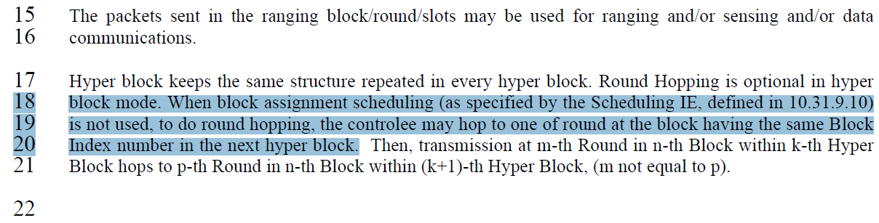
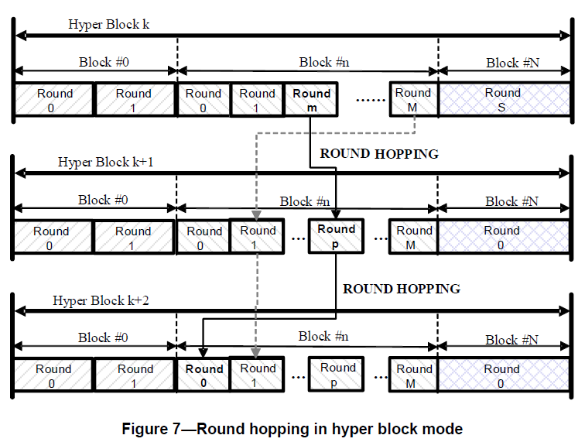

- Proposed change
Revise the sub-clause 10.31.3.5 Hyper block mode in IEEE P802.15.4ab/Draft (pre-ballot) C as follows:
(pp. 31 line #xx)
Hyper block keeps the same structure repeated in every hyper block. Round hopping is optional in hyper block mode. Round hopping may be performed in the hyper block mode in one of the following methods:
- If a controlee receives an Enhanced Ranging Round IE (ERR IE) (as described in 10.31.9.11) in which the Hopping Mode field is set to one, the controlee may hop to one of the ranging rounds in the ranging block indicated by the ERR IE.
- If the controlee receives a Scheduling IE (as described in 10.31.9.10) with the Scheduling List Type equal to six in which the controlee’s address is present in a Block Assignment field in which the Hopping Mode field is set to one, the controlee may hop to one of the ranging rounds in the ranging block indicated by the Block Assignment field.
- Otherwise, if the controlee receives a second RR IE in its ranging round in which the Hopping Mode field is set to one, the controlee may hop to one of round at the block having the same Block Index number in the next hyper block.
Note – If the controlee receives a second RR IE in its ranging round in which the Hopping Mode field is set to one, any other block scheduling method (e.g. Bitmap-based block scheduling) in hyper block mode is not necessary.

Comment index #529 in 15-24-0010-14-04ab-tg4ab-consolidated-comments-draft-c.xlsx
Name | Index # | Pg | Sub-clause | Ln | Comment | Proposed change | Disposition
Hong Won Lee | 529 | 32 | 10.31.9.3 | 29-30 | RR IE signaling rule is not described for hyper block mode | RR IE signaling method should be additionally described for the hyper block mode  Proposed change text is 15-24-0003-00-04ab-proposed-change-for-RR-IE.doc | Revised

Discussion:
The signalling behaviour for the RR IE in hyper block mode may need to be clarified. In case of hyper block mode, the signalling behaviour for the RR IE is mostly the same as described in section 10.31.9.3. However, the signalling behaviour for the RR IE, as described in section 10.31.9.3, may need further clarification for hyper block mode. In the description to signal the RR IE on page #47, lines 7-18 in IEEE Std 802.15.4z-2020, signalling behaviour explains only how RR IE is signalled for block-based mode. The signalling information for the next ranging round between block-based mode and hyper block mode is different, and this difference should be additionally explained for the hyper block mode.
Resolution: Revised
Proposed text change on P802.15.4ab™/Draft (pre-ballot) C:
10.31.9.3 Ranging Round IE (RR IE)
- Original Text
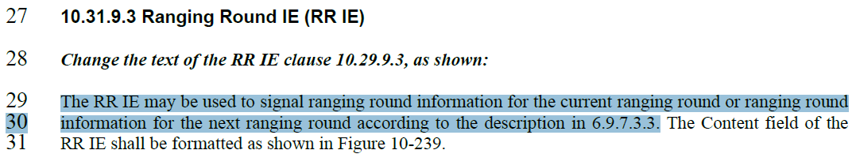

- Proposed change
Revise the sub-clause 10.31.9.3 Ranging Round IE (RR IE) in IEEE P802.15.4ab/Draft (pre-ballot) C as follows:
10.31.9.3 Ranging Round IE (RR IE)

(pp. 32 line #29)
The RR IE may be used to signal ranging round information for the current ranging round or ranging round information for the next ranging round, in both block-based mode and hyper block mode according to the description in section 6.9.7.3.3. However, in case of hyper block mode, the "next ranging block" or “ranging block i+1” mentioned in section 6.9.7.3.3 does not specify the next ranging block in the current hyper block (k), but rather specifies the ranging block in the next hyper block with the same block index as the current ranging block (i.e., ranging block i in hyper block k+1).
…

Comment index #4 in 15-24-0010-14-04ab-tg4ab-consolidated-comments-draft-c.xlsx
Name | Index # | Pg | Sub-clause | Ln | Comment | Proposed change | Disposition
Li-Hsiang Sun | 4 | 33 | 10.31.3.5 | 14 | "The RR IE is used in block-based mode and in hyper block mode without block assignment scheduling." should Bitmap-based block scheduling also be excluded for hopping within the same block index? | Change L14 to "The RR IE is used in block-based mode and in hyper block mode with neither block assignment scheduling nor bitmap-based scheduling".  Change L2 to "In hyper block mode, when neither block assignment scheduling (as described in 10.31.9.10 Scheduling IE) nor bitmap-based block scheduling is used, the Ranging Block Index field is assumed to specify Hyper Block Index for the ranging hyper block 4 and controlee may assume the block index will be the same with previous hyper block." | Revised

Discussion:
Basically, the Commentor is correct. It could be accepted. Small change from the commentor’s proposed change is applied. Additionally, RR IE can be used both in block-based mode and in hyper block mode. Only difference is the meaning of the Ranging Block index in hyper block mode when neither block assignment scheduling nor Bitmap-based block scheduling is used. Therefore, in P33L15, “without block assignment scheduling” is removed
Resolution: Revised

Proposed text change on P802.15.4ab™/Draft (pre-ballot) C:
10.31.9.3 Ranging Round IE (RR IE)
- Original Text
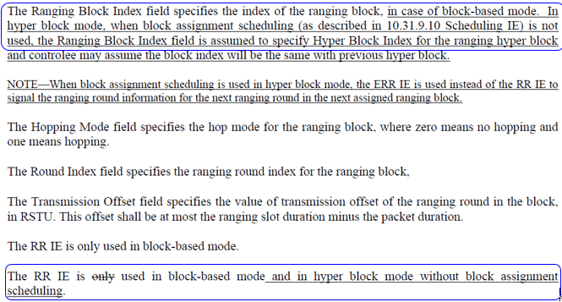
- Proposed change
Revise the sub-clause 10.31.9.3 Ranging Round IE (RR IE) in IEEE P802.15.4ab/Draft (pre-ballot) C as follows:
(pp. 33 line #2-4)
The Ranging Block Index field specifies the index of the ranging block except in hyper block mode when neither block assignment scheduling nor Bitmap-based block scheduling (as described in 10.31.9.10 Scheduling IE) is used. In hyper block mode when neither block assignment scheduling nor Bitmap-based block scheduling is used, the Ranging Block Index field is assumed to specify Hyper Block Index for the ranging hyper block and controlee may assume the block index will be the same with previous hyper block.
(pp. 33 line #14-15)
The RR IE is used both in block-based mode and in hyper block mode

Comment index #199, 530 in 15-24-0010-14-04ab-tg4ab-consolidated-comments-draft-c.xlsx
Name | Index # | Pg | Sub-clause | Ln | Comment | Proposed change | Disposition
Billy Verso | 199 | 34 | 10.31.9.10 | 19 | Sentence beginning with "For example," is long and is not clear in meaning. | Sentence should be reworded/clarified, perhaps as a number of shorter sentences. | Revised
Hong Won Lee | 530 | 34 | 10.31.9.10 | 20 | The reference of behavior for HBS IE should be indicated correctly. The subsection 10.31.9.12 is definition of the HBS IE, however there is no description of transmission cycle. It is described in the subsection 10.31.3.5 | Change from "For example, Scheduling IE with Scheduling List Type 5 may be transmitted with same cycle of HBS IE, defined in 10.31.9.12, for hyper block mode scheduling and the bitmap in each Scheduling List element represents scheduled blocks to a single device in a hyper block." to "For example, Scheduling IE with Scheduling List Type 5 may be transmitted with same cycle of HBS IE, as described in 10.31.3.5, for hyper block mode scheduling, and the bitmap in each Scheduling List element represents scheduled blocks to a single device in a hyper block." | Revised

Discussion:
The intention to refer is to describe behaviour of transmitting HBS IE. The reference should be changed from HBS IE definition to HBS IE transmission behaviour. With applying this, the sentence may be clarified through making a number of shorter sentences
Resolution: Revised

Proposed text change on P802.15.4ab™/Draft (pre-ballot) C:
10.31.9.10 Scheduling IE
- Original Text
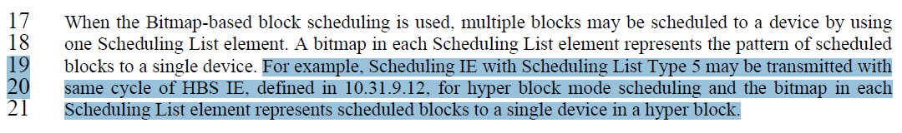
- Proposed change
Revise the sub-clause 10.31.9.10 Scheduling IE in IEEE P802.15.4ab/Draft (pre-ballot) C as follows:
(pp. 34 line #19-21)
For example, Scheduling IE with Scheduling List Type 5 may be transmitted with the same cycle as the HBS IE, as described in 10.31.3.5, for block scheduling in hyper block mode. The Block Scheduling Bitmap of the Scheduling IE represents multiple ranging blocks assigned to a device for transmission using a single Scheduling List element in a hyper block.

Comment index #198 in 15-24-0010-14-04ab-tg4ab-consolidated-comments-draft-c.xlsx
Name | Index # | Pg | Sub-clause | Ln | Comment | Proposed change | Disposition
Billy Verso | 198 | 34 | 10.31.3.5 | 17 | Phrase is slightly unclear, I recommend modification as per proposed change. Assuming I have taken the correct meaning. | Change "multiple blocks may be scheduled to a device by using one Scheduling List element." to | Revised

Discussion:
Proposed change is missed and provided by the commenter later. Agreed to the Commenter. For clarity “slots”, “rounds” and “blocks” should be called “ranging slots”, “ranging rounds” and “ranging blocks”. Same terminology “scheduled to a device” used in four places, so it would be good to change all four of them in a similar way
Resolution: Revised
Proposed text change on P802.15.4ab™/Draft (pre-ballot) C:
10.31.9.10 Scheduling IE
- Original Text
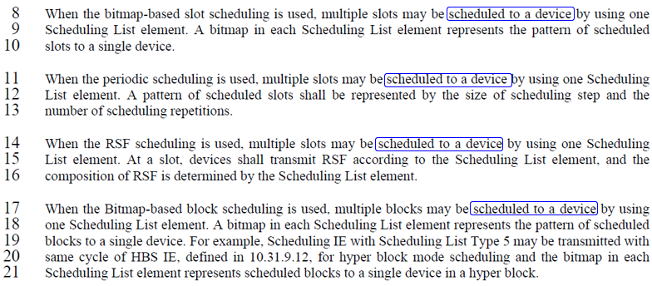
- Proposed change
Revise the sub-clause 10.31.9.10 Scheduling IE in IEEE P802.15.4ab/Draft (pre-ballot) C as follows:
(pp. 34 line #8, 11, 14)
multiple ranging slots may be assigned to a device for transmissions using a single Scheduling List element

(pp. 34 line #17)
When the Bitmap-based block scheduling is used, one or multiple ranging blocks may be assigned to a device for transmissions using a single Scheduling List element.
Comment index #594 in 15-24-0010-14-04ab-tg4ab-consolidated-comments-draft-c.xlsx
Name | Index # | Pg | Sub-clause | Ln | Comment | Proposed change | Disposition
Rojan Chitrakar | 594 | 37 | 10.31.9.10 | 21 | Table 5 allows a maximum bitmap length of 64 bits, however block index field may be 1 or even 2 octets, meaning there will be more than 64 blocks per hyper block. How are the rest of blocks (with index > 64) signaled? | The Block scheduling Bitmap Length field should be larger to signal all the blocks in a hyper block. | Revised

Discussion:
Extend the size of the Block Scheduling Bitmap in Scheduling List Element for bitmap-based Block scheduling is needed since the Ranging Block Index in HBS IE and RR IE (from 4z) is 2 octets. However, it is discussed that the size of the Ranging Block Index is reduced to 1 octet. Adding new field in Scheduling List element format with Scheduling List Type five can be applied to extend the size of the Block Scheduling Bitmap
Resolution: Revised
Proposed text change on P802.15.4ab™/Draft (pre-ballot) C:
- Original Text
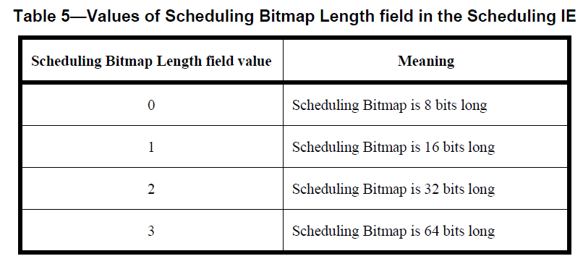
….
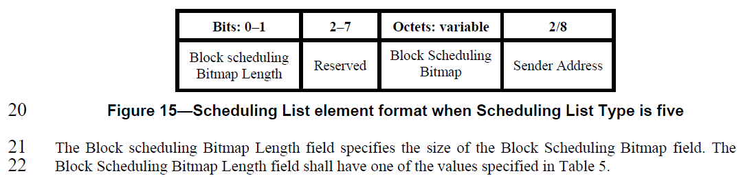
….

- Proposed change
Revise the sub-clause 10.31.9.10 Scheduling IE in IEEE P802.15.4ab/Draft (pre-ballot) C as follows:
10.31.9.10 Scheduling IE
--------------------------------------------------------------------------------------------------------------------------------
….
(pp. 37 line #20)
Bits: 0–1 | 2 | 3–7 | Octets: variable | 2/8
Block scheduling Bitmap Length | Scaling Factor | Reserved | Block Scheduling Bitmap | Sender Address
Figure 15—Scheduling List element format when Scheduling List Type is five
…
(pp. 37 line #23)
The Scaling Factor is a multiple of the value of the size of Block Scheduling Bitmap field. The Value of the Scaling Factors are defined in Table X.
Table X—Values of Scaling Factors
Scaling Factor | Value
0 | 1
1 | 16

The size of the Block Scheduling Bitmap is determined by the Meaning of the Scheduling Bitmap Length field value times the Value of the Scaling Factor. If the Block scheduling Bitmap Length field value is set to 0(The Meaning is 8 bits long) and Scaling Factor is set to 1(The Value is 16), the size of the Block Scheduling Bitmap is 128.

