IEEE P802.15
Wireless Personal Area Networks

Project | IEEE P802.15 Working Group for Wireless Personal Area Networks (WPANs)
Title | Proposed resolution for MMS MAC public part2 for P802.15.4ab™/Draft (pre-ballot) C
Date Submitted | Mar 2024
Sources | Hong Won Lee, Insun Jang, Jinsoo Choi, HanGyu Cho (LG Electronics)
Re: | Contribution to IEEE 802.15.4ab
Abstract
Purpose | To propose comments and proposed changes to “P802.15.4ab™/ Draft (pre-ballot) C Draft Standard for Low-Rate Wireless Networks”.
Notice | This document does not represent the agreed views of the IEEE 802.15 Working Group or IEEE 802.15.4ab Task Group. It represents only the views of the participants listed in the “Sources” field above. It is offered as a basis for discussion and is not binding on the contributing individuals. The material in this document is subject to change in form and content after further study. The contributors reserve the right to add, amend or withdraw material contained herein.

Abstract
This submission contains the proposed comment resolutions for the CIDs 534-538, 545, 649, 806, 808, 811 and 908

R0: initial document
R1: Update discussions and resolution proposals

This document aims to propose a resolution proposal regarding MMS comments for P802.15.4ab™/ Draft (pre-ballot) C Draft Standard
Comment indices #534, 535, 536, 537, 538 in 15-24-0010-14-04ab-tg4ab-consolidated-comments-draft-c.xlsx
Name | Index # | Pg | Sub-clause | Ln | Comment | Proposed change | Disposition
Hong Won Lee | 534 | 55 | 10.38.7.2 | 13 | Group ID shall be used for one-to-many broadcasting message | Change from "to-many" to "to-many broadcasting message" | Revised
Hong Won Lee | 535 | 55 | 10.38.7.2 | 16-20 | Group ID shall be used for one-to-many broadcasting message | Change from "A GroupID represents a group of devices in a one-to-many ranging session, as described in 10.38.9. By transmitting a Public Advertising Poll Compact frame with the MessageControl field set to 0x21 on the  initialization channel, a GroupID is shared with responders. The GroupID shall be used to generate the IRK for the RPA_hash used in One-to-many Poll Compact frame (message id 0x12) in the one-to-many ranging session, as described in 10.38.9, in case GroupID is shared with responders." to "In one-to-many session, POLL (one-to-many) message (message id 0x12, with MessageControl not set to 0x00) in the first sub-round shall be broadcasted as described in 10.35.8. After initialization using public addresses, an IRK for broadcasting message shall be generated. The IRK for broadcasting message is generated using a GroupID which represents a group of devices in a one-to-many ranging session. By transmitting a Public Advertising Poll Compact frame with the MessageControl field set to 0x21 on the  initialization channel, a GroupID is shared with responders." | Revised
Hong Won Lee | 536 | 55 | 10.38.7.2 | 23 | Group ID shall be used for one-to-many broadcasting message | Change from "One-to-many Poll Compact message (message id 0x12)" to "One-to-many Poll Compact message (message id 0x12, with MessageControl not set to 0x00)" | Revised
Hong Won Lee | 537 | 55 | 10.38.7.2 | 31 | Group ID shall be used for one-to-many broadcasting message | Change from "IRK2 (for One-to-many Poll Compact frame, message id 0x12)" to "IRK2 (for One-to-many Poll Compact frame, message id 0x12, with Message Control field not set to 0x00)" | Revised
Hong Won Lee | 538 | 56 | 10.38.7.2 | 3 | Group ID shall be used for one-to-many broadcasting message | Change from "IRK2 (for One-to-many Poll Compact frame, message id 0x12)" to "IRK2 (for One-to-many Poll Compact frame, message id 0x12, with Message Control field not set to 0x00)" | Revised

Discussion:
The IRK for RPA_hash of One-to-many Poll Compact frame (Message Control not set to 0x00, multicast) after initialization using public addresses should be generated using the Group ID. The IRK for RPA_hash of one-to-many Poll Compact frame for sub-rounds (Message Control set to 0x00, unicast) after initialization using public addresses should be generated using InitiatorAddr and RespAddr. This changes to clarify which IRK should be used for RPA_hash generation according to Message Control id of One-to-many Poll Compact frame.
Resolution: Revised

Proposed text change on P802.15.4ab™/Draft (pre-ballot) C:
10.38.7.2 RPA_hash generation and resolution after initialization using public addresses
- Original Text
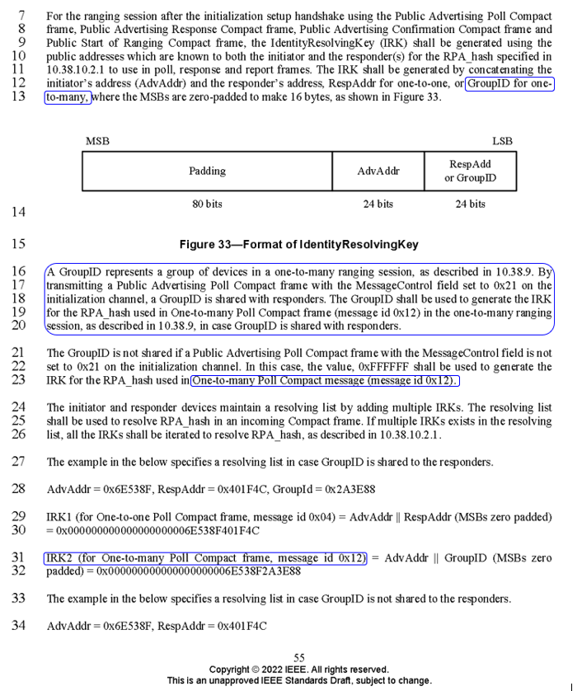
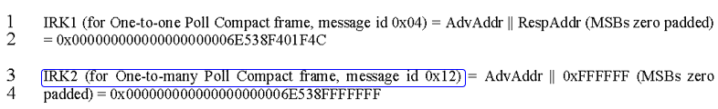

- Proposed change
Revise the sub-clause 10.38.7.2 RPA_hash generation and resolution after initialization using public addresses in IEEE P802.15.4ab/Draft (pre-ballot) C as follows:
10.38.3.2.4.2 RPA_hash generation and resolution after initialization using public addresses
……….
CID#534(pp. 55 L13)
The IRK shall be generated by concatenating the initiator’s address (InitiatorAddr) and the responder’s address, RespAddr for one-to-one POLL compact frame, or GroupID for applicable one-to-many POLL compact frame, where the MSBs are zero-padded to make 16 bytes, as shown in Figure 33.
……….
CID#535(pp. 55 L16-18)
In a one-to-many session, a one-to-many POLL compact frame in the first sub-round shall be transmitted to multiple responders as described in 10.38.9. To transmit to multiple responders simultaneously, the IRK for the one-to-many POLL compact frame with the Message Control field not set to 0x00 should be generated using a GroupID, which represents a group of multiple devices in a one-to-many ranging session. By transmitting a Public Advertising Poll Compact frame with the MessageControl field set to 0x21 on the initialization channel, a GroupID is shared with responders.
CID#536(pp. 55 L21-23)
The GroupID is not shared if a Public Advertising Poll Compact frame with the MessageControl field value is not set to 0x21 on the initialization channel. In this case, the value, 0xFFFFFF shall be used to generate the IRK for the RPA_hash used in One-to-many Poll Compact frame with the Message Control field not set to 0x00.
……….
CID#537(pp. 55 L31)
IRK2 (for One-to-many Poll Compact frame with the Message Control field not set to 0x00) = InitiatorAddr || GroupID (MSBs zero padded) = 0x000000000000000000006E538F2A3E88
……….
CID#538(pp. 56 L3)
IRK2 (for One-to-many Poll Compact frame with the Message Control field not set to 0x00) = InitiatorAddr || 0xFFFFFF (MSBs zero padded) = 0x000000000000000000006E538FFFFFFF
……….

Comment index #806 and 808 in 15-24-0010-14-04ab-tg4ab-consolidated-comments-draft-c.xlsx
Name | Index # | Pg | Sub-clause | Ln | Comment | Proposed change | Disposition
Carl Murray | 806 | 91 | 10.38.10.16 | 9 | Consider moving variable fields to the end |  | Revised
Carl Murray | 808 | 91 | 10.38.10.16 | 13 | Consider moving variable fields to the end |  | Revised

Discussion:
The resolution proposal is prepared to adapt the commenter’s opinion. The variable field can be moved to the end. The size of the Adv Data field is changed based on approved resolution proposal, “15-24-0108-02-04ab-proposed-resolution-for-MMS-MAC-public_part1.docx”
Resolution: Revised
- Original Text
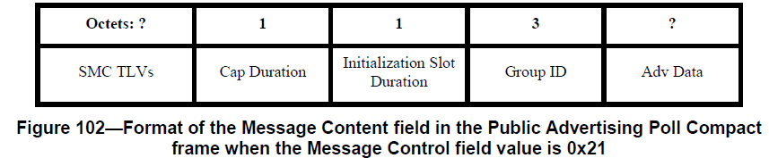
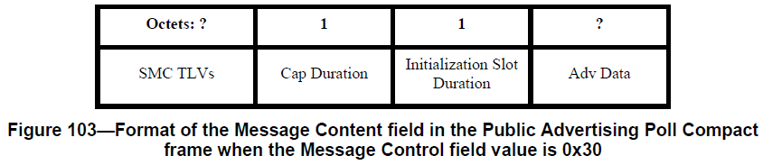
- Proposed Chane
Revise the sub-clause 10.38.10.16 Public Advertising Poll Compact frame in IEEE P802.15.4ab/Draft (pre-ballot) C as follows:
10.38.10.16 Public Advertising Poll Compact frame
……….
Pp91, L9
Octet: 1 | 1 | 3 | ? | 0 / variable
Cap Duration | Initialization Slot Duration | Group ID | SMC TLVs | Adv Data
……….
Pp91, L13
Octet: 1 | 1 | ? | 0 / variable
Cap Druation | Initialization Slot Duration | SMC TLVs | Adv Data

Comment index #649 in 15-24-0010-14-04ab-tg4ab-consolidated-comments-draft-c.xlsx
Name | Index # | Pg | Sub-clause | Ln | Comment | Proposed change | Disposition
Rojan Chitrakar | 649 | 91 | 10.38.10.16 | 20 | To allow the slot duration to be updated via the Public Advertising Poll, the Initialization Slot Duration field should be included in all Public Advertising Poll versions, not just the ones with Cap Duration. Initialization slots are also applicable in one-to-one session initialization (see 10.38.3.2 Session initialization) | as in comment | Revised

Discussion:
This resolution proposal is written based on the Commenter’s opinion. Initialization Slot Duration shall be included for whole Message Control ID in Public Advertising Poll Compact frame
Resolution: Revised
- Original Text
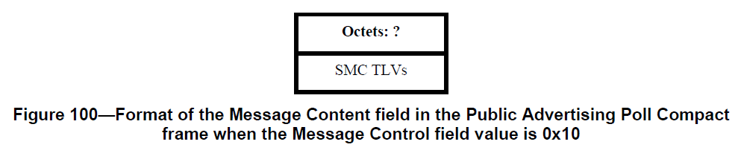
- Proposed Chane
Revise the sub-clause 10.38.10.16 Public Advertising Poll Compact frame in IEEE P802.15.4ab/Draft (pre-ballot) C as follows:
10.38.10.16 Public Advertising Poll Compact frame
……….
Pp91, L1
Octets: 1 | ?
Initialization Slot Duration | SMC TLVs

Comment index #811, 545 and 908 in 15-24-0010-14-04ab-tg4ab-consolidated-comments-draft-c.xlsx
Name | Index # | Pg | Sub-clause | Ln | Comment | Proposed change | Disposition
Rojan Chitrakar | 811 | 91 | 10.38.10.16 | 19 | Field description missing | Add field description | Revised
Hong Won Lee | 545 | 91 | 10.38.10.16 | 19 | The description of the Group ID field is missed | Change from "The Group ID field… ???" to "The Group ID field represents a group of devices in a one-to-many public ranging session. It is assigned by an initiator and used for broadcast messages in a one-to-many public ranging session described in 10.38.7.2." | Revised
Mickael Maman | 908 | 91 | 10.38.10.16 | 19 | The Group ID field… ??? | "The Group ID field is the ID of a group of devices in a one-to-many ranging session, as described in 10.38.9" | Revised

Discussion:
Regarding missing definition for Group ID, the description of the Group ID field should be defined

Resolution: Revised
Proposed text change on P802.15.4ab™/Draft (pre-ballot) C:
10.38.7.3 Advertisement information in Public Advertising Poll Compact frame
- Original Text
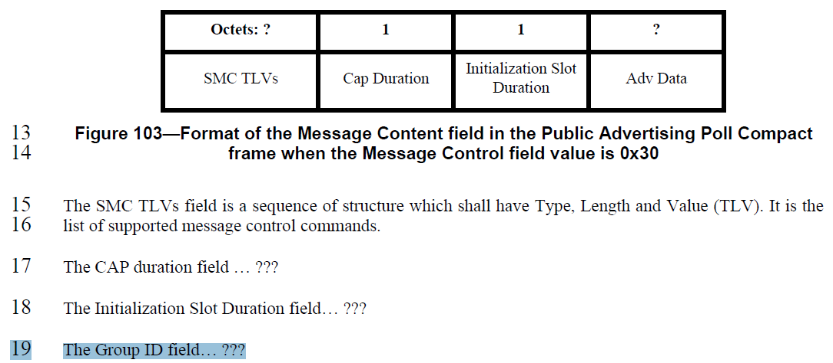
- Proposed change
Revise the sub-clause 10.38.10.16 Public Advertising Poll Compact frame in IEEE P802.15.4ab/Draft (pre-ballot) C as follows:
pp. 91 line #19
The Group ID field is the ID of a group of multiple responders in a one-to-many ranging session, as described in 10.38.3.2.4.2

