IEEE P802.15
Wireless Personal Area Networks

Project | IEEE P802.15 Working Group for Wireless Personal Area Networks (WPANs)
Title | Proposed Resolutions for Comments:  92, 93, 115, 117, 118, 176, 215, 216, 217, 218, 295, 297, 460, 839, 840,  841, 843, 877, 878, 879
Date Submitted | March 2024
Sources | Xiliang Luo (Apple)
Re:
Abstract
Purpose | To propose resolutions to comments for “P802.15.4ab™/Draft (pre-ballot) C Draft Standard for Low-Rate Wireless Networks”
Notice | This document does not represent the agreed views of the IEEE 802.15 Working Group or IEEE 802.15.4ab Task Group. It represents only the views of the participants listed in the “Sources” field above. It is offered as a basis for discussion and is not binding on the contributing individuals. The material in this document is subject to change in form and content after further study. The contributors reserve the right to add, amend or withdraw material contained herein.

1 CID #92, 839 (Accepted, Solved) 3
2 CID #93 (Solved) 4
3 CID #115 (Accepted, Solved) 5
4 CID #117, 295 (Accepted, Solved) 6
5 CID #118, 297 (Accepted, Solved) 7
6 CID #176 (Accepted, Solved) 8
7 CID #215, 216, 217, 218, 840 (Accepted, Solved) 9
8 CID #460 (Accepted, Solved) 12
9 CID #841 (Accepted, Solved) 13
10 CID #843 (Solved) 14
11 CID #877 (Accepted, Solved) 15
12 CID #878 (Solved) 16
13 CID #879 (Solved) 18

CID #92, 839 (Accepted, Solved)
Name | Idx # | Cat. | Pg. | Sub-clause | Line # | Comment | Proposed Change
Pooria Pakrooh | 92 | Technical | 104 | 10.38.12.2 | 6 | The modes in table 10 are mandatory for NBA-UWB-MMS mode of ARDEV. Not mandatory for UWB only, | Change to: "Table 10 provides a mandatory set of combinations of MMRS code index and gap size for NBA-UWB-MMS mode of ARDEV, used to form RSF, as described in 16.2.11.2."
Carl Murray | 839 | Technical | 104 | 10.38.12.1 | 3 | In the text describing MMS configurations there are "shalls" everywher on individual configurations - how does this relate to the mandatory set(combinations). Should every "shall" setting not be exercised?
Reference
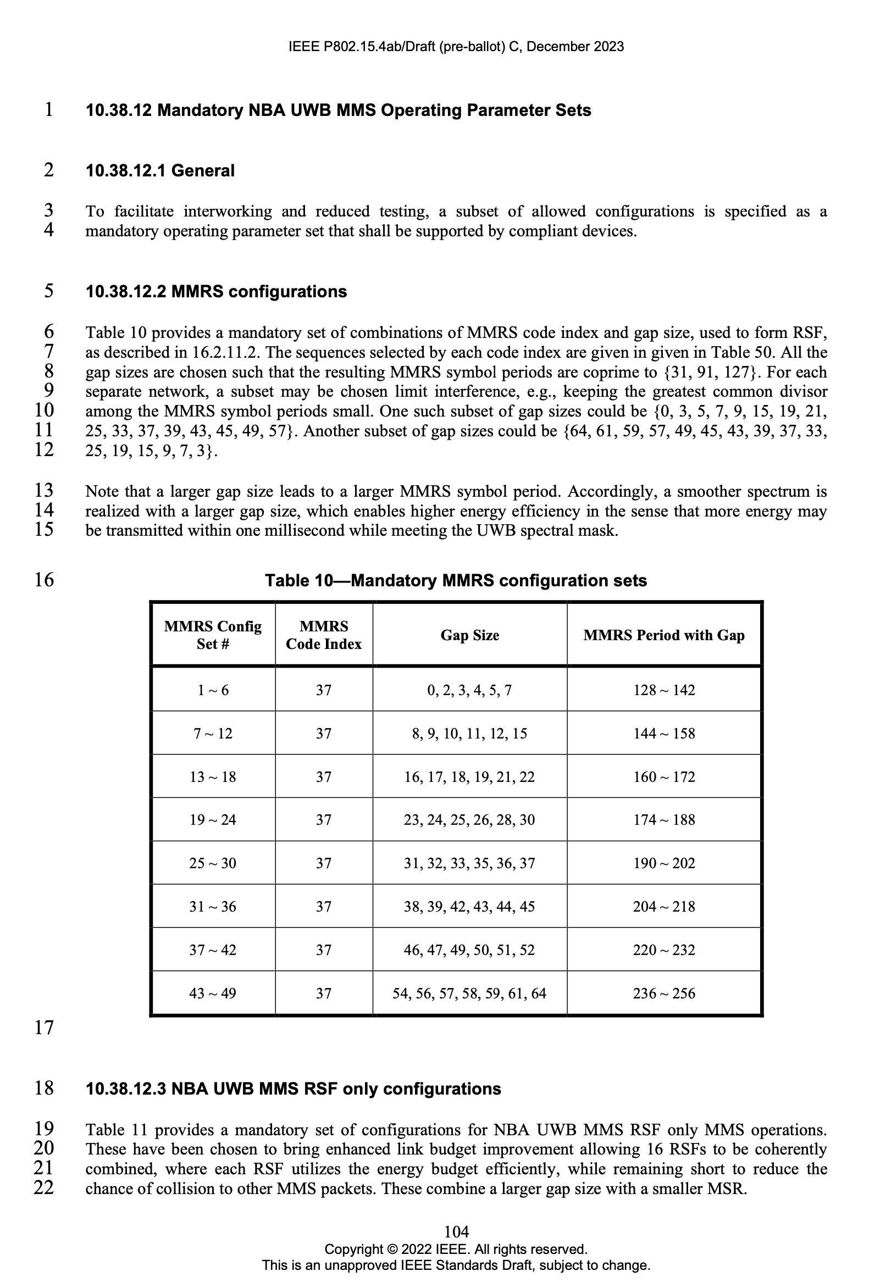
Proposed Resolution:
Change the sentence in line 6, page 104, to the following one:
“Table 10 provides a set of combinations of MMRS code index and gap size, used to form RSF, as described in 16.2.11.2. This set of combinations is mandatory for HRP-ARDEV when operating in the mode of NBA-UWB MMS. HRP-ARDEV should be support the combinations in Table 10 when operating in the mode of UWB Only MMS.”

CID #93 (Solved)
Name | Idx # | Cat. | Pg. | Sub-clause | Line # | Comment | Proposed Change
Pooria Pakrooh | 93 | Technical | 105 | 10.38.12.4 | 7 | Configs 2-4 have unequal RSF and RIF. Why do we need these? | Clarify the reasoning for having mixed MMS sets 2-4.
Reference
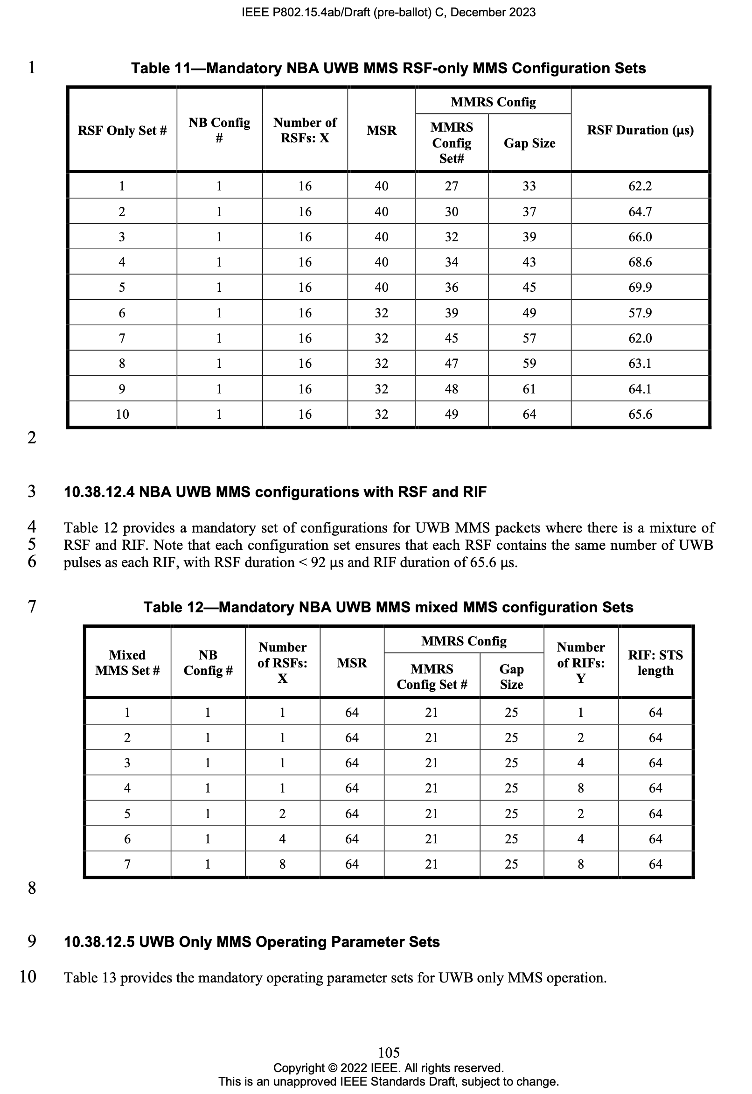
Proposed Resolution: No change to the draft-C spec.
These are from the agreed NBA-UWB MMS Technical Framework 15-23-0100-02-04ab and are called baseline modes therein. This is to enable different levels of security. Also clarified in Draft-C page 161, line 5.

CID #115 (Accepted, Solved)
Name | Idx # | Cat. | Pg. | Sub-clause | Line # | Comment | Proposed Change
Pooria Pakrooh | 115 | Technical | 155 | 16.1 | 18 | An HRP-ARDEV shall support mandatory features of UWB-driven MMS or NBA UWB MMS, in clause 10.38. | Add: "An HRP-ARDEV shall support mandatory features of UWB-driven MMS or NBA UWB MMS, in clause 10.38."
Reference
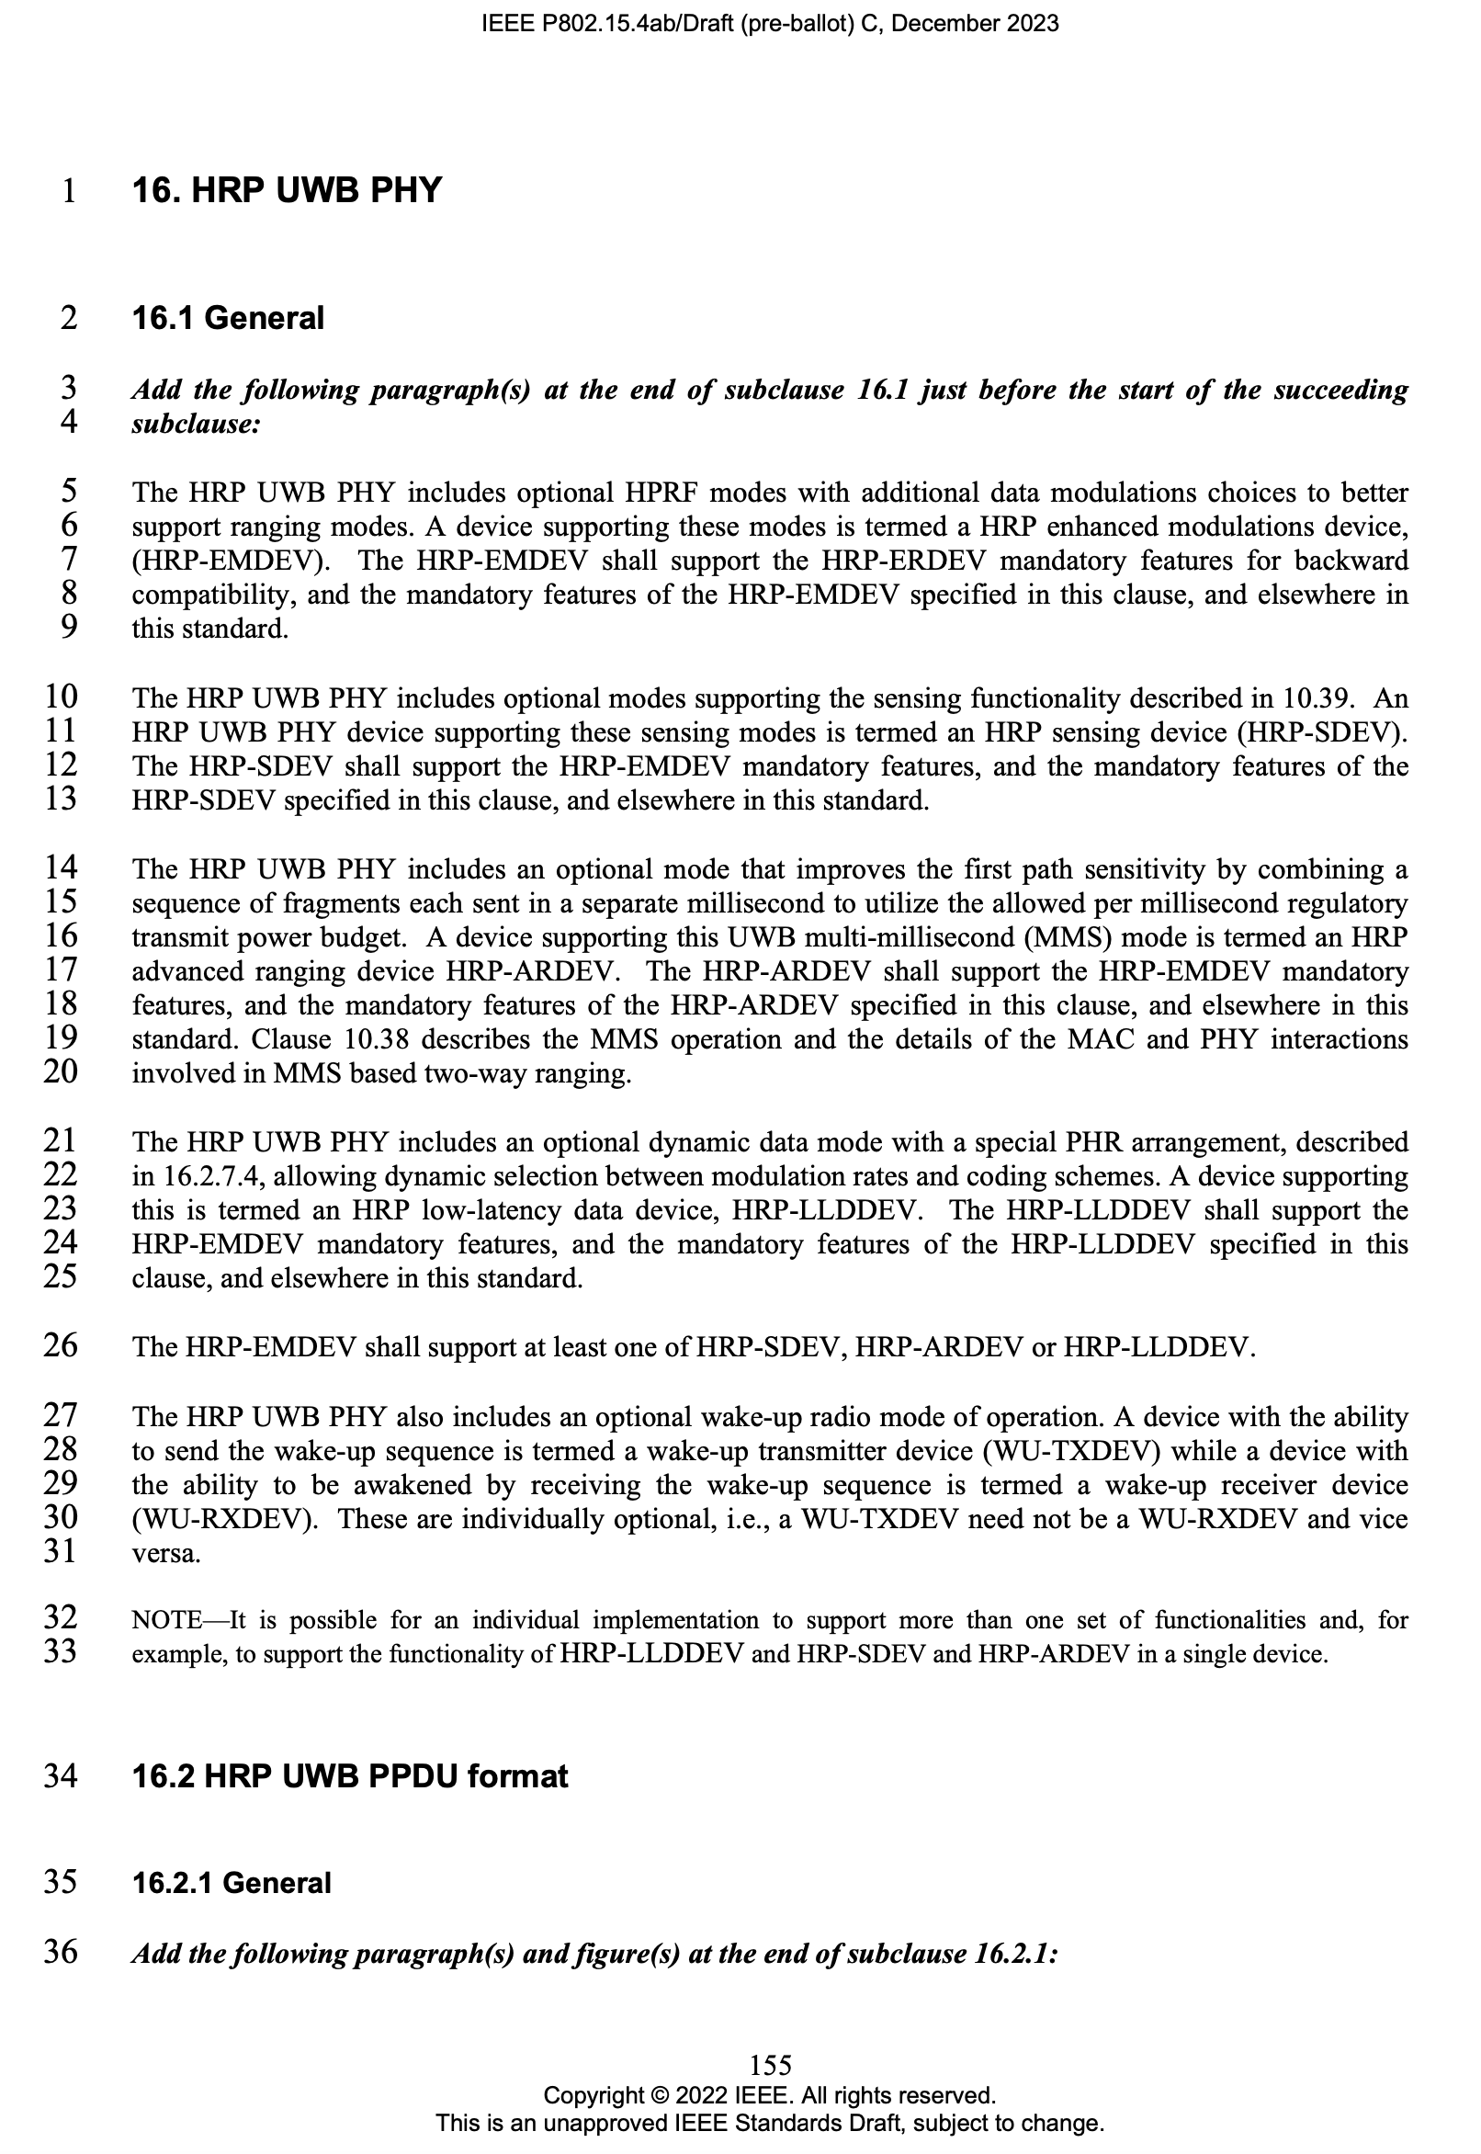
Proposed Resolution:
Change the sentence in line 18, page 155, to the following one:
“… features, either the UWB-Only MMS operation or the NBA-UWB MMS operation, and the mandatory features of the …”
Also, add the following sentence at the end of line 20, page 155:
“… based two-way ranging. The mandatory operating parameter sets for NBA-UWB MMS operation is specified in 10.38.12 and the mandatory operating parameter sets for NBA-UWB MMS operation is specified in 10.38.13.”

CID #117, 295 (Accepted, Solved)
Name | Idx # | Cat. | Pg. | Sub-clause | Line # | Comment | Proposed Change
Pooria Pakrooh | 117 | Technical | 160 | 16.2.11.1 | 9 | This sentence is inaccurate. The mandatory configs for UWB-driven MMS are specified in subclause 10.38.12.5. Not all of the configs here are mandatory to support for UWB-driven MMS. What is listed in 16.2.11.1 is mandatory for NBA-UWB-MMS. | Change the sentence to: "The NBA-UWB-MMS mode shall support transmission and reception the MMS modulation packet formats specified in this subclause."
Riku Pirhonen | 295 | General | 160 | 16.2.11.1 | 9 | Shall gives impression that all the specfied packet formats specified would have to be supported, adding "as" clarfies that the requirements are defined later in the subclause, and the shall doesn't apply to all possible permutations. The mandatory sets for various packet configurations are defined in 10.38.12. | …MMS modulation packet formats as specified in this subclause.
Reference
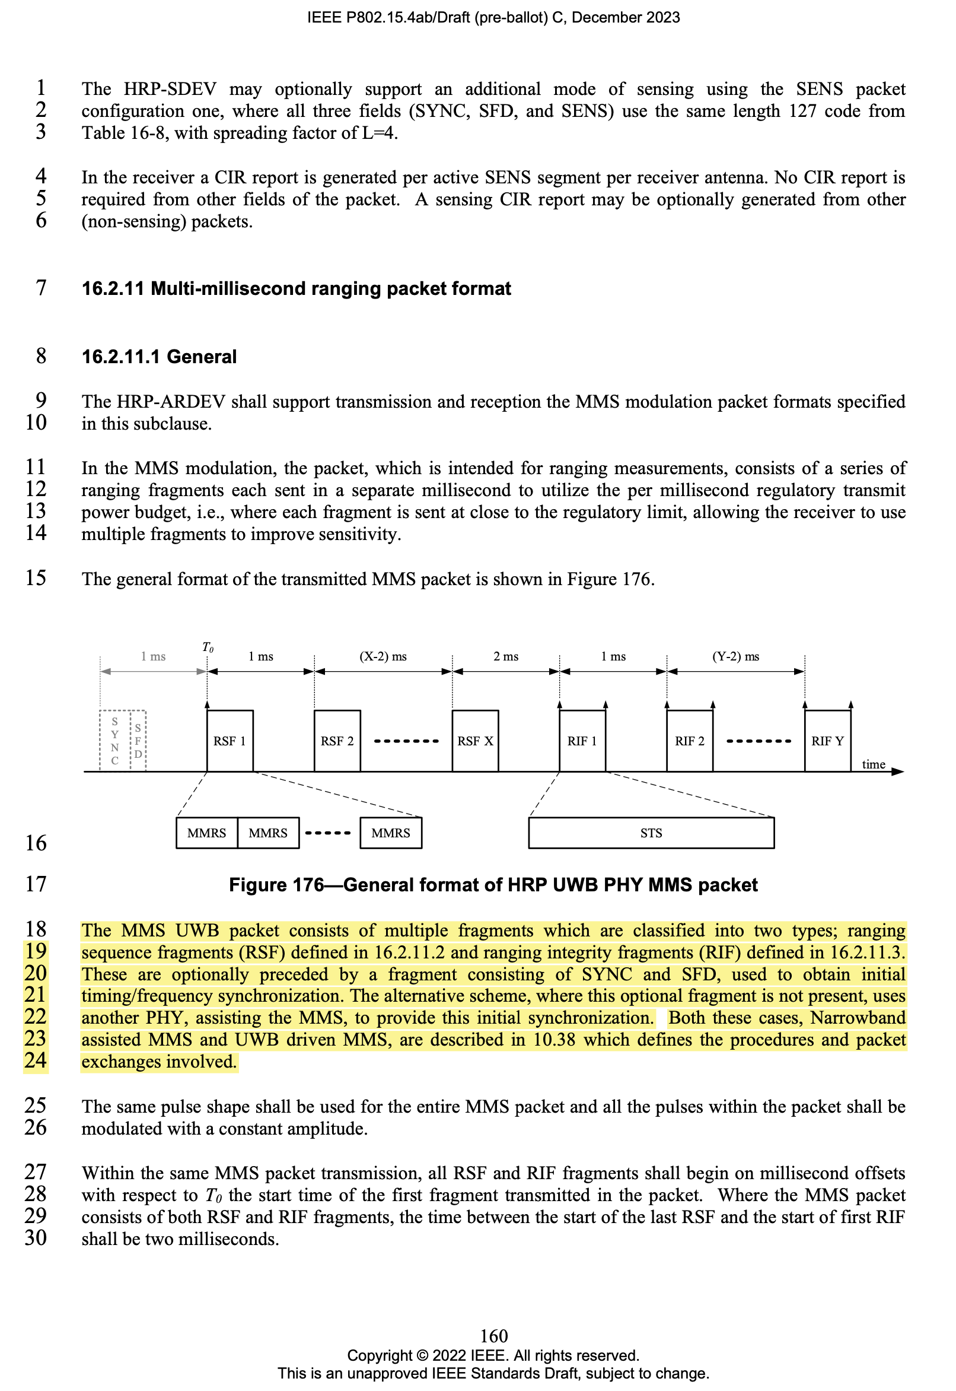
Proposed Resolution:
Change the sentence in line 9, page 160, to the following one:
“When operating in the mode of NBA-UWB MMS, the HRP-ARDEV shall support transmission and reception of the MMS modulation packet formats as specified in this subclause. When operating in the mode of UWB Only MMS, the HRP-ARDEV should support the MMS fragments as specified in this subclause. The mandatory parameter sets are specified in 10.38.”

CID #118, 297 (Accepted, Solved)
Name | Idx # | Cat. | Pg. | Sub-clause | Line # | Comment | Proposed Change
Pooria Pakrooh | 118 | Technical | 161 | 16.2.11.1 | 2 | The configs listed in this subclause are mandatory for NBA-UWB-MMS. The mandatory configs for UWB-driven MMS are specified in subclause 10.38.12.5. | Change to: "the following are the combinations that shall be supported in the NBA-UWB-MMS mode."
Riku Pirhonen | 297 | General | 161 | 16.2.11.1 | 2 | Lines 3 - 5 describe the modes that can be supported, but not all options or mode combinations are defined mandatory in 10.38.12. Change "shall" to "can", add defintion that at least one of the modes shall be supported, and add reference to the mandatory set tables in chapter 10.38.12. | .. the following are the combinations that shall can be supported by the HRP-ARDEV. A HRP-ARDEV shall support at least one of these MMS packets and corresponding configuration sets defined in 10.38.12 table 11, 12 or 13.
Reference
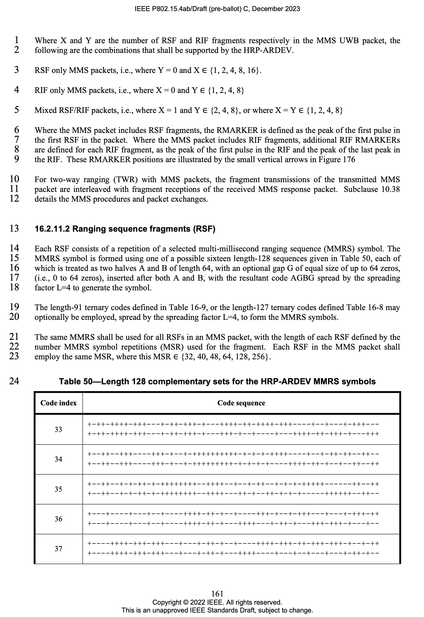
Proposed Resolution:
Change the sentence in line 2, page 161, to the following one:
“…, the following are the combinations for HRP-ARDEV.”

CID #176 (Accepted, Solved)
Name | Idx # | Cat. | Pg. | Sub-clause | Line # | Comment | Proposed Change
Benjamin Rolfe | 176 | Technical | 160 | 16.2.11.1 | 25 | "The same pulse shape shall be used for the entire MMS packet and all the pulses within the packet shall be modulated with a constant amplitude." will any pulse shape do, or do we have a specific pulse shape to specify in some way? E.g. reference to pulse shape definitions (or suggestions?) | Add reference to the pulse shape to use
Reference
Proposed Resolution:
Change the sentence in line 25, page 160, to the following one:
“The same pulse shape following the time domain mask as specified in Figure 16-24 in 16.4.4 shall be used for the entire MMS packet and all the pulses within the packet shall be modulated with a constant amplitude.”

CID #215, 216, 217, 218, 840 (Accepted, Solved)
Name | Idx # | Cat. | Pg. | Sub-clause | Line # | Comment | Proposed Change
Billy Verso | 215 | Technical | 104 | 10.38.12.2 | 16 | In Table 10, it is ambiguous how MMRS set numbers, gap sizes, and periods are related. To make it clear, should use one row for each configuration set. | Provide a table with one row for each configuration set so that the configurations are clear. To save space the MMRS Code Index value which is always 37 can be stated separately, and the table can probably then use 2 or 3 columns on the page.
Billy Verso | 216 | Technical | 104 | 10.38.12.2 | 17 | Units MMSR period not specified here. To save space the MMRS period is not needed in the table,. Instead can just note underneath that the symbol period is (128 + 2 x Gap) x (L=4) chips. | Remove MMRS period column, and add a note below with the formula to calculate period.
Billy Verso | 217 | Technical | 104 | 10.38.12.2 | 17 | The unit of the gap size should be specified. | Add something to specify the gap is in unspread code bits.
Billy Verso | 218 | Technical | 104 | 10.38.12.2 | 17 | Given that Table 12 Mandatory NBA UWB MMS mixed MMS configuration Sets, and Table 11 Mandatory NBA UWB MMS RSF-only MMS Configuration Sets only use MMRS indices, 21 and 27, 30, 32, 34, 36, 39, 45, 47, 48, 49 the other "Mandatory MMRS configuration sets" of Table 10 are not really mandatory since no mandatory packet uses them. | Reduce Table 10 to only capture the configuration numbers 21 and 27, 30, 32, 34, 36, 39, 45, 47, 48, 49 used in the mandatory packets defined in Tables 11 and 12.
Carl Murray | 840 | Technical | 104 | 10.38.12.2 | 16 | What is the meaning of the Mandatory MMRS configuration sets if in subsequent mandatory RSF and RIF configurations they are not used? They draw on a subset of the "mandatory" set.

Reference
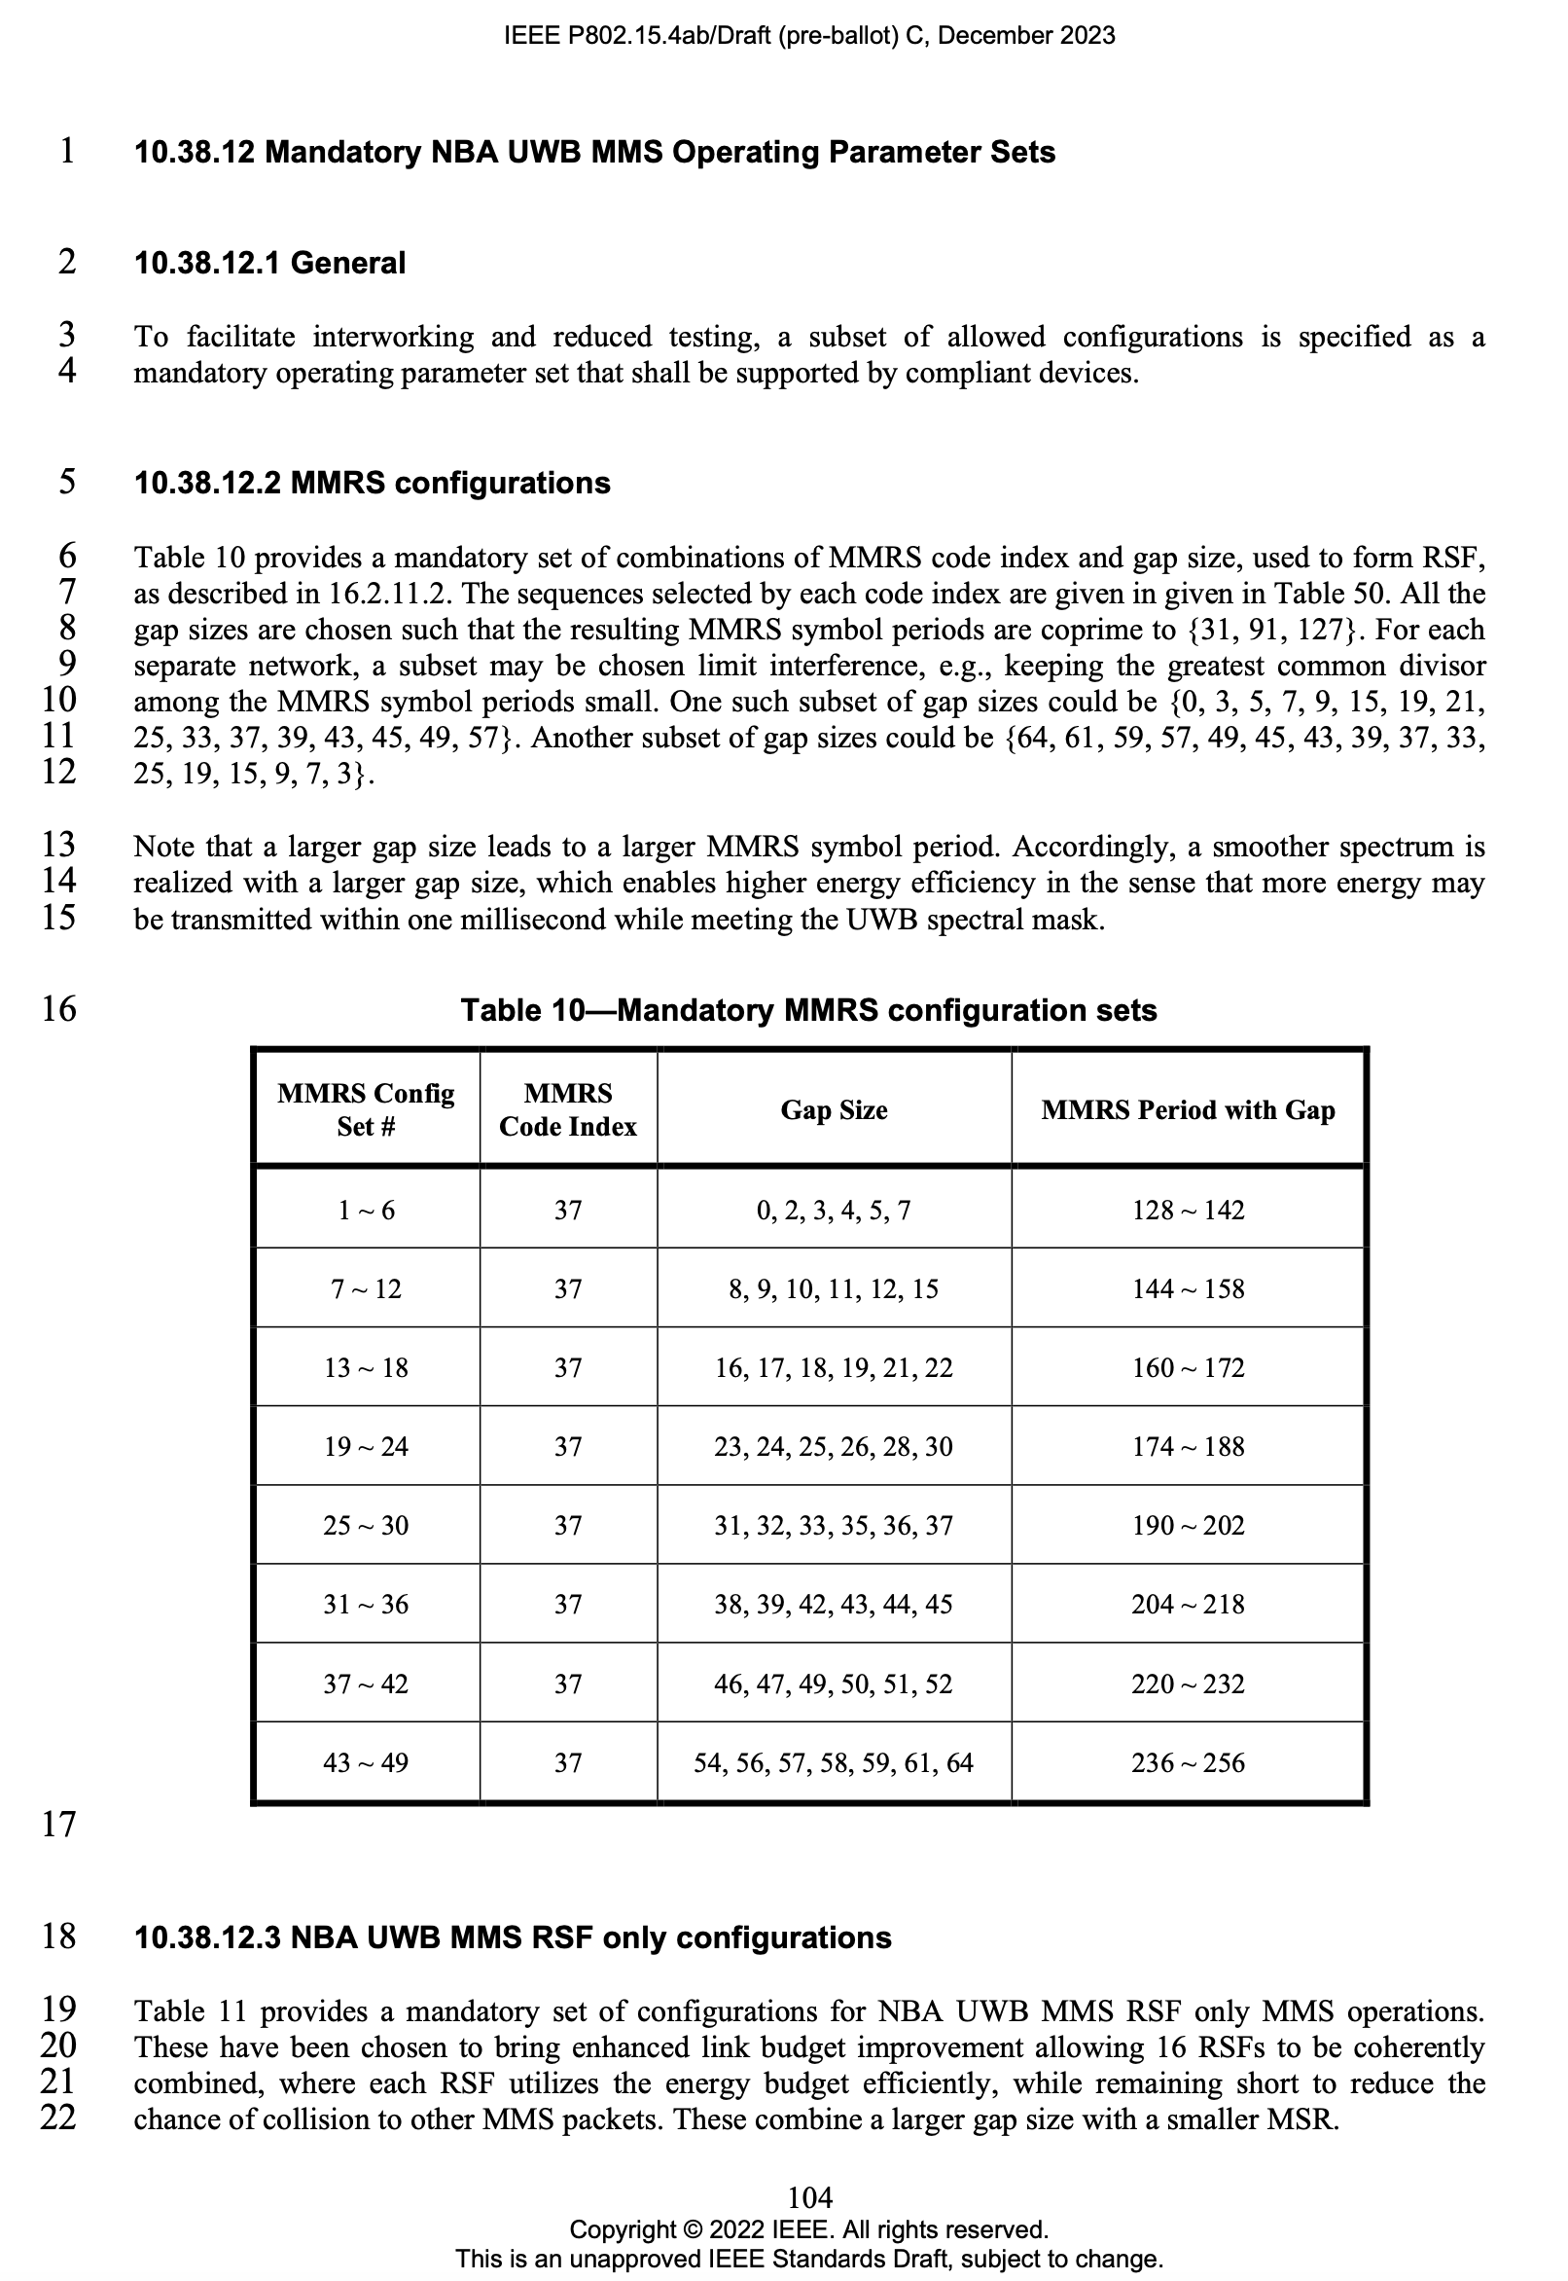
Proposed Resolution:
Change Table 10 in page 104 to the following one:
MMRS Config Set# | MMRS Code Index | Gap Size | Comment
1 | 37 | 0
2 | 37 | 2
3 | 37 | 3
4 | 37 | 4
5 | 37 | 5
6 | 37 | 7
7 | 37 | 8
8 | 37 | 9
9 | 37 | 10
10 | 37 | 11
11 | 37 | 12
12 | 37 | 15
13 | 37 | 16
14 | 37 | 17
15 | 37 | 18
16 | 37 | 19
17 | 37 | 21
18 | 37 | 22
19 | 37 | 23
20 | 37 | 24
21 | 37 | 25 | Note-1
22 | 37 | 26
23 | 37 | 28
24 | 37 | 30
25 | 37 | 31
26 | 37 | 32
27 | 37 | 33 | Note-2
28 | 37 | 35
29 | 37 | 36
30 | 37 | 37 | Note-2
31 | 37 | 38
32 | 37 | 39 | Note-2
33 | 37 | 42
34 | 37 | 43 | Note-2
35 | 37 | 44
36 | 37 | 45 | Note-2
37 | 37 | 46
38 | 37 | 47
39 | 37 | 49 | Note-2
40 | 37 | 50
41 | 37 | 51
42 | 37 | 52
43 | 37 | 54
44 | 37 | 56
45 | 37 | 57 | Note-2
46 | 37 | 58
47 | 37 | 59 | Note-2
48 | 37 | 61 | Note-2
49 | 37 | 64 | Note-2
Note-1: Selected and utilized in Table 12 to facilitate inter-operation.
Note-2: Selected and utilized in Table 11 to facilitate inter-operation.
Note-3: Code 37 has zero mean.
Note-4: Gap size here determines the number of zeros to be inserted to the complementary set in Table 50 before spreading to form one MMRS symbol
Note-5: The period of one configuration is (128 + 2xGapSize). The period of each MMRS configuration above is coprime with {31, 91, 127}.

CID #460 (Accepted, Solved)
Name | Idx # | Cat. | Pg. | Sub-clause | Line # | Comment | Proposed Change
Bin Qian | 460 | Technical | 154 | 13.3.2 | 15 | The details of the PSD limits are missing | As in the comment
Reference
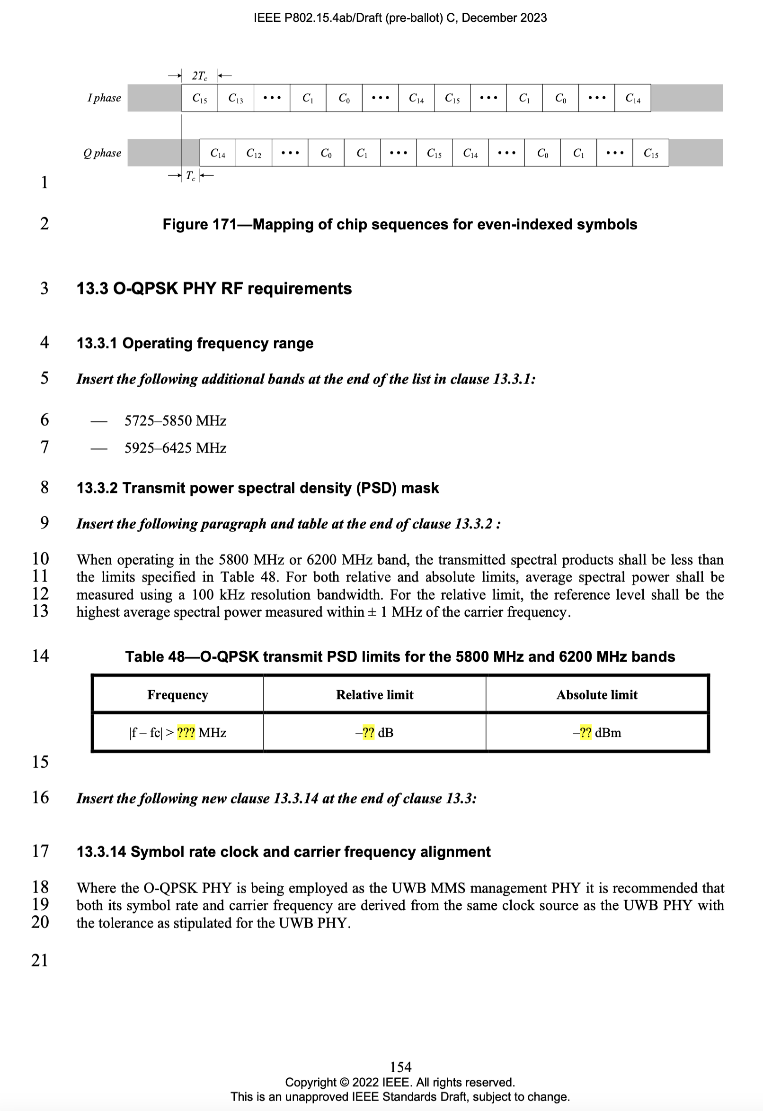
Proposed Resolution:
Change Table 48 to the following one:
Frequency | Relative Limit | Absolute Limit
|f-fc|>3.5 MHz | -20 dB | X dBm  (X depends on respective regulations)

CID #841 (Accepted, Solved)
Name | Idx # | Cat. | Pg. | Sub-clause | Line # | Comment | Proposed Change
Carl Murray | 841 | Technical | 105 | 10.38.12.3 | 2 | What does "NB Config #" refer to?
Reference
Proposed Resolution:
Add the following information at the end of line 22, page 104:
“NB Config # in Table 11 refers to the set of NB configurations in Table 45 in 13.2.5.”
Add the following information at the end of line 6, page 105:
“NB Config # in Table 12 refers to the set of NB configurations in Table 45 in 13.2.5.”

CID #843 (Solved)
Name | Idx # | Cat. | Pg. | Sub-clause | Line # | Comment | Proposed Change
Carl Murray | 843 | Technical | 105 | 10.38.12.3 | 2 | Why is the gao size specified - it is already determined by MMRS Config Set #.
Reference
Proposed Resolution: No need of changes to the draft-C spec.
This will help the reading of the spec, e.g., deriving the time duration.

CID #877 (Accepted, Solved)
Name | Idx # | Cat. | Pg. | Sub-clause | Line # | Comment | Proposed Change
Carl Murray | 877 | Technical | 160 | 16.2.11.1 | 27 | This text does not align with Figure 176 when SYNC+SFD is part of the MMS packet and forms the first fragment (see line 20).  "Within the same MMS ... T0 the start time of the first fragment transmitted in the packet." | Change to  "Within the same MMS packet transmission, all RSF and RIF fragments shall begin on millisecond offsets with respect to T0 the start time of the first sequence/integrity fragment transmitted in the packet."
Reference
Proposed Resolution:
Change the sentence at line 27, page 160, to the following one:
“Within the same MMS packet transmission, all RSF and RIF fragments shall begin on millisecond offsets with respect to T0 the start time of the first ranging sequence/integrity fragment transmitted in the packet.”

CID #878 (Solved)
Name | Idx # | Cat. | Pg. | Sub-clause | Line # | Comment | Proposed Change
Carl Murray | 878 | Technical | 160 | 16.2.11.1 | 25 | If the SYNC+SFD is a part of the MMS packet then the following text will lead to sub optimum performance.  "The same pulse shape shall be used for the entire MMS packet and all the pulses within the packet shall be modulated with a constant amplitude." | Change to:  "The same pulse shape shall be used for the entire MMS packet and all RIF and RSF pulses within the packet shall be modulated with a constant amplitude."
Reference
Proposed Resolution:
- Update the following sentence at line 20, page 160, to the following one:
“These are optionally preceded by a fragment consisting of SYNC and SFD formatted according to the HPRF mode, used to obtain initial timing and frequency synchronization.
- Add the following sentence at line 10, page 105:
“The SYNC and SFD in Table 13 shall be formatted according to the HPRF mode specified in Clause 16.”
- - - - - - - - - - - - - - - - - - - - - - - - - - - -
More comments (not to be added to the draft spec): The default mode is to ensure the same pulse amplitude over the whole MMS packet. For the mandatory packet formats for UWB Only MMS in Table 13, the energy in different milliseconds is pretty balanced and the SYNC+SFD shall be modulated with the same pulse amplitude as other fragments.
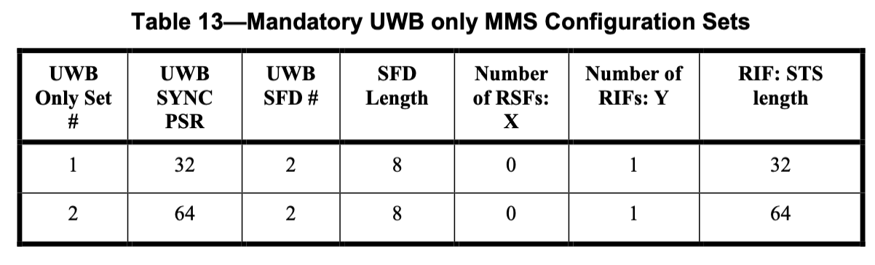

CID #879 (Solved)
Name | Idx # | Cat. | Pg. | Sub-clause | Line # | Comment | Proposed Change
Carl Murray | 879 | Technical | 160 | 16.2.11.1 | 28 | The following text allows for a gap after the RSF only if there is RIFs. Is this gap not needed also when there are only RSFs and also a similar gap after the RIFs. If the intention is that this gap can be specified via the slot size then a note to this effect would add great clarity.  "Where the MMS packet consists of both RSF and RIF fragments, the time between the start of the last RSF and the start of first RIF shall be two milliseconds."
Reference
Proposed Resolution: No need of changes to the draft-C spec.
The 2ms gap is to allow more processing time at the modem. When there are no mixing of RSFs and RIFs, the 2ms gap is not needed.

