IEEE P802.15
Wireless Personal Area Networks

Project | IEEE P802.15 Working Group for Wireless Personal Area Networks (WPANs)
Title | Proposed 4ab Draft C Comments Resolution for SSBD
Date Submitted | February 27, 2024
Sources | Larry Zakaib (Spark Microsystems)  larry.zakaib@sparkmicro.com
Re:
Abstract | Proposed comment resolutions for the CIDs 187, 489, 490, 493, 494, 495.
Purpose | Proposed resolutions to SSBD comments for “P802.15.4ab™/D (pre-ballot) C Draft Standard for Low-Rate Wireless Networks”.
Notice | This document does not represent the agreed views of the IEEE 802.15 Working Group or IEEE 802.15.4ab Task Group. It represents only the views of the participants listed in the “Sources” field above. It is offered as a basis for discussion and is not binding on the contributing individuals. The material in this document is subject to change in form and content after further study. The contributors reserve the right to add, amend or withdraw material contained herein.
Introduction
This submission contains the proposed comment resolutions for the CIDs 187, 489, 490, 493. 494, 495.

CID 187

CID 187 and 494
Note: CID 187 and 494 are similar, hence the proposed disposition is the same.

Name | Index # | Page | Sub-clause | Line # | Comment | Proposed Change | Disposition Status (Accepted, Rejected, Revised) | Disposition Detail | Category
Billy Verso | 187 | 17 | 6.2.2.2 | 9 | phyCcaEdThreshold is not defined. | Add it the PIB attribute table with appropriate definition, range, description. | Rejected | Rejected:  Resolution Detail: phyCcaEdThreshold is presently defined in Table 12-2 in RevME D03. | SSBD
Tero Kivinen | 494 | 17 | 6.2.2.2 | 9 | The phyCcaEdThreshold is not defined anywhere. | Define it | Rejected | Rejected:  Resolution Detail: phyCcaEdThreshold is presently defined in Table 12-2 in RevME D03. | SSBD

Extract of Table 12-2 of IEEE P802. 14.4me/D03.

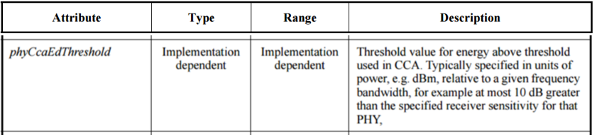

CID 489 and 493
CID 489 proposes to change 2x BF to BF and use macSsbdUnitBackoffPeriod that has double the value than before. The proposal to change 2x BF to BF is accepted, and the maximum value of macSsbdUnitBackoffPeriod will be changed from 31 to 63.

For CID 493, 2xBF will change to BF, and the diagram will be clarified to indicate the delay is the random integer from 0 to BF multiplied by macSsbdUnitBackoffPeriod.

Name | Index # | Page | Sub-clause | Line # | Comment | Proposed Change | Disposition Status (Accepted, Rejected, Revised) | Disposition Detail | Category
Tero Kivinen | 489 | 16 | 6.2.2.2 | 1 | why is the "Delay for random" has "2 x BF x macSsbdUnitBackoffPeriod", would it not be more logical to have just BF x macSsbdUnitBackoffPeriod, and use macSsbdUnitBackoffPeriod that has double the value than before? | Explain why it is 2 x BF, or remove 2 x. | Revised | Revised:  Agree to remove 2x BF. This results in changes to Draft C as follows:  Change Figure 1 SSBD algorithm:  Change from:  Delay for random (2 × BF) ×  macSsbdUnitBackoffPeriod  to:  Delay for random(BF) SSBD unit backoff periods  On P16, Lines 6 & 7, Change “number” to “integer” and remove "twice".  - In Table 8-35: change macSsbdUnitBackoffPeriod range from 1-31 to 1-63 | SSBD
Tero Kivinen | 493 | 16 | 6.2.2.2 | 6 | The figure 1 and text does not match. The figure says we take random delay between 0 and (2 * BF) * macSsbdUnitBackoffPeriod, and I assume the text is trying to say that we take random integer between 0 and 2 * BF, and then multiple that integer with macSsbdUnitBackoffPeriod, i.e., the delay is always multiple of macSsbdUnitBackoffPeriod. Which one of those is supposed to be correct. Is the delay supposed to be multiple of macSsbdUnitBackoffPeriod, if so, then the figure 1 needs to be clarified. On the other hand it would be better to say same thing only once, i.e., either only in text, or only in figure 1. | Reduce the place where you define things to one. | Revised | Change Figure 1 SSBD algorithm as proposed in the resolution to CID489:  Change from:  Delay for random (2 × BF) ×  macSsbdUnitBackoffPeriod  to:  Delay for random(BF) SSBD unit backoff periods

See the proposed changes to Figure 1, SSBD algorithm, and to P16 lines 6 & 7 below. ￼ The revised figure follows the same style as Figure 6-2 in 802.15.4 Rev E. We noticed that currently random() function as used in CSMA is not precisely defined. Thus the clarifying sentence at Page 16, line 6&7 is not repeating what is in the figure.

Page 16, Figure 1,

change
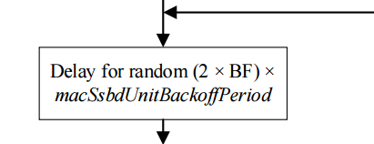
to

Delay for random(BF) SSBD unit backoff periods

Page 16, Lines 6 & 7

Change from:
6 period determined by the macSsbdUnitBackoffPeriod attribute value multiplied by a random number
7 between zero and twice BF.

to:

6 period determined by the macSsbdUnitBackoffPeriod attribute value multiplied by a random integer
7 between zero and BF

Page 23, Table 8-35
Change

to

1-63

CID 490

Name | Index # | Page | Sub-clause | Line # | Comment | Proposed Change | Disposition Status (Accepted, Rejected, Revised) | Disposition Detail | Category
Tero Kivinen | 490 | 15 | 6.2.2.2 | 8 | the macSsbdCcaDuration is not mentioned anywhere in the CCA text. | Perhaps add new entry to the list at the end of 11.2.8 or modify step b) where the phyCcaDuration to include macSsbdCcaDuration, not just provide reference to the 6.2.2.2. | Revised | Revised: There is no need for MAC attribute macSsbdCcaDuration as this is (now) defined as a PHY attribute in the base standards (Rev E D03).  - Change macSsbdCcaDuration to phyCcaDuration in 6.2.2.2 (P15, line 8)  - Delete macSsbdCcaDuration row in Table 8-35  - In section 11.2.8, P147, line 21, remove "Except when SSBD is being used"  - In section 11.2.8, P147, lines 22 & 23, remove "When SSBD is being used, the CCA detection time shall comply with the specification in 6.2.2.2." | SSBD

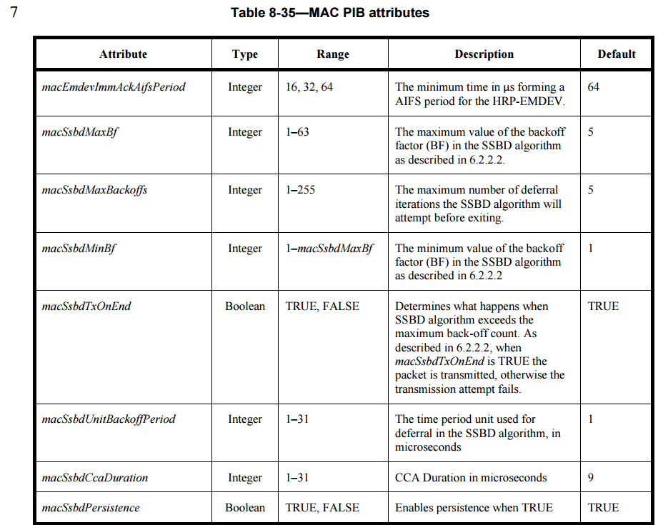

Name | Index # | Page | Sub-clause | Line # | Comment | Proposed Change | Disposition Status (Accepted, Rejected, Revised) | Disposition Detail | Category
Tero Kivinen | 495 | 17 | 6.2.2.2 | 9 | why this is using phyCcaDuration, even when the page 15, line 8 uses macSsbdCcaDuration. | Change to use macSsdbCcaDuration.. | Revised | Revised:  Similar to proposed in the resolution to CID490:  There is no need for a MAC attribute macSsbdCcaDuration as this is (now) defined as a PHY attribute in the base standards (Rev E D03).  Hence all occurrences of macSsbdCcaDuration will be changed to phyCcaDuration as proposed in resolution to CID490.  For CID 495 (P17, line 9) no changes are needed as the attribute is already defined as phyCcaDuration. | SSBD

P17, Line 9. No changes are needed as the attribute is already defined as phyCcaDuration as shown below.

8 When used for SSBD, and CCA Mode 1 or Mode 3 are used, the CCA threshold shall be set to
9 phyCcaEdThreshold and the CCA detection time shall be set to phyCcaDuration.

