IEEE P802.15
Wireless Personal Area Networks

Project | IEEE P802.15 Working Group for Wireless Personal Area Networks (WPANs)
Title | Proposed 4ab Draft C Comments Resolution for SSBD
Date Submitted | February 16 2024
Sources | Larry Zakaib (Spark Microsystems)  larry.zakaib@sparkmicro.com
Re:
Abstract | Proposed comment resolutions for the CIDs 187, 489, 490.
Purpose | Proposed resolutions to SSBD comments for “P802.15.4ab™/D (pre-ballot) C Draft Standard for Low-Rate Wireless Networks”.
Notice | This document does not represent the agreed views of the IEEE 802.15 Working Group or IEEE 802.15.4ab Task Group. It represents only the views of the participants listed in the “Sources” field above. It is offered as a basis for discussion and is not binding on the contributing individuals. The material in this document is subject to change in form and content after further study. The contributors reserve the right to add, amend or withdraw material contained herein.
Introduction
This submission contains the proposed comment resolutions for the CIDs 187, 489, 490.

CID 187

CID 187

Name | Index # | Page | Sub-clause | Line # | Comment | Proposed Change | Disposition Status (Accepted, Rejected, Revised) | Disposition Detail | Category
Billy Verso | 187 | 17 | 6.2.2.2 | 9 | phyCcaEdThreshold is not defined. | Add it the PIB attribute table with appropriate definition, range, description. | Rejected | Rejected:  Resolution Detail: phyCcaEdThreshold is presently defined in Table 12-2 in RevME D03. | SSBD

Extract of Table 12-2 of IEEE P802.14.4me/D03.
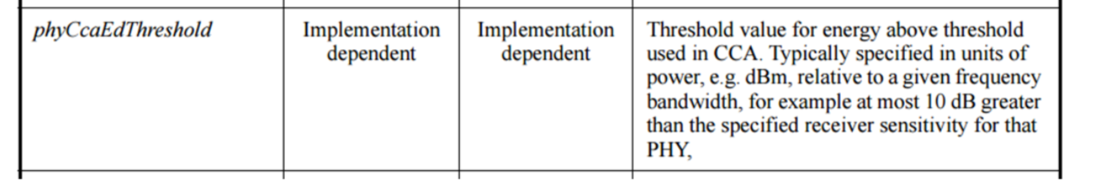

CID 489

Name | Index # | Page | Sub-clause | Line # | Comment | Proposed Change | Disposition Status (Accepted, Rejected, Revised) | Disposition Detail | Category
Tero Kivinen | 489 | 16 | 6.2.2.2 | 1 | why is the "Delay for random" has "2 x BF x macSsbdUnitBackoffPeriod", would it not be more logical to have just BF x macSsbdUnitBackoffPeriod, and use macSsbdUnitBackoffPeriod that has double the value than before? | Explain why it is 2 x BF, or remove 2 x. | Revised | Revised:  Agree to remove 2x BF as follows:  - Remove 2x in P16 Figure 1  - P16, Line 7, remove "twice"  - In Table 8-35: change macSsbdUnitBackoffPeriod range from 1-31 to 1-63 | SSBD

Page 16, Figure 1
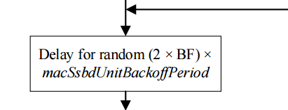
Page 16, Line 7

Page 23, Table 8-35

CID 490

Name | Index # | Page | Sub-clause | Line # | Comment | Proposed Change | Disposition Status (Accepted, Rejected, Revised) | Disposition Detail | Category
Tero Kivinen | 490 | 15 | 6.2.2.2 | 8 | the macSsbdCcaDuration is not mentioned anywhere in the CCA text. | Perhaps add new entry to the list at the end of 11.2.8 or modify step b) where the phyCcaDuration to include macSsbdCcaDuration, not just provide reference to the 6.2.2.2. | Revised | Revised: There is no need for a MAC attribute macSsbdCcaDuration as this is (now) defined as a PHY attribute in the base standards (Rev E D03).  - Change macSsbdCcaDuration to phyCcaDuration in 6.2.2.2 (P15, line 8)  - Delete macSsbdCcaDuration row in Table 8-35  - In section 11.2.8, P147, line 21, remove "Except when SSBD is being used"  - In section 11.2.8, P147, lines 22 & 23, remove "When SSBD is being used, the CCA detection time shall comply with the specification in 6.2.2.2." | SSBD

