IEEE P802.15
Wireless Personal Area Networks

Project | IEEE P802.15 Working Group for Wireless Personal Area Networks (WPANs)
Title | Proposed Resolution for MMS short term operating parameters – CID 77
Date Submitted | May 2024
Sources | Rojan Chitrakar, Lei Huang (Huawei)  rojan.chitrakar@huawei.com
Re:
Abstract
Purpose | To propose resolution for MMS short term operating parameters related comments for “P802.15.4ab™/D (pre-ballot) C Draft Standard for Low-Rate Wireless Networks” .
Notice | This document does not represent the agreed views of the IEEE 802.15 Working Group or IEEE 802.15.4ab Task Group. It represents only the views of the participants listed in the “Sources” field above. It is offered as a basis for discussion and is not binding on the contributing individuals. The material in this document is subject to change in form and content after further study. The contributors reserve the right to add, amend or withdraw material contained herein.

Rev 0: Initial version.
Rev 1: New disposition for CID#77
Rev 2: Revised disposition for CID#77

Comment Indices in 15-24-0010-00-04ab-consolidated-comments-draft-c:
Name | Index# | Pg | Sub-Clause | Ln | Comment | Proposed Change | Disposition
Pooria Pakrooh | 77 | 58 | 10.38.8.4.2 | 19 | If all channels are blocked, devices shall not transmit. | Change "devices should not engage in an MMS ranging session." to "device shall quit the ranging session." | Rejected

Comment #77
Discussion：
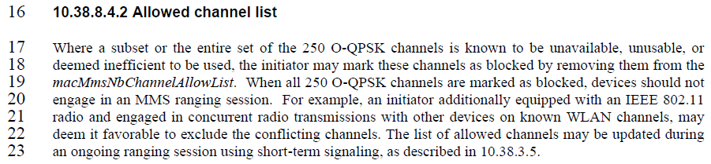
Disposition: Rejected.
Disposition Detail:
When all 250 O-QPSK channels are marked as blocked due to short term channel outage event, macMmsNbChannelAllowList will be empty and responders will not transmit NB signal in that ranging block. If the channel outage event is persistent, the initiator can update the macMmsNbChannelAllowList as long-term operating parameter using higher layer negotiation. As such, a “should” behaviour is sufficient and it is not necessary to mandate that devices quit an existing ranging session. Implementations can decide whether a device chooses to wait out the channel outage event or quit the ranging session.

