IEEE P802.15
Wireless Personal Area Networks

Project | IEEE P802.15 Working Group for Wireless Personal Area Networks (WPANs)
Title | Resolution proposal regarding MMS MAC-public part 1 for P802.15.4ab™/Draft (pre-ballot) C
Date Submitted | Feb 2024
Sources | Hong Won Lee, Insun Jang, Jinsoo Choi, HanGyu Cho (LG Electronics)
Re: | Contribution to IEEE 802.15.4ab
Abstract
Purpose | To propose comments and proposed changes to “P802.15.4ab™/ Draft (pre-ballot) C Draft Standard for Low-Rate Wireless Networks”.
Notice | This document does not represent the agreed views of the IEEE 802.15 Working Group or IEEE 802.15.4ab Task Group. It represents only the views of the participants listed in the “Sources” field above. It is offered as a basis for discussion and is not binding on the contributing individuals. The material in this document is subject to change in form and content after further study. The contributors reserve the right to add, amend or withdraw material contained herein.

Abstract
This submission contains the proposed comment resolutions for the CIDs 38, 87, 151, 383, 539, 540, 546, 650, 699, 704, 801, 812 and 813.

R0: initial document

This document aims to propose a resolution proposal regarding MMS comments for P802.15.4ab™/ Draft (pre-ballot) C Draft Standard
Comment index #699, 801 in 15-24-0010-04-04ab-tg4ab-consolidated-comments-draft-c.xlsx
Name | Index # | Pg | Sub-clause | Ln | Comment | Proposed change | Disposition
Carl Murray | 699 | 53 | 10.38.7.1 | 31 | AdvAddr is a bad name for many reasons but one is that is that it does not follow the same naming convention as RespAddr | Consider changing to InitiatorAddr | Revised
Carl Murray | 801 | 90 | 10.38.10.15 | 16 | Why have we changed terminology here replacing Initiator with Advertiser (also in other places). Note that the advertiser is refered to as the initiator later (eg pg93, line 2) | Replace Advertiser with Initiator throughout the text | Revised

Discussion:
These comments are basically agreed. There is no Advertiser but Initiator in Draft C. The name 'InitiatorAddr' is appropriate. Therefore, all 'AdvAddr' should be changed to 'InitiatorAddr.' Furthermore, 'Advertiser Address' in sub-clause 10.38.10 should be consistently changed to 'InitiatorAddr'. The resolutions are revised to change 'AdvAddr' and 'Advertiser Address' to 'InitiatorAddr' throughout the text.
Resolution: Revised
Proposed text change on P802.15.4ab™/Draft (pre-ballot) C:
- Original Text
10.38.7 UWB MMS ranging session initialization using public addresses
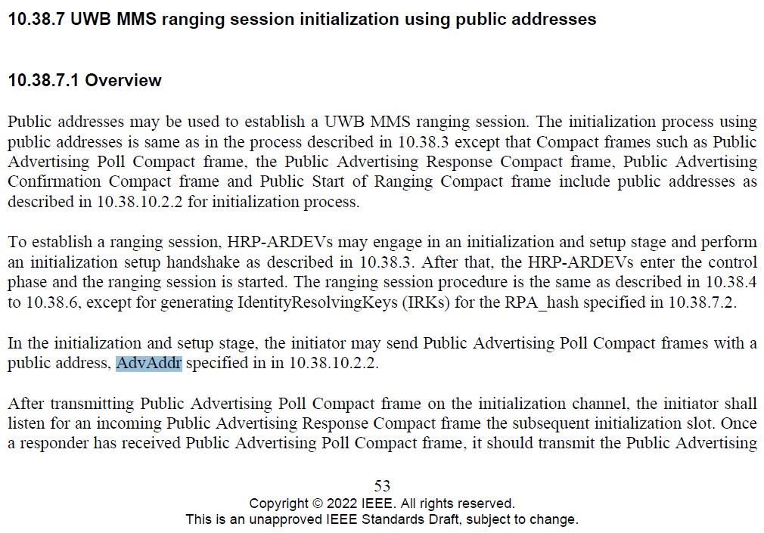

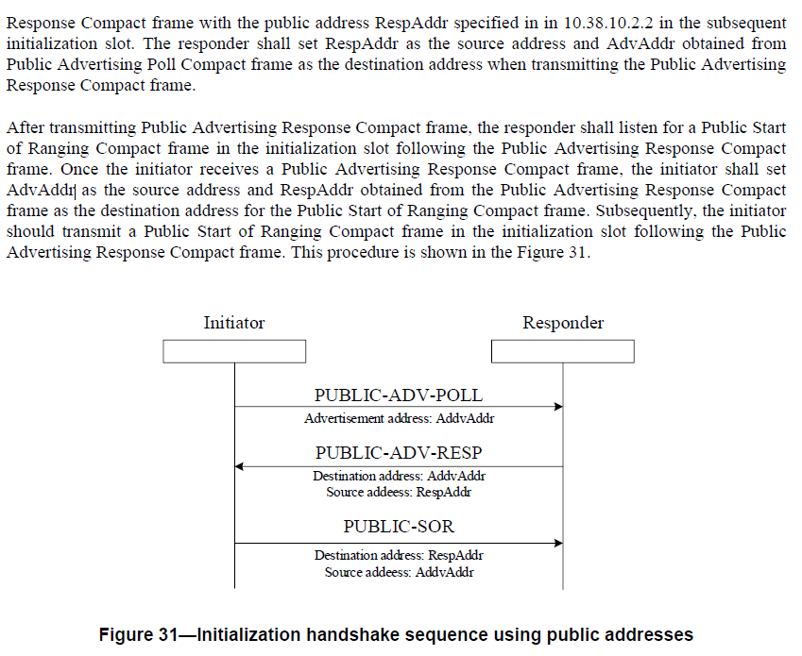
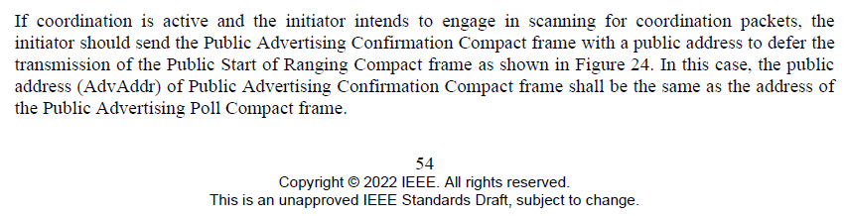

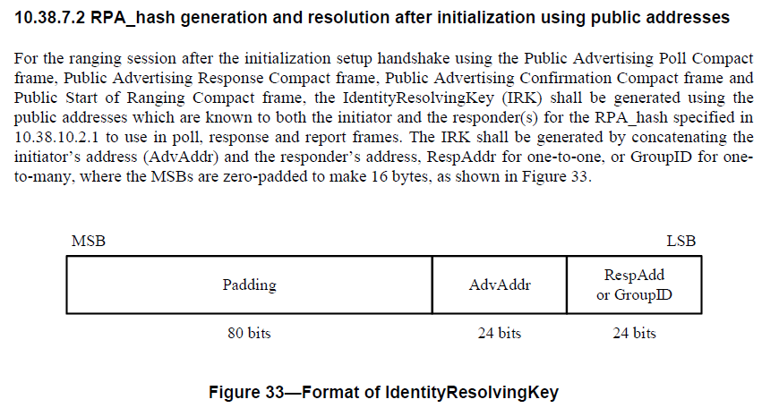
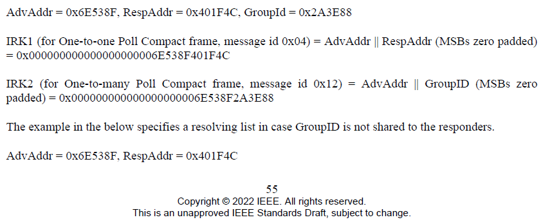
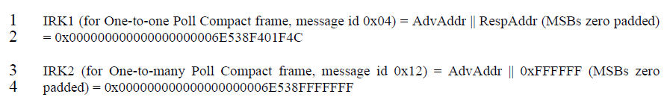

10.38.10.2.2 Public addresses
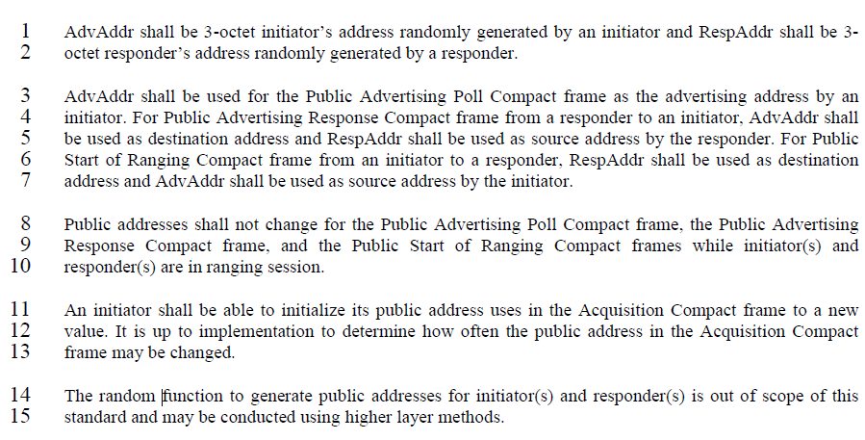
10.38.10.16 Public Advertising Poll Compact frame
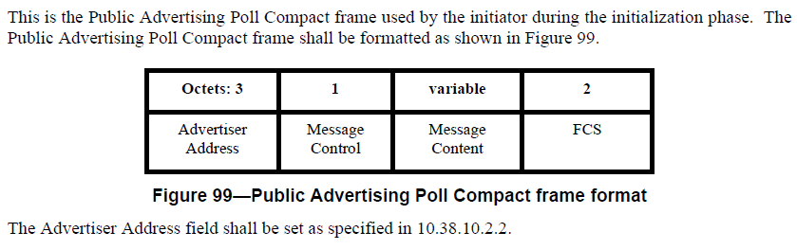
10.38.10.17 Public Advertising Response Compact frame
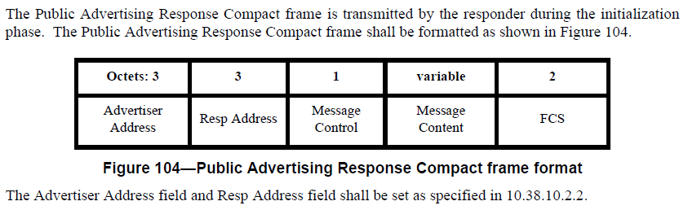
10.38.10.18 Public Start of Ranging Compact frame
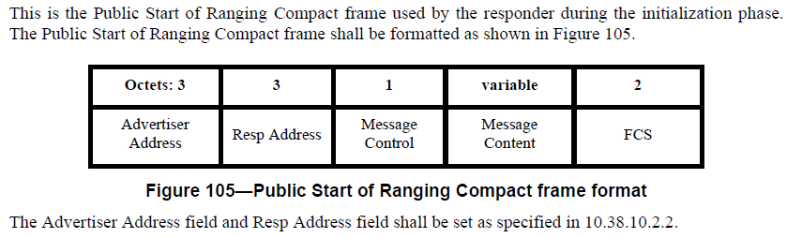
10.38.10.19 Public Advertising Confirmation Compact frame
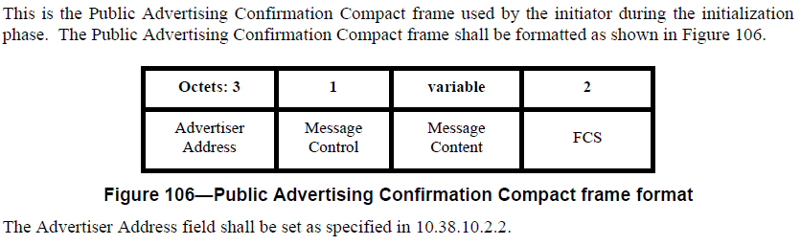
- Proposed change
pp. 53 line #31 / pp.54 line #2, 8, 13, 20 / pp.55 line#12, 14, 28, 29, 31, 34 / pp.56 line#1, 3 / pp.65 line#1, 3, 4, 7
Change all AdvAddr to InitiatorAddr
pp.54 line#13
Change Advertisement to Initiator
pp. 90 line #16, 17 / pp.92 line #5, 6, 21, 22 / pp.93 line#4, 5
Change all Advertiser Address to InitiatorAddr

Comment index #704, 650, 546, 812 in 15-24-0010-04-04ab-tg4ab-consolidated-comments-draft-c.xlsx
Name | Index # | Pg | Sub-clause | Ln | Comment | Proposed change | Disposition
Carl Murray | 704 | 56 | 10.38.7.3 | 7 | Why have LTV when there is already TLV | Decide if we should just be using 1 structure | Revised
Rojan Chitrakar | 650 | 91 | 10.38.10.16 | 20 | What is AD structure? | Define AD structure | Revised
Hong Won Lee | 546 | 91 | 10.38.10.16 | 20 | The reference for Adv Data should be indicated | Change from "The Adv Data field is the sequence of AD structures which shall have Length, Type and Value." to "The Adv Data field is the sequence of AD structure which shall have Length, Type and Value as specified in 10.38.7.3." | Revised
Carl Murray  (Editorial) | 812 | 91 | 10.38.10.16 | 20 | Refer to AD structures section | Change  The Adv Data field is the sequence of AD structure which shall have Length, Type and Value  to  The Adv Data field is the sequence of AD structures which are defined in 10.38.7.3. | Revised

Discussion:
The data structure for AdvData field does not need to be defined because it is not used by IEEE but the next higher layer. This is a variable length field of data used by the next higher layer. The Adv Data length field should be defined
Resolution: Revised
Proposed text change on P802.15.4ab™/Draft (pre-ballot) C:
10.38.7.3 Advertisement information in Public Advertising Poll Compact frame
- Original Text
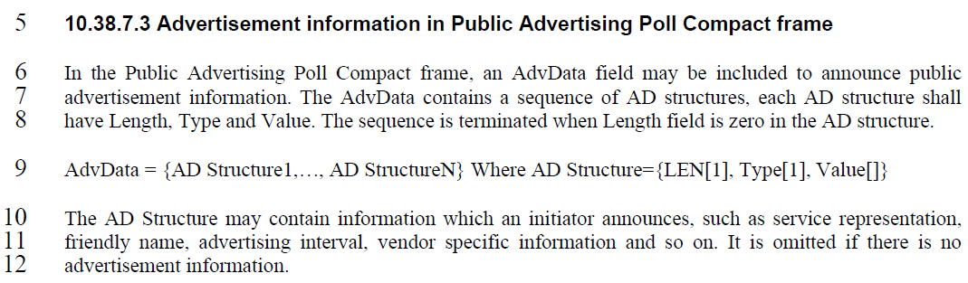
10.38.10.16 Public Advertising Poll Compact frame
…..
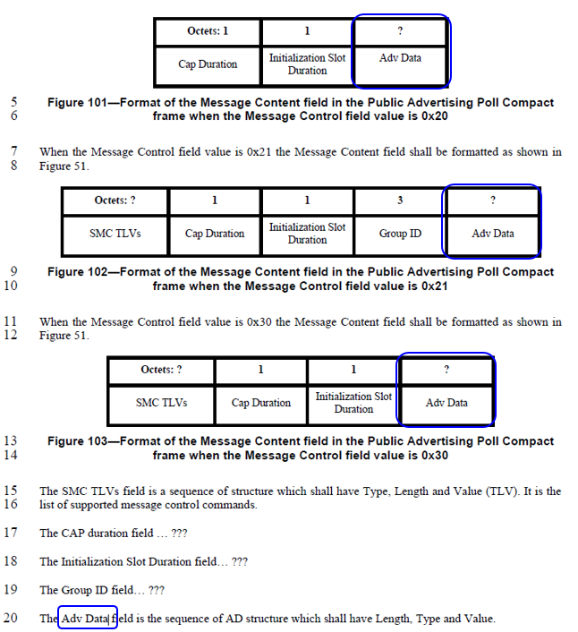
- Proposed change
Remove the sub-clause 10.38.7.3 Advertisement information in Public Advertising Poll Compact frame in IEEE P802.15.4ab/Draft (pre-ballot) C as follows:
pp. 56 line #5-12

Add a sub-clause 10.38.10.3.20 The Adv Data Length field and 10.38.10.3.21 The Adv Data field in IEEE P802.15.4ab/Draft (pre-ballot) C as follows:
pp. 71 line #3
10.38.10.3.20 The Adv Data Length field
This is a single octet field that specifies a length data that is in the Adv Data field. It is omitted if there is no Adv Data
10.38.10.3.21 The Adv Data field
This is a variable length field of data used by a higher application layer. The length of this field is determined by the Adv Data Length field value. The contents of this field are determined by the initiator’s higher application layer. For example, this field may contain advertisement information which an initiator announces, such as service representation, friendly name, vendor specific information and so on.
Revise a sub-clause 10.38.10.16 Public Advertising Poll Compact frame in IEEE P802.15.4ab/Draft (pre-ballot) C as follows:
pp. 91 line #5
Octets: 1 | 1 | 0 / 1 | 0 / variable
Cap Duration | Initialization Slot Duration | Adv Data length | Adv Data
pp. 91 line #9
Octets: ? | 1 | 1 | 3 | 0 / 1 | 0 / variable
SMC TLVs | Cap Duration | Initialization Slot Duration | Group ID | Adv Data length | Adv Data
pp. 91 line #13
Octets: ? | 1 | 1 | 0 / 1 | 0 / variable
SMC TLVs | Cap Duration | Initialization Slot Duration | Adv Data length | Adv Data
pp. 91 line #20
The Adv Data length field is defined in 10.38.10.3.20. The presence of this field is determined by Frame Length defined in 13.1.3.2 of IEEE P802.15.4me/D03.
The Adv Data field is defined in 10.38.10.3.21. If the Adv Data length field is not present, the Adv Data is omitted.

Comment index #65 in 15-24-0010-04-04ab-tg4ab-consolidated-comments-draft-c.xlsx
Name | Index # | Pg | Sub-clause | Ln | Comment | Proposed change | Disposition
Hong Won Lee | 539 | 65 | 10.38.10.2 | 3 | Public Advertising Confirmation Compact frame is missed in the description for usage of AdvAddr | Change from "AdvAddr shall be used for the Public Advertising Poll Compact frame" to "AdvAddr shall be used for the Public Advertising Poll Compact frame and the Public Advertising Confirmation Compact frame" | Revised

Discussion:
InitiatorAddr shall be used for the Public Advertising Confirmation Compact frame as well. AdvAddr is changed to InitiatorAddr based on the CID#699
Resolution: Revised
Proposed text change on P802.15.4ab™/Draft (pre-ballot) C:
10.38.10.2.2 Public addresses
- Original Text
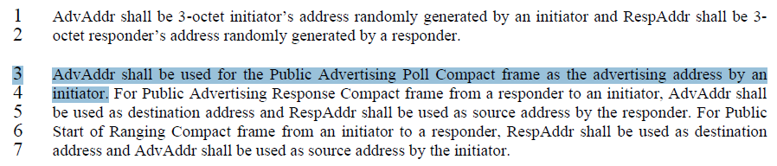
- Proposed change
Revise the sub-clause 10.38.10.2.2 Public addresses in IEEE P802.15.4ab/Draft (pre-ballot) C as follows:
pp. 65 line #3
InitiatorAddr shall be used for the Public Advertising Poll Compact frame and the Public Advertising Confirmation Compact frame as the advertising address by an initiator.

Comment index #151, 540 in 15-24-0010-04-04ab-tg4ab-consolidated-comments-draft-c.xlsx
Name | Index # | Pg | Sub-clause | Ln | Comment | Proposed change | Disposition
Benjamin Rolfe | 151 | 65 | 10.38.10.2.2 | 8 | Use of "shall not" leads to is ambiguous and unverifiable. Poor specification practice. As stated leaves it unclear which address is used. Should be stated positively and unambiguously. Taking my best guess at what is meant… | Change to: the Public Advertising Poll Compact frame, the Public Advertising Response Compact frame, and the Public Start of Ranging Compact frames shall contain the same public addresses for the duration of the ranging session. | Revised
Hong Won Lee | 540 | 65 | 10.38.10.2 | 9 | Public Advertising Confirmation Compact frame is missed in the description for life cycle for public addresses | Change from "Response Compact frame, and the Public Start of Ranging Compact frames" to Response Compact frame, the Public Start of Ranging Compact frame and the Public Advertising Confirmation Compact frame" | Revised

Discussion:
Regarding CID#151, the commenter is correct. “Shall not change” should be revised to “Shall” statement. Regarding CID#540, Public Advertising Confirmation Compact frame is missed in the description for life cycle for public addresses
Resolution: Revised
Proposed text change on P802.15.4ab™/Draft (pre-ballot) C:
10.38.10.2.2 Public addresses
- Original Text
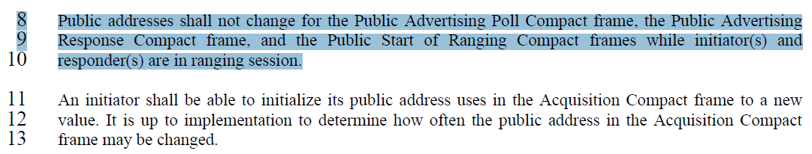

- Proposed change
Revise the sub-clause 10.38.10.2.2 Public addresses in IEEE P802.15.4ab/Draft (pre-ballot) C as follows:
pp. 65 line #8-10
The Public Advertising Poll Compact frame, the Public Advertising Response Compact frame, the Public Start of Ranging Compact frame and the Public Advertising Confirmation Compact frame shall contain the same public addresses for the duration of the ranging session.

Comment index #87, 383, 813 in 15-24-0010-04-04ab-tg4ab-consolidated-comments-draft-c.xlsx
Name | Index # | Pg | Sub-clause | Ln | Comment | Proposed change | Disposition
Pooria Pakrooh | 87 | 92 | 10.38.10.19 | 19 | "Responder" should be replaced with "Initiator". | Change "Responder" to "Initiator". | Revised
Bin Qian (Editorial) | 383 | 92 | 10.38.10.18 | 19 | It is not clear to state as "used by the responder" | Change the sentence as "The Public Start of Ranging Compact frame is transmitted by the initiator during the initialization phase. | Revised
Carl Murray (Editorial) | 813 | 92 | 10.38.10.19 | 19 | The SOR is actually used by both sides. | Change  This is the Public Start of Ranging Compact frame used by the responder during the initialization phase  To  This is the Public Start of Ranging Compact frame sent by the advertiser during the initialization phase | Accepted

Discussion:
Same as CID#383 and #813. This should be changed from the perspective of the Initiator.

Resolution: Revised and Accepted
Proposed text change on P802.15.4ab™/Draft (pre-ballot) C:
10.38.7.3 Advertisement information in Public Advertising Poll Compact frame
- Original Text
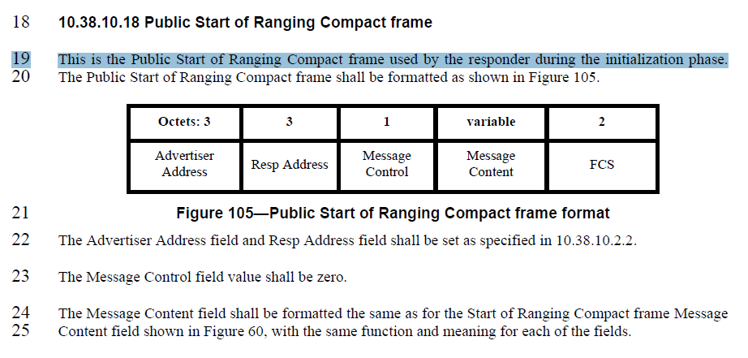
- Proposed change
Revise the sub-clause 10.38.10.18 Public Start of Ranging Compact frame in IEEE P802.15.4ab/Draft (pre-ballot) C as follows:
pp. 92 line #19
This is the Public Start of Ranging Compact frame sent by the initiator during the initialization phase.

Comment index #38 in 15-24-0010-04-04ab-tg4ab-consolidated-comments-draft-c.xlsx
Name | Index # | Pg | Sub-clause | Ln | Comment | Proposed change | Disposition
Li-Hsiang Sun | 38 | 93 | 10.38.10.20.1 | 19 | The address should be the same for NB and UWB PHY if both types of Acquisition Compact frames are transmitted | as in comment | Reassigned(Youngwan)

Discussion:
This comment is related to the Acquisition Compact frames. The comment should be reassigned to the main author of the sub-clause, “10.38.3.6 Coordination”

Resolution: Reassigned
