**IEEE P802.15**

**Wireless Specialty Networks (WSN)**

|  |  |  |
| --- | --- | --- |
| Project | IEEE P802.15 Working Group for Wireless Specialty Networks (WSN) | |
| Title | **Next Generation SUN PHY Technical Guidance Document** | |
| Date Submitted | 15 November 2024 | |
| Source | Joerg ROBERT  (TU Ilmenau / Fraunhofer IIS)  Phil Beecher (Wi-SUN Alliance)  Hiroshi Harada (Kyoto University) | Voice:  Fax:  E-mail: [joerg.robert@ieee.org](mailto:joerg.robert@ieee.org)  [pbeecher@wi-sun.org](mailto:pbeecher@wi-sun.org)  harada@ieee.org |
| Re: | SG NG OFDM PHY Technical Guidance for Proposals | |
| Abstract |  | |
| Purpose | To capture essential PHY requirements, parameterized into a set of PHY characteristics that technical proposals can address. Guide discussion within task group, help proposers and provide a framework for evaluation of proposals by the TG. | |
| Notice | This document has been prepared to assist the IEEE P802.15. It is offered as a basis for discussion and is not binding on the contributing individual(s) or organization(s). The material in this document is subject to change in form and content after further study. The contributor(s) reserve(s) the right to add, amend or withdraw material contained herein. | |
| Release | The contributor acknowledges and accepts that this contribution becomes the property of IEEE and may be made publicly available by P802.15. | |

# Contents:

Contents: 2

DRAFT 802.15.4ad Next Generation SUN PHY Technical Guidance Document 3

Introduction 3

Project Authorization Request (PAR) 3

Methodology for Assessment of proposals 3

Proposal Criteria 4

Scope of proposals 4

Proposal criteria. 4

Annex A Channel Model 5

Annex B Interference Model 5

DRAFT 802.15.4ad Next Generation SUN PHY Technical Guidance Document

# Introduction

This document provides technical guidance that should be considered when submitting a proposal to be considered for inclusion in the IEEE P802.15.4ad amendment.

# Project Authorization Request (PAR)

The following paragraphs are extracts from the PAR approved by Nescom:

<https://mypr-nodejs.standards.ieee.org/mypr-file/par/11073/mypr> included here for convenience.

**5.2.a Scope of the complete standard**:

This standard defines the physical layer (PHY) and medium access control (MAC) sublayer specifications for low-data-rate wireless connectivity with fixed, portable, and moving devices with no battery or very limited battery consumption requirements. In addition, the standard provides modes that allow for precision ranging. PHYs are defined for devices operating in a variety of geographic regions.

**5.4 Purpose:**

The standard provides for ultra low complexity, ultra low cost, ultra low power consumption, and low data rate wireless connectivity among inexpensive devices, especially targeting the communications requirements of what is now commonly referred to as the Internet of Things. In addition, some of the alternate PHYs provide precision ranging capability that is accurate to one meter. Multiple PHYs are defined to support a variety of frequency bands.

**802.15.4ad Scope of the project**:

This amendment defines new data rate extensions by increasing the occupied bandwidth, adding new modulation and coding schemes (MCSs), and extending the SUN PHYs to provide long-range communication in congested environments. Additionally, this amendment defines at least one mode of the SUN-Orthogonal Frequency Division Multiplexing (OFDM) PHY that exceeds a sensitivity of -120 dBm at a 1 % packet error rate (PER) with a 64 B payload, intended for the Federal Communications Commission (FCC) 15.247 digital modulation system. At least one of the new MCSs achieves a data rate greater than 2.4 Mb/s. The amendment defines the MAC modifications required to support the amended PHYs. The amendment also defines frequency bands based on updated regional regulations.

**802.15.4ad Need for the Project:**

The PHY enhancements address the needs of emerging applications where additional data rates expand the usefulness of the SUN PHYs.

# Methodology for Assessment of proposals

The methodology is based on a consensus approach to defining a minimal set of features, characteristics, performance and constraints to be considered when making a proposal.

This document provides a functional view of the PHY characteristics, in the form of specific parameters which define externally verifiable performance and interoperability considerations.

The parameters discussed in this document are essential parameters for the design of physical layer in order to satisfy the PAR requirements. The proposal shall reference the relevant regulations. Devices implementing shall abide by regulations in the region it is operating.

# Proposal Criteria

## Scope of proposals

Proposers are welcome to propose a complete system proposal. However, proposers are also welcome to propose specific technology elements only.

## Proposal criteria.

The following should be included in the proposal:

* **The Scope of proposal:** with reference to the PAR requirements
* **Use cases:** Provide a reference to the Use case document [mentor ref goes here] and summarize the Use cases that the proposal addresses.
* **Complexity:** The complexity should not be significantly higher compared to existing SUN PHYs.
* **Receiver Sensitivity:** if the proposal addresses the required OFDM mode specified in the PAR, then this OFDM mode shall have a sensitivity of at least -120dBm with an occupied channel bandwidth of at least 500 kHz as specified in FCC ?? [rule reference goes here]
* **Data Rate:** One mode with an effective payload data rate higher than of 2.4 Mbps. Proposers are encouraged to propose modes with higher data rates.
* **Channel Bandwidth:** Proposers should support a minimum channel spacing of 200kHz for the OFDM modes to meet the regulation in specific regions. Proposers should support at least one mode with an occupied channel bandwidth of at least 500kHz as specified in FCC 15.247. Proposers should consider the current channel plans specified for IEEE 802.15.4 SUN PHYs.
* Packet length: When performing computer simulations, the PSDU length in a packet should be 250 bytes for transmission rates faster than the current 802.15.4-2020 SUN-defined transmission rate, and 64 and 20 bytes for slower transmission rates than 50 kbit/s.
* **Performance Evaluation:** Proposers are strongly encouraged to show simulation results for the applicable application scenarios. Channel model and interference model for simulations are described in the appendices. The required PER should be 1% when transmitting 64 and 20 bytes for slower transmission rates than 50 kbit/s and 10% when transmitting 250 bytes for the rest of the transmission rates.
* **Mandatory and Optional Features:** Proposals shall clearly stipulate the mandatory and optional behaviors/features.
* **Forward Error Correction:** The use of a least an optional FEC should be possible in all modes.
* **Modulation:** The proposer should describe modulation.
* **Symmetrical Links:** It should be possible to use the same class of devices for transmit and receive.
* **PHY Frame Structure:** The PHY should be based on the existing SUN PHY specifications. Include packet length here – describe packet length vs PER for simulation and maybe other w.r.t. Use cases
* **Crystal Tolerance:** The PHY should support oscillator tolerances comparable to the existing SUN PHYs.
* **Coexistence Features:** It is highly recommended that the proposer explains how interference to existing IEEE 802.15.4 networks can be avoided.
* **Operational Bands:** At least one of the operational bands relevant to the scope of the project should be supported.
* **Multipath Robustness:** The proposer should describe the immunity to multi-path reception. Simulation results using the Channel Model defined in Annex A are strongly encouraged.
* **Interference Robustness:** The proposer should describe the immunity to interference. Simulation results using the interference model defined in Annex B are strongly encouraged

# Annex A Channel Model

IEEE 802.11ad is expected to primarily operated with uni-directional antennas. This will result in multi-path propagation that will have an impact on the overall system. Generally, the effects depend on the used frequency range. Therefore, two models are presented. This first model is for frequencies below 500 MHz, and the second model for frequencies above 500 MHz. All channel models are for classical single antenna operation, as this will most likely be the dominant mode of operation.

### Channel Model for Frequencies below 500 MHz

For the frequency range below 500 MHz in urban areas, the COST 207 GSM Typical Urban model with 6 taps as defined in [1, Table 2.4.2d] shall be used. For the frequency range below 500 MHz in rural areas, the IEEE 802.22 Profile A model with 6 taps defined in [2, Table 1] shall be used.

In order to model the changes of the environment, a Doppler frequency of 0.6Hz shall be assumed. A new channel realization shall be used for every packet. The delay times and relative powers for each channel model are presented in Tables 1 and 2.

**Table 1: COST 207 GSM Typical Urban model with 6 taps**

|  |  |  |
| --- | --- | --- |
| **Taps #** | **Delay (μs)** | **Power in (dB)** |
| 1 | –0.2 | –3.0 |
| 2 | 0.0 | 0.0 |
| 3 | 0.3 | –2.0 |
| 4 | 1.4 | –6.0 |
| 5 | 2.1 | –8.0 |
| 6 | 4.8 | –10 |

**Table 2: IEEE 802.22 Profile A model with 6 taps**

|  |  |  |
| --- | --- | --- |
| **Taps #** | **Delay (μs)** | **Power in (dB)** |
| 1 | 0.0 | 0.0 |
| 2 | 3.0 | –7.0 |
| 3 | 8.0 | –15 |
| 4 | 11 | –22 |
| 5 | 13 | –24 |
| 6 | 21 | –19 |

### Channel Model for Frequencies above 500 MHz

For the frequency range above 500 MHz the Tapped Delay Line (TDL) models defined in [3, Section 7.7.2] shall be used. In order to model the changes of the environment, a Doppler shift of 2.5Hz shall be assumed. The scaling parameter DSdesired shall be set to 1000 ns, according to [3, Table 7.7.3-1].

For non-LoS (Line of Sight) simulations the channel coefficients according to TDL-B shall be used. A new channel realization shall be used for every packet.

For LoS simulations the channel coefficients according to TDL-D shall be used. The scaling parameter DSdesired shall be set to 1000 ns. A new channel realization shall be used for every packet.

# Annex B Interference Model

IEEE 802.15.4ad is expected to primarily operate in license-exempt frequency bands, which may result in high interference levels, especially in densely populated urban areas. To ensure system resilience, this annex presents a simple interference model to evaluate and compare the robustness of various proposals against typical interference conditions.

For the following evaluation, the duration of a packet shall be defined by its payload part and potential additional synchronization signals.

For the modeling of the interference, two scenarios are considered: A narrow-band interferer scenario and a broad-band interferer scenario.

### Narrow-Band Interferer Scenario

The intention of the narrow-band interferer scenario is the modelling of typical narrow-band interferers like UHF Radio Frequency Identification (UHF-RFID) systems, or narrow-band Low Power Wide Area Networks (LPWAN). These interferers are typically of narrow bandwidth, but long duration.

The narrow-band interferer shall be bandpass-filtered White Gaussian Noise with a 3dB-bandwidth of 10kHz. A rectangular window shall be used to reduce the sidelobes of the bandpass-filtered White Gaussian noise.

The duration of the interferer shall be longer than the actual packet duration. Figure 1 shows an example for the simulation with multiple packets.

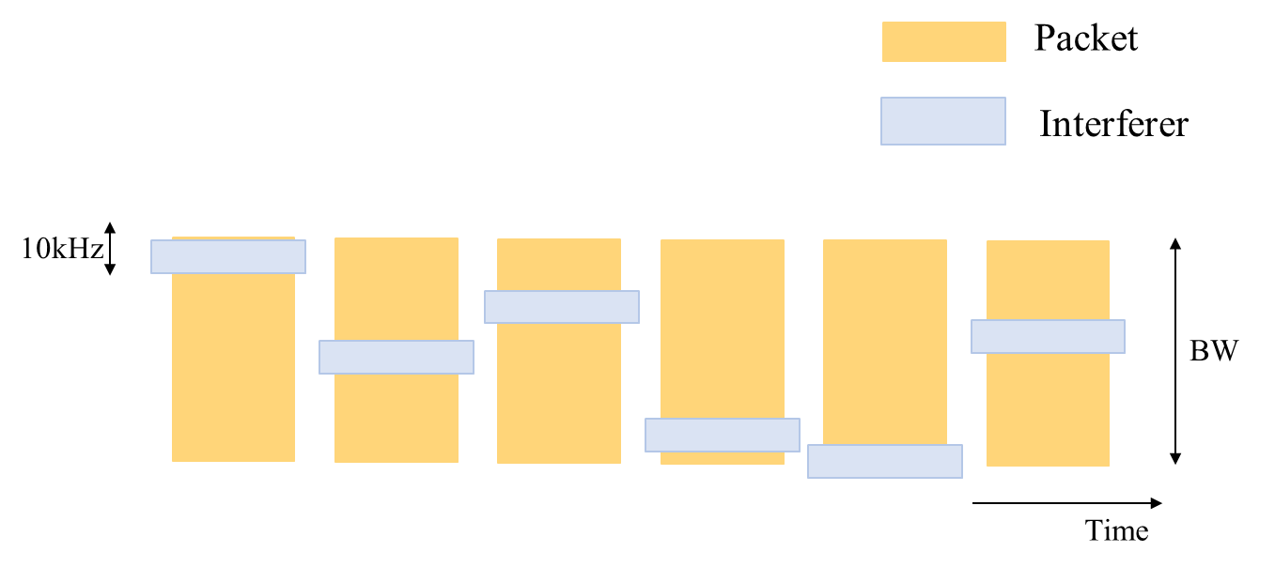

Figure 1: Structure of the narrow-band interferer

The exact frequency of the interferer shall be randomly chosen, and a new frequency shall be chosen for each new packet. The probability distribution of the frequency shall be identical within the packet bandwidth. Further, the center frequency of the interferer shall be within the 3dB-bandwidth of the packet.

The Carrier-to-Interference Ratio (C/I) shall be varied to show different levels of interference. The carrier power C shall be given by the signal power of the packet during the packet duration within the 3dB-bandwidth of the packet. The interference power I shall be given by the signal power of the interferer during the interferer duration within the 3dB-bandwidth of the interferer. The proposer should conduct a computer simulation to evaluate the packet error rate (PER) and present graphs that illustrate the relationship between the setting C/I and PER.

### Broad-Band Interferer Scenario

The intention of the broad-band interferer scenario is the modeling of systems with higher bit-rates, e.g., IEEE Std 802.11ah. These interferers are typically of broad bandwidth, but short duration.

The interferer shall be bandpass-filtered White Gaussian Noise with a 3dB-bandwidth of 125 kHz, 200 kHz, and 2 MHz. For the broad-band interferer, a rectangular window shall be used for the bandpass-filter. The duration of the interferer shall be 5 ms for all cases.

The frequency of the interferer shall be randomly chosen within the 3dB bandwidth of the packet, with identical distribution within 3dB-bandwidth of the packet. A new frequency shall be chosen for each new packet.

The start position of the interferer shall also be randomly chosen with identical probability over the complete packet duration. A new start position shall be chosen for each packet. Further, the temporal interferer position shall be within the packet duration.

Figure 2 shows and example of multiple packets for a broadband interferer where the bandwidth of the interferer is smaller than the bandwidth of the packet.

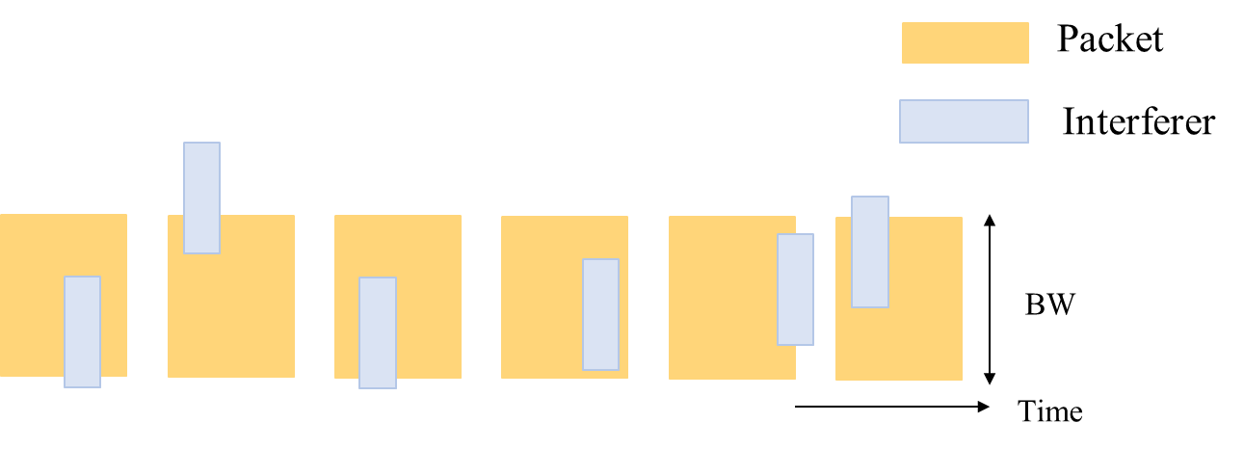

Figure 2: Structure of broad-band interferer where the bandwidth of the interferer is smaller than the bandwidth of the payload packet

The Carrier-to-Interference Ratio (C/I) shall be varied to show different levels of interference. The C shall be given by the signal power during the on-times of the packet. The interference power I shall be given by the signal power of the interferer during the duration within the 3dB-bandwidth of the interferer, namely bandpass-filtered White Gaussian Noise during its on-time. The proposer should conduct a computer simulation to evaluate the packet error rate (PER) and present graphs that illustrate the relationship between the setting C/I and PER.

# Literature

# [1] M. Failli, “Cost 207: Digital Land Mobile Radio Communications,” 1989. [2] E. Sofer and G. Chouinard, “WRAN Channel Modeling,” doc.: IEEE 802.22-05/0055

[3] ETSI TR 138 901, “5G; Study on channel model for frequencies from 0.5 to 100 GHz (3GPP TR 38.901 version 16.1.0 Release 16),” V16.1.0, Nov. 2020