IEEE P802.15
Wireless Personal Area Networks

Project | IEEE P802.15 Working Group for Wireless Personal Area Networks (WPANs)
Title | Proposed Comments Resolution on Compact Frame
Date Submitted | Jan. 2024
Sources | Bin Qian, Lei Huang, Rojan Chitrakar (Huawei)
Re:
Abstract
Purpose | To propose comments resolution for “P802.15.4ab™/D (pre-ballot) C Draft Standard for Low-Rate Wireless Networks”
Notice | This document does not represent the agreed views of the IEEE 802.15 Working Group or IEEE 802.15.4ab Task Group. It represents only the views of the participants listed in the “Sources” field above. It is offered as a basis for discussion and is not binding on the contributing individuals. The material in this document is subject to change in form and content after further study. The contributors reserve the right to add, amend or withdraw material contained herein.

Comment Index #359, #35, #360, #361, #84, #42, #755, #43, #756, #362 in 15-24-0010-01-04ab-cc-consolidated-comments
Index # | Commenter | Sub-Clause | Page | Line | Comment | Proposed Change
359 | Bin Qian | 10.38.10.11 | 80 | 7 | “RPA hash” should be “RPA Hash” | As in the comment
35 | Li-Hsiang Sun | 10.38.10.11 | 80 | 14 | L14 and L18 about 5 octets of zeros are wrong | remove description of 5 octets and refer to figure
360 | Bin Qian | 10.38.10.11 | 80 | 14 | Figure 74 and its corresponding description in Line 14-15 are contradictory | As in the comment
361 | Bin Qian | 10.38.10.11 | 80 | 18 | Figure 75 and its corresponding description in Line 18-19 are contradictory | As in the comment
84 | Pooria Pakrooh | 10.38.10.11 | 80 | 19 | In control field value of 0x01, the content is not zeros. | Change "shall consist of five octets with the value of zero as shown in Figure 75" to "shall be formatted as shown in Figure 75."
42 | Jinjing Jiang | 10.38.10.11 | 80 | 23 | complete the sentence | The number of Responders field specifies the number of responders that will be participating the ranging phase, which shall be set as the number of responders minus 1.
755 | Carl Murray | 10.38.10.11 | 80 | 23 | Field description missing | Add field description
43 | Jinjing Jiang | 10.38.10.11 | 80 | 24 | complete the sentence | The Responder Address list contains the list of Addresses of the Responders that will be participating the ranging phase.
756 | Carl Murray | 10.38.10.11 | 80 | 24 | Field description missing | Add field description
362 | Bin Qian | 10.38.10.11 | 80 | 23-24 | The description is not complete. | As in the comment

Discussion:
When the Message Control field value is 0x10, the Advertising Confirmation Compact frame is used in the contention based initialization setup.
During the contention based initialization setup phase, upon receipt of one or more Advertising Response Compact frames in the CAP, the initiator could select one or more of the responders from which the initiator has received the Advertising Response Compact frame in the CAP.
If only a single responder is selected and the coordination is active, the initiator should send an Advertising Confirmation Compact frame to the selected responder in the initialization slot following the CAP to indicate the SOR time offset.
If two or more responders are selected, the initiator shall send an Advertising Confirmation Compact frame indicating the selected responders and the SOR time offset of each responder.
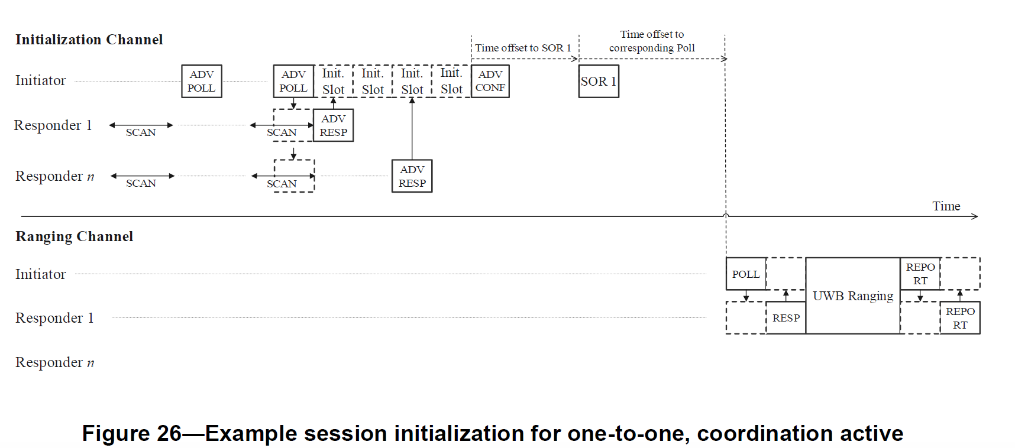
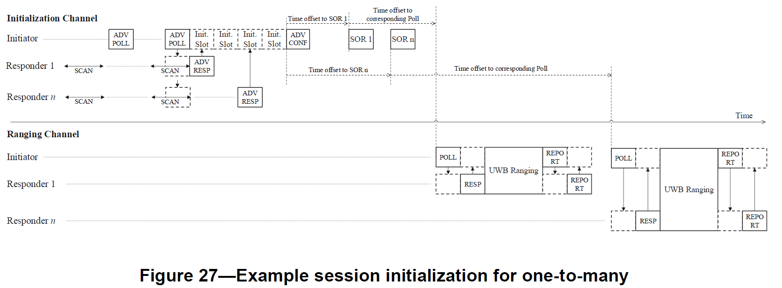
Resolution: Revised
Proposed text changes on P802.15.4ab™/D (pre-ballot) C:
Change sub-clause 10.38.10.11 as follows
10.38.10.11 Advertising Confirmation Compact frame
This is the Advertising Confirmation Compact frame used by the initiator during the initialization phase. The Advertising Confirmation Compact frame shall be formatted as shown in Figure 73.
Octets: 3 | 1 | variable | 2
RPA Hash | Message Control | Message Content | FCS
Figure 73 - Advertising Confirmation Compact frame format
The RPA Hash field shall be set as specified in 10.38.10.2.1. Note that if the Message Content field contains one or more Responder Address fields, each Responder Address in the Message Content field shall represent an eligible responder's RPA hash generated using the initiator's RPA_prand from the preceding Advertising Poll Compact frame along with the responder's IRK.
The Message Control field value shall be either 0x00 or 0x10. This value determines the formatting of the Message Content field.
When the Message Control field value is 0x00 the Message Content field shall be formatted as shown in Figure 74.
Octets: 4
SOR Time Offset
Figure 74 - Format of the Message Content field in the Advertising Confirmation Compact frame when the Message Control field value is 0x00
When the Message Control field value is 0x10 the Message Content field shall be formatted as shown in Figure 75.
Octets: 1 | variable
Number of Responders | Responder SOR Time Offset List
Figure 75 - Format of the Message Content field in the Advertising Confirmation Compact frame when the Message Control field value is 0x10
The Number of Responders field indicates the number of responders selected by the initiator to be involved in the following ranging session and determines the length of the Responder SOR Time Offset List field.

The Responder SOR Time Offset List field is a list of Responder SOR Time Offset elements, each formatted as per Figure a.
Octets: 3 | 4
Responder Address | SOR Time Offset
Figure a – Responder SOR Time Offset element format (Message Control = 0x10)

The Responder Address field identifies the address of the responder selected by the initiator to be involved in the following ranging session.
The SOR Time Offset field is as defined in 10.38.10.3.13.

-------------------------------------------------------------------------------------------------------------------------------
Comment Index #787 in 15-24-0010-01-04ab-cc-consolidated-comments
Index # | Commenter | Sub-Clause | Page | Line | Comment | Proposed Change
787 | Carl Murray | 10.38.10.12 | 86 | 20 | Field description missing | Add field description

Discussion:
The original text of Draft C is as follows
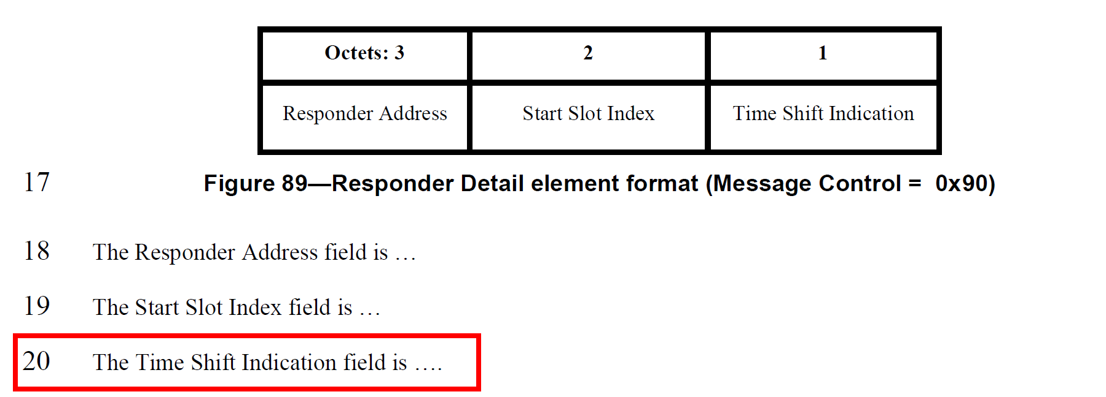
The one-to-many Poll Compact frame with the Message Control field set to 0x90 or 0xA0 serves to enable the time efficient one-to-many ranging from an initiator to even number of responders. For two responders involved in each sub-round, the corresponding Time Shift Indication fields shall set to zero and one, respectively.
The responder with Time Shift Indication field set to zero may start transmitting the first UWB RSF fragment at RpRsfOffset slots plus 400 RSTUs into the ranging phase, and continue to send the second UWB RSF fragment at an interval of 1200 RSTUs. The responder with Time Shift Indication field set to one may start transmitting the first UWB RSF fragment at RpRsfOffset slots plus 800 RSTUs into the ranging phase, and continue to send the second UWB RSF fragment at an interval of 1200 RSTUs.

Resolution: Revised
Proposed text changes on P802.15.4ab™/D (pre-ballot) C:
10.38.10.12 One-to-many Poll Compact frame
Change Figure 89 as follows
Octets: 3 | 2 | Bits: 0 | 1-7
Responder Address | Start Slot Index | Time Shift Indication | Reserved

Change Line 20 on Page 86 as follows
The Time Shift Indication field when zero indicates the corresponding responder transmits the first UWB RSF fragment at RpRsfOffset slots plus 400 RSTUs into the ranging phase, and when one indicates the corresponding responder transmits the first UWB RSF fragment at RpRsfOffset slots plus 800 RSTUs into the ranging phase.

-------------------------------------------------------------------------------------------------------------------------------
Comment Index #518, #637, #741, #905, #519, #742, #906 in 15-24-0010-01-04ab-cc-consolidated-comments
Index # | Commenter | Sub-Clause | Page | Line | Comment | Proposed Change
518 | Tero Kivinen | 10.38.10.4 | 72 | 6 | Line seems to be incomplete. | Complete it.
637 | Rojan Chitrakar | 10.38.10.4 | 72 | 6 | CapDuration[], InitializationSlotDuration[] are not defined. | Define CapDuration[], InitializationSlotDuration[]
741 | Carl Murray | 10.38.10.4 | 72 | 6 | Field description missing | Add field description
905 | Mickael Maman | 10.38.10.4 | 72 | 6 | The CAP duration field … ??? | "The CAP duration field is an unsigned integer that specifies the duration of a CAP period in Initialization Slot "
519 | Tero Kivinen | 10.38.10.4 | 72 | 7 | Line seems to be incomplete | Complete it
742 | Carl Murray | 10.38.10.4 | 72 | 7 | Field description missing | Add field description
906 | Mickael Maman | 10.38.10.4 | 72 | 7 | The Initialization Slot Duration field… ??? | The Initialization Slot Duration field is an unsigned integer that specifies the duration of a Initialization slot duration macMmsNbInitSlotDuration as defined in Table 9

Discussion:
The original text of Draft C is as follows
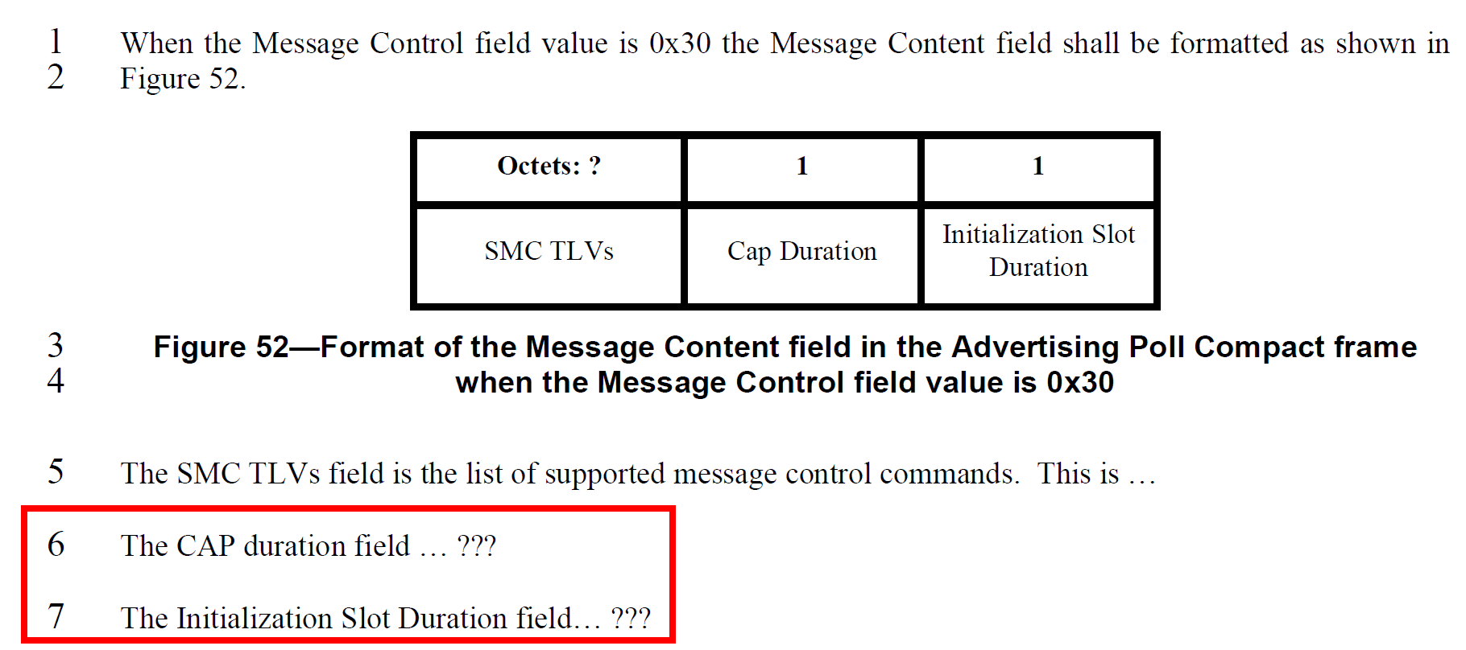
In the contention based initialization and setup phase, the initiator sends an Advertising Poll Compact frame to one or more intended responders opportunistically at times and intervals as deemed suitable for the higher layer functionality to be supported. The Advertising Poll Compact frame sets the number of slots for contention access period (CAP) starting from the end of the Advertising Poll Compact frame. The CAP consists of multiple initialization slots with the initialization slot duration specified in the Advertising Poll Compact frame.
The duration of the initialization slot is defined in Table 9 as follows

Resolution: Revised
Proposed text changes on P802.15.4ab™/D (pre-ballot) C:
10.38.10.4 Advertising Poll Compact frame
Change Line 6 and Line 7 on Page 72 as follows
The CAP duration field is an unsigned integer that specifies the duration of the contention access period in units of initialization slots, that is the number of initialization slots in the CAP.
The Initialization Slot Duration field is an unsigned integer that specifies the duration of an initialization slot in RSTU (as defined in 10.28.1.5). The duration of an initialization slot is equal to 600 plus 300 times the value of the Initialization Slot Duration field in RSTU (as defined in Table 9 in 10.38.11.1).

-------------------------------------------------------------------------------------------------------------------------------
Comment Index #809, #810, #381 in 15-24-0010-01-04ab-cc-consolidated-comments
Index # | Commenter | Sub-Clause | Page | Line | Comment | Proposed Change
809 | Carl Murray | 10.38.10.16 | 91 | 17 | Field description missing | Add field description
810 | Carl Murray | 10.38.10.16 | 91 | 18 | Field description missing | Add field description
381 | Bin Qian | 10.38.10.16 | 91 | 17, 18 | The description is not complete | As in the comment

Discussion:
The original text of Draft C is as follows
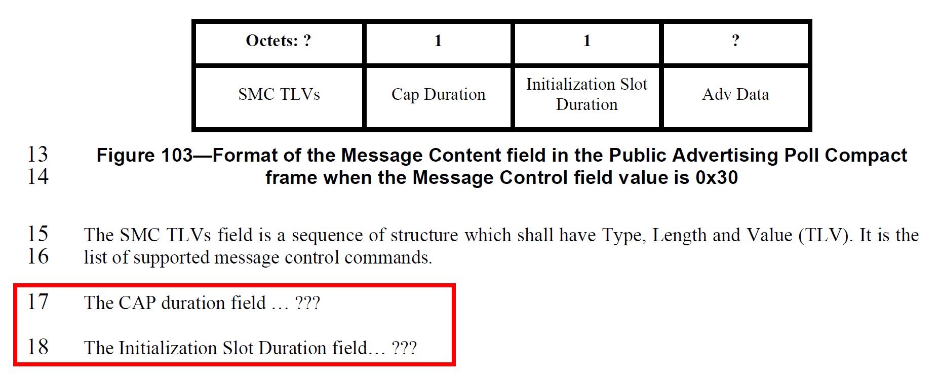
The definitions of the Cap Duration field and the Initialization Slot Duration field are same as that in 10.38.10.4.

Resolution: Revised
Proposed text changes on P802.15.4ab™/D (pre-ballot) C:
10.38.10.16 Public Advertising Poll Compact frame
Change Line 17 and Line 18 on Page 91 as follows
The CAP duration field is an unsigned integer that specifies the duration of the contention access period in units of initialization slots, that is the number of initialization slots in the CAP.
The Initialization Slot Duration field is an unsigned integer that specifies the duration of an initialization slot in RSTU (as defined in 10.28.1.5). The duration of an initialization slot is equal to 600 plus 300 times the value of the Initialization Slot Duration field in RSTU (as defined in Table 9 in 10.38.11.1).

