IEEE P802.15
Wireless Personal Area Networks

Project | IEEE P802.15 Working Group for Wireless Personal Area Networks (WPANs)
Title | Proposed Resolution for MMS – Synchronized Responders
Date Submitted | May 2024
Sources | Rojan Chitrakar, Lei Huang (Huawei)  rojan.chitrakar@huawei.com
Re:
Abstract
Purpose | To propose resolution for MMS – Synchronized Responders related comments for “P802.15.4ab™/D (pre-ballot) C Draft Standard for Low-Rate Wireless Networks” .
Notice | This document does not represent the agreed views of the IEEE 802.15 Working Group or IEEE 802.15.4ab Task Group. It represents only the views of the participants listed in the “Sources” field above. It is offered as a basis for discussion and is not binding on the contributing individuals. The material in this document is subject to change in form and content after further study. The contributors reserve the right to add, amend or withdraw material contained herein.

Rev 0: Initial version.
Rev 1: Simplified the signaling for synchronized O2M by adding O2M Ranging Mode field.

Comment Indices in 15-24-0010-00-04ab-consolidated-comments-draft-c:
Name | Index# | Pg | Sub-Clause | Ln | Comment | Proposed Change | Disposition
Rojan Chitrakar | 640 | 73 | 10.38.10.5 | 5 | It is beneficial to also include a field (e.g., Number Of Responders) to indicate that the Advertising Response Compact frame is requesting for one-to-many ranging from a group of connected responders, in which case the field can also indicate how many responders will particate in the subsequent ranging phase. This was presented in 23/337r0 (Proposal-1). | Add a field (Number Of Responders (N)) to the "Advertising Response Compact frame when the Message Control field value is 0x10" to indicate that the the Advertising Response Compact frame is requesting one-to-many ranging from a group of N connected responders. Also add the corresponding bit in the Presence Bitmap field. | Revised
Rojan Chitrakar | 642 | 75 | 10.38.10.6 | 2 | For the one-to-many ranging with a group of connected responders, it is beneficial to also include a field (e.g., Number Of Responders) in the Start of Ranging Compact frame to indicate how many responders are accepted to particate in the subsequent ranging phase. This was presented in 23/337r0 (Proposal-1). | Include an option field (e.g., Number Of Responders) in the Start of Ranging Compact frame to indicate the number of responders accepted to particate in the subsequent ranging phase. | Revised
Rojan Chitrakar | 648 | 81 | 10.38.10.12 | 19 | For one-to-many ranging with a group of connected responders,the initiator need not schedule the responders in the ranging phase and hence the O2M POLL can be a simplified version of Message Control field value= 0x10 without Responder Address List field. | Add a variant of the O2M POLL for the one-to-many ranging with a group of connected responders,which is a simplified version of Message Control field value= 0x10 but without the Responder Address List field. | Revised
Rojan Chitrakar | 651 | 92 | 10.38.10.17 | 9 | It is beneficial to also include a field (e.g., Number Of Responders) to indicate that the Public Advertising Response Compact frame is requesting for one-to-many ranging from a group of connected responders, in which case the field can also indicate how many responders will particate in the subsequent ranging phase. This was presented in 23/337r0 (Proposal-1). | Add a field (Number Of Responders (N)) to the "Public Advertising Response Compact frame when the Message Control field value is 0x00" to indicate that the the Advertising Response Compact frame is requesting one-to-many ranging from a group of N connected responders. Also add the corresponding bit in the Presence Bitmap field. | Revised  651 is automatically resolved by the changes made for #640 since the content of the public Advertising Response Compact frame is the same as the Advertising Response Compact frame.
Rojan Chitrakar | 653 | 92 | 10.38.10.18 | 21 | For the one-to-many ranging with a group of connected responders, it is beneficial to also include a field (e.g., Number Of Responders) in the Public Start of Ranging Compact frame to indicate how many responders are accepted to particate in the subsequent ranging phase. This was presented in 23/337r0 (Proposal-1). | Include an option field (e.g., Number Of Responders) in the Public Start of Ranging Compact frame to indicate the number of responders accepted to particate in the subsequent ranging phase. | Revised

Discussion：
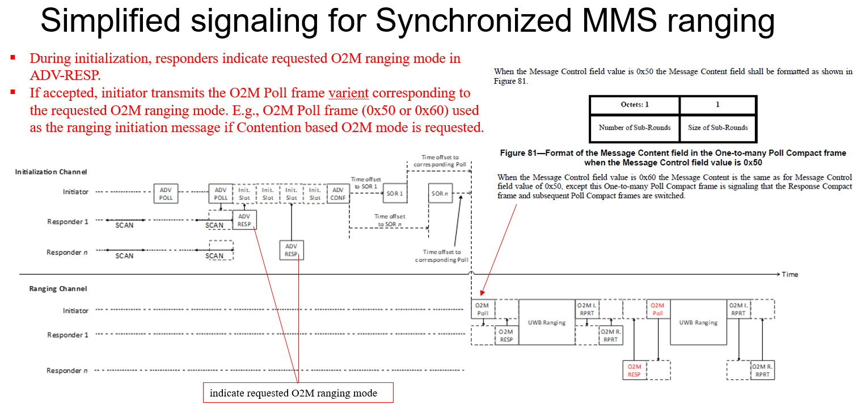

We also noted an error in Draft-C: Ranging MAC Configuration field should be 1 octet and not 2.
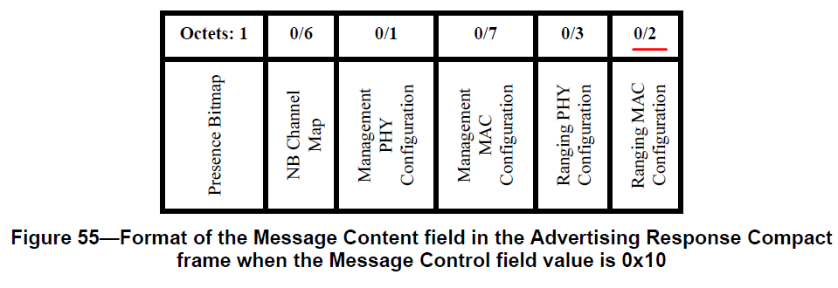
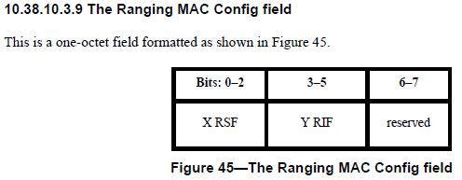
We also received feedback that the ranging phase in Figure 27A looks like multiple O2O ranging instead of O2M and hence replaced the figure for better clarity.
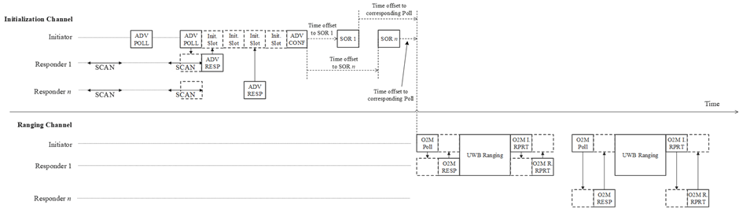
Figure 27A – Example session initialization for one-to-many

Disposition: Revised
Disposition Detail:
Proposed text changes on P802.15.4ab™/D (pre-ballot) C:
10.38.10.5 Advertising Response Compact frame (#640)
Change the subfield as follows (Track changes ON)
Also change the Ranging MAC Configuration field size from 0/2 to 0/1, or from 2 to 1 as appropriate in P72L17, P74L10, P75L3, P76L5, P79L14, P84L7, P85L25, P87L16, P89L11, P99L17, P102L1
…
Octets: 1/2 | 0/6 | 0/1 | 0/7 | 0/1 | 0/1
Presence Bitmap | NB Channel Map | Management PHY Configuration | Management MAC Configuration | Ranging PHY Configuration | Ranging MAC Configuration
Figure 55—Format of the Message Content field in the Advertising Response Compact frame when the Message Control field value is 0x10
The Presence Bitmap field is set as specified in 10.38.10.3.xx (The Presence Bitmap field)shall be formatted as shown in Figure 56.
10.38.3.2.3 Contention based initialization setup handshake
Change the subfield as follows (Track changes ON)
Note to editor: the changes are made on top of the changes made by 15-24/125r1.
…
If two or more responders are selected and the initiator intends to perform one-to-many ranging with the selected responders, each Start of Ranging Compact frame specifies the corresponding ranging configurations and the time offset between the first symbol of the Start of Ranging Compact frame and the first symbol of the first One-to-many Poll Compact frame addressed to all the selected responders in the first ranging block. Figure 27A shows an example contention-based initialization and setup process for one-to-many ranging.
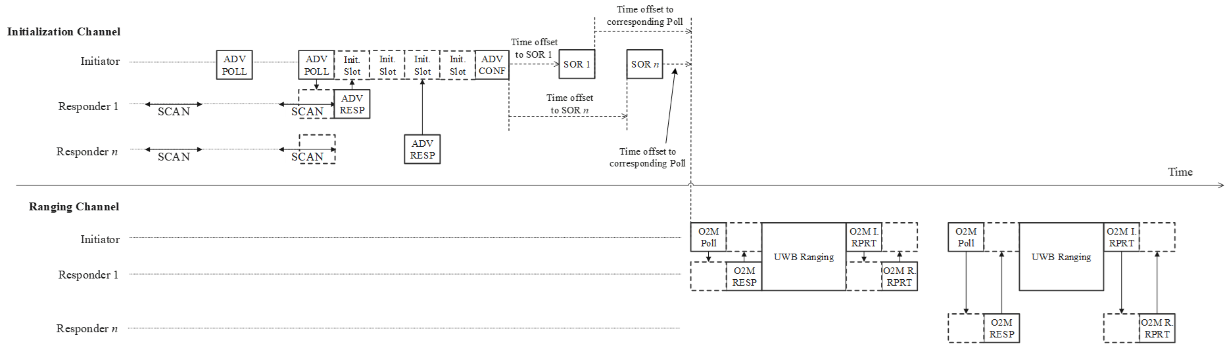
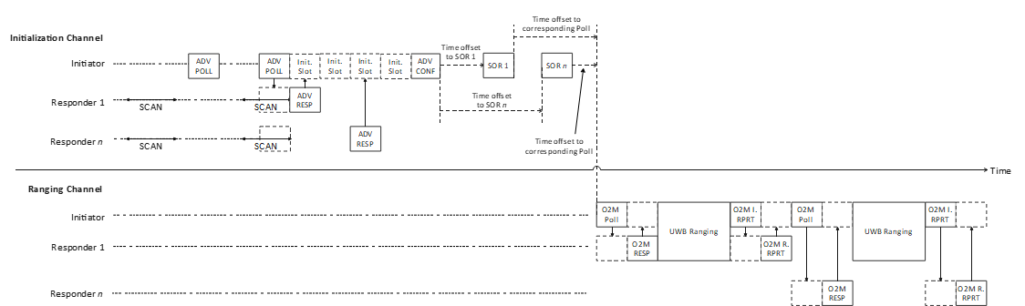
Figure 27A – Example session initialization for one-to-many
Upon receipt of the Advertising Confirmation Compact frame in the CAP, each of the selected responders shall listen for its incoming Start of Ranging Compact frame at the corresponding time specified in the Advertising Confirmation Compact frame.
After transmitting the Start of Ranging Compact frame, the initiator shall enter the control phase. If the initiator had accepted the responder’s request for a specific one-to-many ranging mode during the initialization and setup phase, as explained in 10.38.3.4, the initiator shall transmit the One-to-many Poll Compact frame with the Message Control field value that matches the requested one-to-many ranging mode. After receiving the Start of Ranging Compact frame, the responder shall enter the control phase. After the initiator has confirmed receipt of the RESP Compact frame from the responder during the control phase, and unless initialization of further devices is required, the initiator shall discontinue ranging initialization and cease the transmission of Advertising Poll Compact frame.

10.38.3.4 Initialization setup handshake
Change the subfield as follows (Track changes ON)
The responder (controlee) requests ranging session configuration in the Advertising Response Compact frame. The responder may request a specific one-to-many ranging mode by including the O2M Ranging Mode field in the Presence Bitmap field of the Advertising Response Compact frame.
The initiator (controller) receives the request from the responder via the Advertising Response Compact frame, sets the session configuration and communicates it in the Start of Ranging Compact frame to the responder.
The Advertising Response Compact frame is defined in 10.38.10.5 and the Start of Ranging Compact frame is defined in 10.38.10.6 and contain common fields: NB Channel Map, Management PHY Configuration, Management MAC Configuration, Ranging PHY Configuration and Ranging MAC Configuration. For these fields, the initiator may either use the same values received via the Advertising Response Compact frame from the responder or change the values of each field before transmitting the updated field values in the Start of Ranging Compact frame. If the O2M Ranging Mode field is included in the Presence Bitmap field of the Advertising Response Compact frame, the initiator may accept the request and use the same value for the O2M O2M Ranging Mode field in the Start of Ranging Compact frame or it may reject the request and suggest a different value for the O2M Ranging Mode field in the Presence Bitmap field of the Start of Ranging Compact frame.

10.38.10.3 Common message fields
Note to editor: Modify the subclause as below (track changes On)

10.38.10.3.xx The Presence Bitmap field
The Presence Bitmap field shall be formatted as shown in Figure xx1.
Bits: 0-1 | 2 | 3 | 4 | 5 | 6 | 7 | Octets: 0/1
NB Channel Map Present | Management  PHY  Configuration  Present | Management  MAC  Configuration  Present | Ranging PHY  Configuration  Present | Ranging MAC  Configuration  Present | Block and Round Index Present | Extended Presence Bitmap  Present | Extended Presence Bitmap
Figure xx1—Presence Bitmap format
The NB Channel Map Present field set to a value 0 indicates absence of a NB Channel Map in the Message Content field, a value of 1 indicates the presence in the Message Content field of a 2-byte NB Lower Channel Map as shown in Figure 44, a value of 2 indicates the presence in the Message Content field of a 5-byte NB Higher Channel Map as shown in Figure 44, and a value of 3 indicates the presence in the Message Content field of a 6-byte NB Channel Map as shown in Figure 43.
The Management PHY Configuration Present field when one indicates that the Management PHY Configuration field is included in the Responder Detail List elements or is not included when the Management PHY Configuration Present field value is zero.
The Management MAC Configuration Present field when one indicates that the Management MAC Configuration field is included in the Responder Detail List elements or is not included when the Management MAC Configuration Present field value is zero.
The Ranging PHY Configuration Present field when one indicates that the Ranging PHY Configuration field is included in the Responder Detail List elements or is not included when the Ranging PHY Configuration Present field value is zero.
The Ranging MAC Configuration Present field when one indicates that the Ranging MAC Configuration field is included in the Responder Detail List elements or is not included when the Ranging MAC Configuration Present field value is zero.
The Block and Round Index Present field when one indicates that both the Block index field and the Round Index field are included in the Message Content field or are not included when the Block and Round Index Present field value is zero.
The Extended Presence Bitmap Present field when one indicates that the Extended Presence Bitmap is included in the Presence Bitmap field or is not included when the Extended Presence Bitmap Present field is zero.
The Extended Presence Bitmap field shall be formatted as shown in Figure xx2.
Bits: 0 | 1 | 2 - 3 | 4 - 7
SMC_TLVs  Present | Start and End Slot Indices Present | O2M Ranging Mode | Reserved
Figure xx2—Extended Presence Bitmap format
The SMC_TLVs Present field when set to value 1 in indicates that the SMC_TLVs field is present in the Message Content field. A value of zero indicates absence of the SMC_TLVs field in the Message Content field.
The Start and End Slot Indexes Present field when one indicates that both the Block index field and the Round Index field are included in the Responder Detail List elements or are not included when the Block and Round Index Present field value is zero.
The O2M Ranging Mode field specifies the one-to-many ranging mode requested by the responder, as listed in Table xx3.
Table xx3— O2M Ranging Mode
O2M Ranging Mode value | One-to-many ranging mode | Sub-clause
0 | Basic one-to-many ranging | 10.38.9.1
1 | Contention-based one-to-many | 10.38.9.2
2 | Time Efficient one-to-many | 10.38.9.3
3 | One-to-many ranging with multiple RSF transmissions per slot | 10.38.9.4

