IEEE P802.15
Wireless Personal Area Networks

Project | IEEE P802.15 Working Group for Wireless Personal Area Networks (WPANs)
Title | Proposed Resolution for Key ID field
Date Submitted | January 2024
Sources | Rojan Chitrakar, Lei Huang (Huawei)  rojan.chitrakar@huawei.com
Re:
Abstract
Purpose | To propose resolution for Key ID field related comments for “P802.15.4ab™/D (pre-ballot) C Draft Standard for Low-Rate Wireless Networks” .
Notice | This document does not represent the agreed views of the IEEE 802.15 Working Group or IEEE 802.15.4ab Task Group. It represents only the views of the participants listed in the “Sources” field above. It is offered as a basis for discussion and is not binding on the contributing individuals. The material in this document is subject to change in form and content after further study. The contributors reserve the right to add, amend or withdraw material contained herein.

Rev 0: Initial version. Addresses the following comments:

Comment Indices in 15-24-0010-00-04ab-consolidated-comments-draft-c:
Name | Index# | Pg | Sub-Clause | Ln | Comment | Proposed Change | Disposition
Rojan Chitrakar | 634 | 71 | 10.38.10.3.19 | 2 | When the One-to-many Initiator Secure Report Compact frame is meant to be received by more than one responders, group Key may be used to secure the frame instead of a unicast Key. As such a 1 bit Key ID field is not enough. Suggest to use one octet for the Key ID field for all secure frames. Regardless, it is not necessary to desciribe the size of the field here and suggest to change to a general langugauage similar to the baseline. | Change to:  "The Key ID field allows unique identification of different keys with the same originator." | Revised
Carl Murray | 824 | 98 | 10.38.10.21 | 19 | Field description missing | Add field description | Revised
Mickael Maman | 909 | 98 | 10.38.10.21 | 19 | The Key ID field… ??? | "The Key ID field is the KeyIndex parameter as defined in 10.38.10.3.19." | Revised
Carl Murray | 826 | 99 | 10.38.10.22 | 11 | Field description missing | Add field description | Revised
Carl Murray | 828 | 99 | 10.38.10.22 | 20 | Field description missing | Add field description | Revised
Rojan Chitrakar | 654 | 100 | 10.38.10.23 | 19 | When the One-to-many Initiator Secure Report Compact frame is meant to be received by more than one responders, group Key may be used to secure the frame instead of a unicast Key. As such a 1 bit Key ID field is not enough. Suggest to use one octet for the Key ID field for all secure frames. | Change the Key ID field to one octet and reposition as the first field of the Message Content field | Revised
Rojan Chitrakar | 655 | 100 | 10.38.10.23 | 21 | If a separate octet is used for the Key ID field, suggest to make the PT Data Length 1 octet for all secure compact frames, same as unsecure compact frames. | Delete ", except it is a 7-bit field" | Revised
Benjamin Rolfe | 169 | 100 | 10.38.10.23 | 22 | More missing field definitions (???) | Complete specification or remove clause | Revised
Carl Murray | 830 | 100 | 10.38.10.23 | 22 | Field description missing | Add field description | Revised
Benjamin Rolfe | 170 | 101 | 10.38.10.24 | 15 | More missing field definitions (???) | Complete specification or remove clause | Revised
Carl Murray | 832 | 101 | 10.38.10.24 | 15 | Field description missing | Add field description | Revised
Carl Murray | 834 | 102 | 10.38.10.24 | 4 | Field description missing | Add field description | Revised

Discussion：
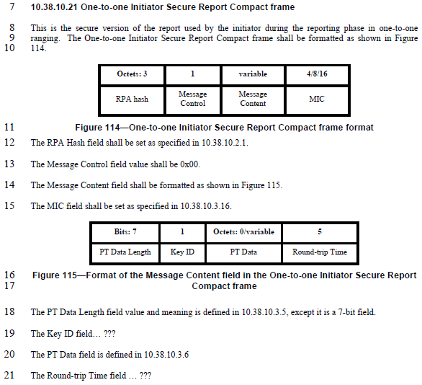
Disposition: Revised
Disposition Detail:
Proposed text changes on P802.15.4ab™/D (pre-ballot) C:
10.38.10.3.19 The Key ID field (#634)
The Key ID field allows unique identification of different keys with the same originator.

10.38.10.21 One-to-one Initiator Secure Report Compact frame (#824, #909)
Change the subfield as follows (Track changes ON)
…
Octets: 1 | 1 |  | 0/variable | 5
Key ID | PT Data Length |  | PT Data | Round-trip Time
Figure 115—Format of the Message Content field in the One-to-one Initiator Secure Report Compact frame
The PT Data Length field value and meaning is defined in 10.38.10.3.5.
The Key ID field is defined in 10.38.10.3.19.

10.38.10.22 One-to-one Responder Secure Report Compact frame (#826, #828)
Change the subfield as follows (Track changes ON)
…
Octets: 1 | 1 |  | 0/variable | 5
Key ID | PT Data Length |  | PT Data | Round-trip Time
Figure 117—Format of the Message Content field in the One-to-one Responder Secure Report Compact frame when the Message Control field value is 0x00
The PT Data Length field value and meaning is defined in 10.38.10.3.5.
The Key ID field is defined in 10.38.10.3.19.
…
Octets: 1 | 1 |  | 0/variable | 1 | 0/6 | 0/1 | 0/7 | 0/3 | 0/2 | 5
Key ID | PT Data Length |  | PT Data | Presence Bitmap | NB Channel Map | Management PHY Configuration | Management MAC Configuration | Ranging PHY Configuration | Ranging MAC Configuration | Reply Time
Figure 118— Format of the Message Content field in the One-to-one Responder Secure Report Compact frame when the Message Control field value is 0x10
The PT Data Length field value and meaning is defined in 10.38.10.3.5.
The Key ID field is defined in 10.38.10.3.19.

10.38.10.23 One-to-many Initiator Secure Report Compact frame (#654, #655, #169)
Change the subfield as follows (Track changes ON)
…
Octets: 1 | 1 |  | 0/variable | 5
Key ID | PT Data Length |  | PT Data | Round-trip Time
Figure 120—Format of the Message Content field in the One-to-many Initiator Secure Report Compact frame when the Message Control field value is 0x00
The PT Data Length field value and meaning is defined in 10.38.10.3.5.
The Key ID field is defined in 10.38.10.3.19.

10.38.10.24 One-to-many Responder Secure Report Compact frame (#170, #832, #834)
Change the subfield as follows (Track changes ON)
…
Octets: 1 | 1 |  | 0/variable | 5
Key ID | PT Data Length |  | PT Data | Round-trip Time
Figure 122—Format of the Message Content field in the One-to-many Responder Secure Report Compact frame when the Message Control field value is 0x00
The PT Data Length field value and meaning is defined in 10.38.10.3.5.
The Key ID field is defined in 10.38.10.3.19.
…
Octets: 1 | 1 |  | 0/variable | 1 | 0/6 | 0/1 | 0/7 | 0/3 | 0/2 | 5
Key ID | PT Data Length |  | PT Data | Presence Bitmap | NB Channel Map | Management PHY Configuration | Management MAC Configuration | Ranging PHY Configuration | Ranging MAC Configuration | Reply Time
Figure 123—Format of the Message Content field in the One-to-many Responder Secure Report Compact frame when the Message Control field value is 0x10
The PT Data Length field value and meaning is defined in 10.38.10.3.5.
The Key ID field is defined in 10.38.10.3.19.

