6.3.37.5.1 Simplified Network Entry with Authentication
- With Authentication, there is an intermediate message sent from BS to MS.
- The Network Attach Response message which is sent during simplified network entry without Authentication is replaced by two messages.
  - PreAuth Network Attach Response
  - PostAuth Network Attach Response
- The message PreAuth Network Attach response message contains basic CID, primary CID and authentication parameters necessary for the remote to enter Authentication phase.
- After completing Authentication, the BS shall send PostAuth Network Attach Response message to MS.

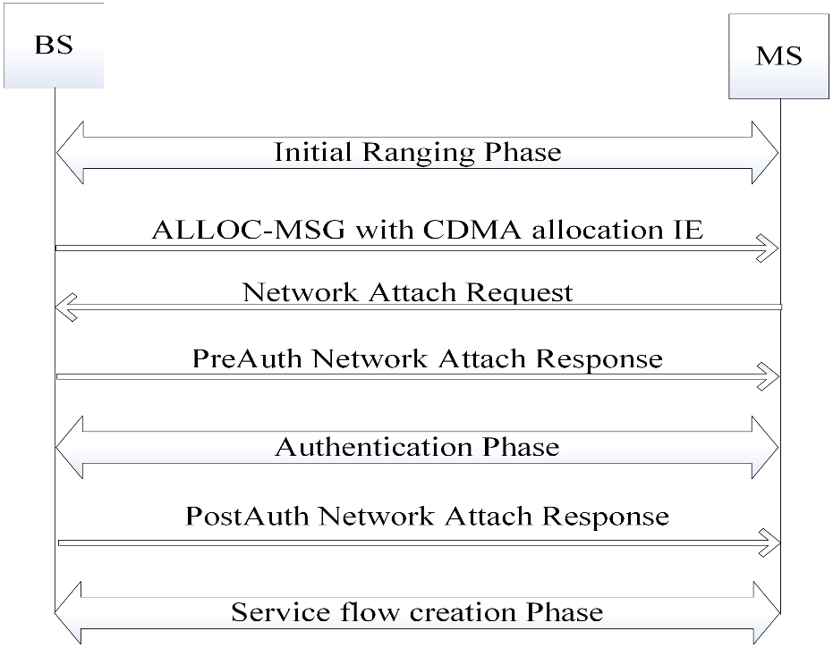

Figure 6-225—Simplified network entry with authentication

PreAuth Network Attach Response Message format
Syntax | Size(bit) | Notes
PreAuth_Network_Attach_Response () { | --- | ----
Management Message Type | 8 | 42
MS MAC Address | 24 | The least significant 24 bits of the MS MAC address.
Basic CID | 8 | Basic CID assigned by BS.
Primary Management CID | 16 | Primary Management CID assigned by BS. Security Support Parameters
Authentication Type | 3 | 0 : Security disabled  1 : EAP TLS  2 : EAP TTLS_CHAP  3 : EAP TTLS_MS_CHAP  4 : MS_CHAPv2  5 : PKMv3  6 -7 : Reserved
Encryption Type | 1 | 0 : Security Supports AES 128 Encryption method  1 : Security Supports AES 256 Encryption method
Reserved | 4 | Unused
} | --- | ----

PostAuth Network Attach Response Message format
Syntax | Size(bit) | Notes
PostAuth_Network_Attach_Response () { | --- | ----
Management Message Type | 8 | 43
Response Message | 1 | 0: Accept  1 : Reject
If (Response Message = = Accept) { | --- | ---
BS MAC Address | 24 | The least significant 24 bits of the Base Station MAC address.
BS IP Address | 32 | IPv4 Address
Mobility Features Support | 3 | 0: Mobility (HO) support  1: Sleep mode support  2: Idle mode support
Reserved | 4
} | --- | ----
else if (Response Message = =Reject) { | --- | ----
Reason | 7 | 0 : Capabilities Mismatch, Others: Not specified
} | --- | ----
} | --- | ----

Table 6-331—Network Attach Request message format
Syntax | Size (bit) | Notes
Network_Attach_Request () { | --- | ---
Management Message Type | 8 | 19
MS Mac Address | 4
Authentication Type | 3 | 0: Security disabled  1: EAP TLS  2: EAP TTLS_CHAP  3: EAP TTLS_MS_CHAP  4: MS_CHAPv2  5 : PKMv3  6 -7 : Reserved
Encryption Type | 1 | 0: Security supports AES 128 Encryption method  1: Security supports AES 256 Encryption method
DL FEC Code | 4 | Maximum DL FEC Code
UL FEC Code | 4 | Maximum UL FEC Code
Reserved | 4 | Unused
}

