IEEE P802.15
Wireless Personal Area Networks

Project | IEEE P802.15 Working Group for Wireless Personal Area Networks (WPANs)
Title | Resolution proposals for comments #21, 22, 25, 26, 28, 99, 155, 164, 166
Date Submitted | November 2023
Sources | Alex Krebs, Robert Golshan (Apple)
Re:
Abstract
Purpose | To propose resolution to NBA-UWB MMS comments for “P802.15.4ab™/D (pre-ballot) B Draft Standard for Low-Rate Wireless Networks”
Notice | This document does not represent the agreed views of the IEEE 802.15 Working Group or IEEE 802.15.4ab Task Group. It represents only the views of the participants listed in the “Sources” field above. It is offered as a basis for discussion and is not binding on the contributing individuals. The material in this document is subject to change in form and content after further study. The contributors reserve the right to add, amend or withdraw material contained herein.

CIDs #21, 22, 25, 28, 164, 166 (NB channel map) 3
CID #99 Revise 7

CIDs #21, 22, 25, 28, 164, 166 (Revise NB channel map)
Name | Idx # | Cat. | Pg. | Sub-clause | Line # | Comment | Proposed Change
Li-Hsiang Sun | 21 | Technical | 44 | 10.35.7.4.1 | 17 | Which message updates macMmsNbChannelAllow List? Is it NB channel select in control message can we unify the format of NB channel select and macMmsNbChannelMap? | unify the format of the representation of allowed channel list->done
Li-Hsiang Sun | 22 | Technical | 44 | 10.35.7.4.1 | 8 | This paragraph should also describe that responder can make inputs of the allowed channel list in ADV_RESP | not clear what the commenter means. ADV-RESP is sent by responder, and the input processing to for the initiator is defined p.37 l.16.
Li-Hsiang Sun | 25 | Technical | 51 | 10.35.9.3.9 | 1 | for countries do not have UNII-3 band, how to use this field to block the entire band? | as in comment->fixed by unified 6-octet encoding
Li-Hsiang Sun | 28 | Technical | 58 | 10.35.9.8 | 6 | NbaChannelMap is not defined and in this message it is NB channel select | as in comment->fixed
Pooria Pakrooh | 164 |  | 44 | 10.35.7.4.2 | 17 | Scaling factor needs to be defined. | Add the scaling factor defenition.->fixed
Pooria Pakrooh | 166 | General | 50 | 10.35.9.3.6 | 26 | Clarification questions:  1. Is the NBAllowed list the reference for "the NB Channel Select field"? If yes, which message contains the Allowed list? It is not specified.  2. Is this flexible enough to signal reasonable selection possibilities? | Clarifications as per comment.->deleted

References:
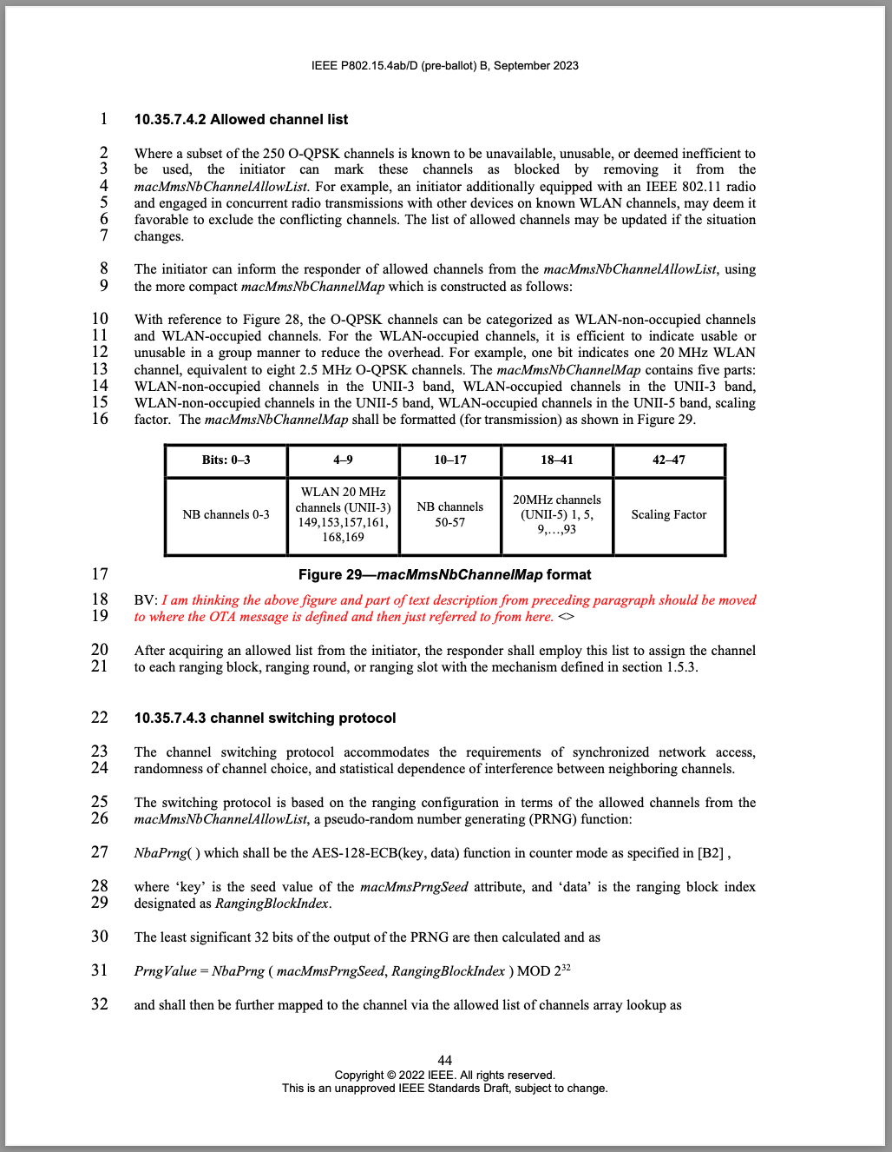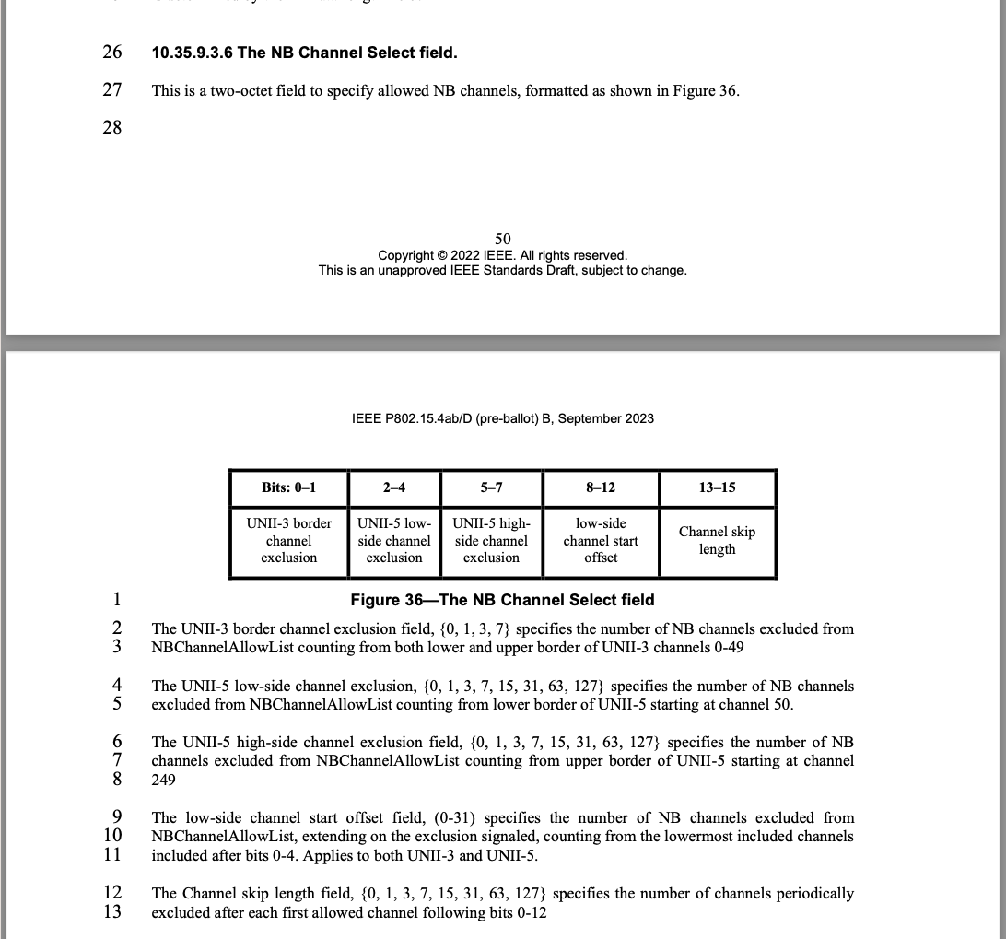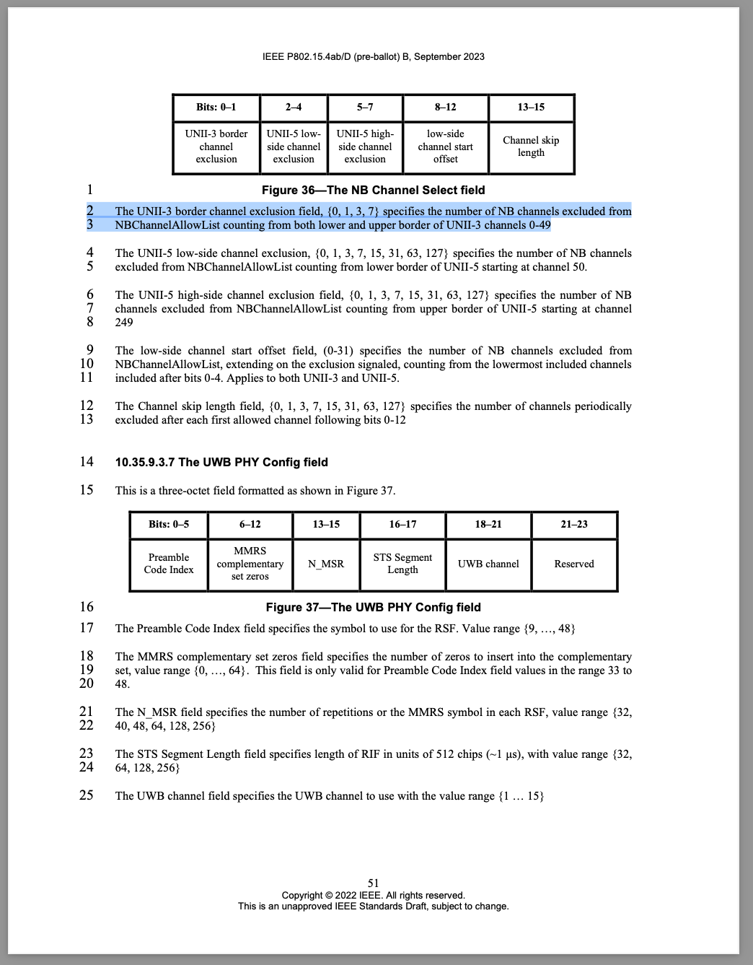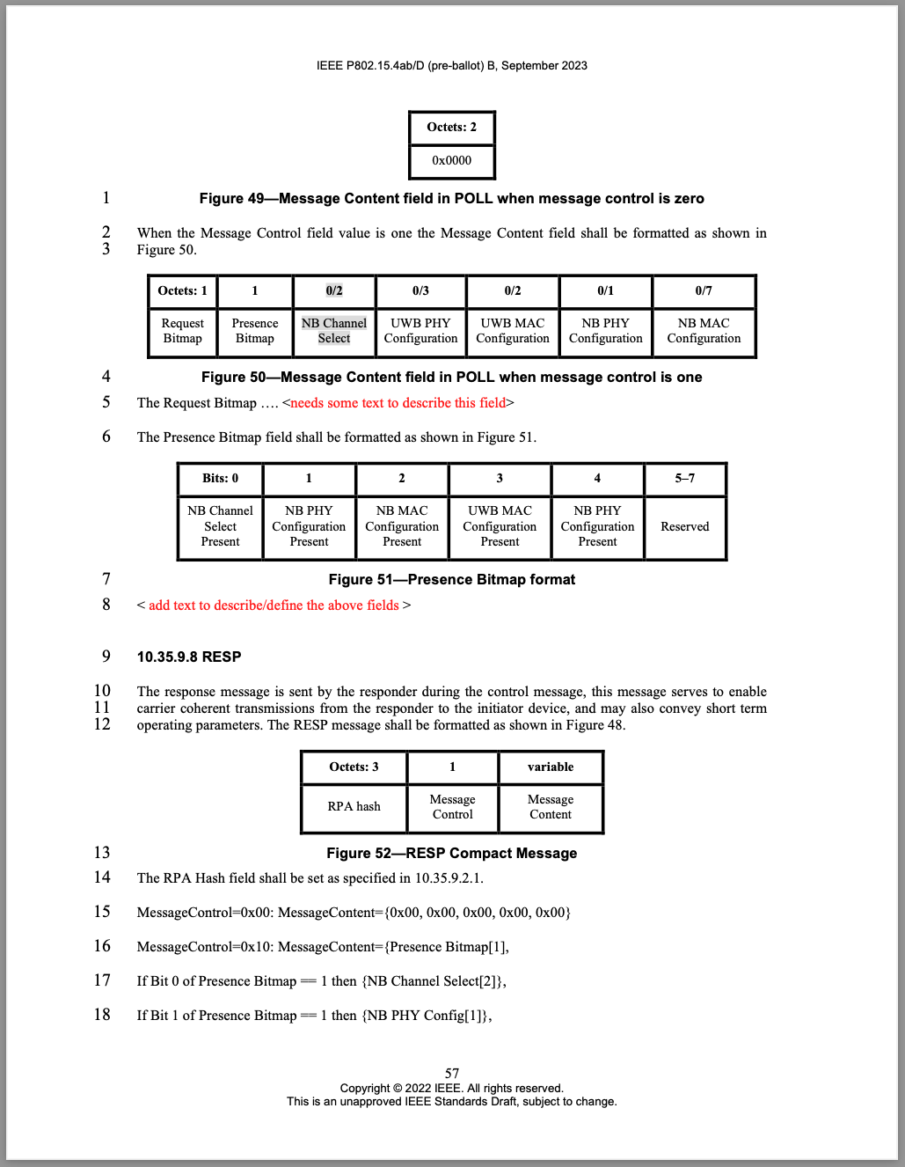
Discussion: All these CIDs are related to technical and/or editorial issues regarding the two different encodings for the NB channels to be selected either long-term during initialization phase, or short term during ranging phase. The proposed solution to all these issues is to use technically simplify the channel selection by unifying the encoding for both short- and long-term and fix all editorial issues alongside.
Proposed resolution: Revise.
Change subsection 10.35.7.4.2 "Allowed channel list" p.44 l.2-21:
Where a subset of the 250 O-QPSK channels is known to be unavailable, unusable, or deemed inefficient to be used, the initiator can mark these channels as blocked by removing it from the macMmsNbChannelAllowList. For example, an initiator additionally equipped with an IEEE 802.11 radio and engaged in concurrent radio transmissions with other devices on known WLAN channels, may deem it favorable to exclude the conflicting channels. The list of allowed channels may be updated during an ongoing ranging session using short-term signaling messages (see 10.35.3.5).

The initiator can inform the responder of allowed channels from the macMmsNbChannelAllowList, using the NB Channel Map field which is constructed as shown in Figure XXX in subsection 10.35.9.3.6.

With reference to Figure XXX, the O-QPSK channels can be categorized as WLAN-non-occupied channels and WLAN-occupied channels. For the WLAN-occupied channels, it is efficient to indicate usable or unusable in a group manner to reduce the overhead. For example, each bit in the WLAN channel bitmask (UNII-3) field or the WLAN channel bitmask (UNII-5) field indicates one 20 MHz WLAN channel, equivalent to eight 2.5 MHz O-QPSK channels.
All devices shall use macMmsNbChannelAllowlist to assign NB channels to ranging blocks as defined in subsection 10.35.7.4.3.

Replace the entire subsection 10.35.9.3.6 "The NB Channel Select field" from p.50 l.26 to p.51 l.13 by:
10.35.9.3.6 The NB Channel Map field
The 6-octet NB Channel Map field (Figure XXX) is used to communicate the macMmsNbChannelAllowlist between initiators and responders, by referencing the NB channel indexes as defined in subsection 11.1.3.15.
Bits: 0–3 | 4–9 | 10–17 | 18–41 | 42–44 | 45-46 | 47
NB channels 0-3 | WLAN channel bitmask (UNII-3) | NB channels 50-57 | WLAN channel bitmask (UNII-5) | NB channel start | NB channel step | Reserved
Figure XXX— The NB Channel Map field
The allowed list of NB channels is defined as
macMmsNbChannelAllowlist = NbChannelBitmaskSet ∩ NbChannelAffineSet
where NbChannelBitmaskSet is obtained from bits 0-41 and NbChannelAffineSet is obtained from bits 42-46 of the NB Channel Map field.
Bit 0 to bit 3 set to 1 include NB channels 0 to 3 in NbChannelBitmaskSet, respectively, the lowest bit corresponding to NB channel 0.
If bit N (4≤N≤8) is set to 1, NbChannelBitmaskSet includes the 8 NB channels with indexes (N-4)*8+4 to (N-4)*8+11 (corresponding to UNII-3 20 MHz WLAN channels 149, 153, 157, 161, 165 and NB channels 4 to 43). If bit 9 is set to 1, NbChannelBitmaskSet includes the 6 NB channels with indexes 43 to 49 to NbChannelBitmaskSet (corresponding to UNII-3 WLAN channel 169).
If bit 10 to bit 17 are set to 1, NbChannelBitmaskSet includes NB channels 50 to 57, respectively, the lowest bit corresponding to NB channel 50.
If bit N (18≤N≤41) is set to 1, NbChannelBitmaskSet includes the 8 NB channels with indexes (N-18)*8+58 to (N-18)*8+65 (corresponding to UNII-5 20 MHz WLAN channels 1 to 93 and NB channels 58 to 249).
Bits 42 to 44 encode the value of NB_channel_start in the range 0 to 7.
Bits 45 to 46 encode the enumeration of NB_channel_step {1, 2, 4, 8}.
NbChannelAffineSet is then constructed from NB_channel_start and NB_channel_step as
NbChannelAffineSet = {y = x*NB_channel_step + NB_channel_start}, s.t. 0 ≤ y ≤ 249 and x ∈ ℕ₀,
where ℕ₀ is the set of natural numbers, additionally including 0.

Change the number of octets from 2 to 6 and "NB Channel Select" to "NB Channel Map" on p.55 Fig.45 and l.9, p.56 Fig.47, p.57 l.17, p.63 l.17,24, p.64 l.9.

CID #99 Revise
Name | CID | Category | page | section | line | Comment | Proposed change
Youngwan So | 99 | Editorial | 52 | 10.35.9.3.9 | 13 | Not enough definition or decription on fields | Looks to need some definition or description.
Reference: 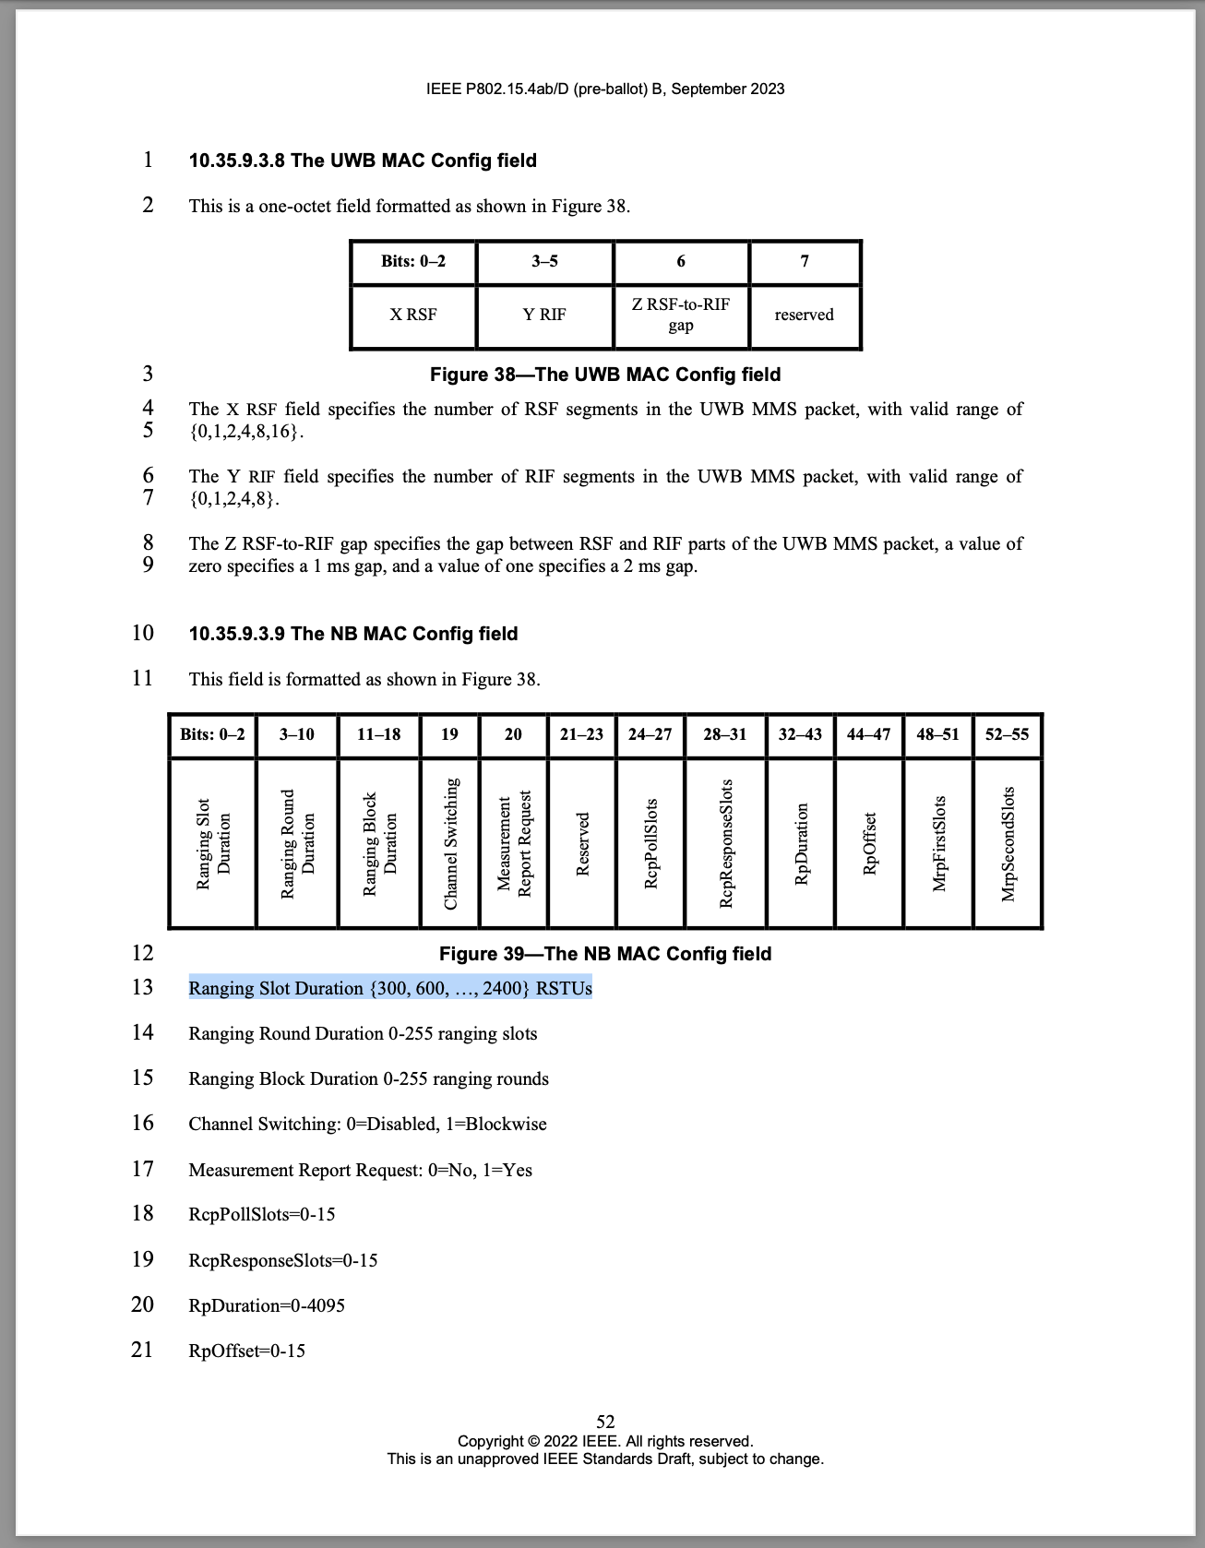
Discussion: Agree with comment.
Proposed resolution: Revise. Replace p.52f l.13ff by:
The Ranging Slot Duration field encodes the ranging slot duration (see subsection 6.9.7.2 in [802.15.4z-2020]) as (Ranging Slot Duration + 1)*300 RSTU.
The Ranging Round Duration field encodes the ranging round duration (see subsection 6.9.7.2 in [802.15.4z-2020]) in units of ranging slots in the range 0 to 255.
The Ranging Block Duration field encodes the ranging block duration (see subsection 6.9.7.2 in [802.15.4z-2020]) in units of ranging rounds in the range of 0 to 255.
The Channel Switching field encodes the status of the channel switching mechanism (subsection 10.35.7.4) where a value 0 encodes the disabled state and the value of 1 encodes the enabled state. If channel switching is disabled, the lowermost value of macMmsNbChannelAllowlist shall be used for all NB messages during the ranging session.
The Measurement Report Request is independently filled by the initiator and the responder in the ADV-RESP (subsection 10.35.9.5) and SOR (subsection 10.35.9.6) messages, respectively.
If the Measurement Report Request field is encoded as 1 in the ADV-RESP packet, the initiator shall provide a ranging report to the responder during the ranging measurement report phase (see subsection 10.35.6). If the Measurement Report Request field is encoded as 0 in the ADV-RESP packet, the initiator shall provide a ranging report to the responder during the ranging measurement report phase.
If the Measurement Report Request field is encoded as 1 in the SOR packet, the responder shall provide a ranging report to the initiator during the ranging measurement report phase (see subsection 10.35.6). If the Measurement Report Request field is encoded as 0 in the SOR packet, the responder shall not provide a ranging report to the initiator during the ranging measurement report phase.
The RcpPollSlots field encodes the duration of macMmsRcpPollNSlots (see subsection 10.35.3) used by the initiator for transmission of the POLL message in units of ranging slots in the range 0 to 15.
The RcpResponseSlots field encodes the duration of macMmsRcpRespNSlots (see subsection 10.35.3) used by the responder for transmission of the RESP message in units of ranging slots in the range 0 to 15.
The RpDuration field encodes the duration RpDuration of the MMS ranging phase (see subsection 10.35.5) used by intiator and responders for transmission of RSF and RIF fragments in units of ranging slots in the range 0 to 4095.
The RpOffset field encodes the time offset RpRsfOffset (see subsection 10.35.5) from the beginning of the ranging phase to the beginning of the first ranging fragment in units of ranging slots in the range 0 to 15.
The MrpFirstSlots field encodes the duration of macMms1stReportNSlots (see subsection 10.35.6) possibly used by the initiator or the responder for transmission of the REPORT message in units of ranging slots in the range 0 to 15.
The MrpSecondSlots field encodes the duration of macMms2ndReportNSlots (see subsection 10.35.6) possibly used by the responder for transmission of the REPORT message in units of ranging slots in the range 0 to 15.

