IEEE P802.15
Wireless Personal Area Networks

Project | IEEE P802.15 Working Group for Wireless Personal Area Networks (WPANs)
Title | <802.15 TG4ab (NG-UWB) Conf. Call Mins. Sep. to Nov. 2023>
Date Submitted | [10 Nov, 2023]
Source | [David Xun Yang]  [Huawei]  [Bantian, Shenzhen, China] | Voice: [+86.159.1411.7462]  Fax: [--]  E-mail: [david.yangxun@huawei.com]
 | [Ben Rolfe]  [BCA]  [--] | Voice: [--]  Fax: [--]  E-mail: [ben@blindcreek.com]
Re: | [802.15 TG4ab Conf. Call Mins]
Abstract | [Official Minutes of the Call]
Purpose | [Record the main points of the call]
Notice | This document has been prepared to assist the IEEE P802.15. It is offered as a basis for discussion and is not binding on the contributing individual(s) or organization(s). The material in this document is subject to change in form and content after further study. The contributor(s) reserve(s) the right to add, amend or withdraw material contained herein.
Release | The contributor acknowledges and accepts that this contribution becomes the property of IEEE and may be made publicly available by P802.15.

802.15 TG4ab (NG-UWB) Conf. Call Minutes
between Sep. and Nov. 2023 Mtgs.

Tuesday, 26 Sep 2023

Opening
9:02 AM ET 802.15 TG4ab Chair, Ben Rolfe (BCA), called the meeting to order

Minutes
>30 participants were noted during the duration of the call

Utilizing the meeting and agenda doc. # 15-23-0529-00, the Chair conducted the following business:
- Opening
- Reviewed IEEE Patent Policy
  - Made call for claims with no responses
- Reviewed IEEE SA Participation Policy
- Reviewed IEEE SA Copyright Policy
- Reviewed 802 Rules

Announcement
Chair reviewed the proposed agenda. There was no objection to the agenda. It was approved with unanimous consent.

Chair reviewed the progress of draft updates and the revised timeline.

Chair reviewed the motions that the group run in Sep F2F meeting.

Li-Hsiang Sun (Mediatek) presented “Proposed Resolution for CID 41”
(doc.# 15-23-0508-01-04ab)
This presentation is to discuss the resolution to CID 41.

Clint Chaplin (SRA) reviewed the received comments in “CC Consolidated Comments” (doc. # 15-23-0475-11-04ab). There were discussions on the resolutions. Clint filled in the table with the discussion consensus and updated it into 15-23-0475-12-04ab.
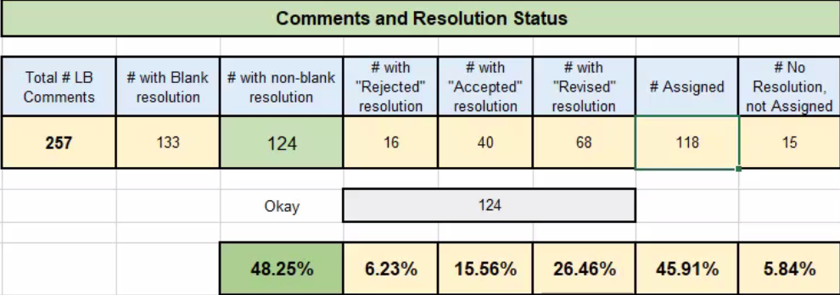

Chair reviewed the consideration of time

Chair reviewed the telecon schedule and reminded people to send requests few days before the next call.

Carl Murray (Qorvo) briefly introduced the progress update of draft.

Chair asked if there is any other business to discuss. No request heard.

Chair adjourned the call @10:31am ET.

Tuesday, 3 Oct 2023

Opening
10:03 PM PT 802.15 TG4ab Chair, Ben Rolfe (BCA), called the meeting to order

Minutes
26 participants were noted during the duration of the call

Utilizing the meeting and agenda doc. # 15-23-0537-00, the Chair conducted the following business:
- Opening
- Reviewed IEEE Patent Policy
  - Made call for claims with no responses
- Reviewed IEEE SA Participation Policy
- Reviewed IEEE SA Copyright Policy
- Reviewed 802 Rules

Announcement
Chair reviewed the proposed agenda (doc 15-23-0537-00): Following discussion, agenda approved by unanimous consent. There was no objection to the agenda. It was approved with unanimous consent.

Comment resolution contributions:
15-23-0534-00 (CID #51 and #56): Presented, explained, no objections to adopting.

15-23-0536-00 (CID #38, #39, #49, and #50): Presented, explained, no objections to adopting.

15-23-0538-00 (CID #206, #184, #186, and #185): Presented, explained, some discussion:
Question on why RSSI uses 1dB resolution.
Answer: Re-using form for RSSI from existing (base standard) SRM Following discussion no objection to move forward as proposed resolution (1 dB resolution).
Following discussion no objection to adoption.

15-23-0539-01 (CIDs 10,146,147,148): Presented, explained, and discussion follows. CID 146, 147, 148 needs further discussion. CID 10 resolution is adopted.

15-23-0514-01 (see xls for CIDs): 24 comments. Presented, explained and discussed. List of adopted resolutions captured in the consolidated comment spreadsheet (CCS), doc 15-23-0475 as r16 (https://mentor.ieee.org/802.15/dcn/23/15-23-0475-16-04ab-cc-consolidated-comments.xlsx).

Editor’s report (see slide 30 in doc 0537-02 for editor status). Discussion: none.

Next steps:
• Next call 06:00 PT Oct 10
• Window for completing comment collection on a revised draft before November plenary session has closed
• Will have detailed plan for November following our next few calls

Next call agenda:
1. Review status of CCS
2. Billy’s comments to discuss from CCS
3. Open comments form today (after discussion on reflector)
4. Alex will have some comment resolutions to present

AoB: None heard

Meeting adjourned at 11:30pm PT.

Tuesday, 10 Oct 2023

Opening
9:03 AM ET 802.15 Working Group Chair, Clint Powell (HID), called the meeting to order.

Minutes
>30 participants were noted during the duration of the call

Utilizing the meeting and agenda doc. # 15-23-0537-03, the Chair conducted the following business:
- Opening
- Reviewed IEEE Patent Policy
  - Made call for claims with no responses
- Reviewed IEEE SA Participation Policy
- Reviewed IEEE SA Copyright Policy
- Reviewed 802 Rules

Announcement
Chair reviewed the proposed agenda. There was no objection to the agenda. It passed with unanimous consent.

Clint Chaplin (SRA) reviewed the received comments in “CC Consolidated Comments” (doc. # 15-23-0475-18-04ab). There were discussions on the resolutions. Clint filled in the table with the discussion consensus and updated it into 15-23-0475-19-04ab.

Chenchen Liu (Huawei) presented “Proposed draft text for the CIR Report field of AC IE”
(doc. # 15-23-0466-01-04ab)
This presentation introduces the draft text for the CIR Report field of AC IE.
Questions/comments raised include the order changes in Figure 84.

Bin Qian (Huawei) presented “Proposed Resolution for AC IE Comments Part Two”
(doc. # 15-23-0541-00-04ab)
This presentation introduces the second part of resolutions to AC IE comments.

Chair asked if there is any other business to discuss. No request heard.

Chair adjourned the call @10:26am ET.

Tuesday, 17 Oct 2023

Opening
10:03 PM PT 802.15 TG4ab Chair, Ben Rolfe (BCA), called the meeting to order.

Minutes
>20 participants were noted during the duration of the call

Utilizing the meeting and agenda doc. # 15-23-0537-05, the Chair conducted the following business:
- Opening
- Reviewed IEEE Patent Policy
  - Made call for claims with no responses
- Reviewed IEEE SA Participation Policy
- Reviewed IEEE SA Copyright Policy
- Reviewed 802 Rules

Announcement
Chair reviewed the proposed agenda. There was no objection to the agenda. It passed with unanimous consent.

Bin Qian (Huawei) presented “Proposed Resolution for AC IE Comments Part Two”
(doc. # 15-23-0541-01-04ab)
This presentation introduces the second part of resolutions to AC IE comments, which has been updated based on the received comments after the last meeting.
No objection heard to adopt the comment resolutions in this document.

Chenchen Liu (Huawei) presented “Proposed draft text for the CIR Report field of AC IE”
(doc. # 15-23-0466-02-04ab)
This presentation introduces the draft text for the CIR Report field of AC IE, which has been updated based on the received comments after the last meeting.
No objection heard to adopt the comment resolutions in this document.

Editor Billy Verso (Qorvo) introduced the current progress of including comment resolutions in the new version of draft.
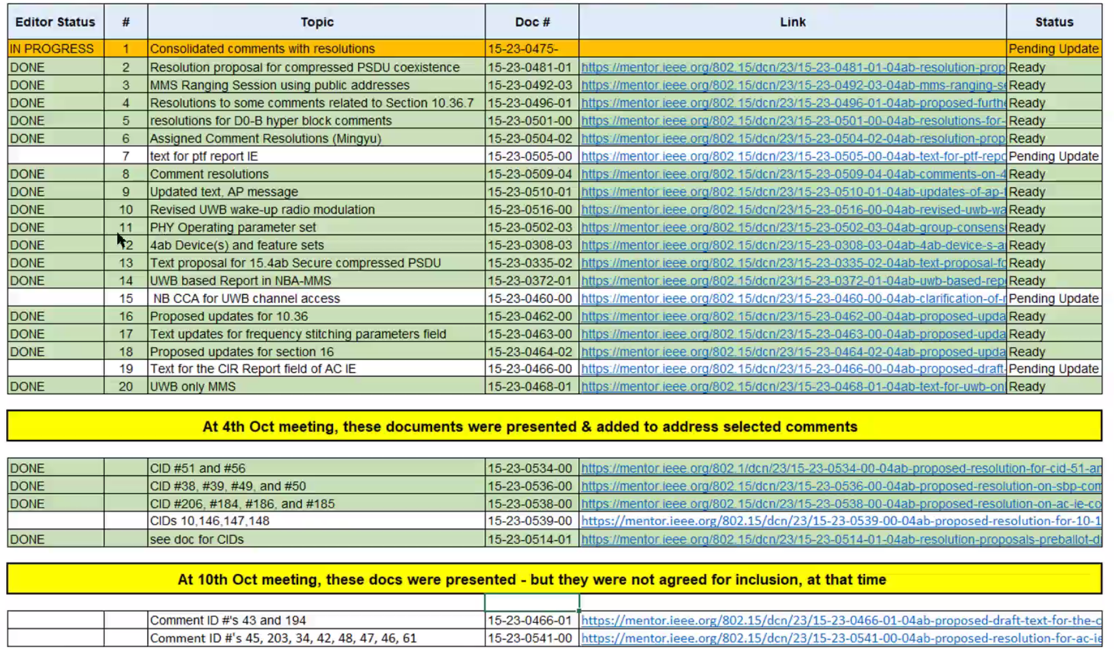
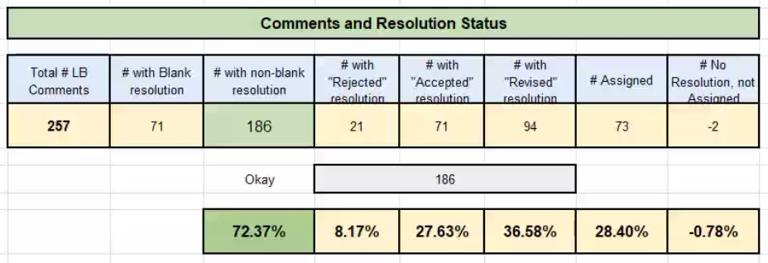

Billy Verso (Qorvo) reviewed the received comments in “CC Consolidated Comments” (doc. # 15-23-0475-20-04ab). There were discussions on the resolutions. Billy filled in the table with the discussion consensus and updated it into 15-23-0475-21-04ab.

Chair reviewed the schedule for the following conference calls.

Chair asked if there is any other business to discuss. No request heard.

Chair adjourned the call @11:36pm PT.

Tuesday, 24 Oct 2023

Opening
9:01 AM ET 802.15 TG4ab Chair, Ben Rolfe (BCA), called the meeting to order.

Minutes
~30 participants were noted during the duration of the call

Utilizing the meeting and agenda doc. # 15-23-0537-06, the Chair conducted the following business:
- Opening
- Reviewed IEEE Patent Policy
  - Made call for claims with no responses
- Reviewed IEEE SA Participation Policy
- Reviewed IEEE SA Copyright Policy
- Reviewed 802 Rules

Announcement
Chair reviewed the proposed agenda. There was no objection to the agenda. It passed with unanimous consent.

Clint Chaplin (SRA) reviewed the received comments in “CC Consolidated Comments” (doc. # 15-23-0475-23-04ab). There were discussions on the resolutions. Clint filled in the table with the discussion consensus and updated it into 15-23-0475-24-04ab.
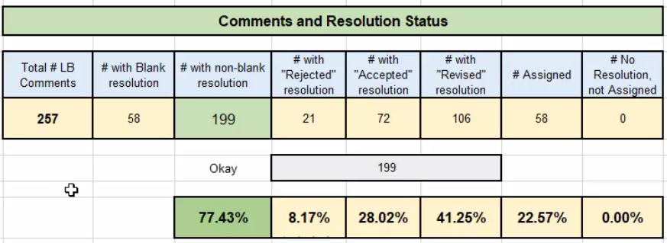

Larry Zakaib (Spark Microsystems) presented “Low Energy UWB PHY Proposed Comments Resolution”
(doc. # 15-23-0545-00-04ab)
This presentation proposes resolution to LE UWB PHY comments for Clause 33.

Chair raised two options to move draft forward and planned to discuss it next week.

Chair adjourned the call @10:30am ET.

Tuesday, 31 Oct 2023

Opening
10:02 PM PT 802.15 TG4ab Chair, Ben Rolfe (BCA), called the meeting to order.

Minutes
~30 participants were noted during the duration of the call

Utilizing the meeting and agenda doc. # 15-23-0537-06, the Chair conducted the following business:
- Opening
- Reviewed IEEE Patent Policy
  - Made call for claims with no responses
- Reviewed IEEE SA Participation Policy
- Reviewed IEEE SA Copyright Policy
- Reviewed 802 Rules

Announcement
Chair reviewed the proposed agenda. There was no objection to the agenda. It passed with unanimous consent.

Recap: no questions nor discussions on scope or schedule.

Comment Resolution Presentations:
15-23-0547 to address CIDs 52, 54, and 228 (Carlos)
Discussion: discussion on CID 52, need more time to review and discuss; to decide on Nov-7 call. Proposed resolutions to CID 64 and 228 adopted by unanimous consent.

15-23-0548 to address CIDs #11-16, 19, 20, 23, 24, 26, 156
Provides resolution proposals for comments #11-16, 19, 20, 23, 24, 26, 156; Proposes to reassign CID #7, #237, #238 to Rojan.
CID 19: Needs further discussion (to be announced on reflector prior to Nov 7 call).
CID 26: Needs further discussion (to be announced on reflector prior to Nov 7 call).
Following discussion, comments #11-16, 20, 23, 156 proposed resolutions adopted by unanimous consent.

15-23-0552 to propose additional details for 10.36.7.1
Following discussion, needs further review. To be closed on the Nov 7 call.

Note: during discussion, chair asks to extend the call for 10 minutes. No objections heard.

Next steps: reviewed meeting schedule. Reminder to use the email reflector for technical discussions. Reminder to get agenda requests submitted for the Nov 7 call and November plenary session.

Any other Business: none.

Adjourned at 11:40pm Oct 31 PT.

Tuesday, 7 Nov 2023

Opening
9:03 AM ET 802.15 TG4ab Chair, Ben Rolfe (BCA), called the meeting to order.

Minutes
~30 participants were noted during the duration of the call

Utilizing the meeting and agenda doc. # 15-23-0537-09, the Chair conducted the following business:
- Opening
- Reviewed IEEE Patent Policy
  - Made call for claims with no responses
- Reviewed IEEE SA Participation Policy
- Reviewed IEEE SA Copyright Policy
- Reviewed 802 Rules

Announcement
Chair reviewed the proposed agenda. There were several requests to change the agenda. There was no objection to the updated agenda. It passed with unanimous consent.

Chair reviewed the revised timeline.

Clint Chaplin (SRA) reviewed the received comments in “CC Consolidated Comments” (doc. # 15-23-0475-27-04ab). There were discussions on the resolutions. Clint filled in the table with the discussion consensus and updated it into 15-23-0475-28-04ab.

Chair asked if there is any objection to include the resolution as in doc. # 15-23-0545-00-04ab into Draft C. No objection heard. It passed with unanimous consent.

Alex Krebs (Apple) presented “Resolution proposals for comments #12 and #27”
(doc. # 15-23-0554-00-04ab)
This presentation is to propose resolutions to CID 12 and 27.
There was no objection to include this document into Draft C.

Carlos Aldana (Meta) presented “Proposed Resolution for #52, 54, 228”
(doc. # 15-23-0547-02-04ab)
This presentation is to propose resolutions to CID 52, 54 and 228.
There was no objection to include this document into Draft C.

Bin Qian (Huawei) introduced that doc. # 15-23-0552-01-04ab needs more discussions next week.

Clint Chaplin (SRA) checked the status quo of remaining comments as in “CC Consolidated Comments” with the assignees, and filled in the table with agreed resolutions (doc. # 15-23-0475-28-04ab).
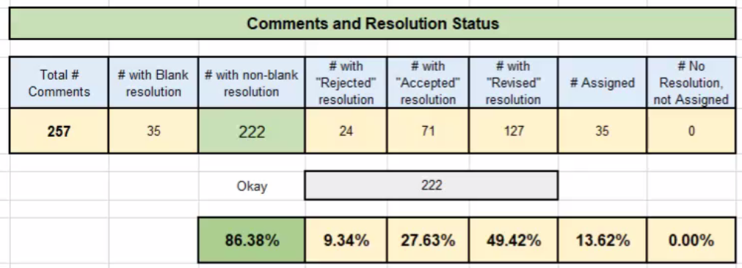

Chair asked if there is any other business. No request heard.

Chair adjourned the call @10:32am ET.

