IEEE P802.15
Wireless Personal Area Networks

Project | IEEE P802.15 Working Group for Wireless Personal Area Networks (WPANs)
Title | Proposed Resolution for Request Bitmap field
Date Submitted | November 2023
Sources | Rojan Chitrakar, Lei Huang (Huawei)  rojan.chitrakar@huawei.com
Re:
Abstract
Purpose | To propose resolution Request Bitmap field comments for “P802.15.4ab™/D (pre-ballot) B Draft Standard for Low-Rate Wireless Networks” .
Notice | This document does not represent the agreed views of the IEEE 802.15 Working Group or IEEE 802.15.4ab Task Group. It represents only the views of the participants listed in the “Sources” field above. It is offered as a basis for discussion and is not binding on the contributing individuals. The material in this document is subject to change in form and content after further study. The contributors reserve the right to add, amend or withdraw material contained herein.

Rev 0: Initial version. Addresses the following comments:
115

Comment Index #115 in 15-23-0475-28-04ab-cc-consolidated-comments
Name | Sub-Clause | Page.Line | Comment | Proposed Change
Youngwan So | 10.35.9.3.10 | 53.6 | Seems no definition or descriptions about fieds | Please add definition and description

Discussion：
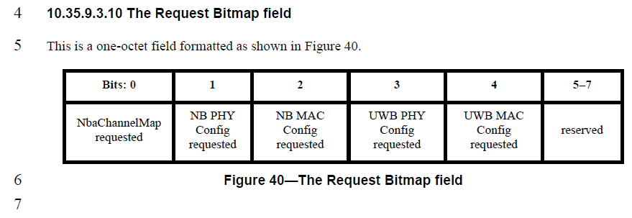
Agree with the comment that definition of the sub-fields should be added.
Disposition: Revised
Disposition Detail:
Proposed text changes on P802.15.4ab™/D (pre-ballot) B:
10.35.9.3.10 The Request Bitmap field
Change the subfield as follows (Track changes ON)
This is a one-octet field formatted as shown in Figure 40.
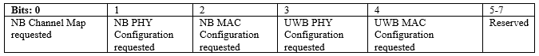
Figure 40—The Request Bitmap field
The Request Bitmap field indicates the field(s) that the initiator requests the responder to include in the applicable response message (RESP, RESP (One-to-many), REPORT (Responder) or REPORT (from responder in one-to-many ranging)).
The NB Channel Map requested bit when set to 1 indicates that the NB Channel Map field is requested to be included in the response message.
The NB PHY Config requested bit when set to 1 indicates that the NB PHY Config field is requested to be included in the response message.
The NB MAC Config requested bit when set to 1 indicates that the NB MAC Config field is requested to be included in the response message.
The UWB PHY Config requested bit when set to 1 indicates that the UWB PHY Config field is requested to be included in the response message.
The UWB MAC Config requested bit when set to 1 indicates that the UWB MAC Config field is requested to be included in the response message.

