IEEE P802.15
Wireless Personal Area Networks

Project | IEEE P802.15 Working Group for Wireless Personal Area Networks (WPANs)
Title | Resolution proposals for comments #12 and #27
Date Submitted | November 2023
Sources | Alex Krebs, Jinjing Jiang (Apple)
Re:
Abstract
Purpose | To propose resolution to NBA-UWB MMS comments for “P802.15.4ab™/D (pre-ballot) B Draft Standard for Low-Rate Wireless Networks”
Notice | This document does not represent the agreed views of the IEEE 802.15 Working Group or IEEE 802.15.4ab Task Group. It represents only the views of the participants listed in the “Sources” field above. It is offered as a basis for discussion and is not binding on the contributing individuals. The material in this document is subject to change in form and content after further study. The contributors reserve the right to add, amend or withdraw material contained herein.

CID #12 Revise
Name | Idx # | Category | Pg. | Sub-clause | Line # | Comment | Proposed Change
Li-Hsiang Sun | 12 | Technical | 35 | 10.35.3.3 | 24 | For 1 to many case using CAP, What is IdentityResolvingKey used in ADV_POLL and ADV_RESP?  How does initiator selects one of the responders if all their RPA hash the same (corresponding to the RPA hash of ADV_POLL)? | clarify the addressing in this case
Li-Hsiang Sun | 27 | Technical | 59 | 10.35.9.11 | 7 | Not sure what are the Responder Address when RPA is used | as in comment
Reference:
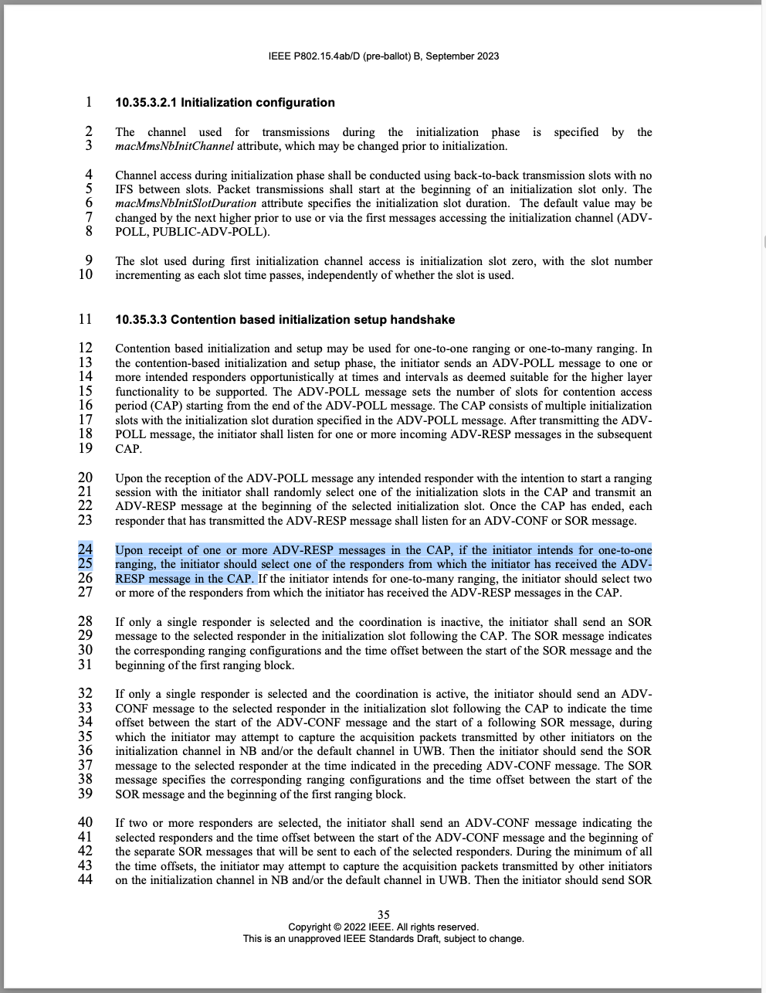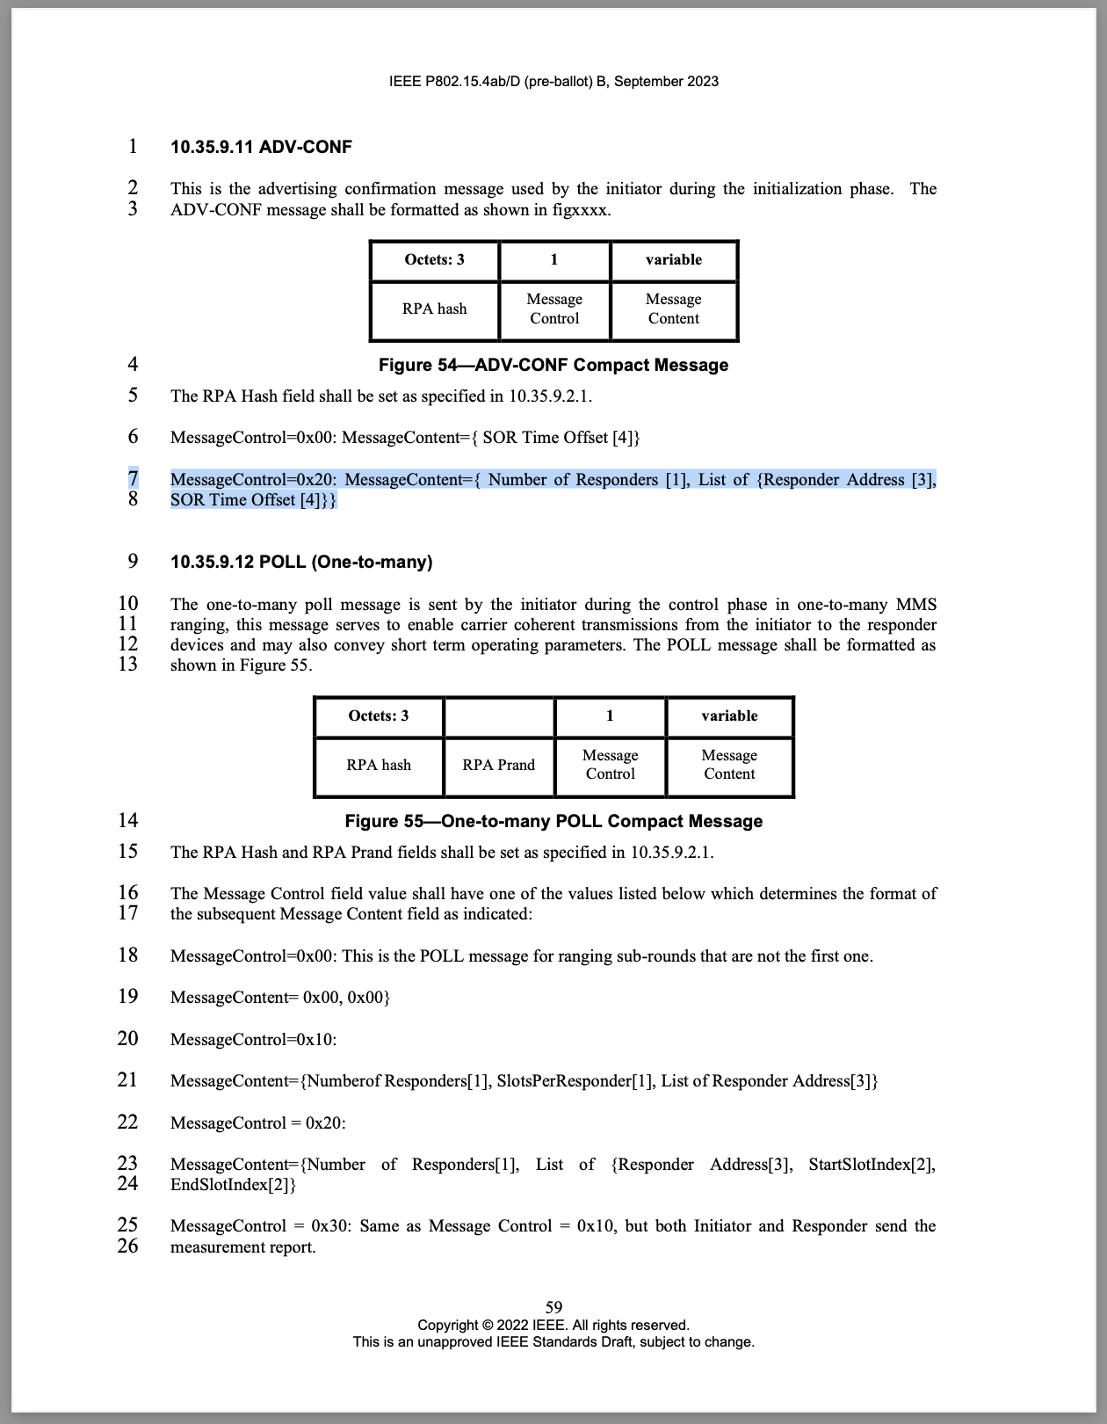
Discussion: Agree that we need to clearly define the Responder Address calculation and clarify the existing subsection on private address calculation. Rojan: 1) ADV-CONF is ambiguously used for P2P and O2M => needs distinction in text. 2) ADV-RESP's RPA_hash == ADV_CONF's Responder Address (same RPA_prand taken from preceding ADV-POLL).
Proposed resolution: Revise. Change p.49, l. 13-32, subsection 10.35.9.2.1 as follows:
10.35.9.2.1 Private addresses

To impede tracking of HRP-ARDEVs, resolvable private addresses (RPA)s are used by initiator and responder devices. To generate a private address, every device shall use a 128-bit identity resolving key (IRK) and every initiator shall be equipped with a cryptographically secure pseudo random number generator (CSPRNG). The initiator shall generate and communicate a 3-octet output RPA_prand of the CSPRNG in the ADV-POLL message during session initialization (10.35.3.2) and in the POLL (or POLL one-to-many) message during the ranging control phase (10.35.4).

A 3-octet RPA_hash is then computed using an IRK and the initiator’s RPA_prand as follows:

RPA_hash = AES-128-ECB(key=IdentityResolvingKey, data=RPA_prand]) % 2²⁴

where AES-128-ECB is defined in [2] (using MSB-wise zero-padded inputs) and % is the integer modulo operator. RPA_hash shall then be used by the device as it’s source RPA for its own packet transmissions.

In order to resolve an RPA of an incoming packet the receiving device shall compute RPA_hash using the IRK of an assumed sender device and the RPA_prand communicated by the initiator. If the result of the computation matches the received RPA, the incoming packet shall be marked as resolved. Otherwise, the incoming packet shall be marked as unresolved. If marked unresolved, the receiving device may retry the RPA_hash using other possible IRKs until the incoming packet is marked as resolved, or the receiving device’s list of possible IRKs is exhausted.

The generation and mutual exchange of IRKs among initiator(s) and responder(s) is out of scope of this standard and may be conducted using higher layer methods. Note that devices may carry multiple IRKs to, e.g., assert privacy among multiple responders and/or ranging sessions. Again, methods for association and assignment of IRKs is not defined in this standard, but may be carried out using higher layer methods.

Change in subsection "10.35.9.4 ADV-POLL" on p.54, l. 7 as follows:
The RPAprand field shall be set as specified in 10.35.9.2.1. During initialisation phase, the value of RPA_prand as conveyed in this message shall be used to compute RPA_hash in all following messages, until the initiator transmits another ADV-POLL message.
Change in subsection "10.35.9.7 POLL" on p.56, l. 16 as follows:
The RPA Hash and RPA Prand fields shall be set as specified in 10.35.9.2.1. In the scope of a ranging round, the value of RPA_prand as conveyed in this message shall be used to compute RPA_hash in all following messages, until the initiator transmits another POLL or POLL (One-to-many) message.
Change in subsection "10.35.9.11 ADV-CONF" on p.59, l. 5 as follows:
The RPA_hash field shall be set as specified in 10.35.9.2.1. Note that if Message Content contains one or more Responder Address fields, each Responder Address in Message Content shall represent an eligible responder's RPA hash generated using the initiator's RPA_prand from the preceding ADV-POLL message along with that responder's IRK.
Change in subsection "10.35.9.12 POLL (One-to-many)" on p.59, l. 14-15 as follows:
Octets: 3 | 3 | 1 | variable
RPA_hash | RPA_prand | Message Control | Message Content
Figure 55—One-to-many POLL Compact Message
The RPA_hash and RPA_prand fields shall be set as specified in 10.35.9.2.1. Note that if Message Content contains one or more Responder Address fields, each Responder Address in Message Content shall represent an eligible responder's RPA hash generated using the RPA_prand as conveyed in this message along with that responder's IRK.

