IEEE P802.15
Wireless Personal Area Networks

Project | IEEE P802.15 Working Group for Wireless Personal Area Networks (WPANs)
Title | Proposed Resolutions for comments #140, 225, 226
Date Submitted | November 2023
Sources | Xiliang Luo (Apple)
Re:
Abstract
Purpose | To propose resolutions to comments for “P802.15.4ab™/D (pre-ballot) B Draft Standard for Low-Rate Wireless Networks”
Notice | This document does not represent the agreed views of the IEEE 802.15 Working Group or IEEE 802.15.4ab Task Group. It represents only the views of the participants listed in the “Sources” field above. It is offered as a basis for discussion and is not binding on the contributing individuals. The material in this document is subject to change in form and content after further study. The contributors reserve the right to add, amend or withdraw material contained herein.

1 CID #140 (Accept & Merge with CID #225) 3
2 CID #225 (Accept) 4
3 CID #226 (Solved) 5

CID #140 (Accept & Merge with CID #225)
Name | Idx # | Cat. | Pg. | Sub-clause | Line # | Comment | Proposed Change
Xiliang Luo | 140 | Technical | 115 | 16.2.11.1 | 23 | Z=2 as the default value. Alternative Z=1 could be signaled by higher layers. | Clarify:  Z=2 as the default value. Alternative Z=1 could be signaled by higher layers.
Reference
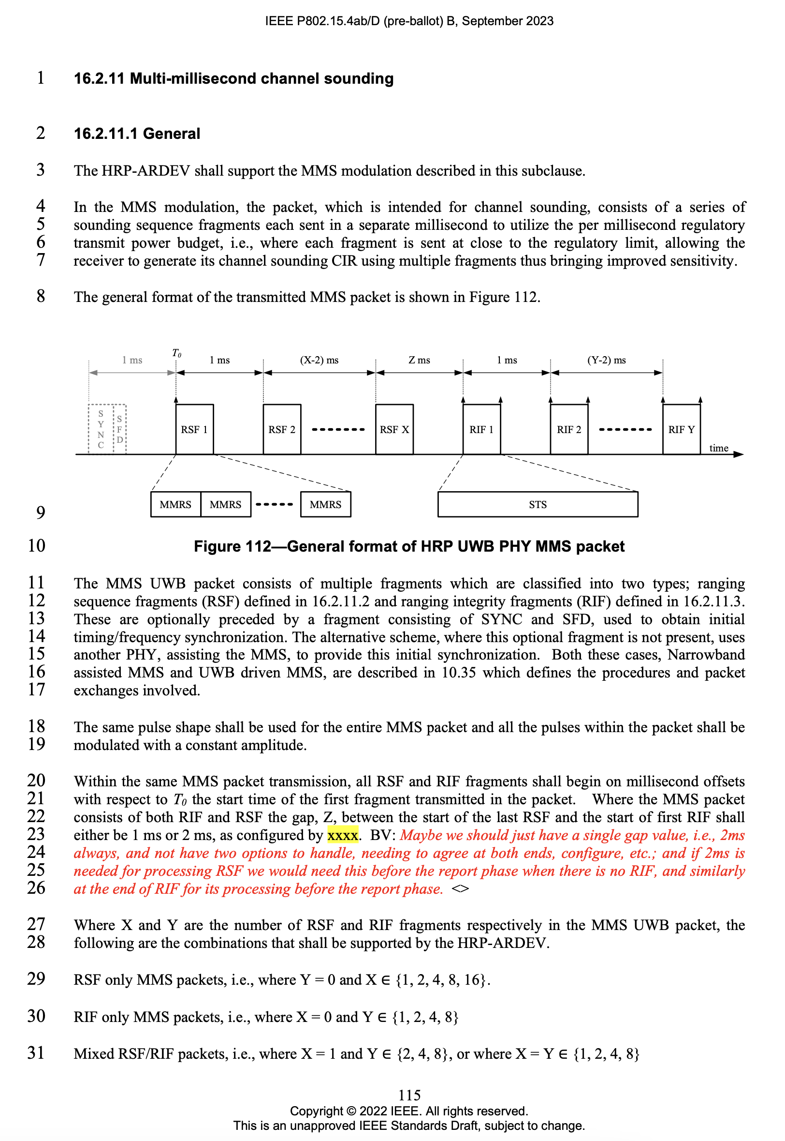
Proposed Resolution:
Change the sentence in lines 21~23, page 115, to the following one:
“… Where the MMS packet consists of both RIF and RSF the gap, the time distance between the start of the last RSF and the start of first RIF shall be 2ms. ”

CID #225 (Accept)
Name | Idx # | Cat. | Pg. | Sub-clause | Line # | Comment | Proposed Change
Pooria Pakrooh | 225 | Technical | 115 | 16.2.11.1 | 23 | We support adding a single option of 2ms. | Set Z=2ms.
Reference
Proposed Resolution:
Change the sentence in lines 21~23, page 115, to the following one:
“… Where the MMS packet consists of both RIF and RSF the gap, the time distance between the start of the last RSF and the start of first RIF shall be 2ms. ”

CID #226 (Solved)
Name | Idx # | Cat. | Pg. | Sub-clause | Line # | Comment | Proposed Change
Pooria Pakrooh | 226 | General | 115 | 16.2.11.1 | 23 |  | 1. Set the attribure "RpRifOffset" in page 41 to 2ms.  2. Define another attriburte to signal the gap at the end of RIFs, before report.
Reference
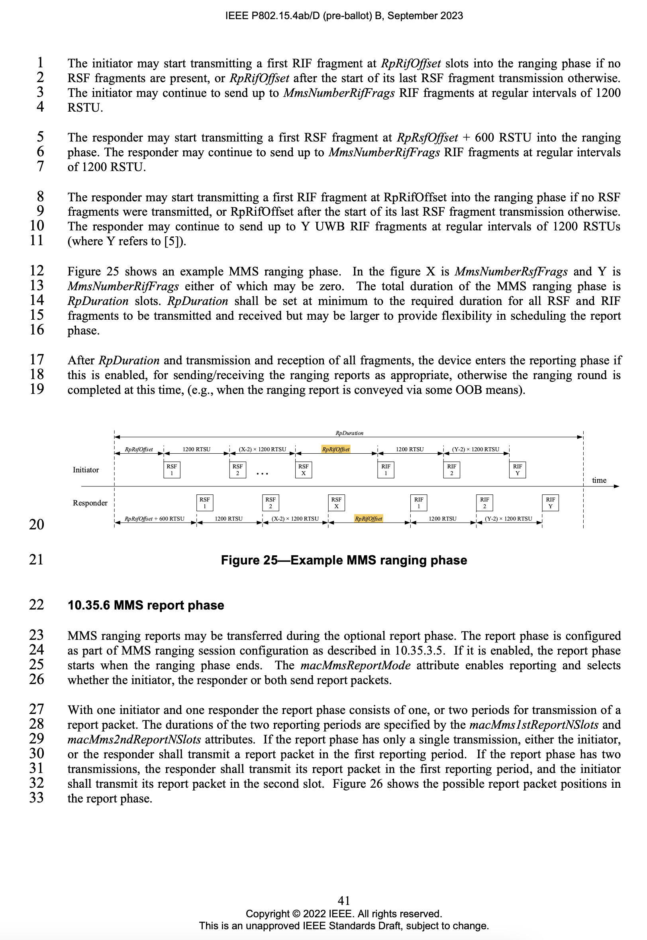
Proposed Resolution:
Proposed Change #1: Accepted.
Add the following sentence in line 11, page 41:
“(where Y refers to [5]). The value of RpRifOffset is 2ms. ”
Proposed Change #2: Rejected
There is already the RpDuration attribute. We do not need to introduce additional ones.

