IEEE P802.15
Wireless Personal Area Networks

Project | IEEE P802.15 Working Group for Wireless Personal Area Networks (WPANs)
Title | Low Energy UWB PHY Proposed Comments Resolution for Comments #66 and #75
Date Submitted | October 2023
Source | Frederic Nabki - Mohammad Rahmani, Michiel Soer, Eric Gauthier, Larry Zakaib (Spark Microsystems) - Benjamin Rolfe (Blind Creek Associates) - Dries Neirynck (Ultra Radio Ltd) - Boris Danev - David Barras (3dB Access)
Re:
Abstract
Purpose | To propose resolution to LE UWB PHY comments for Clause 33 of “P802.15.4ab™/D (pre-ballot) B Draft Standard for Low-Rate Wireless Networks”
Notice | This document does not represent the agreed views of the IEEE 802.15 Working Group or IEEE 802.15.4ab Task Group. It represents only the views of the participants listed in the “Source(s)” field above. It is offered as a basis for discussion and is not binding on the contributing individual(s) or organization(s). The material in this document is subject to change in form and content after further study. The contributor(s) reserve(s) the right to add, amend or withdraw material contained herein.

Contents
1 LE UWB PHY Layer Proposal for 15.4ab Introduction 3
1.1 Definitions 3
1.2 Acronyms and abbreviations 3
1.3 Introduction 3
1.4 PPDU format 3
1.4.1 General 3
1.4.2 PPDU Encoding 3
1.4.3 Frame Structure 4
1.4.4 PSDU timing 4
1.4.5 SHR field 4
1.4.6 PHR field 5
1.4.7 PHY payload 7
1.5 Modulation 7
1.5.1 Modulation Framework 7
1.5.2 Scrambler 7
1.5.4 On-Off Keying (OOK) modulation 9
1.5.5 Manchester OOK 9
1.6 RF requirements 9
1.6.1 Operating frequency bands 9
1.6.2 Regulatory compliance 10
1.6.3 Pulse shape 10
1.6.4 Transmit PSD mask 10
1.6.5 Symbol rate clock 10
1.6.6 Transmit center frequency tolerance 10

Comment Index #66 and #75 in 15-23-0475-20-04ab-cc-consolidated-comments

This document addresses comments 66 and 75 through a more comprehensive description of the LE UWB PHY contained within this document.

LE UWB PHY Layer Proposal for 15.4ab Introduction

1.1 Definitions

1.2 Acronyms and abbreviations

1.3 Introduction
The Low Energy UWB (LE-UWB) PHY waveform is based upon an impulse radio signaling scheme with PHY layer parameters defined for data communications that enables non-coherent detection.
The LE-UWB PHY with non-coherent detection obviates the need for RF carrier generation and allows shorter airtime. The default modulation defined for the LE-UWB PHY is OOK, with optional support for Manchester OOK.
The FEC defined for the LE-UWB PHY is a convolutional code with K=5 for reduced energy and complexity. Optionally, the K = 7 convolutional coding according to Clause 16.3.4 and puncturing with ratios 1/1, 4/3, 5/3 and 2/1 may also be used.
The LE-UWB PHY shall support CCA Mode 1 according to Clause 11.2.8 for compatibility with SSBD according to clause 6.

1.4 PPDU format

1.4.1 General
Figure 1.1 illustrates how the PPDU is constructed conceptually. The actual order of steps is up to the implementation.
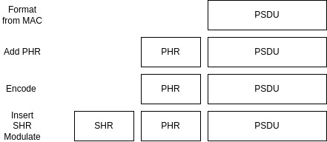
Figure 1.1 – Illustration of the construction of the PPDU

1.4.2 PPDU Encoding
The following procedure details the encoding process:
- Produce the PHR and Sub-PHR as described in Section 1.4.6.
- Perform FEC encoding on the Sub-PHR and PSDU as described in Section 1.5.3.
- Perform modulation on Sub-PHR and PSDU as described in Section 1.5.
- Add SHR as described in Section 1.4.5.

1.4.3 Frame Structure
Figure 1.2 illustrates the LE-UWB PHY Frame structure. The structure is designed to minimize complexity and provide flexibility and extensibility.
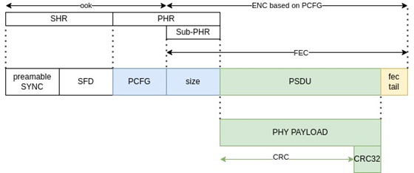
Figure 1.2 – LE-UWB Frame structure

1.4.4 PSDU timing
The structure of each symbol shall consist of an integer number of possible chip positions, Nc, each with duration T_{c}. The number of pulses in the active burst N_{cbp} shall be 1, 2 or 4. Each symbol may contain N_{cbp} pulses. The same number of active chips shall be maintained throughout the PPDU. Nc varies according to the modulation. Refer to Sections 1.5.4 and 1.5.5.
T_{c} = T_{sym}/N_{c} ≈ 4.07ns

N_{cbp} = 1, 2, 4

1.4.5 SHR field

1.4.5.1 Overview
The SHR shall be formatted as follows:
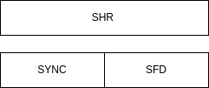
Figure 1.3 – SHR header
The Synchronization header, SHR, is constructed of a SYNC field sequence and SFD field.

1.4.5.2 SYNC field
The SYNC field sequence shall use the OOK modulation described in Section 1.5.4 to transmit repetitions of alternating ‘1’ and ’0’ symbols. The phase of chips may be scrambled using the scrambler defined in Section 1.5.2. The minimum SYNC length shall be 128 (i.e., contains 64 active ‘1’ symbols).

1.4.5.3 SFD field
The SFD sequence shall be one of the eight 32-bit sequences given in Table 1.1. The most significant bit of the sequence shall be sent first. The SFD length shall be 32 symbols. The SFD field sequence shall use the OOK modulation described in Section 1.5.4.
Table 1.1 – SFD sequences
SFD Index | SFD sequence
1 | 0x08ecad3e
2 | 0x09ae74e5
3 | 0x0b1ae937
4 | 0x0cbad627
5 | 0x0daf91ac
6 | 0xe1225779
7 | 0xf53a30ac
8 | 0xe589b2f0

1.4.6 PHR field
The PHR shall be formatted as shown in Figure 1.4. The PHR is structured as two parts:
- The PCFG field
- The Sub-PHR field
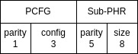
Figure 1.4 – PHR header

1.4.6.1 PCFG field
The PHY Configuration (PCFG) field indicates the current PHY parameters. It consists of 4 bits; 3 bits of configuration (d(2:0)) and one bit of odd parity of the configuration(d(3)), where d(3) = XNOR (d(2),d(1),d(0)). The PHR PCFG field shall be transmitted using OOK as defined in Section 1.5.4.

Table 1.2 – PCFG Field
PCFG Index value | Description
0 | Modulation = OOK; FEC (k=5) Rate = 1/2; Number of Pulses = 1 (mandatory)
1 | Optional configurable definition
2-7 | Reserved

The support of the PCFG value of 0 is mandatory. The optional configuration definition, PCFG index 1, shall be handled by the higher layer and is not within the scope of this standard. The configurable parameters are described in Tables 1.3, 1.4 and 1.5. For the number of pulses refer to Section 1.5.1.

Table 1.3 – Modulation Configuration parameters
Modulations
OOK
Manchester OOK

Table 1.4 – FEC Configuration parameters
FEC (K=5) RATE
4/5
2/3
4/7
1/2

Table 1.5 – Pulse Configuration parameters
Pulse
1
2
4

1.4.6.2 Sub PHR Field
The Sub-PHR is defined as all the bits contained in the size field and the size parity field, refer to Figure 1.2. The Size field shall be an unsigned integer that encodes the length of the PHY payload in octets. It consists of 8 bits. The length in octets may range from 0 to 255 bytes. The Size Parity field shall be composed of 5 bits and is described in Section 1.4.6.2.1. The Sub-PHR field shall be transmitted using the configuration parameters defined by PCFG. The Sub-PHR shall be passed to the modulator most significant bit first.

1.4.6.2.1 The Size parity field
The Size parity field shall be generated with the following where b_{x} is a bit of the size parity field and d_{x} is a bit of the size field.
b₄ = XOR (d₅, d₄, d₃, d₂, d₁, d₀)
b₃ = XOR (d₆, d₂, d₁, d₀)
b₂ = XOR (d₇, d₄, d₃, d₀)
b₁ = XOR (XNOR (d₇, d₆, d₅), d₃, d₁)
b₀ = XOR (XNOR (d₇, d₆, d₅), d₄, d₂)

1.4.7 PHY payload
The PHY Payload field is encoded as shown in Figure 1.5. The PHY payload shall be transmitted using the configuration parameters defined by PCFG. Both the Sub-PHR and PSDU with tail bits are passed through the convolutional encoder and the modulator. Details are provided in the next clauses.
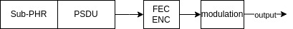
Figure 1.5 – Encoding process

1.5 Modulation

1.5.1 Modulation Framework
The transmit waveform during the k_{th} symbol interval may be expressed as follows:

This equation describes the pulse train for each symbol, including polarity scrambling. The k_{th} symbol carries one information bit g₀^{(k)}. The sequence S_{n+kNcpb} is a scrambling sequence to whiten the transmitted spectrum, and p(t) is the transmitted pulse shape at the antenna input.

1.5.2 Scrambler
The time varying scrambler sequence S_{n}+_{kNcpb} shall be generated from a PRBS scrambler. The polynomial for the scrambler generator is left up to the implementation and can for example be implemented by the LFSR described in clause 16.3.2.

The non-coherent detector in the LE UWB receiver is effectively removing the polarity of the pulses, and does not need to implement a matching, synchronized scrambler.

1.5.3 FEC convolutional encoding
The convolutional encoding used for forward error correction shall employ an encoder depth of k=5 and support the maximum redundancy rate of R=½. Upon transmission of each PPDU, the encoder shall be initialized to the all-zero state. Additionally, the encoder shall be returned to the all-zero state in the end by appending four 0-valued tail bits to the PPDU.

The parity of each encoded bit (e) shall be according to Figure 1.6. where e[1]=XNOR(i₄, i₂, i₀) and e[0]=XOR(i₄, i₃, i₂, i₁, i₀).

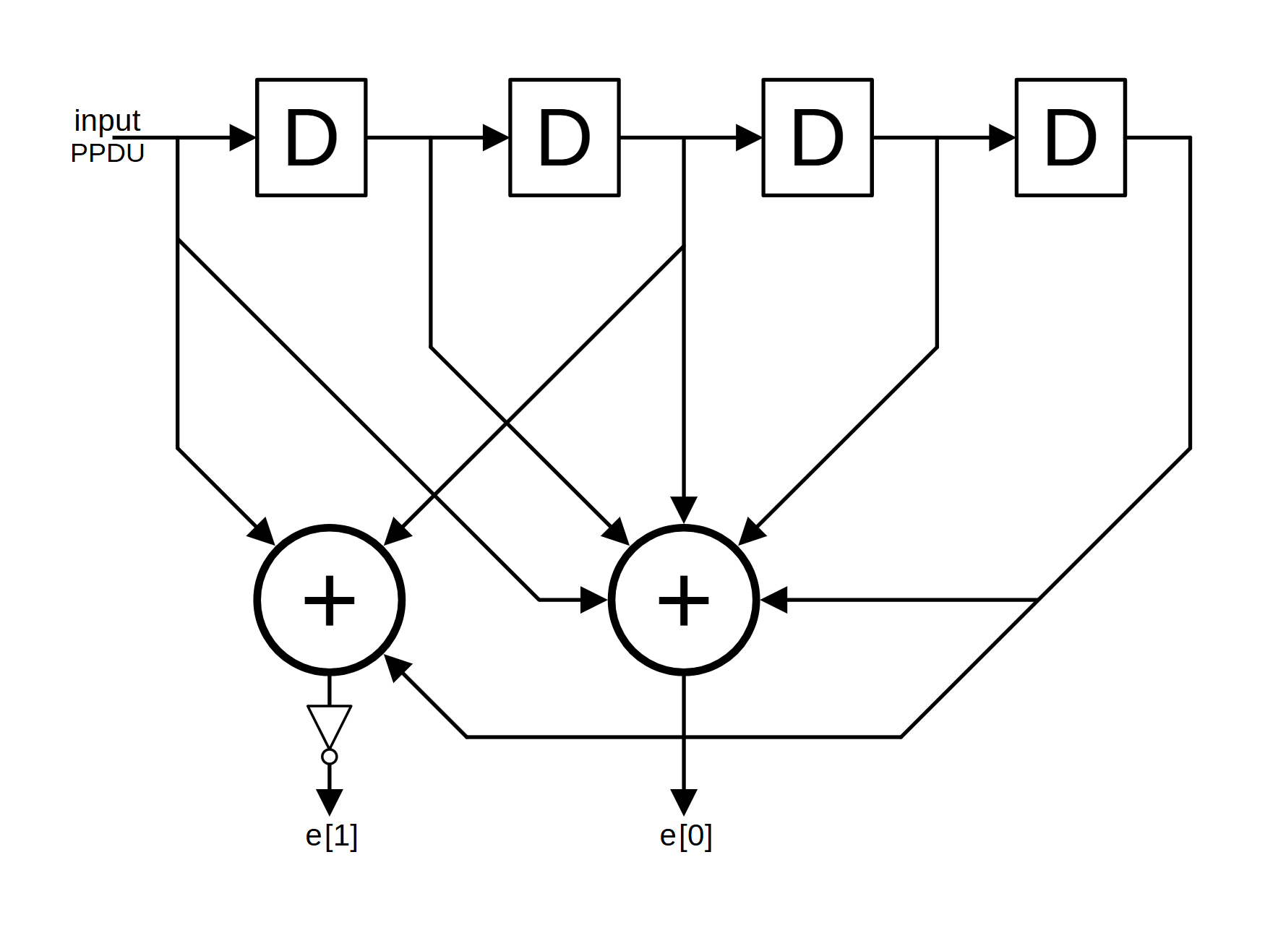
Figure 1.6 – Encoder
While support for the unpunctured redundancy rate of R=½ is mandatory, compliant devices may also optionally support punctured variants of this convolutional code for which the encoded bit e[1] is periodically omitted from the transmission according to the puncturing patterns of Table 1.6. Each × in it signifies that the encoded bit e[1] of the bit pair number # of every 4 pairs has been removed before transmission. All encoded bits of output e[0] are always present in each convolutionally encoded transmission. For example, if the chosen rate is R=4/7, every 4th bit is omitted (for example, the 1st bit, 5th bit, 9th bit, 13th bit and so on are omitted). The convolutional encoded bits shall be passed to the modulator most significant bit first.

Table 1.6 Symbol puncturing pattern for each supported rate
e[1] bit number modulo 4 | 1st of 4 | 2nd of 4 | 3rd of 4 | 4th of 4
R=4/5 | × | × | ×
R=4/6 (2/3) | × |  | ×
R=4/7 | ×
R=4/8 (1/2)

Additionally, compliant devices may optionally bypass the convolutional encoding entirely to keep an effective rate of R=1.

1.5.4 On-Off Keying (OOK) modulation
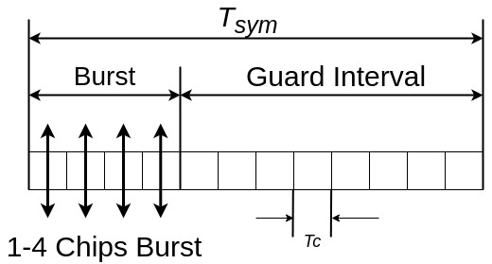
Figure 1.7 – OOK Modulation
The OOK symbol duration shall be 12 chips duration (N_{c}) , transmitted at a chip rate of 245.76 MHz corresponding to a 20.48 MHz and Tsym ~48.83 ns ). A symbol may have 1, 2 or 4 active chips. A ’0’ will be encoded as a silent symbol, while a ’1’ is represented by an active chip sequence.

1.5.5 Manchester OOK
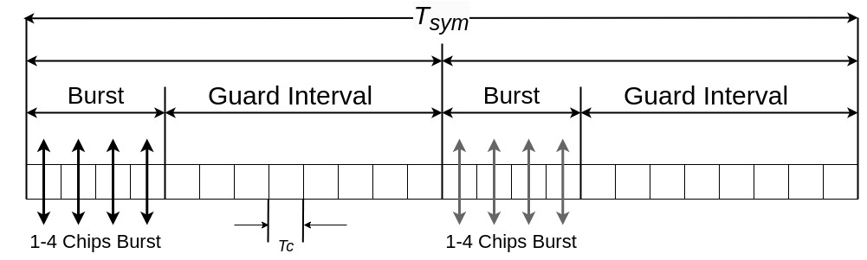
Figure 1.8 – Manchester OOK modulation
The Manchester OOK symbol duration shall be 24 chips duration (N_{c}), transmitted at a chip rate of 245.76 MHz, corresponding to a 10.24 MHz symbol rate (T_{sym} ~95.41 ns). The burst of active chips is either located at the beginning of the first or second half of the symbol, as shown in Figure 1.8.

An active burst in the first position corresponds to a ‘0’ bit and in the second position to a ‘1’ bit.

1.6 RF requirements

1.6.1 Operating frequency bands
The LE-UWB PHY employs channel center frequencies, and bandwidths as defined by the equation in 16.4.1.2.

1.6.2 Regulatory compliance
The maximum allowable output PSD shall be in accordance with practices specified by the appropriate regulatory bodies.

1.6.3 Pulse shape
The pulse shall comply with the Transmit PSD Mask defined in 16.4.5.

1.6.4 Transmit PSD mask
The transmit PSD mask shall comply with the transmit PSD Mask defined in 16.4.5.

1.6.5 Symbol rate clock
The LE-UWB PHY transmitter shall be capable of sending symbols at the rate of 20.48 MHz with an accuracy of ± 20 PPM. The symbol rate can be derived for example from a 32.768 kHz crystal, by multiplying by 725.

1.6.6 Transmit center frequency tolerance
The transmit center frequency tolerance shall be ±100 MHz. The transmit center frequency need not be derived from the same reference oscillator as the symbol rate.

