IEEE P802.15
Wireless Personal Area Networks

Project | IEEE P802.15 Working Group for Wireless Personal Area Networks (WPANs)
Title | Proposed Resolution for Comments #10,54,146,147,148
Date Submitted | November 13, 2023
Sources | Carlos Aldana (Meta)
Re:
Abstract
Purpose | To propose resolution to some comments for “P802.15.4ab™/D (pre-ballot) B Draft Standard for Low-Rate Wireless Networks”
Notice | This document does not represent the agreed views of the IEEE 802.15 Working Group or IEEE 802.15.4ab Task Group. It represents only the views of the participants listed in the “Sources” field above. It is offered as a basis for discussion and is not binding on the contributing individuals. The material in this document is subject to change in form and content after further study. The contributors reserve the right to add, amend or withdraw material contained herein.

Comment Index #10 and #146 in 15-23-0475-15-04ab-cc-consolidated-comments

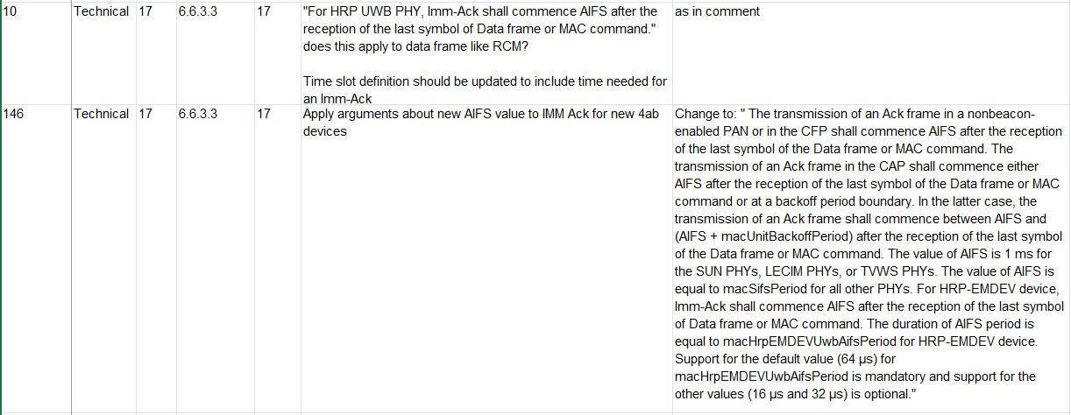

Discussion: RCM frames are data frames that may have the AR field set to request an acknowledgement. If they do not have the AR field set to request an acknowledgement, then the immediate Ack is not transmitted.
Proposed Resolution: Revised
Proposed text changes on P802.15.4ab™/D (pre-ballot) B:
6.6.3.3 Acknowledgment
Original text
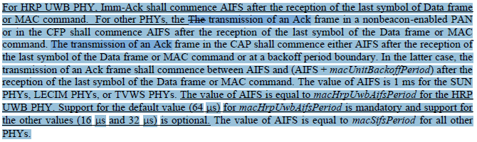
Proposed text
For HRP UWB PHY, when Acknowledgment is requested, Imm-Ack shall commence AIFS after the reception of the last symbol of Data frame or MAC command. For other PHYs, the transmission of an Ack frame in a nonbeacon-enabled PAN or in the CFP shall commence AIFS after the reception of the last symbol of the Data frame or MAC command. The transmission of an Ack frame in the CAP shall commence either AIFS after the reception of the last symbol of the Data frame or MAC command or at a backoff period boundary. In the latter case, the transmission of an Ack frame shall commence between AIFS and (AIFS + macUnitBackoffPeriod) after the reception of the last symbol of the Data frame or MAC command. The value of AIFS is 1 ms for the SUN PHYs, LECIM PHYs, or TVWS PHYs. The value of AIFS is equal to macHrpEMDEVUwbAifsPeriod for the HRP UWB PHY. Support for the default value (64 μs) for macHrpEMDEVUwbAifsPeriod is mandatory and support for the other values (16 μs and 32 μs) is optional. The value of AIFS is equal to macSifsPeriod for all other PHYs.

10.29.2 Ranging block and round structure

Instruction to editor: Insert the following sentence and figure.
Each ranging round is further subdivided into an integer number of ranging slots where a ranging slot is a time period of sufficient duration for the transmission of at least one RFRAME in the case an Imm-Ack is not expected. In the case an Imm-Ack is expected, the ranging slot is a time period of sufficient duration for the transmission of at least two RFRAMEs (as shown in Figure XX).

AIFS
Data
ACK
Ranging Slot

Figure XX

Comment Index #147 and #148 in 15-23-0475-15-04ab-cc-consolidated-comments
Discussion: Agee with Commenter.
Resolution: Accept

Comment Index #54 15-23-0475-22-04ab-cc-consolidated-comments
Discussion: The Association Request and Association Response should not have Ack, as they increase the probability of collision and thus, the association delay. The controlee can send Assoc Request not only at the start of any unscheduled slot in the round, but anywhere in the slot. The Association Response already serves as an Ack to the Association Request.
Resolution: Reject. There is not Ack to association req/resp.

