IEEE802.16t Direct Peer-to-Peer (DPP) Requirements
July 11th, 2023

Content
1 Content 2
2 Definitions and Terms 3
3 Abbreviations and acronyms 6
4 General (DPP Should be a new clause 9 at same level as PHY 7
5 DPP Air Interface Protocol (AIP) (9.2) 9
6 Channel Access 14
7 DPP SS States 23
8 DPP link Establishment and Maintenance Procedures 28
9 Relay Station 38
10 Frequency Diversity 41
11 Messages format 42
12 DPP SS Configurable parameters 45

Definitions and Terms
Air Interface Protocol (AIP): A set of rules defining how two DPP SSs communicate with each other over the air.
Air Interface Resource (AIR): A two-dimensional entity with a frequency and a time range. Can be expressed in terms of slots.
CTS Deferral: A period after CTS reception during which a non-intended receiver will not access the channel.
CSMA/CA: Carrier Sense Multiple Access with Collision Avoidance. The DPP mode of 802.16t operation uses Non-Persistent CSMA, which means that when a transmitting DPP SS has a frame to send and it senses a busy channel, it waits for a random period of time without sensing the channel in the interim and repeats the CSMA algorithm again. Other common variants of CSMA are 1-Persistent CSMA and P-Persistent CSMA.
Direct Peer-to-Peer (DPP): One or more instances of a Direct link between two SSs with no Base Station used nor required for operation.
DPP Association: One to one relationship between two DPP SS established by successful pairing and mutual Authentication.
DPP Link: An association between two DPP SS..
DPP PDU: A Protocol Data Unit (PDU) used in DPP communication.
DPP SS: Each of the SSs of the same DPP link.
DPP Channel: A continuous frequency range or an aggregation of multiple non-adjacent frequency ranges used for communication between DPP SSs.
DPP Sub-channel: A partition of DPP channel in the frequency domain.
DPP Sub-channel group: An aggregation of one or more adjacent or non-adjacent DPP sub-channels. A DPP link operates over one subchannel group.
Half Duplex (HD): Communication in both directions is not done at the same time.
Link Adaptation (LA): A process by which a DPP SS is notified by its peer DPP SS, what MCS it can use for transmission.
LA Hold Timer: Link Adaptation Hold Timer is a timer that starts/restarts once a measurement report is received and resets once maximum duration time is reached which is configured in terms of seconds between 1 to 60 seconds.
MAX RBC: Maximum Random Backoff Count, a configuration parameter used to declare the transmission failure once the random backoff count exceeds the configured value.
MAX CO: Maximum Channel Occupancy, a configuration parameter defining the maximum duration of the burst in terms of the number of slots.
Maximum Latency: A configurable parameter, which defines the time before an SDU expires.
Minimum Inter Burst Gap: A minimum duration between consecutive transmission of a DPP SS in which it is not allowed to transmit.

Nominal CINR: A configurable parameter in each DPP SS. It defines the nominal range (minimum and maximum) of CINR for each MCS for optimal demodulation by the DPP SS. The upper limit for each MCS coincides with the lower limit for the next higher MCS, except for the highest MCS, in which case the upper limit is infinity.
Non-Intended Receiver: Any DPP SS other than the intended DPP SS receiver as identified by the destination Ethernet address in the burst.
Operational State Time Limit: A configurable parameter that sets the time duration after which the DPP SS will leave Operational state and return to the Association state if its peer DPP SS does not respond/transmit any burst. It is specified in terms of seconds.
Paired DPP Channel: Two distinct DPP channels are used, one for each direction.
Paired DPP subchannel group: Two distinct subchannel groups are used, one for each direction.
Random Back-Off Duration: A duration in which a DPP SS avoids channel access following an access attempt in which the channel was busy. The backoff is random so that if multiple DPP SSs are trying to access the channel at the same time, the probability of collision next time is minimized.
Receive MCS: The MCS used by the DPP SS for reception.
Relay Wait Time: A configurable parameter in each Relay Station that specifies the amount of time the Relay Station is to wait for an acknowledgment before relaying a burst or PDU for which an acknowledgment was required but not received when the Relay Option value in the burst’s Control Message is set to 2.
Repetition Factor: the number of PHY layer repetition used for a given MCS
Robust MCS: The highest MCS that can reliably be decoded by the peer DPP SS.
RSSI Threshold: A configurable parameter in a DPP SS. The measured RSSI is compared with the configurable RSSI Threshold parameter for use by the CSMA mechanism to determine whether or not the channel is in use.
Slot: The minimal duration usage within a subchannel.
Service Flow (SF): A one direction virtual association used to carry DPP PDUs meeting certain classification rules.
Transmit MCS: The MCS used by the DPP SS for transmission.
Unpaired DPP Channel: the same DPP channel is used for communication in both directions.
Unpaired DPP Sub-channel group: The same subchannel group is used for both directions of communication between two DPP SSs.

Abbreviations and acronyms
CTS: Clear to Send
OTA: Over the Air
RTS: Request to Send
RX: Receive, receiving, reception
TX: Transmit, transmitting, transmission

General (DPP Should be a new clause 9 at same level as PHY
this section General would be 9.1, and so on.

This document specifies the requirements for Direct Peer-to-Peer (DPP) communication between multiple DPP SSs, which is peer-to-peer operation without the use of base station infrastructure. A Relay Station, however, may be used in DPP mode for range extension. The associated DPP SSs of a DPP link are peers (i.e., there is no master-slave relationship) and the DPP Air Interface Protocol (AIP) is symmetrical. Minimal a priori configuration as described in this document is needed to establish link.

DPP SSs communicate over a single subchannel or a paired or unpaired DPP sub-channel group. When two distinct bands are used, the higher frequency band will be referred to as the “high band” and the lower frequency band will be referred to as the “low band”.

When more than one bands are available, an optional DPP frequency diversity (<insert ref here>) mode may be implemented.

A DPP link operates in Half Duplex (HD) mode with no strict framing, using a CSMA/CA access mechanism. A DPP SS shall only transmit when needed. The CSMA/CA mechanism is used to resolve contention between the two DPP SSs of the DPP link and resolve possible contention with DPP SSs of other in-range DPP links.

A DPP SS employs the same PHY layer for transmit and receive. The PHY layer is identical to the uplink of the WirelessMAN-NB PHY

Each DPP SS employs CSMA/CA before the start of a transmission. A DPP link may interfere with a nearby WirelessMAN-NB PtMP system if operated on the same frequency. Moreover, if operated on the same frequency, the DPP SSs may be starved due to high utilization activity in a nearby WirelessMAN-NB PtMP system. It is therefore required to use a dedicated frequency for DPP whenever it is in range of a WirelessMAN-NB PtMP system.

A DPP SS employs various management messages with its peer for power control, MCS selection (this is also referred to as “Link Adaptation”) and automatic PHS rules establishment.

The DPP PDU structure is described in section 5.6. It is optimized for the DPP requirements. The DPP PDU can be used to encapsulate one SDU, concatenate multiple SDUs, encapsulate a fragment of concatenated SDUs or concatenate fragments of multiple SDUs.

A DPP link may employ multiple service flows in each direction. Each service flow carries SDUs which meet classification rules configured at the DPP SS at which the SDU is received. Each service flow has an associated traffic priority between 0 to 7 (the higher the number, the higher the priority). Higher priority SDUs are transmitted before lower priority SDUs.

The DPP SS shall have a Maximum Latency value to be configured by the user for each SF. When an SDU is received for transmission, the DPP SS shall enforce the Maximum Latency value in accordance with the SF requirement. The DPP SS shall remove an SDU from the transmission queue if its Maximum Latency time expires.

Each DPP SS shall have the ability to automatically establish Packet Header Suppression (PHS) rules with its peer.

DPP Air Interface Protocol (AIP) (9.2)

The DPP SS shall generate bursts in accordance with Figure 1 below. The DPP burst consists of a Gain Adjustment, Synchronization, Control Message and one or more DPP PDU fields. The gain adjustment field is added in the beginning of every burst to support connectionless operation.

The DPP SS shall use a SC-FDMA waveform for communication in both directions as described in the WirelessMAN-NB PHY specification section “8.6.4 Uplink”. The DPP SS shall generate Control Messages and Data DPP PDUs in accordance with the procedure described in the WirelessMAN-NB PHY specification document, section “8.6.8 Uplink transmitter”.

In generating the Gain Adjustment and Synchronization fields of a burst, the DPP SS shall omit the channel coding and slot formation part of the procedure described in the WirelessMAN-NB PHY specification document, section “8.6.8 Uplink transmitter”. The DPP SS shall transmit the Gain Adjustment and Synchronization fields in the lowest subchannel of the subchannel group if more than one subchannel is used (aggregated) between a pair of radios operating in DPP mode.

One transmission cycle constitutes one burst, and a burst can have multiple DPP PDUs. The DPP SS shall limit the number of DPP PDUs in a burst to not exceed 16.
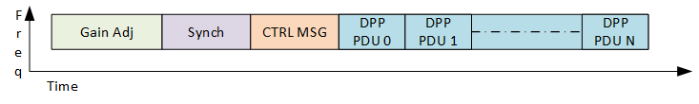
Figure 1. Burst structure

Burst Structure:

Gain Adjustment Period: The DPP SS shall begin each burst by transmitting one slot worth of alternate 1’s and 0’s as a BPSK modulated signal for a receiver to adjust the gain.

Synchronization: Following the Gain Adjustment Period, the DPP SS shall transmit a preamble to be used as a synchronization signal carrying a Gold sequence of length 63 as described in WirelessMAN-NB PHY specification document, refer to the section “8.6.7 Downlink Preamble Transmission”.

Control Message: The DPP SS shall use the robust MCS when transmitting a control message (CTRL MSG). Table 4 describes the CTRL MSG structure. In the control message Type field, the DPP SS shall indicate whether the CTRL MSG is used to convey information about DPP PDUs that follow the CTRL MSG in the burst or is used to indicate an RTS, CTS, or Ack message. The DPP SS shall set the ACK indication to a value of 1 in the CTRL MSG if any PDU within the burst requires an Ack. An ACK indication is set based on the presence of any DPP PDU which needs an ACK. The DPP SS shall set the ACK indication to a value of 0 in the CTRL MSG for RTS and CTS messages. A non-intended DPP SS receiver shall use the ACK indication for ACK-based deferral as defined in section 6.4.3.

DPP PDU: The DPP SS shall transmit DPP PDUs in accordance with 802.16t PHY specification document, section “8.6.8 Uplink transmitter” except for the Ranging section.

Slots Mapping: DPP SS shall map all the slots starting with CTRL-MSG followed by DPP PDUs after the last Preamble symbol. DPP SS shall map the lowest numbered slot such that it occupies the lowest subchannel starting with the lowest SC-FDMA symbol and the next slots occupy the next subchannel in the group till the highest subchannel in the group is reached before starting with the lowest subchannel again over next SC-FDMA slot symbol offset.
The DPP SS shall limit the total duration of a burst to the value of a configurable Maximal Channel Occupancy (MAX CO) specified in terms of a number of slots.

DPP PDU structure
- The DPP SS shall begin each PDU with 4 bytes of header followed by a variable length payload and a 4-byte CRC as shown in Figure 2.

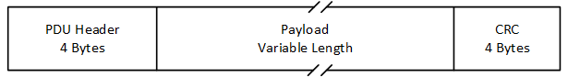
Figure 2. DPP PDU Structure

- The DPP SS shall produce PDU headers in accordance with Figure 3 and Table 1.
Figure 3. DPP PDU Header Structure
Table 1 DPP PDU Header fields
- Syntax | Size(bits) | Notes
PDU header () { | --- | ----
Header Type | 1 | 0: Management DPP PDU 1: Data DPP PDU
Encryption indication | 1 | 0: Off 1: On
PHS indication | 1 | 0: Off 1: On
Sub-header indication | 1 | 0: Absent 1: Present
ACK Indication | 1 | 0: Off 1: ACK to be sent.
Length | 11 | 0 to 2047 Length in bytes of the DPP PDU including the header and the 4-Byte CRC.
If (PHS indication == 1) PHS index | 8 | If PHS Indication is set to 0, PHS is turned off and there is no PHS index.  PHS Index= 0, PDU is unsuppressed.  PHS Index != 0 PDU is suppressed ,with PHS Index indicating the PHS rule used.
HCS | 8 | CRC8 for the above 3 bytes (as in Table 6-3)
}

.

- The DPP SS shall include the following fields in the header of each DPP PDU it transmits:
- A Header Type, indicating the type of the DPP PDU:
- The value 0 indicates it is a Management DPP PDU used to carry management messages mentioned below,
- Association Messages, refer to Table 5 and Table 6
- Measurement Report, refer to Table 7
- Automatic PHS, refer to Table 9 and Table 10
- The value 1 indicates it is a Data DPP PDU.
- An Encryption indication. The value 0 indicates the data is not encrypted. The value 1 indicates the data is encrypted.
- A PHS indication. The value 0 indicates PHS is disabled and the value 1 indicates PHS is enabled. The value of the PHS indication field is determined by the PHS configuration in the SF associated with this PDU.
- A sub-header Indication. The value 0 indicates there are no sub-headers and 1 indicates there are sub-headers present within the DPP PDU. Sub-headers are present immediately after the DPP PDU header and then onwards until the beginning of the first SDU. Within the sub-headers, the sub-header type field describes the SDUs as either packed by value of 0 or fragmented by value of 1. The sub-header format is described in Table 2.
- ACK Indication field (ACKI). The value 0 indicates that an ACK is not needed for the DPP PDU. The value 1 indicates that an ACK is needed.
- A DPP PDU length field. The value can be from 0 to 2047 referring to the number of bytes comprising the DPP PDU.
- A PHS Index field. If the PHS indication is 1 this field indicates the PHS index. Otherwise, it is 0. Refer to section 8.3 for PHS related details.
- The HCS is computed in the same manner as described in Table 6-3 of 802.16-2017.

Table 2 Sub-Header format
- Syntax | Size(bits) | Notes
Sub-header () { | --- | ----
Sub-header Type | 1 | 0: Packing 1: Fragmentation
Fragmentation state | 2 | Indicates the fragmentation state of the payload:  00 = No fragmentation  01 = Last fragment  10 = First fragment  11 = Continuing (middle) fragment
FSN | 8 | Sequence number of the current SDU fragment. The value shall be increased by one (modulo 256) for each fragment.
Length | 11 | 0 to 2047 Length in bytes of the SDU including the Sub-header.
Reserved | 2
}
}

- The DPP SS shall pack queued SDUs awaiting transmission in a single DPP PDU if those are having the same PHS index value and ACK requirements, subject to the limit of the Maximum Channel Occupancy. DPP SS shall have the same PHS index value and ACK requirements for SDUs mapped to the same SF. If the number of queued SDUs mapped to the same SF awaiting transmission exceed the limit of the Maximum Channel Occupancy, the DPP SS shall send the remaining SDUs in the next burst. If an SDU needs to be fragmented, the DPP SS shall indicate “fragmentation” in the PDU Sub-header Type field. Refer to Table 2 for sub-header details.
- The 4-byte DPP PDU CRC is computed in the same manner as described in 802.16 section 6.3.3.5 CRC calculation.

Channel Access

General

The DPP SS shall support the following configurable channel/sub-channel access schemes:

Half Duplex non-persistent CSMA with the one band used in both directions.

Half Duplex non-persistent CSMA with the two bands used in both directions. In this case, sensing is done on both transmit bands.

In addition to the above, the channel access procedure may be configured to use Request to Send (RTS) and Clear to Send (CTS) messages. Mixed access operation of some SS with RTS/CTS enabled and disabled is supported.

The DPP SS shall support the partitioning of a channel dedicated to DPP service into adjacent and non-adjacent sub-channels and sub-channel groups, the same as is done in the WirelessMAN-NB PHY. A DPP link operates over one subchannel group.

The DPP SS shall limit each burst length to a multiple of the slot duration that is specified as an integer in a configurable Maximum Channel Occupancy (MAX CO) parameter. The MAX CO parameter will be configured by the user based on the application/deployment scenario. This feature helps to avoid excessive usage of the channel by one DPP SS.

Each DPP SS shall have a configurable Minimum Inter Burst Gap between its consecutive transmission. This shall disallow the advantage in channel access to a DPP SS who has just transmitted and would otherwise have an advantage relative to other DPP SS.

When the DPP SS has data to transmit and the channel is free, it shall compute the total duration of the burst in slots, based on the length of the SDUs in the buffer and the MCS to be used for transmission. If the computed duration of the burst for all available SDUs to be transmitted is less than the Maximum Channel Occupancy parameter, then the DPP SS shall send all available SDUs immediately in the same burst; else when the computed burst duration exceeds the Maximum Channel Occupancy parameter, the DPP SS shall send the remaining SDUs in the next burst after the DPP SS performs carrier sense and determines the channel is free. The DPP SS shall use fragmentation necessary to ensure that the burst duration does not exceed the configured Maximum Channel Occupancy parameter.

The DPP SS shall transmit higher priority SDUs first while lower priority SDUs are left in the queue and transmitted in the next burst. An SDU shall be discarded when its Maximum Latency expires .

A DPP SS shall compute the RSSI of a signal of interest at the antenna connector. The RSSI measurement method is vendor specific. One possible method to estimate RSSI is given by equation (8-151) described in 8.4.12.2. The RSSI measured shall be averaged over the latest burst received. RSSI shall be reported in dBm and shall be quantized in 1 dB steps.

When the DPP terminal has an entirely new data burst ready to transmit, the terminal shall set the Random Backoff Count (RBC) to zero. When the DPP terminal has a data burst ready to transmit and RBC is zero, the terminal shall transmit the data immediately upon detecting that the measured RSSI on the transmit channel is less than the RSSI threshold. In case the DPP terminal with data to transmit senses that the transmit channel is busy as indicated by the measured RSSI being greater than the RSSI threshold, the terminal shall increment the RBC count, and select a Random Back-Off Duration based on the integer random function output with the range of values between one to MAX CO in terms of slots. When the DPP terminal has postponed transmission due to sensing that the measured RSSI is greater than the RSSI threshold, after waiting for the Random Back-Off Duration, the DPP terminal shall modify the burst by removing Maximum Latency expired SDUs and adding new SDUs received based on the priority since the previous attempt. The DPP terminal shall repeat the process of channel sensing and:
- transmit if the measured RSSI is less than the RSSI threshold, or
- increment the RBC and compute a new Random Back-Off time. In case the RBC exceeds the MAX RBC, the DPP terminal shall reset RBC to zero and send a vendor-specific indication to the operator.

The DPP SS shall indicate to its peer the need to acknowledge error free receipt of one or more DPP PDUs in the burst by using the ACK Indication bit in the DPP PDU header shown in Table 1. The DPP SS shall set the ACK Indication bit to 1 in the CTRL MSG if the transmitted burst requires any of its DPP PDUs to be acknowledged.

Upon detecting a burst, the DPP SS receiver shall decode all the PDUs in the burst and check whether the CRC passed or failed for each of the PDUs. DPP SS shall discard the CRC failed PDUs. If the ACK Indication bit in the CTRL-MSG of a received burst is set to 1 then the DPP SS receiver shall update the ACK bit map value for the bit position corresponding to each of the PDUs to 1 for pass or 0 for fail. The ACK bitmap LSB indicates the first DPP PDU received and MSB last. If the ACK Indication bit in the CTRL-MSG of a received burst is set to 1, the DPP SS shall transmit a CTRL MSG to the sender DPP SS with the Type field indicating ACK (value 3) along with the ACK bit map determined for the PDUs received in that burst.

When an ACK is required, the sending DPP SS shall wait for the ACK message for a configurable duration (this should be greater than or equal to the Maximum Round Trip Delay,) before retransmitting the PDU if no ACK is received.

Half Duplex CSMA

This paragraph describes the behavior of DPP SSs using HD CSMA.

The DPP SS shall conform with the flowchart behavior shown in Figure 4 when initiating a transmission.
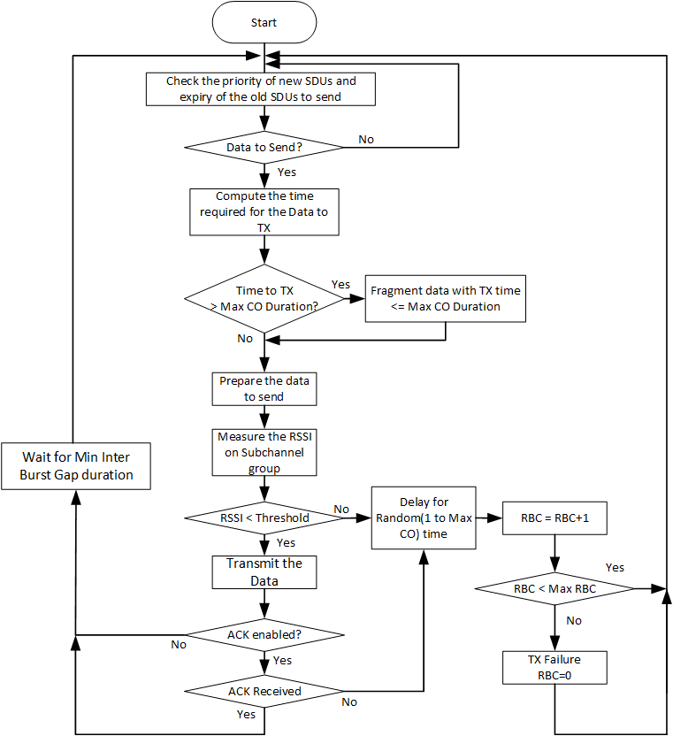
Figure 4. CSMA flowchart for transmitting radio

Intended receiver behavior
- The DPP SS shall determine that it is the intended receiver if it identifies its MAC address or Name in an incoming CTRL MSG (data fields: Receiver ID and Receiver Name).
- The intended DPP SS receiver shall decode the DPP PDUs based on the MCS identified within the CTRL MSG.
- If an ACK is required, the intended DPP SS receiver shall perform the CSMA procedure to send the ACK. The DPP SS receiver shall transmit ACK messages using Robust MCS.
- Refer Figure 6 for the DPP SS RX flowchart.

Non-Intended Receiver behavior
The DPP SS shall determine that it is a non-intended receiver if it does not identify its MAC address or Name in the incoming message. The DPP SS shall discard a message for which it is a non-intended receiver. The non-intended receiver shall perform ack deferral. <add reference>

CSMA/CA with RTS, CTS

The CSMA mechanism has the known problem of hidden nodes. This is optionally addressed in DPP operation by the exchange of Request to Send (RTS) and Clear to Send (CTS) Messages between the two DPP SSs, referred to as “collision avoidance” (CA).

The DPP SS shall be configurable to enable or disable RTS/CTS collision avoidance. When configured to enable RTS/CTS collision avoidance, the DPP SS shall transmit each CTRL-MSG indicating RTS with Control Message Type value of 1, as described in Table 4. Upon receiving the CTS in response to an RTS it sent, the DPP SS shall transmit the burst as per the CTS message received. CTS is CTRL-MSG with Control Message Type value of 2 described in Table 4.

The access procedure described in this paragraph includes a RTS message transmitted by the DPP SS with SDU(s) queued to transmit, referred to as the “initiating DPP SS”, and a CTS response by the intended receiver. RTS and CTS are short messages that precede the data transmission. Upon having one or more SDUs queued to send and CSMA-sensing that the channel is clear, the DPP SS shall transmit a RTS message that specifies the requested number of bytes including the DPP PDU and SDU overheads. The intended DPP SS receiver specifies within the CTS message the allocated number of slots to be transmitted and the MCS to be used which is based on the measured CINR. Refer Table 4 to RTS/CTS message details.

The initiating DPP SS shall conform with the flowchart behavior shown in Figure 5 when the need for the RTS is configured.
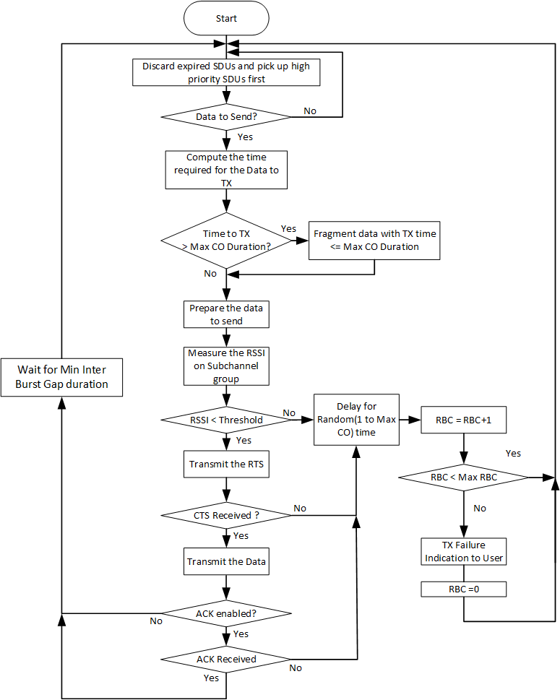
Figure 5. CSMA/CA RTS CTS flowchart for DPP SS initiating transmission

Intended DPP SS Receiver behavior:
- The intended DPP SS receiver shall detect its MAC address or Name in CTRL MSG as described in Table 4.
- Upon receiving a RTS message, the intended DPP SS receiver shall convert the number of bytes that were requested in the CTRL MSG into the number of slots that it is allocating at the MCS which it determines based on the CINR measured in the received RTS message, plus the additional slots required to transmit the CTRL MSG, using the Robust MCS.
- Upon CSMA-sensing that the channel is clear after receiving a RTS message, the intended DPP SS receiver shall transmit a CTS message identifying the number of slots it has allocated along with the MCS to be used in accordance with Table 4.
- When the intended DPP receiver transmits a CTS message in response to a RTS message, the DPP SS receiver shall delay any subsequent transmission by the CTS Deferral time as defined in 6.4.2.
- Upon receiving a message without errors, the intended DPP SS receiver shall decode the message and upon CSMA-sensing that the channel is clear, send an ACK to the sender if required per the CTRL MSG.
- Refer Figure 6 for the DPP SS RX flowchart.

Non-Intended DPP SS Receiver behavior
- A DPP SS is considered to be a non-intended DPP SS receiver for a message it receives in which it does not recognize its MAC address or Name (see Table 4).
- If a received CTRL MSG indicates RTS in the Control Message Type field, the non-intended DPP SS receiver shall avoid transmitting within the RTS Deferral duration from the time the CTRL MSG was received as defined in 6.4.1.
- If a received CTRL MSG indicates CTS in the Control Message Type field, the non-intended DPP SS receiver shall avoid transmitting within the CTS Deferral duration from the time the CTRL MSG was received as defined in 6.4.2.
- If CTRL MSG is received with an ACK Indication field requiring an ACK, then the non-intended DPP SS receiver will avoid transmitting within the ACK deferral duration from the time the CTRL MSG was received as defined in 6.4.3.
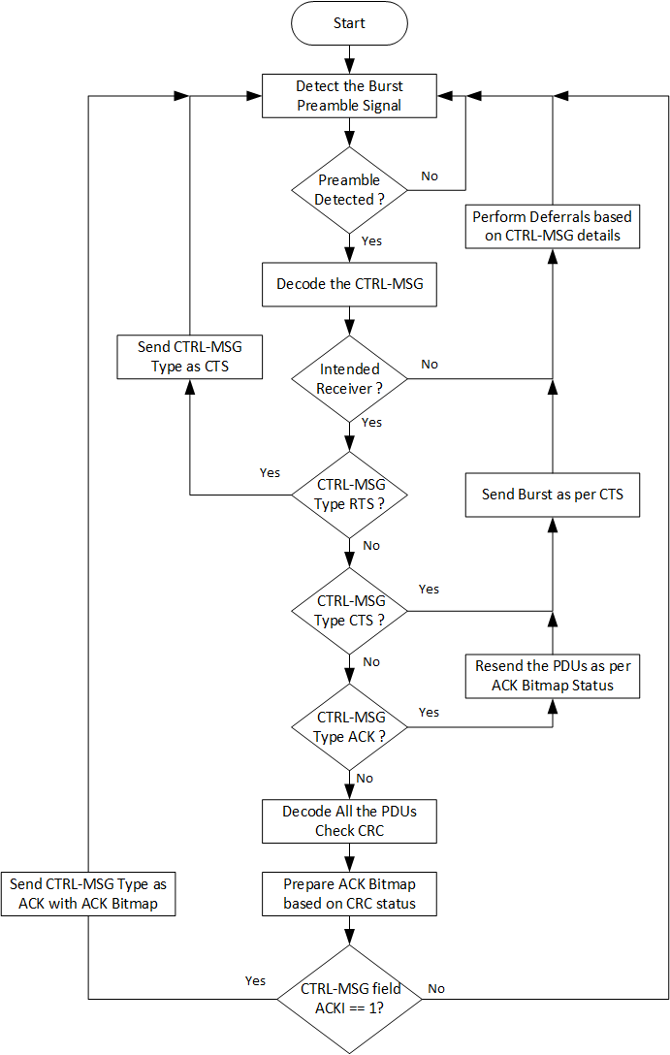
Figure 6 DPP SS RX flowchart

Deferrals

RTS Deferral: When the non-intended DPP SS receiver detects a CTRL MSG with indication of RTS in the Control Message Type field, it shall compute the deferral time by adding a 1.5 * (configurable Maximum Round Trip Delay for the transmission of the RTS and CTS messages) plus the burst duration. The non-intended DPP SS receiver shall compute the burst duration in slots required to send the bytes requested in the RTS message using the robust MCS, plus the duration of the CTRL MSG, the gain adjustment, and the synchronization fields.

CTS Deferral:
- When the non-intended DPP SS receiver detects a CTRL MSG with the indication of CTS in the Control Message Type field, it shall compute the CTS Deferral Time by adding the burst duration and the configurable Maximum Round Trip Delay. The non-intended DPP SS receiver shall compute the burst duration by adding the number of slots allocated in the CTS message and the duration of the CTRL MSG, gain adjustment, and synchronization fields.
- When the intended DPP SS receiver sends a CTRL MSG with the indication of CTS in the Control Message Type field, it shall compute the CTS Deferral Time the same as the non-intended DPP SS receiver.

ACK Deferral: When a non-intended DPP SS receiver detects a CTRL MSG with the ACK indication ON, it shall compute the deferral time by adding the duration required for the number of slots allocated in the current burst plus the duration of the burst with a CTRL MSG, and configurable Maximum Round Trip Delay.

Relay Deferral:
- When the DPP SS sets the Relay Option in the CTRL-MSG of a burst to a non-zero value then it shall defer any transmissions for the duration of the burst transmitted plus the Maximum Round Trip Delay.
- When a non-intended DPP SS receiver detects a burst with the CTRL-MSG Relay option set to a non-zero value then it shall defer any transmission until the completion of the current burst plus the duration of the same burst and the Maximum Round Trip Delay.

DPP SS States

General

A DPP SS has two states: Offline State and Online State. The Online State is further divided into an Associate Sub-State and an Operational Sub-state with respect to each association it establishes.

A DPP SS may establish and maintain an association with multiple DPP terminals. Successful association establishment is conditioned on successful pairing and authentication. Each association has an independent state diagram.

Offline state

The DPP SS when turned ON shall enter the Offline state by default.

Each DPP SS shall have a unique MAC Address and public/private key pair that is configured during production.

The DPP SS shall allow an X.509 certificate signed by a Certificate Authority to be installed during production or later by a Certificate Authority under customer responsibility. The purpose of the certificate is to protect the identity of the DPP SS and is used by the TLS authentication scheme for the DPP SSs to mutually authenticate each other.

The DPP SS shall be configurable with the following operational parameters:

Bands (one or two bands),

Channel parameters (Subchannel bandwidth, subchannel bitmap and subchannel group)

Service flows with their associated QoS profiles.

Pairing mode as described in 7.2 subparagraph 5 below.

Name (optional)

Maximum number of peers (1-7)

Other DPP parameters identified in this document as “configurable”.

The DPP SS shall have a configurable peer selection mode. The two DPP SSs of a DPP link must be configured to the same selection mode in order to pair. The DPP SS shall support the following two peer selection modes:
- Automatic Selection: If configured for Automatic Selection, a DPP SS shall identify its peer(s) using up to 7 preconfigured peer MAC addresses or Names.
- Manual Selection: If configured for Manual Selection, a DPP SS shall support a vendor-specific display of the names of DPP SSs from which it has received an ASSOCIATE Request message with a Certificate Authority (CA) name, matching its configured peer CA name or another CA name with which it has been configured as that of an acceptable peer. During Manual Selection, the DPP SS shall allow the user to manually select up to maximum number of peers desired peer SSs from the list of DPP SSs having matching CA name(s), using a vendor-specific process, to complete the association process. Refer to section 8.1 for the identity Filtering process description.

If configured for the ‘Automatic’ Selection mode, the DPP SS shall be configurable with the following parameters of its peer DPP SS:

MAC address of each peer SS and optionally its Name

public key of each peer SS.

If configured for the ‘Manual’ Selection mode, the DPP SS shall be configurable with the following parameters:

its peer DPP CA name(s), as appears in the certificate Issuer Name field.

its peer DPP SS CA root public key(s).

Pairing mode:
Any – multiple associations supported;
Server– may pair with multiple (up to maximum number of peers) DPP SSs – a.k.a. “Server Pairing mode”
Client– may pair with one unpaired or already paired DPP SS – a.k.a. “Client Pairing mode”.

The DPP SS shall switch to the Online state based on a vendor-specific manual trigger.

Online state
- The Online state is used when the DPP SS is paired or is seeking its configured peer for pairing. While in the Online state, if not configured to Client pairing mode and if it did not reach its configurable maximum number of peers, the DPP SS shall periodically transmit an ASSOCIATE Request message. The information included in the message depends on the DPP SS selection mode as follows:
  - When configured for Automatic Selection mode, the ASSOCIATE Request message transmitted by a DPP SS shall indicate the transmitting and receiving DPP SS MAC address and Name, and a zero length CA Name field.
  - When configured for Manual Selection mode, the ASSOCIATE Request message transmitted by a DPP SS shall indicate the transmitting DPP SS pairing mode (single, client or server), its MAC Address, its Name, the CA name, as appear in its certificate, and all zeros in the receiving DPP SS MAC address field.
- While in the Online state, if configured to Server pairing mode, the DPP SS shall ignore ASSOCIATE Request message.

Associate state

Upon receipt or sending of an ASSOCIATE Response message from a peer, the DPP SS shall enter the Associate state with that peer.

The DPP SS shall perform the following activities during the Association state:

Verify the DPP SS identity of its peer as described in section 8.1 and 7.1-5-b.

Authenticate its peer as described in section 8.2.

Automatically configure PHS as described in section 8.3.
On failure of any of the above activities, the DPP SS shall terminate the association with the peer.

While in the Association state, the DPP SS shall receive and transmit internal control messages described in section 11.1.2,11.1.3, and 11.1.4, but does not transmit any user data until it reaches the Operational state.
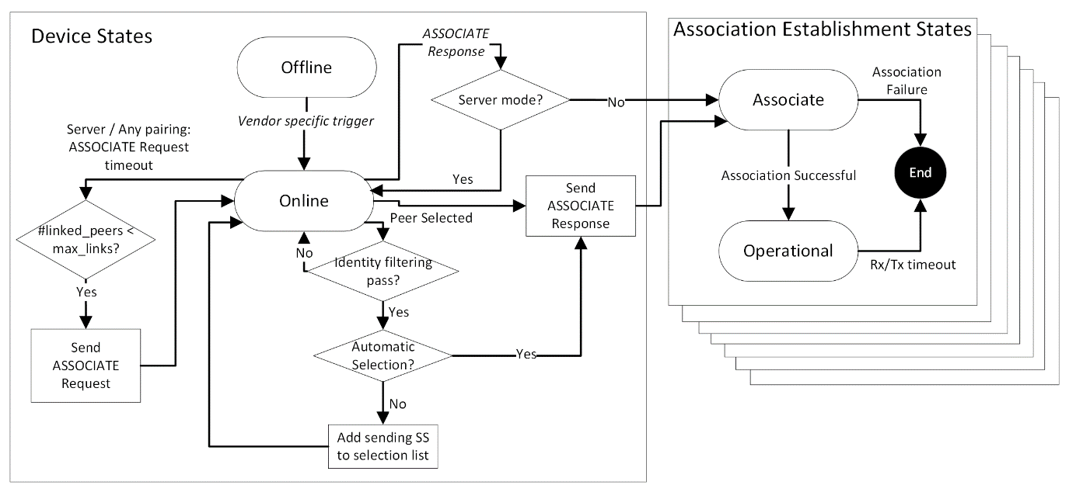
Figure 7: DPP SS State Diagram

Operational state

The DPP SS shall enter the Operational state automatically, following the successful completion of the activities described in the Associate state.

The DPP SS shall perform the following activities during the Operational state:

Exchange data messages with its peer DPP SS.

Perform continuous link adaptation to adjust MCS and repetitions based on the CINR at the peer DPP SS receiver. Link adaptation is performed in each direction independent of the other direction. Refer to section 8.4 for the link adaptation process description.

Perform continuous receive gain adjustments as needed to attempt to maximize level of the received signal subject to no saturation of ADC.

Perform power control to minimize the TX power subject to the RSSI performance criteria. Refer to section 8.5 for the power control process description.

Continuously adjust automatic PHS rules. Refer to section 8.3 for the automatic PHS process description.

The DPP SS shall terminate the association if its peer DPP SS does not respond/transmit any burst for a configurable Operational State Time Limit in seconds.

The transitions between DPP states are shown in Figure 7.

DPP link Establishment and Maintenance Procedures

Identity Filtering

If configured to use the ‘Automatic’ selection mode, a pair of DPP SS peers shall exchange their MAC addresses and Names using ASSOCIATE Request/Response messages. The DPP SS receiving an ASSOCIATE Request message shall compare the received selection mode, and MAC address or Name with the selection mode and MAC address(es) or Name(s) of its configured peer DPP SS(s) and send an ASSOCIATE Response message to the sender of the ASSOCIATE Request message if a match is found. If there is no match, the DPP SS shall not respond to the ASSOCIATE request message. The identity verification process is shown in Figure 8 below.

If configured to use the ‘Manual’ Selection mode, the DPP SS receiving an ASSOCIATE Request message shall compare the selection mode and the CA name identified in the received ASSOCIATE Request message with its configured peer DPP SS CA name(s) and if matched will add the SS’s name and MAC address, as appear in the ASSOCIATE Request message, to the list of candidates DPP SS peers presented to the user.

If configured to use the ‘Manual’ Selection mode with pairing single or Client, the DPP SS shall include a vendor-specific function to display the list of candidates DPP SS peer Names to enable manual selection of the peer DPP SS(s). When the operator selects a DPP SS from the list of candidates DPP SS peer Names displayed while operating in ‘Manual’ Selection mode, the DPP SS shall send an ASSOCIATE Response message to the selected DPP SS. Figure 9 shows the flow. If no DPP SS is selected after a vendor-specific or configurable period from a list of DPP SS peer Names displayed while operating in ‘List Selection’ pairing mode, the DPP SS shall return to the Online state.
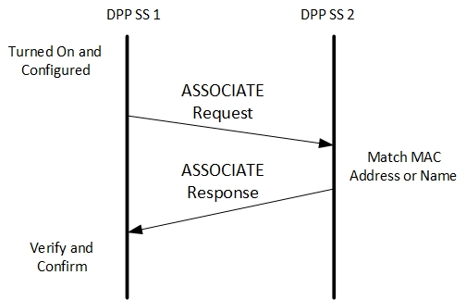
Figure 8. Association message flow Automatic Selection

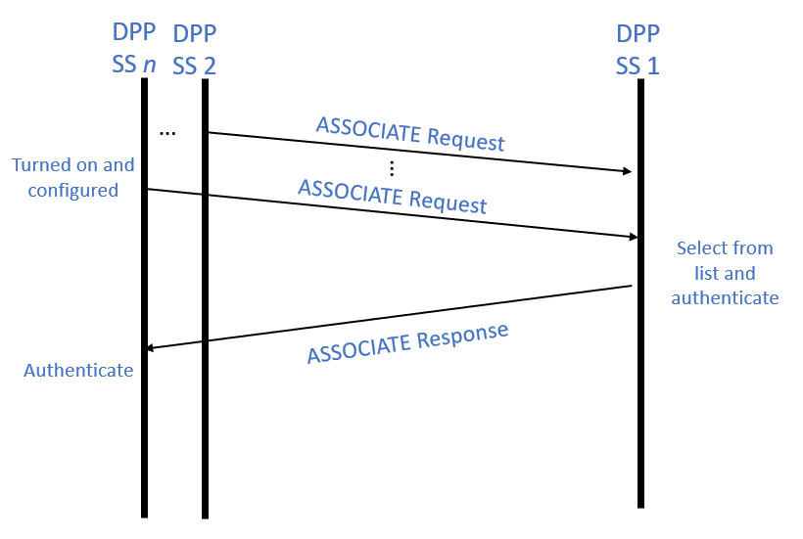
Figure 9 Association message flow: Manual Selection

Authentication

Authentication and Key Management
- Each DPP SS in the network shall include a unique private / public key pair.
- Each DPP SS shall have an X.509 certificate or the ability to be configured with one, that includes the unique public key and has been signed by a trusted CA.
- A DPP SS configured to use the ‘Manual’ Selection’ mode shall have a configurable DPP SS Name.

Each DPP SS shall support both client and server TLS v1.3 for authentication and key management.

If TLS authentication fails, the DPP SS shall terminate the association with that peer.

At minimum, a DPP SS shall support the following TLS v1.3 cipher suites options:
- Key exchange: Elliptic Curve Diffie-Hellman (ECDH) [RFC 4492] or ephemeral Elliptic Curve Diffie-Hellman (ECDHE)
- Authentication: Elliptic Curve Digital Signature Algorithm (ECDSA)
- Encryption: AES-128 or AES-256

Message authentication: HMAC-SHA256, HMAC-SHA384 and HMAC-SHA512.

Upon receiving an ASSOCIATE Response, if configured to Server pairing mode, the DPP SS shall operate as mTLS (mutual TLS) server. Otherwise, the DPP SS shall compare its own MAC address with the MAC address of its peer and shall operate as a mTLS server if its MAC address is higher than the peer DPP SS’s MAC address, otherwise, it shall operate as a mTLS client.

Upon sending an ASSOCIATE Response message, if configured to Client multiple pairing mode, the receiving SS shall operate as mTLS client. Otherwise, the receiving SS shall compare its own MAC address with the MAC address of its peer and shall operate as a mTLS server if its MAC address is higher than the peer DPP SS’s MAC address, otherwise, it shall operate as a mTLS client.

When operating as a TLS server, if the DPP SS does not receive a ClientHello message within TBD msec after beginning operating as a TLS server, association fails and the DPP SS shall terminate the association with the peer.

A DPP SS operating as mTLS server, shall include in the ServerHello optional fields: Certificate, CertificateRequest and CertificateVerify, to support mutual authentication.

Upon receiving a certificate from another DPP SS, if configured to ‘Automatic’ selection, the receiving SS shall authenticate the sending SS identity using its configured public key .

Upon receiving a certificate from another DPP SS, if configured to ‘Manual’ Selection, the receiving SS shall authenticate the issuing CA using its configured root CA public key and then authenticate the SS by the public key sent with the mTLS certificate.

Automatic Packet Header Suppression

A repetitive portion of the data in the SDU shall be suppressed by the sender and restored by the receiver depending on known rules called PHS rules. PHS rules are used in reconstructing the packet correctly at the receiving end.

PHS parameters shall include PHS field, PHS index, PHS mask and PHS size. All these parameters shall be specified during PHS rule creation.
- PHS Field (PHSF): A string of bytes representing the portion of the SDU in which one or more bytes are to be suppressed. It’s a snapshot of the uncompressed SDU inclusive of suppressed and unsuppressed bytes. The most significant byte of the string corresponds to the first byte of the SDU.
- PHS Index (PHSI): The PHS Index has a value between 1 and 255, which uniquely references the PHS rule used to suppress the SDU. If PHS is enabled, each DPP PDU header indicates the PHSI, which references the PHSF. If PHS is enabled and the SDU is not suppressed, the PHS Index is set to 0.
- PHS Mask (PHSM): A bitmask indicating which bytes in the PHS field to suppress and which not to suppress. If a bit has the value 1 in the PHSM, the corresponding byte in the PHSF is supressed, otherwise, if a bit has the value 0 in the PHSM, the corresponding byte in the PHSF is not supressed.
- PHS Size (PHSS): PHS Size is the total length in bytes spanning over entire data portion of the SDU for which the PHS rule is applied. The PHS size includes suppressed and unsuppressed bytes.
- The value of PHSS is equivalent to number of bytes in the PHSF and number of valid bits in the PHSM.

Figure 10 demonstrates SDU suppression and restoration. Note that the PHSF and PHSS span the entire suppression field, included suppressed and unsuppressed bytes.

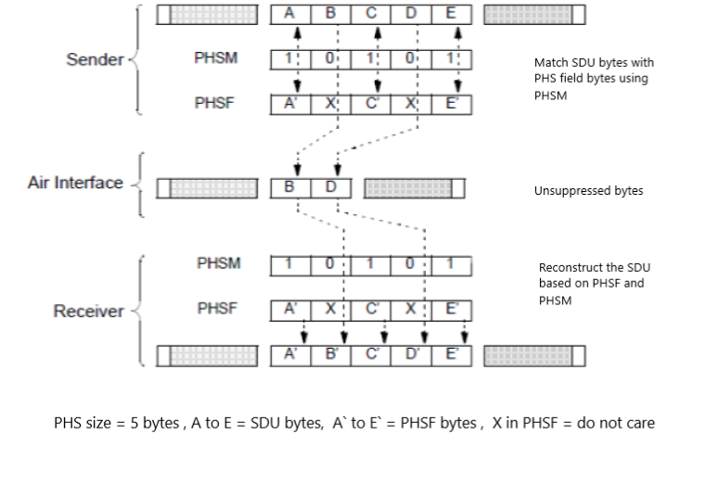

Figure 10 PHS Suppression and Restoration

When PHS is enabled, the DPP SS transmitter shall automatically create a new PHS rule when a SDU is received with a new value for one of the PHS fields for which the PHS mask indicates suppression is required. The DPP SS shall send its peer the PHS request message to specify the field values that can be suppressed in the SDU and the associated PHS index to identify the PHS rule.

When PHS is enabled, a sending DPP SS shall trigger creation of a new PHS rule when any repetitive field value in the traffic is observed and the field values are not matching with any of the already existing PHS rule field values stored.

A sending DPP SS shall apply PHS after creation of a PHS rule. Until a PHS rule is created, the SDU shall be transmitted unsuppressed with PHS index set to 0.

When PHS is applied, the transmitting DPP SS shall include PHS index corresponding to the PHS rule used to suppress the SDU, in the DPP PDU header.

A receiving DPP SS shall identify each PHS rule using a PHS Index (PHSI) as specified in DPP PDU header. A receiving DPP SS shall reconstruct the SDU using the PHS Mask, PHS size and PHS field values corresponding to the PHS rule, this operation is as shown in Figure 11.
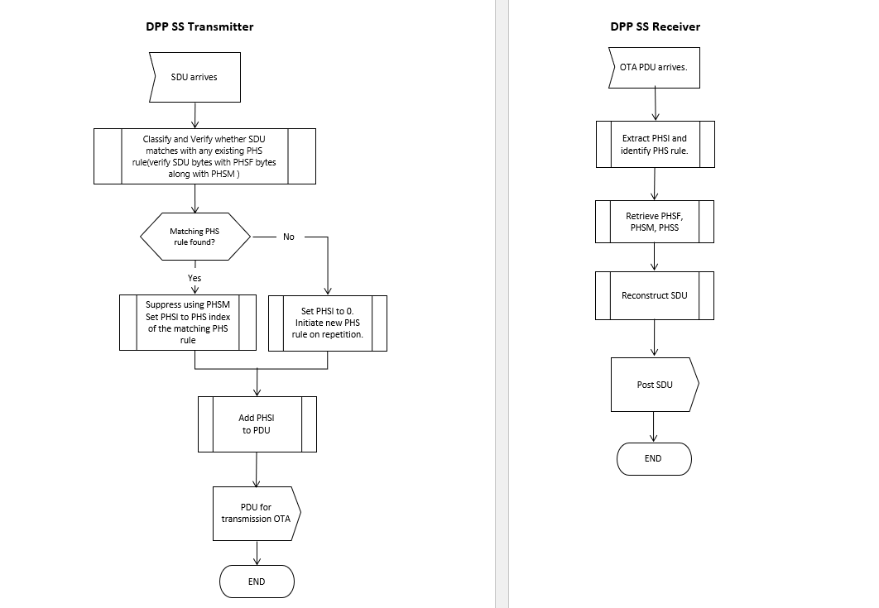
Figure 11 DPP SS transmitter and Receiver Operation

PHS rules are communicated from a transmitting DPP SS to a receiving DPP SS using PHS Request, Response and Ack messages. The message flow between a transmitting DPP SS (DPP SS1) and a receiving DPP SS (DPP SS2) during the process of PHS rule creation shall be as shown in Figure 12. DPP SS1 shall initiate the creation of PHS rule by sending a PHS Request message to DPP SS2. DPP SS2 shall respond with a PHS Response message indicating the response code (Please refer to Table 9 for PHS response message parameters). The response code parameter in the PHS Response message is used to respond to the PHS request message. If the response code is set to 0, it is a “Reject” response. If the response code is set to the PHS index matching with the PHS index received in the PHS request message, it is an “Accept” response. DPP SS2 shall set the response code to PHS Index indicating an “Accept” response if it decides to create the PHS rule. In case the DPP SS2 identifies an error in the PHS Request message (if the PHS Index is already in use or any specified parameter is unacceptable or invalid) then it shall set the response code to 0 indicating a “Reject”. The DPP SS1 shall acknowledge the PHS response message by sending a PHS Ack message.

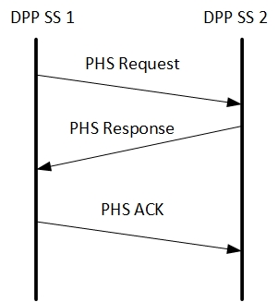
Figure 12 PHS creation message flow

The Automatic PHS-related messages are described in section 11.1.4.

Link Adaptation (LA)

Link adaptation is the process of dynamic selection for transmission of the highest MCS and repetition rate that can support reliable communications subject to the CINR at the peer SS receiver.

The CINR measurement method is vendor specific. One possible method to estimate CINR is given by equation (8-156) described in 8.4.12.3. The CINR shall be measured over all the slots in the latest burst received and based on the DPP SS’s configuration “CINR Reporting”, either averaged or minimum CINR across all the slots present over the burst shall be reported. CINR shall be reported in dB and shall be quantized in 1 dB steps.

At the beginning of the LA process, the DPP SS shall transmit all packets with the Robust MCS. To initiate the LA process, when DPP SS enters the Association state, it shall measure the CINR when it receives the ASSOCIATE Request message and send an unsolicited Measurement Report message to its peer DPP SS. To reinitiate the LA process, the DPP SS shall send an unsolicited Measurement Report message to its peer DPP SS whenever it detects a significant change in CINR measurements. Upon receiving an unsolicited Measurement Report message, a DPP SS shall adjust the MCS with which it transmits as the highest MCS can be decoded within the reported CINR.

Table 3 defines the values of combined MCS and repetition factor.

After receiving a Measurement Report message, the DPP SS shall start/restart its LA hold timer and use the MCS as per the report until the timer expires or another Measurement Report message is received, whichever occurs first. DPP SS shall maintain the independent LA hold timers for each peer DPP SS.

In case the LA hold timer expires, the DPP SS shall use the Robust MCS for transmission until the LA process has reoccurred and determined that a different MCS should be applied.

The Measurement Report message structure is described in section 11.1.3. Figure 13 shows the flow of the LA process.

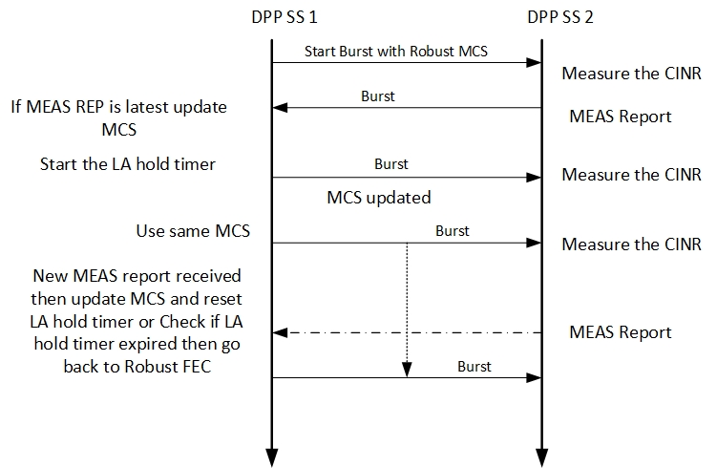
Figure 13. Link Adaptation (LA) Procedure

Table 3 MCS table
MCS | Value
QPSK 1/2 R128 | 0
QPSK 1/2 R64 | 1
QPSK 1/2 R32 | 2
QPSK 1/2 R16 | 3
QPSK 1/2 R8 | 4
QPSK 1/2 R4 | 5
QPSK 1/2 R2 | 6
QPSK 1/2 | 7
QPSK 3/4 | 8
16 QAM 1/2 | 9
16 QAM 3/4 | 10
64 QAM 3/4 | 11
64 QAM 5/6 | 12
256 QAM 7/8 | 13

Power Control

Power control is an optional DPP process. When power control is not enabled, the DPP SS shall transmit at a configurable fixed TX power (typically Max TX power).

The objective of the power control is to minimize self-interference by reduction in TX power as much as possible subject to CINR and/or RSSI criteria at the peer DPP SS. The criteria is vendor specific. The receiving DPP SS sends a Measurement Report message (the same message type as used for LA) which includes the RSSI, so that the transmitting DPP SS can use this RSSI measurement to compare it with the target RSSI and do the delta power correction in the next transmission (if power control is enabled). The power control process (if present) must be designed to work synergistically with the LA process.

The Measurement Report message structure is defined in section 11.1.3 .

Relay Station

General

The Relay station shall perform channel access as per the procedure described in section 6.2. The Relay station shall not use the RTS CTS mechanism.

If a burst is to be relayed, the DPP SS shall indicate that in the CTRL-MSG within the burst using the Relay Option field and ACK Indication field as described in requirement 9.1.3 and in Table 4.

The DPP SS shall be configurable with one of three relay options as follows:
    - Direct transmission only: a CTRL-MSG with Relay Option field value of 0 indicates that a Relay Station receiving it is not to relay the burst.
    - Relay: a CTRL-MSG with Relay Option value of 1 indicates that a Relay Station receiving it is to relay the burst.
    - Relay based on ACK failure: For this option, the ACK Indication field is set to a value of 1 in the CTRL-MSG. A CTRL-MSG with a Relay Option value of 2 indicates that a Relay Station receiving it is to decode the burst and wait for the ACK bit map to be received until the configurable Relay Wait Time duration has passed. If the ACK bit map is not received, the relay station will relay the whole burst. If the ACK bit map is received within the Relay Wait Time duration, depending on the bitmap status, the relay station will relay only the PDUs in the burst whose bit status is zero. The ACK bitmap is present in the CTRL-MSG when the Control Message Type option value is 3.

Upon receiving a burst containing a CTRL MSG with a Relay Option value of 0, the relay station shall discard the burst.

Upon receiving a burst containing a CTRL MSG with a Relay Option value of 1, the relay station shall relay the burst.

Upon receiving a burst containing a CTRL MSG with a Relay Option value of 2 and an ACK Indication field set to a value of 1 in the CTRL-MSG, the Relay Station shall decode the burst and wait for the associated ACK bit map to be received in the CTRL MSG of a message from the destination DPP SS until the configurable Relay Wait Time duration has passed. If an ACK bit map is not received after waiting for the configurable Relay Wait Time duration after receiving a burst containing a CTRL MSG with a Relay Option value of 2 and an ACK Indication field set to a value of 1, the relay Station shall relay the whole unacknowledged burst. If an associated ACK bit map is received before waiting for the configurable Relay Wait Time duration after receiving a burst containing a CTRL MSG with a Relay Option value of 2 and an ACK Indication field set to a value of 1, the Relay Station shall relay the PDUs in the burst whose status in the ACK bit map is zero.
NOTE: The ACK bitmap is present in the CTRL-MSG when the Control Message Type option value is 3.

The relay station shall change the Relay Status to 1 in the CTRL-MSG of a burst that it relays.

Upon receiving a burst containing a CTRL MSG with a Relay Option value of 2 and an ACK Indication field set to a value of 0 in the CTRL-MSG, the Relay Station shall discard the burst.

LA with Relay

The relay station shall measure the CINR on a burst with CTRL-MSG Relay option indicating a nonzero value.

The relay station shall send a Measurement Report message to a DPP SS whenever it determines that a change in MCS is needed based on the latest CINR measured in a burst from that DPP SS.

The relay station shall send a Measurement Report message to a DPP SS with Measurement Type set to 1 when indicating the measurement was done by a Relay Station on a burst received for relay. Refer to Table 7 for definition of the fields in a Measurement Report message.

The relay station shall include the sender ID and name of the destination DPP SS in the CTRL-MSG when it sends a Measurement Report message. The ID and name of the relay is not included in a relayed message.

The DPP SS shall use a Measurement Report message with Measurement Type of 1 for deciding the MCS for a burst that needs to be relayed.

The DPP SS shall start/restart the LA hold timer when a Measurement Report message is received. If the LA timer expires, the DPP SS shall transmit bursts to the associated DPP SS with the Robust MCS.

The DPP SS shall measure the CINR on a relayed bust and send a Measurement Report message with:
- the Measurement Type set to 2, indicating the measurement was done on a relayed burst, and
- the Relay Option set to zero.

The Relay Station shall use the Measurement report sent by the DPP SS with Measurement Type of 2 for deciding the MCS for the burst which needs to be relayed to the same DPP SS.

The relay station shall maintain independent LA hold timer for each DPP SS.

The relay station shall start/restart the LA hold timer when a Measurement Report message is received. If the LA hold timer expires, the Relay Station shall transmit bursts to the associated DPP SS with the Robust MCS.

Figure 14 shows the LA process when a Relay Station is involved.
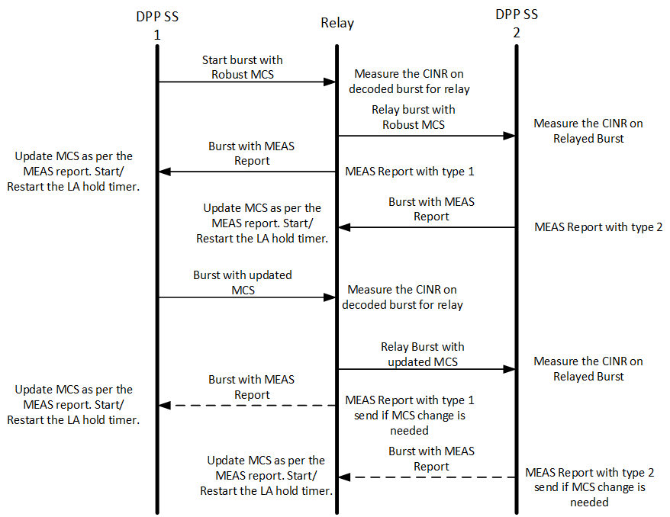
Figure 14 LA with Relay

Frequency Diversity

Frequency diversity is an optional DPP requirement. It can be used to improve the transmission reliability. When using frequency diversity, a DPP terminal will have access to a configurable subchannel group in two bands.

A DPP terminal may support one or more of the following frequency diversity modes:

Frequency Diversity Mode 1: Each burst is transmitted twice over time. Each of the two instances of the burst will be transmitted in a different band. and will use CSMA/CA procedure (as described in para xxx) in the respective band. Peer DPP SS and relay station will listen on both bands so that hop synchronization is not needed.

Frequency Diversity Mode 2: Each burst is transmitted over two bands at the same time. CSMA/CA will be done on both bands.

Frequency Diversity Mode 3: In this mode ACK transmission is needed to the sender DPP SS from the receiving DPP SS for confirming the successful reception of burst. Burst is transmitted over one band first and retransmission is done on the other band if the ACK is not received over ACK Wait Time. The DPP SS shall keep alternating the burst transmission between two frequencies till the ACK is received. Each burst transmission instance will include CSMA/CA procedure in the respective band. The peer DPP SS and relay station will listen on both bands so that hop synchronization is not needed.

Messages format
All data fields are little endian.

Control Message (CTRL MSG)
Table 4 CTRL Message
Syntax | Size(bits) | Notes
Control Message () { | --- | ----
Control Message Type | 2 | This field indicates the type of CTRL MSG based on what description it is carrying.  Value 0: DPP PDU,  1: RTS  2: CTS  3: ACK
Relay Status | 1 | 0: Original transmission, 1: Relay Transmission
Relay Option | 2 | Value 0: Direct transmission only, No Relay  1: Relay  2: Relay based on ACK failure
Sender ID | 48 | MAC address of the Sender DPP SS
Sender Name | 48 | Name of the Sender DPP SS
Receiver ID | 48 | MAC address Receiver DPP SS
Receiver Name | 48 | Name of the Receiver DPP SS
If (control message Type == 1) {
Requested Bytes | 16 | Total bytes to transmit including DPP PDU and SDU overheads.
Reserved | 3
}
ElseIf (control message Type == 3) {
ACK Bit Map | 16 | LSB applies to first DPP PDU and MSB to last. Bit value 1 indicates ACK. Maximum number of DPP PDUs in burst shall not exceed 16.
Reserved | 3
} else {
MCS | 4 | MCS includes the Repetition. Refer Table 3.
ACKI | 1 | ACK Indication. 0: disabled, 1: enabled
Number of Slots | 12 | Number of slots requested (for RTS) or allocated (for CTS/PDU) post CTRL MSG.
Reserved | 1
AUTHI | 1 | Authentication. 0: Disabled 1: Valid CMAC/HMAC is present.
}
CRC | 8 | CRC for above bytes computed per 802.16 section 6.3.3.5 CRC calculation
CMAC/HMAC Digest | 128 | Message integrity code of the message. Must be last field in the message. If AUTHI is 0 then this field is not transmitted, when AUTHI is set to 1 this will be present after the CRC.
}

Association Message (ASSOCIATE Request, ASSOCIATE Response)
Table 5 Associate Request
Syntax | Size(bit) | Notes
ASSOCIATE Request () { | --- | ----
Message Type | 8 | Value: 1
Initiator MAC addr | 48 | MAC address of initiating SS
Receiver MAC addr | 48 | MAC address of peer SS
Selection Mode | 4 | 0: Automatic  1: Manual
Pairing Mode | 4 | 0: Single pairing only  1: Initiating SS is operating in Server mode  2: Initiating SS is operating in Client mode
SS name length | 8
SS name |  | Name of initiating SS, as appears in certificate.subjectName
CA name length | 8
CA name |  | Name of initiating SS, as appears in certificate.issuerName
}

Table 6 Associate Response
Syntax | Size(bit) | Notes
ASSOCIATE_Response () { | --- | ----
Message Type | 8 | Value: 2
Initiator MAC addr | 48 | MAC address of initiating SS
Receiver MAC addr | 48 | MAC address of peer SS
}

Measurement Report Message
Table 7 Measurement report
Syntax | Size(bit) | Notes
Measurement_report () { | --- | ----
Message Type | 8 | Value: 3
CINR | 8 | Averaged CINR measurement report
RSSI | 16 | Averaged RSSI measurement report
MCS | 4 | MCS includes Repetition. Refer Table 3.
Measurement Type | 2 | 0: Measured on non-relayed burst  1: Measured by Relay  2: Measured on Relayed burst
Reserved | 2
}

Automatic PHS Message
Table 8 PHS Request
Syntax | Size(bit) | Notes
PHS Request () { | --- | ----
Message Type | 8 | Value: 4
PHSI | 8 | PHS Index, Identifies the PHS rule
PHS size | 8 | Size of the PHS Field
PHS Mask | 48 | Bitmask that determines which bytes of the PHSF that needs to be suppressed
PHS Field | 48 | Variable Field values 0 to 48 bits
}

Table 9 PHS Response
Syntax | Size(bit) | Notes
PHS Response () { | --- | ----
Message Type | 8 | Value: 5
Response code | 8 | 0: Reject, 1 to 255 : Accept acknowledged with PHSI received in PHS request message
}

Table 10 PHS ACK
Syntax | Size(bit) | Notes
PHS_Ack () { | --- | ----
Message Type | 8 | Value: 6
}

DPP SS Configurable parameters

Table 11 List of DPP SS Configurable Parameters
S No. | Parameter | Description
1 | TX Band Center Frequency | Center frequency of TX band configured in Hz
2 | Diversity TX Band Center Frequency | Center frequency of Diversity TX band configured in Hz
3 | Channel Bandwidth | Bandwidth of the channel in Hz
4 | Subchannel Bandwidth | Bandwidth of the single subchannel in Hz
5 | Subchannel Bitmap | Subchannel bit map showing the active subchannels within a channel.
6 | RSSI Threshold | RSSI threshold in dBm, minimum detection value above which carrier is considered to be busy.
7 | RTS | 1: RTS is needed for doing the data transmission. 0: RTS not needed.
8 | Max RBC | Maximum number of Random Back off Count for declaring channel is busy to user.
9 | Max CO | Maximum Channel Occupancy in terms of slots.
10 | Minimum Inter Burst Gap | A minimum duration in milliseconds between consecutive transmission of a DPP SS in which it is not allowed to transmit.
11 | LA Hold Timer | Link Adaptation Hold Timer configured in seconds.
12 | Nominal CINR | Minimum and Maximum CINR values Per MCS
13 | Operational State Time Limit | Time duration in seconds after which DPP SS will leave Operational state if its Peer does not respond or transmit any burst.
14 | Robust MCS | The highest MCS that can reliably be decoded by the peer DPP SS
15 | SF related Priority for DPP mode | Priority between 0 to 7. Higher the number higher the priority.
16 | SF related Maximum Latency for DPP mode | Time in milliseconds, based on the maximum tolerable latency requirement for the SF.
17 | SF related ACK for DPP mode | 0: ACK not needed; 1: ACK is needed.
18 | Pairing Method | 0: Automatic selection; 1: Manual List selection
19 | DPP Peer SS MAC Address(es) and/or Name(es) | A list of up to Maximum Configurable Peers MAC Addresses
20 | Public Key of peer DPP SS | A list of up to Maximum Configurable Peers public keys
21 | CA Name of peer DPP SS | A list of up to Maximum Configurable Peers CA names
22 | CA Root Public Key of peer DPP SS | A list of up to Maximum Configurable Peers CA names
23 | Authentication Option | 0:Disabled; 1: Enabled
24 | Key Exchange Option | 0:ECDH; 1:ECDHE
25 | Encryption Option | 0:Disabled; 1: AES 128; 2:AES 256
26 | Relay Option | 0:No Relay; 1: Relay; 2:Relay based on ACK failure
27 | Maximum Round Trip Delay | Maximum round trip delay in milliseconds between two DPP SSs.
28 | ACK Wait Time | Wait time in seconds before considering ACK failure.
29 | Pairing Mode | 0: Single; 1: Server, 2: Client
30 | CINR Reporting | 0: Averaged CINR, 1: Minimum CINR.
31 | Maximum Associated Peers | 1 to 7
32 | Frequency Diversity Mode | 0: Disabled  1: Frequency Diversity Mode 1  2: Frequency Diversity Mode 2  3: Frequency Diversity Mode 3

