IEEE P802.15
Wireless Personal Area Networks

Project | IEEE P802.15 Working Group for Wireless Personal Area Networks (WPANs)
Title | NB Assisted Data Communications
Date Submitted | July 2023
Source | Mingyu Lee, Taeyoung Ha, Youngwan So, Aniruddh Rao Kabbinale, Clint Chaplin (Samsung Electronics)
Re: | Contribution to IEEE 802.15.4ab
Abstract
Purpose | This submission proposes text to for the IEEE Std 802.15.4ab specification framework document.
Notice | This document does not represent the agreed views of the IEEE 802.15 Working Group or IEEE 802.15.4ab Task Group. It represents only the views of the participants listed in the “Source(s)” field above. It is offered as a basis for discussion and is not binding on the contributing individual(s) or organization(s). The material in this document is subject to change in form and content after further study. The contributor(s) reserve(s) the right to add, amend or withdraw material contained herein.

Introduction
In PAR objectives, hybrid operation with NB signaling to assist UWB is provided. In this document we address the way to offload UWB data communications to NB.

Recently, UWB ranging based applications are being developed. As one of example, UWB payment system utilizes the UWB contention based ranging to select the nearest user among the users nearby. The selected user can provide the payment information by using UWB data communications between the user device and the UWB payment system

However, since the devices perform ranging and data communication with each other on the same UWB channel, the UWB channel becomes more congested as the number of device increases. Especially, time resources are very limited to support both UWB ranging and UWB data communication occur on the same UWB channel as the number of device increases

Initiator can offload UWB data communication to NB by allocating NB channel and time to responders. The requirements / conditions may vary according the applications. For example,
In UWB gate system, each gates may have their own NB channel(s) which can be allocated to the nearest user selected by using the UWB result. Time resources saved by NB offloading can be used for more frequent ranging OR the increase of the number of gates

To support the operation mentioned above, a method for NB resource allocation is required

There are two main sections: One focuses on MAC aspects of NB assisted data communications, and the other one develops the message formats required to support the feature.

Basic Operation
Initiator may transmit a NB allocation packet during measurement report phase followed by ranging phase. The NB allocation packet shall include NB Allocation IE to responder(s). After ranging phase, ERDEVs are scheduled in the measurement phase to exchange the required information for NB data communications. In the example Figure 1, the initiator send NB allocation packet including NB Allocation IE with NB channel and offset to responder for starting NB data communication during measurement phase.

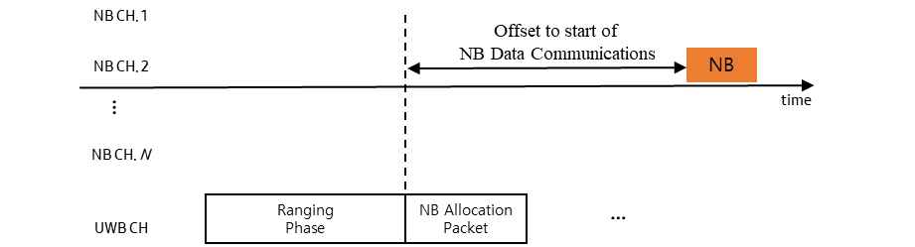

Figure 1 NB Data Communication Triggered by NB Allocation Packet

At the end of time offset, initiator shall transmit NB packet on the allocated NB channel. The responder may listen for incoming NB packet. Once the responder has received NB packet, it may transmit NB packet.

Message Format

NB Allocation IE
The NB Allocation IE is used by an initiator to send the NB resource allocation information to a responder (in a unicast frame). The content field of the NB Allocation IE shall be formatted as shown in Figure 2.
Bits : 2 | 6 | Octets : 2/3/8 | Octets : 2 | 1 | 4
Address  Size | Reserved | Address | NB Channel | NB  PHY | Transmission  Offset
Figure 2 Control Field of the Scheduling IE
Address Size field specifies the size of the address used in NB Allocation IE

Address field identifies the participating device. The size of the Address field is specified by the Address Size field

NB Channel field is used to assign a NB channel index to device identified by the address field
NB PHY specifies the NB PHY configuration index.

Transmission Offset field specifies the remaining until the start of NB packet in the channel specified by NB Channel field relative to the end of NB allocation packet.

